Stock assessment of the yelloweye rockfish (*Sebastes ruberrimus*) in state and Federal waters off California, Oregon and Washington

by

Vladlena Gertseva and Jason M. Cope

Northwest Fisheries Science Center

U.S. Department of Commerce

National Oceanic and Atmospheric Administration

National Marine Fisheries Service

2725 Montlake Boulevard East

Seattle, Washington 98112-2097

2017

This report may be cited as:

Gertseva, V. and Cope, J.M. 2017. Stock assessment of the yelloweye rockfish (*Sebastes ruberrimus*) in state and Federal waters off California, Oregon and Washington. Pacific Fishery Management Council, Portland, OR. Available from http://www.pcouncil.org/groundfish/stock-assessments/

**Table of Contents**

Acronyms used in this document 6

Executive Summary 7

Stock 7

Catches 7

Data and assessment 8

Stock biomass 9

Recruitment 12

Exploitation status 14

Ecosystem considerations 19

Reference points 19

Management performance 21

Unresolved problems and major uncertainties 22

Decision table 23

Research and data needs 23

Rebuilding projections 24

1 Introduction 27

1.1 Basic Information 27

1.2 Map 28

1.3 Life History 28

1.4 Ecosystem Considerations 28

1.5 Fishery Information 28

1.6 Summary of Management History 29

1.7 Management Performance 29

1.8 Fisheries off Canada, Alaska, and/or Mexico 29

2 Assessment 30

2.1 Data 30

2.1.1 Fishery removals 30

2.1.1.1 Commercial and recreational removals 31

2.1.1.1.1 California 31

2.1.1.1.2 Oregon 32

2.1.1.1.3 Washington 33

2.1.1.1.4 Bycatch in the Foreign POP Fishery 34

2.1.1.1.5 Bycatch in the At-Sea Pacific Hake Fishery 34

2.1.2 Abundance Indices 34

2.1.2.1 Fishery-Independent Indices 34

2.1.2.1.1 Bottom Trawl Surveys 34

2.1.2.1.2 IPHC Longline Survey 36

2.1.2.2 Fishery-Dependent Abundance Indices 37

2.1.2.2.1 California MRFSS Dockside CPUE, 1980-1999 37

2.1.2.2.2 California Onboard Observer CPUE, 1988-1998 38

2.1.2.2.3 Oregon Onboard Observer CPUE, 2001-2014 38

2.1.2.2.4 Oregon MRFSS Dockside CPUE, 1982-1999 39

2.1.2.2.5 Oregon ORBS Dockside (release only) CPUE, 2005-2016 39

2.1.2.2.6 Washington Dockside CPUE, 1982-2001 40

2.1.3 Fishery-Dependent Biological Compositions 41

2.1.3.1 California 42

2.1.3.1.1 Length Compositions 42

2.1.3.1.2 Age Compositions 42

2.1.3.2 Oregon 43

2.1.3.2.1 Length Compositions 43

2.1.3.2.2 Age Compositions 43

2.1.3.3 Washington 43

2.1.3.3.1 Length Compositions 43

2.1.3.3.2 Age Compositions 43

2.1.4 Fishery-Independent Biological Compositions 44

2.1.4.1 Length Compositions 44

2.1.4.2 Age Compositions 44

2.1.5 Biological Parameters and Data 44

2.1.5.1 Length-Weight Relationships 44

2.1.5.2 Maturity 45

2.1.5.3 Fecundity 45

2.1.5.4 Natural Mortality 45

2.1.5.5 Ageing Error 46

2.1.6 Environmental or Ecosystem Data 47

2.2 Model 47

2.2.1 History of Modeling Approaches Used for this Stock 47

2.2.1.1 Previous Assessments 48

2.2.1.2 Responses to 2009 STAR Panel Recommendations 49

2.2.2 Model Description 53

2.2.2.1 Changes Made From the Last Assessment 53

2.2.2.2 Model Specifications 55

2.2.2.3 Model Parameters 56

2.2.2.3.1 Life history parameters 56

2.2.2.3.2 Stock -Recruitment Function and Compensation 57

2.2.2.3.3 Selectivity Parameters 58

2.3 Base Model Selection and Evaluation 58

2.3.1 Search for Balance Between Model Realism and Parsimony 59

2.3.2 Convergence 60

2.3.3 Evidence of Search for Global Best Estimates 60

2.4 Changes Made During the 2017 STAR Panel Meeting 60

2.5 Base-Model Results 60

2.6 Evaluation of Uncertainty 62

2.6.1 Sensitivity Analysis 63

2.6.1.1 Likelihood Component Analysis 63

2.6.1.2 Sensitivity to Assumptions Regarding Fishery Removals 63

2.6.1.3 Sensitivity to Updating Selected Parameters from 2011 Model 63

2.6.1.4 Sensitivity to Model Specifications 64

2.6.2 Retrospective Analysis 64

2.6.3 Historical Analysis 65

2.6.4 Likelihood Profile Analysis 65

2.6.4.1 Natural Mortality (M) 65

2.6.4.2 Steepness (h) 65

2.6.4.3 Initial Recruitment (R0) and Distribution of Recruits Between Areas 65

3 Reference Points 66

4 Harvest Projections and Decision Table 67

5 Regional Management Considerations 67

6 Research Needs 67

7 Acknowledgments 68

8 Literature Cited 70

9 Auxiliary Files 75

10 Tables 76

11 Figures 112

Appendix A. SS data file 293

Appendix B. SS control file 293

Appendix C. SS starter file 293

Appendix D. SS forecast file 293

# Acronyms used in this document

|  |  |
| --- | --- |
| ABC | Allowable Biological Catch |
| ACL | Annual Catch Limit |
| ADFG | Alaska Department of Fish and Game |
| AFSC | Alaska Fisheries Science Center |
| A-SHOP | At-Sea Hake Observer Program |
| CalCOM | California Cooperative Groundfish Survey |
| CDFW | California Department of Fish and Wildlife |
| CPFV | Commercial Passenger Fishing Vessel |
| CRFS | California Recreational Fisheries Survey |
| DFO | Canada’s Department of Fisheries and Oceans |
| IFQ | Individual Fishing Quota |
| IPHC | International Pacific Halibut Commission |
| MRFSS | Marine Recreational Fisheries Statistics Survey |
| NMFS | National Marine Fisheries Service |
| NORPAC | the North Pacific Database Program |
| NWFSC | Northwest Fisheries Science Center |
| ODFW | Oregon Department of Fish and Wildlife |
| OFL | Overfishing Limit |
| ORBS | Oregon Recreational Boat Survey |
| OY | Optimum Yield |
| PacFIN | Pacific Fisheries Information Network |
| PFMC | Pacific Fishery Management Council |
| PSMFC | Pacific States Marine Fisheries Commission |
| RecFIN | Recreational Fisheries Information Network |
| SPR | Spawning Potential Ratio |
| SSC | Scientific and Statistical Committee |
| SWFSC | Southwest Fisheries Science Center |
| WCGOP | West Coast Groundfish Observer Program |
| WDFW | Washington Department of Fish and Wildlife |

Executive Summary

Stock

This assessment reports the status of the yelloweye rockfish (*Sebastes ruberrimus*) resource off the coast of the United States from southern California to the U.S. - Canadian border using data through 2016. The species is modeled as a single stock, but with two explicit spatial areas: waters off California (area 1) and waters off Oregon and Washington (area 2). Each area has its own unique catch history and fishing fleets (commercial and recreational), but the areas are linked by a common stock-recruit relationship.

Catches

Yelloweye rockfish have historically been a prized catch in both commercial and recreational fisheries. Commercially, they have been caught by trawl and hook-and-line gear types (Figure ES-1). They have generally yielded a higher price than other rockfish and have largely been retained when encountered. Catches of yelloweye rockfish increased gradually throughout the first half of the 20th century, with a brief peak around World War II due to increased demand. The largest removals of the species occurred in the 1980s and 1990s and reached 552 mt in 1982.

After 2002 (when yelloweye were declared overfished), total catches have been maintained at much lower levels (Table ES-1). Currently, yelloweye are caught only incidentally in commercial and sport fisheries targeting other species that are found in association with yelloweye. The recent fishery encounters a very patchy yelloweye rockfish distribution, and extensive effort is made to avoid all but a small amount of bycatch.

**Table ES-1**: Recent yelloweye rockfish catches within each fleet used in the assessment (landings and discard combined).



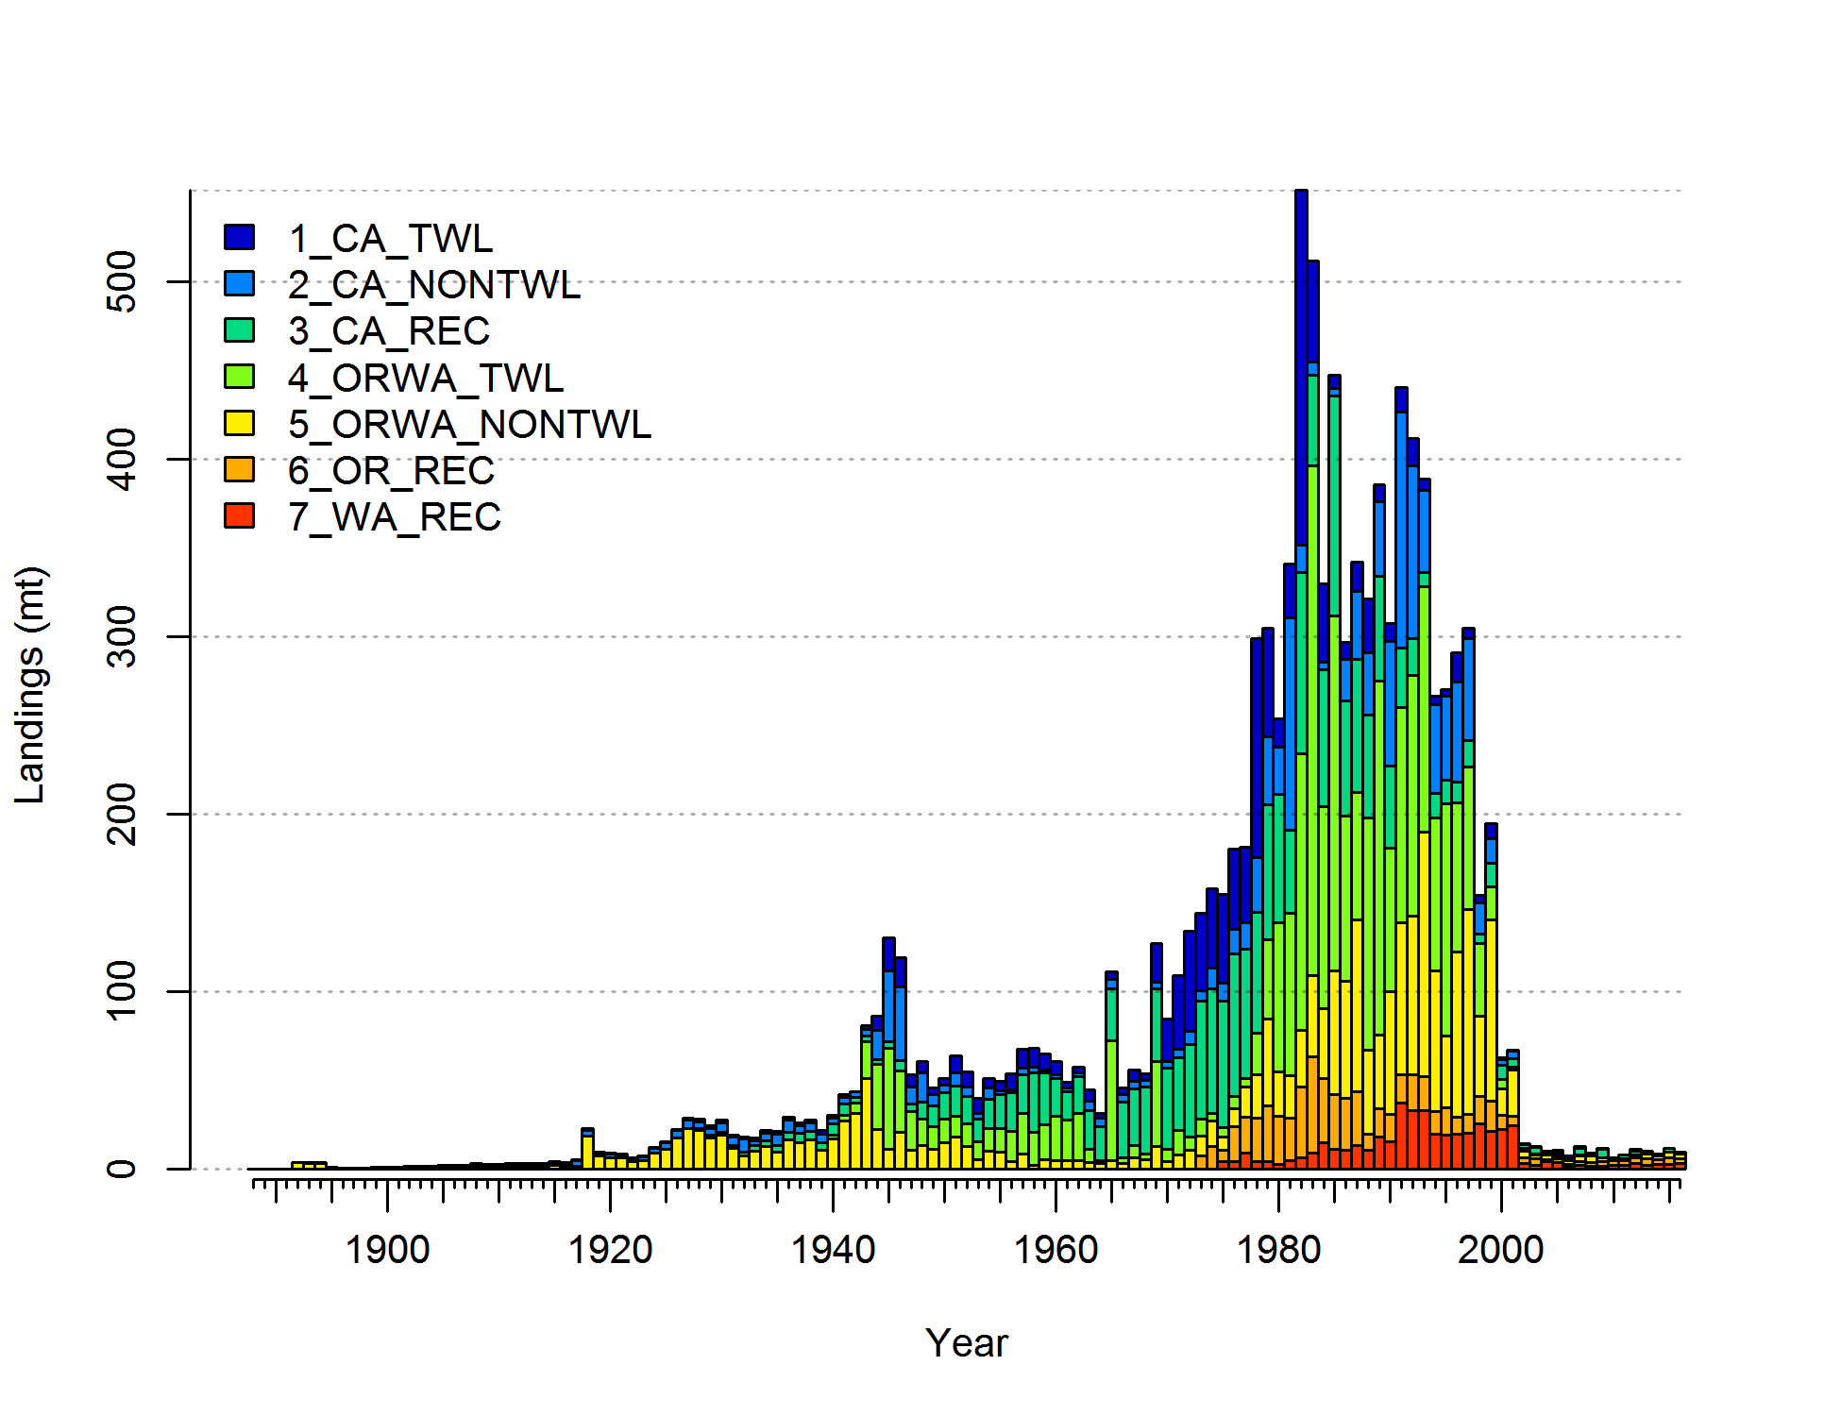

CA trawl

CA non-trawl

CA recreational

OR-WA trawl

OR-WA non-trawl

OR recreational

WA recreational

Yelloweye rockfish catch (mt)

**Figure ES-1:** Yelloweye rockfish catch history between 1889 and 2016 by fleet.

Data and assessment

The last full stock assessment of yelloweye rockfish was conducted in 2009 and it was subsequently updated in 2011. This assessment uses the Stock Synthesis modeling framework (version 3.30.04.02, released June 2, 2017).

The assessed period begins in 1889, when the very first catch records are available for the stock, with the assumption that previously the stock was in an unfished equilibrium condition. Types of data that inform the model include catch, length and age frequency data from seven commercial and recreational fishing fleets. Fishery-dependent biological data used in the assessment originated from both port-based and on-board observer sampling programs. Recreational observer data from Oregon and California were used to construct indices of relative abundance. Yelloweye rockfish catch in the International Pacific Halibut Commission’s (IPHC) long-line survey is also included via an index of relative abundance for Washington and Oregon; IPHC length and age frequency data are also used. Relative biomass indices and information from biological sampling from trawl surveys were included as well; these trawl surveys were conducted by the Northwest Fisheries Science Center (NWFSC) and the Alaska Fisheries Science Center (AFSC) of the National Marine Fisheries Service (NMFS).

The previous assessment modeled three areas that corresponded to waters off California, Oregon and Washington. The choice to model the yelloweye rockfish stock with explicit areas is based on the fact that adult yelloweye have a sedentary life history; at the same time, exploitation rates among areas have been different over the years. In combination, these two factors could have contributed to different trends in abundance among areas and localized depletion. This assessment includes two areas (California and Oregon-Washington). Oregon vessels, particularly those from northern ports, frequently fish in waters off Washington but return to Oregon to land their catch. The same is true to some degree for Washington vessels as well. This issue has become more apparent in recent years, as larger, interagency catch reconstruction efforts have been made. It is infeasible at present to consistently assign removals and biological data landed in Oregon and Washington to area of catch (i.e. Oregon or Washington) with acceptable precision. Oregon and Washington were combined into one area because of this.

Growth is assumed to follow the von Bertalanffy growth model, and the assessment explicitly estimates all parameters describing somatic growth. Females and males in the model are combined, since estimates of growth parameters did not differ between sexes. Externally estimated life history parameters, including those defining the length-weight relationship, female fecundity and maturity schedule were revised for this assessment to incorporate new information. Recruitment dynamics are assumed to follow the Beverton-Holt stock-recruit function, and recruitment deviations are estimated. Natural mortality and stock-recruitment steepness are fixed at the values generated from meta-analytical studies.

Stock biomass

The yelloweye rockfish assessment uses estimates of the egg-to-length relationship from Dick et al. (2017), and spawning output is reported in millions of eggs. The unexploited level of spawning stock output is estimated to be 1,139 million eggs (95% confidence interval: 1,007-1,271 million eggs) (Figure ES-2). At the beginning of 2017, the spawning stock output is estimated to be 323 million eggs (95% confidence interval: 252–394 million eggs), which represents 28.4% of the unfished spawning output level. The biomass in Oregon and Washington is estimated to be larger than in California (Figure ES-3).

The spawning output of yelloweye rockfish started to decline in the 1940s. The species have been lightly exploited until the mid-1970s, when catches increased and a rapid decline in biomass and spawning output began. The relative spawning output reached a minimum of 14.2% of unexploited levels in 2000. Yelloweye rockfish spawning output has been gradually increasing since then in response to large reductions in harvest.

**Table ES-2:** Recent trends in estimated yelloweye rockfish spawning output, recruitment and relative spawning output.

|  |  |  |  |  |  |  |
| --- | --- | --- | --- | --- | --- | --- |
| Years | Spawning Output (million eggs) | ~95% Asymptotic Interval | Recruitment | ~95% Asymptotic Interval | Estimated Depletion (%) | ~95% Asymptotic Interval |
| 2007 | 210 | 160–260 | 200 | 98–407 | 18.4 | 14.9–21.9 |
| 2008 | 219 | 167–270 | 307 | 161–583 | 19.2 | 15.5–22.8 |
| 2009 | 228 | 174–281 | 226 | 111–460 | 20 | 16.2–23.7 |
| 2010 | 237 | 182–292 | 240 | 120–482 | 20.8 | 16.9–24.6 |
| 2011 | 247 | 190–304 | 227 | 111–468 | 21.7 | 17.7–25.7 |
| 2012 | 258 | 199–317 | 115 | 52–252 | 22.6 | 18.5–26.7 |
| 2013 | 269 | 208–331 | 117 | 52–264 | 23.6 | 19.4–27.9 |
| 2014 | 282 | 218–345 | 121 | 51–288 | 24.7 | 20.4–29.1 |
| 2015 | 295 | 229–361 | 141 | 57–347 | 25.9 | 21.4–30.4 |
| 2016 | 309 | 240–377 | 174 | 68–442 | 27.1 | 22.5–31.7 |
| 2017 | 323 | 252–394 | 176 | 69–448 | 28.4 | 23.6–33.1 |

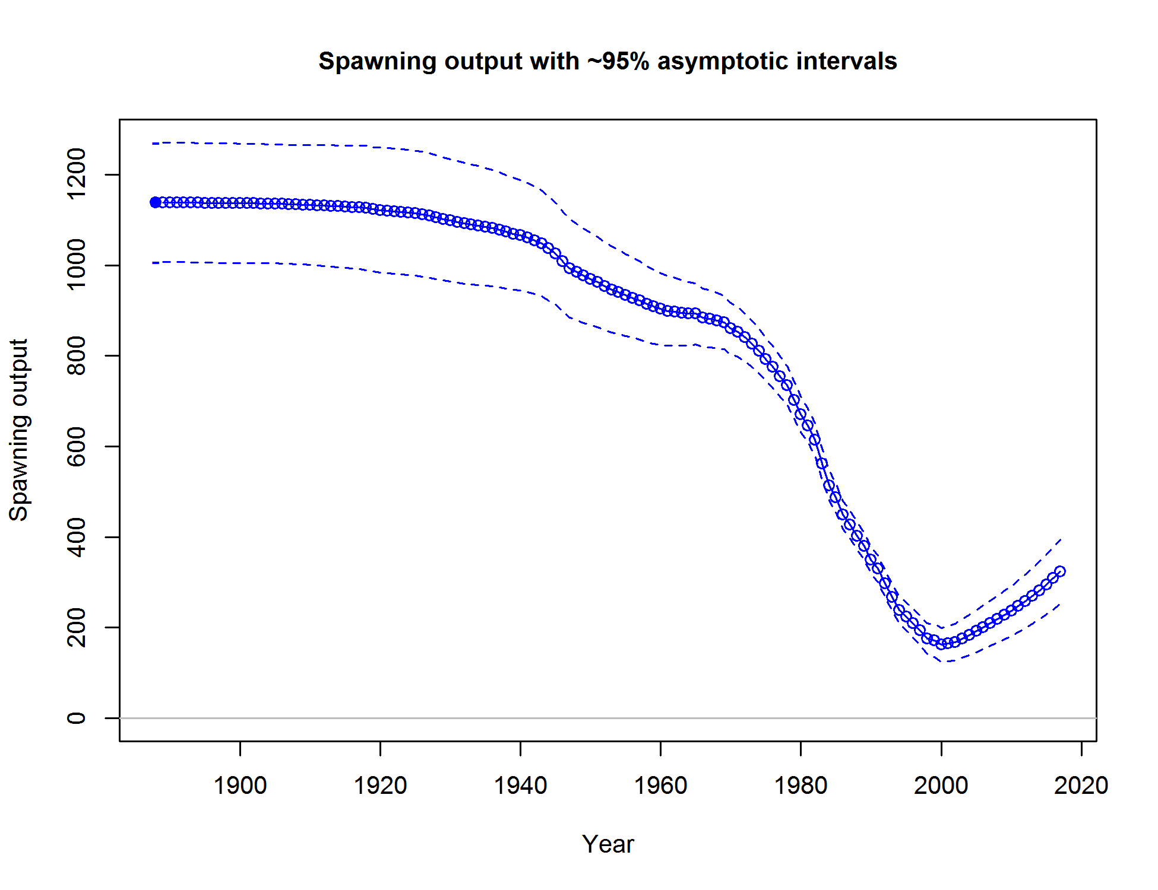

**Figure ES-2:** Time series of estimated spawning output (in million eggs) for the base model (circles) with ~ 95% interval (dashed lines). Spawning output is expressed in million eggs.

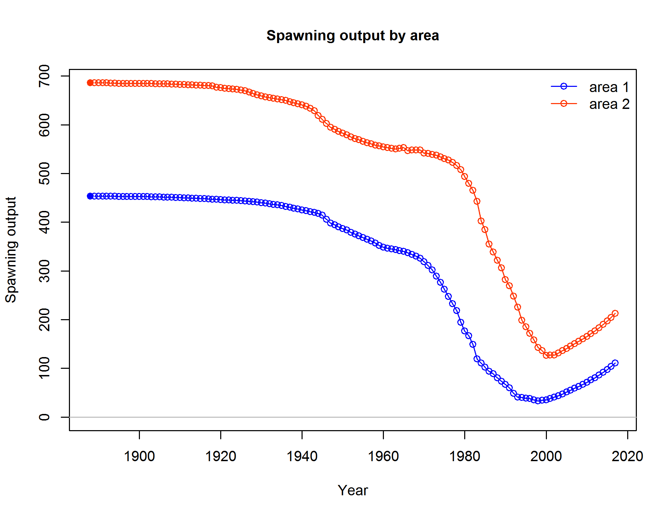

**Figure ES-3.** Time series of estimated spawning output (in million eggs) by area (Area 1 (lower line) = California; Area 2 (upper line) = Oregon and Washington).

Recruitment

Recruitment dynamics are assumed to follow Beverton-Holt stock-recruit function that includes an updated value of the steepness parameter (*h*). The steepness parameter was inestimable, and, therefore, it is fixed at the value of 0.718, which is the mean of steepness prior probability distribution, derived from this year’s meta-analysis of Tier 1 rockfish assessments. The level of virgin recruitment (*R0*) is estimated to inform the magnitude of the initial stock size. ‘Main’ recruitment deviations were estimated for modeled years that had information about recruitment, between 1980 and 2015. We additionally estimated ‘early’ deviations between 1889 and 1979. Peak recruitment events were estimated in years 1971, 1982, 2002, 2008 and 2009 (Figure ES-4). Both areas follow similar recruitment trends, as the overall recruitment pool is distributed between the two areas at an estimated constant fraction (60% to Oregon-Washington and 40% to California; Figure ES-5).

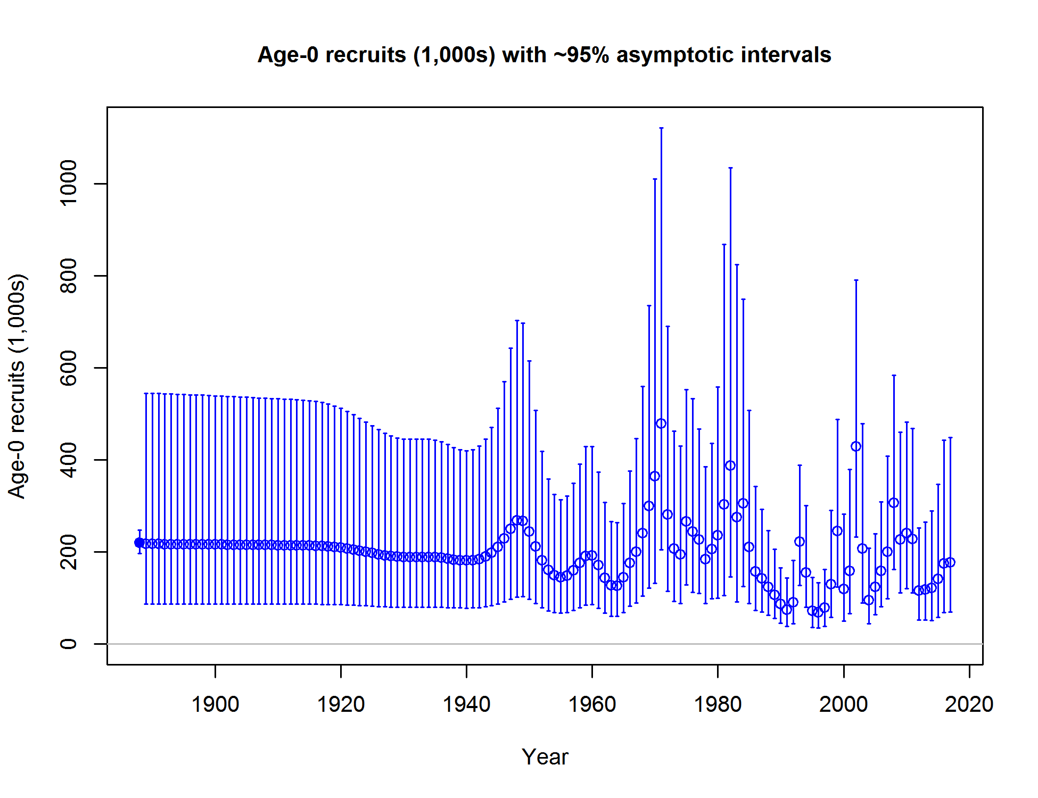

**Figure ES-4:** Time series of estimated yelloweye rockfish recruitments for the base model (circles) with approximate 95% intervals (vertical lines).

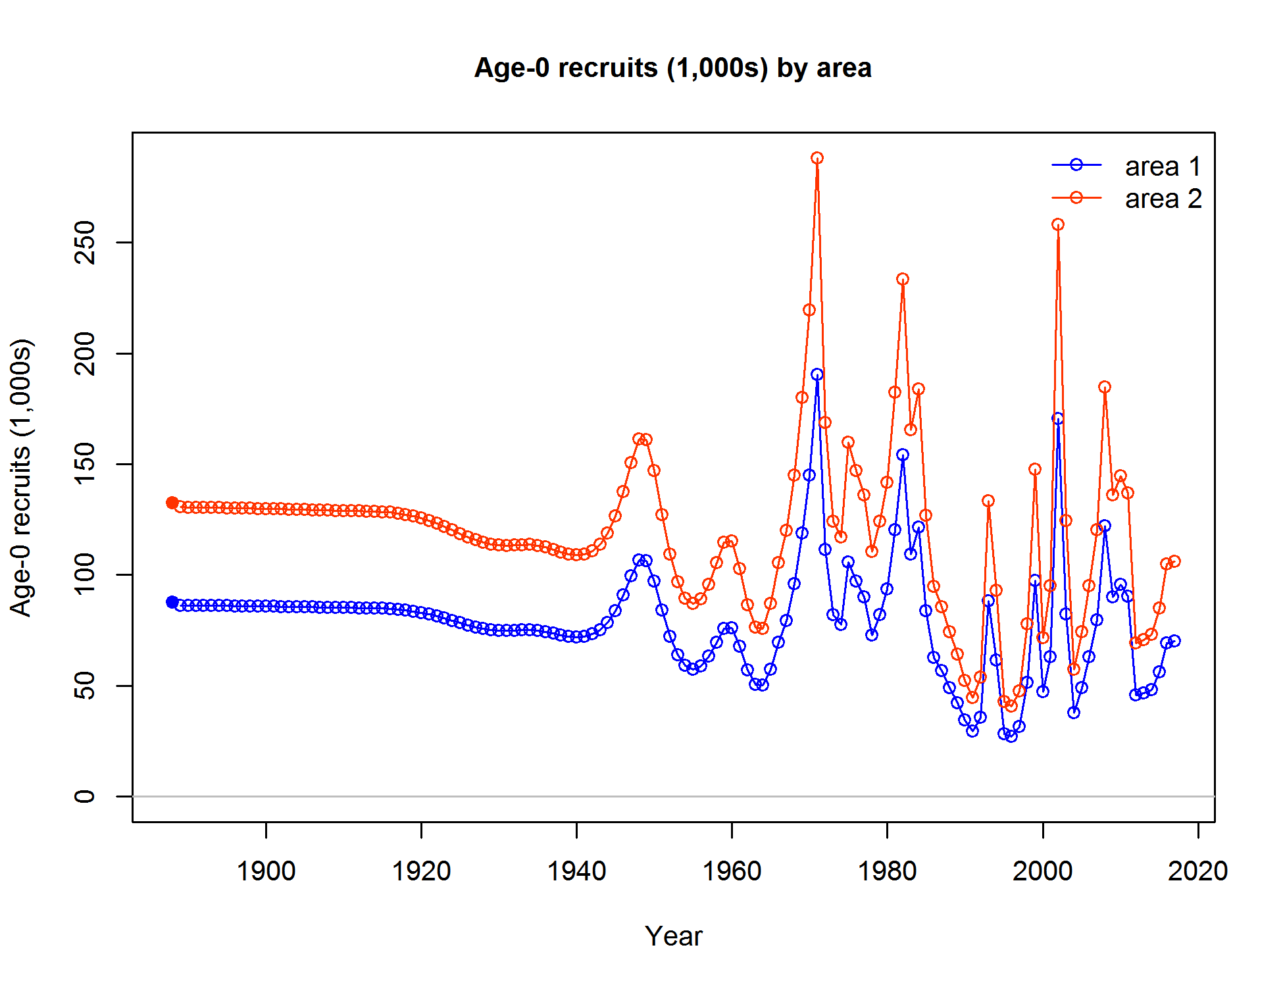

**Figure ES-5** Time series of estimated yelloweye rockfish recruitments for each area of the base model. Area 1 (lower line) = California; Area 2 (upper line) = Oregon and Washington.

Exploitation status

This assessment estimates that the stock of yelloweye rockfish off the continental U.S. Pacific Coast is currently at 28.4% of its unexploited level (Figure ES-6). This is above the overfished threshold of SB25%, but below the management target of SB40% of unfished spawning output. Both areas are above the overfished level of 25% (Figure ES-7). This is 7.4 percent higher than the estimated relative spawning output of 21.0% from the previous assessment, conducted in 2011.

This assessment estimates that historically, the coastwide spawning output of yelloweye rockfish dropped below the SB40% target for the first time in 1986, and below the SB25% overfished threshold in 1993 as a result of intense fishing by commercial and recreational fleets. It continued to decline, and dipped to 14.2% of its unfished output in 2000. In 2002, the stock was declared overfished. Since then, the spawning output is slowly increasing due to management regulations implemented for this and other overfished rockfish species.

This assessment estimates that the Spawning Potential Ratio (SPR) for 2016 was 91%. The SPR used for setting the OFL is 50%, while the SPR-based management fishing mortality target specified in the current yelloweye rockfish rebuilding plan and used to determine the Annual Catch Limit (ACL) is 76%. Relative exploitation rates (calculated as catch/biomass of age-8 and older fish) are estimated to have been below 1% during the last decade (Figure ES-8). As estimated for the historical period, the yelloweye rockfish was fished at a rate above the relative SPR ratio target (calculated as 1-SPR/1-SPRTarget=0.5) between 1977 and 2000 (Figure ES-9).

Table ES-3. Recent trend in relative spawning potential ratio and exploitation rate (catch divided by biomass of age-8 and older fish).

|  |  |  |  |  |
| --- | --- | --- | --- | --- |
| Years | Estimated (1-SPR)/(1-SPR_50%) (%) | ~95% Asymptotic Interval | Harvest Rate (proportion) | ~95% Asymptotic Interval |
| 2007 | 38.11 | 30.66–45.55 | 0.006 | 0.005–0.007 |
| 2008 | 25.49 | 20.43–30.54 | 0.004 | 0.003–0.005 |
| 2009 | 32.96 | 26.47–39.45 | 0.005 | 0.004–0.006 |
| 2010 | 17.46 | 13.94–20.99 | 0.003 | 0.002–0.003 |
| 2011 | 21.26 | 17.01–25.51 | 0.003 | 0.002–0.004 |
| 2012 | 26.51 | 21.38–31.64 | 0.004 | 0.003–0.005 |
| 2013 | 23.00 | 18.61–27.39 | 0.004 | 0.003–0.004 |
| 2014 | 18.84 | 15.23–22.45 | 0.003 | 0.002–0.004 |
| 2015 | 24.74 | 20.12–29.36 | 0.004 | 0.003–0.005 |
| 2016 | 18.79 | 15.29–22.29 | 0.003 | 0.002–0.004 |

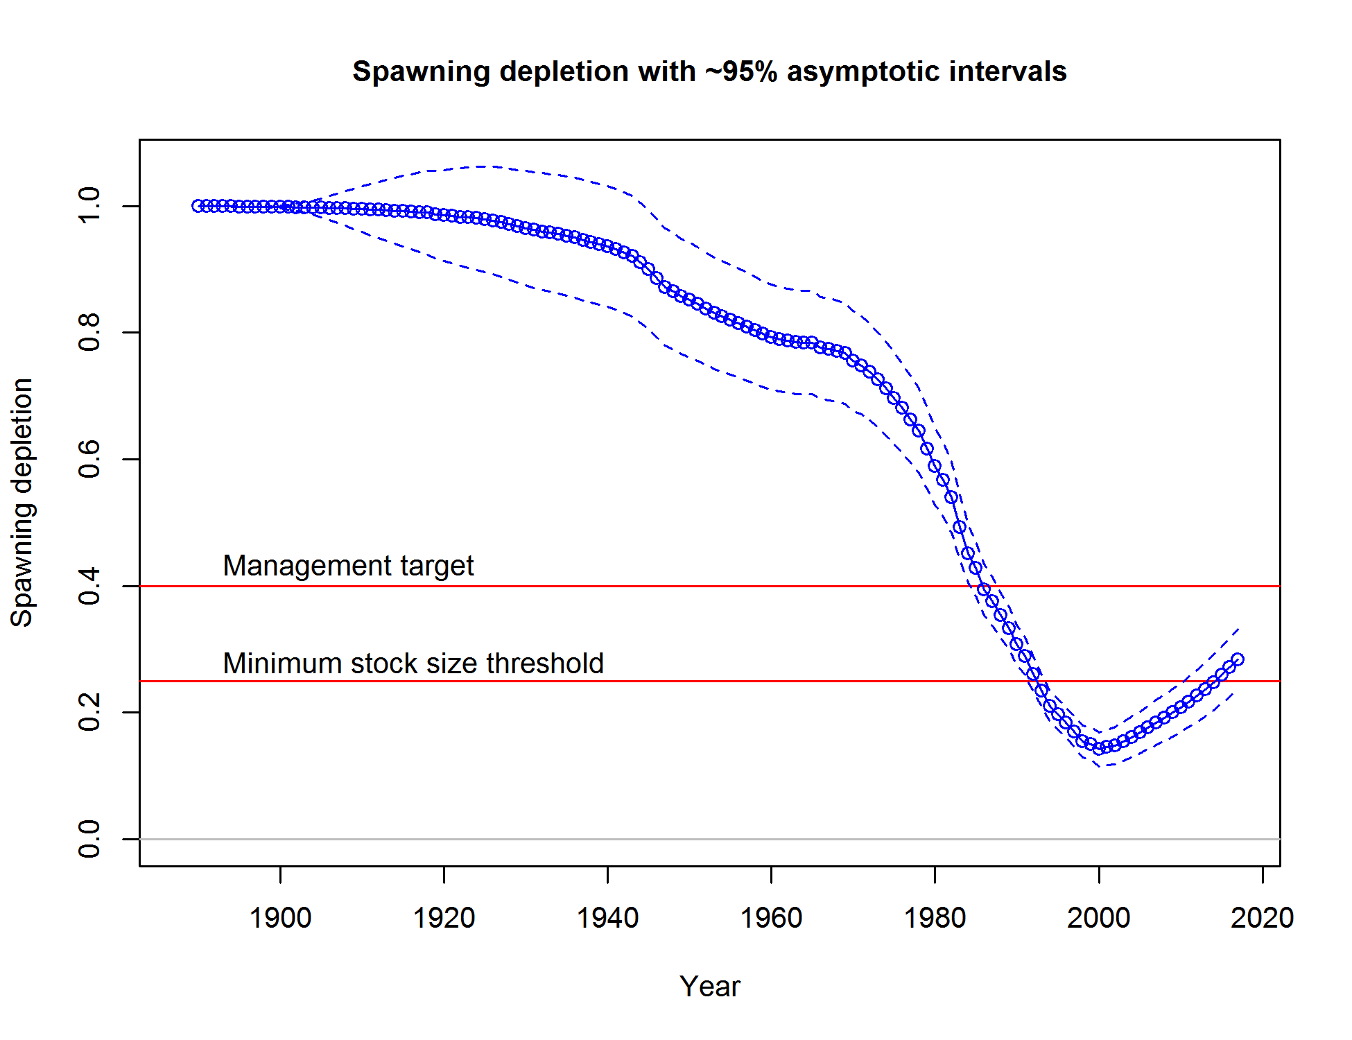

Figure ES-6. Estimated relative spawning output with approximate 95% asymptotic confidence intervals (dashed lines) for the base model.

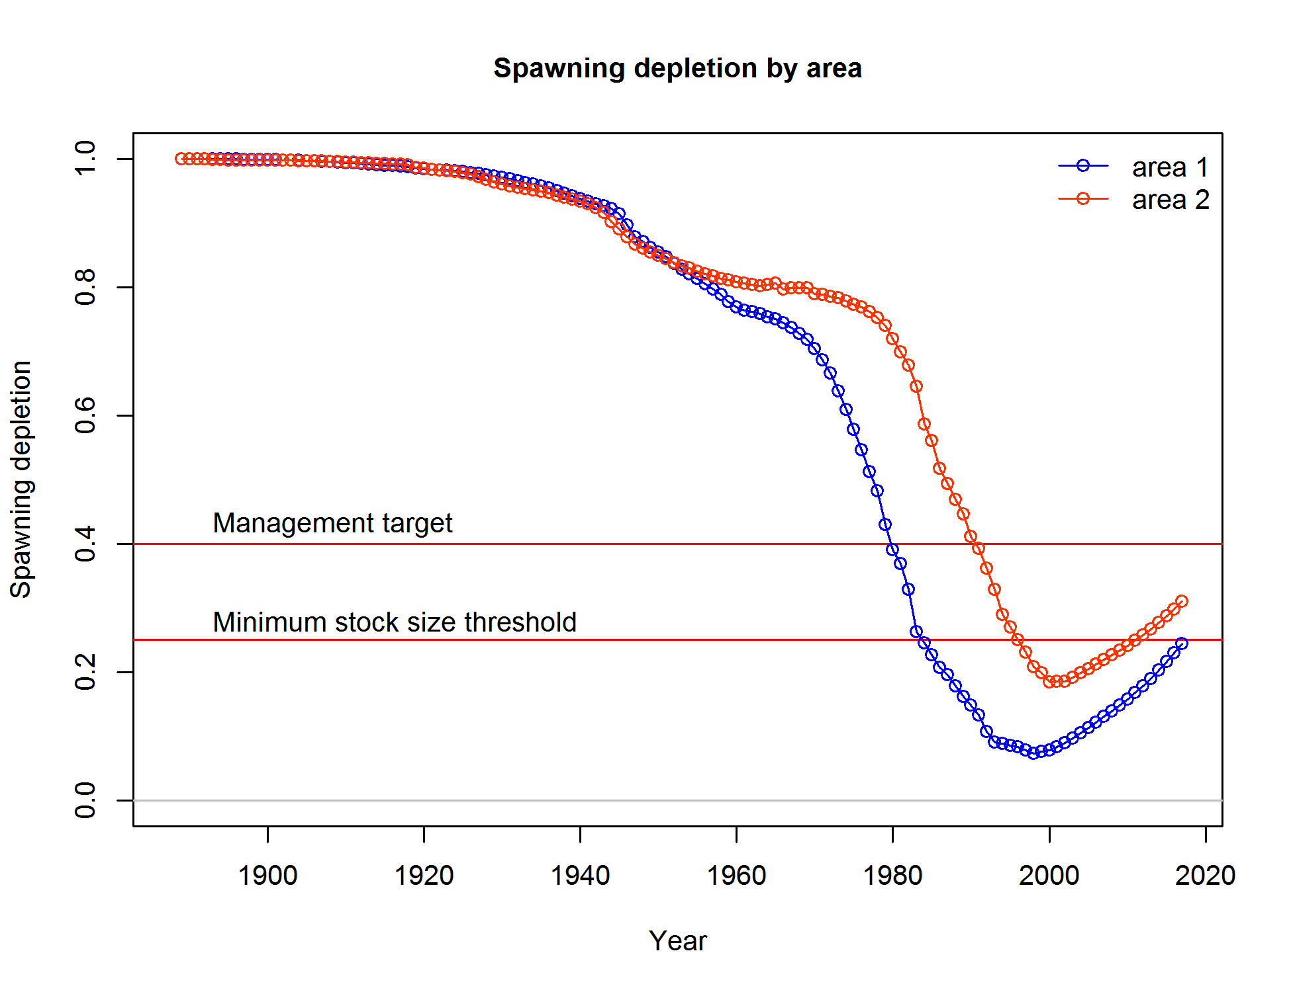

**Figure ES-7.** Estimated relative spawning output for the each area of the base model. Area 1 (lower line) = California; Area 2 (upper line) = Oregon and Washington.

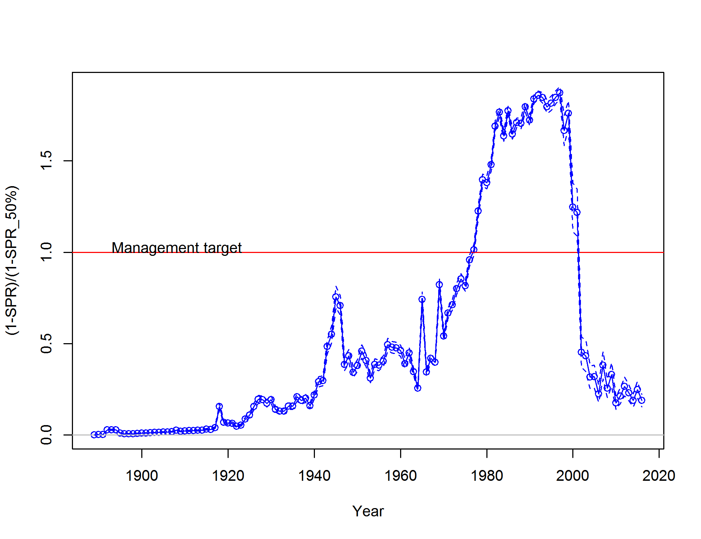

Figure ES-8. Estimated spawning potential ratio (SPR) for the base model with approximate 95% asymptotic confidence intervals. One minus SPR standardized to the target is plotted so that higher exploitation rates occur on the upper portion of the y-axis. The management target is plotted as red horizontal line and values above this reflect harvests in excess of the overfishing proxy based on the SPR50%.

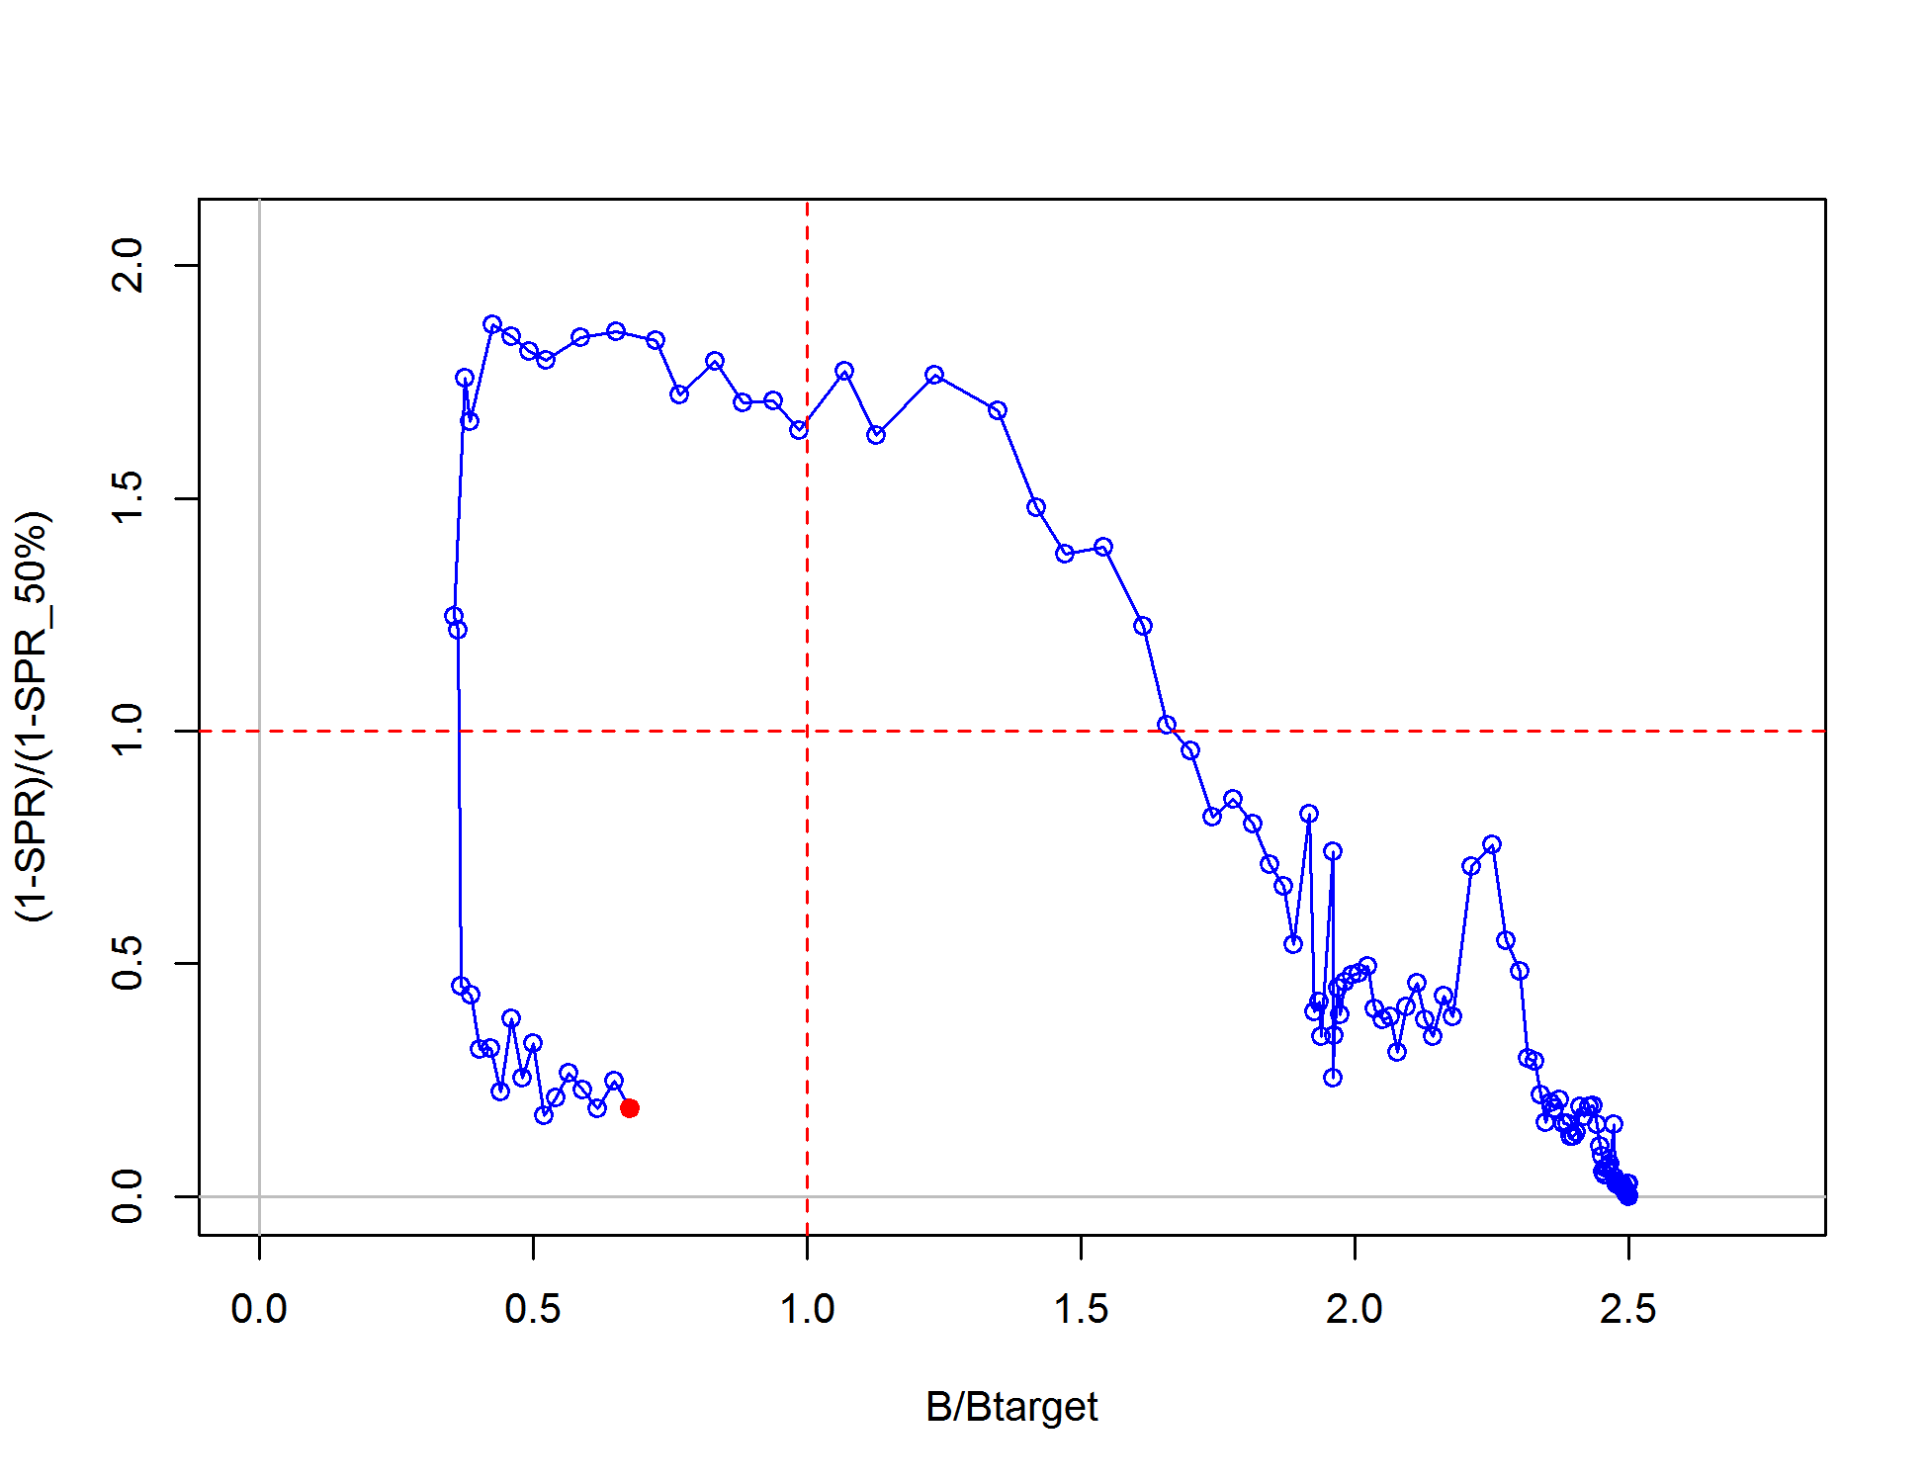

Figure ES-9. Phase plot of estimated relative (1-SPR) vs. relative spawning biomass for the base model. The relative (1-SPR) is (1-SPR) divided by 0.5 (the SPR target). Relative spawning output is the annual spawning biomass divided by the spawning biomass corresponding to 40% of the unfished spawning biomass. The red point indicates the year 2016.

Ecosystem considerations

In this assessment, ecosystem considerations were not explicitly included in the analysis. This is primarily due to a lack of relevant data and results of analyses (conducted elsewhere) that could contribute ecosystem-related quantitative information for the assessment.

Reference points

Unfished spawning stock output for yelloweye rockfish was estimated to be 1,139 million eggs (95% confidence interval: 1,007-1,271 million eggs). The management target for yelloweye rockfish is defined as 40% of the unfished spawning output (SB40%), which is estimated by the model to be 456 million eggs (95% confidence interval: 403-509), which corresponds to an exploitation rate of 0.025. This harvest rate provides an equilibrium yield of 109 mt at SB40% (95% confidence interval: 99-122 mt). The model estimate of maximum sustainable yield (MSY) is 114 mt (95% confidence interval: 101-127 mt). The estimated spawning stock output at MSY is 335 million eggs (95% confidence interval: 296-374 million eggs). The exploitation rate corresponding to the estimated SPRMSY of F36% is 0.034. The equilibrium estimates of yield relative to biomass is provided in Figure ES-10.

**Table ES-4**. Summary of reference points for the base model.

|  |  |  |
| --- | --- | --- |
| Quantity | Estimate | ~95% Asymptotic Interval |
| Unfished Spawning Output (million eggs) | 1,139 | 1,007-1,271 |
| Unfished Age 8+ Biomass (mt) | 9,796 | 8,664–10,928 |
| Unfished Recruitment (R0) | 220 | 194–245 |
| Depletion (2017) | 28.37 | 23.60–33.13 |
| **Reference Points Based SB40%** |  |  |
| Proxy Spawning Output (SB40%) | 456 | 403–509 |
| SPR resulting in SB40% | 0.459 | 0.459–0.459 |
| Exploitation Rate Resulting in SB40% | 0.025 | 0.025–0.025 |
| Yield with SPR Based On SB40% (mt) | 109 | 96–122 |
| **Reference Points based on SPR proxy for MSY** |  |  |
| Proxy Spawning Output (SPR50%) | 508 | 449–567 |
| SPR50 | 0.5 | NA |
| Exploitation rate corresponding to SPR50% | 0.022 | 0.021–0.022 |
| Yield with SPR50% at SBSPR (mt) | 105 | 93–117 |
| **Reference points based on estimated MSY values** | |  |
| Spawning Output at MSY (SBMSY) | 335 | 296–374 |
| SPRMSY | 0.363 | 0.361–0.365 |
| Exploitation rate corresponding to SPRMSY | 0.034 | 0.033–0.035 |
| MSY (mt) | 114 | 101–127 |

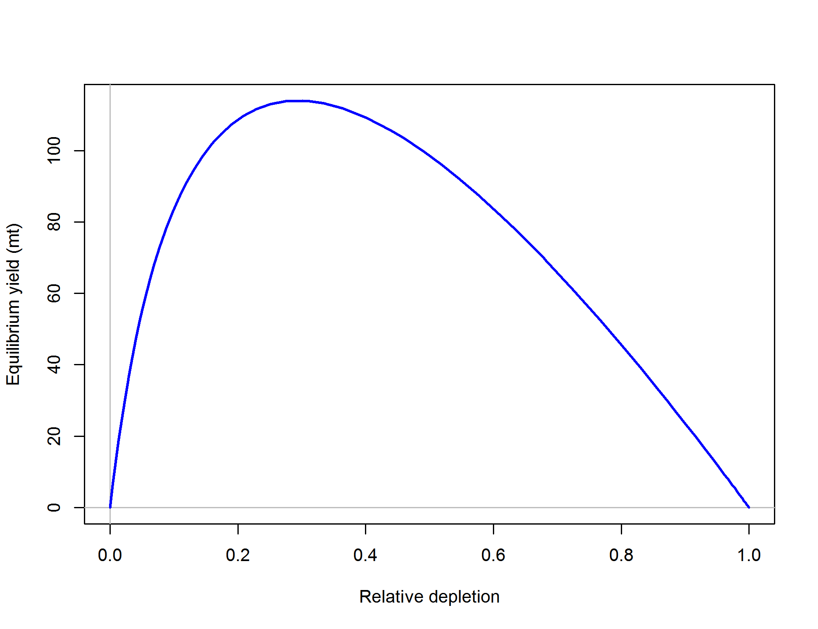

Figure ES-10. Equilibrium yield curve (derived from reference point values reported in Table ES-5) for the base model. Values are based on 2016 fishery selectivity and distribution with steepness fixed at 0.718. The depletion is relative to unfished spawning output.

Management performance

Before 2000, yelloweye rockfish were managed as part of the *Sebastes* Complex, which included all rockfish species without individual assessments, Overfishing Limits (OFLs) and Allowable Biological Catches (ABCs). In 2000, the *Sebastes* Complex was divided into three depth-based group (nearshore, shelf and slope), and yelloweye rockfish were managed as part of the “minor shelf rockfish” group until 2002. Since then, there has been species specific management of yelloweye rockfish, and total catch of this species has been below both the OFL and ABC for yelloweye rockfish each year (Table ES-5).

Management measures implemented for yelloweye rockfish included constraining catches by eliminating all retention of yelloweye rockfish in both commercial and recreational fisheries, instituting broad spatial closures (some specifically for moving fixed-gear fleets away from known areas of yelloweye abundance), and creating new gear restrictions intended to reduce trawling in rocky shelf habitats and bycatching rockfish in shelf flatfish trawls.

**Table ES-5**. Recent trend in total catch and commercial landings (mt) relative to the management guidelines. Estimated total catch reflect the commercial landings plus the model estimated discarded biomass*.

|  |  |  |  |  |  |
| --- | --- | --- | --- | --- | --- |
| Years | OFL | ABC | ACL | Landings | Total Catch |
| 2007 | 47 | NA | 23 | 12.83 | 12.83 |
| 2008 | 47 | NA | 20 | 9.29 | 9.29 |
| 2009 | 31 | NA | 17 | 11.69 | 11.69 |
| 2010 | 32 | NA | 17 | 6.72 | 6.72 |
| 2011 | 48 | 46 | 17 | 8.34 | 8.34 |
| 2012 | 48 | 46 | 17 | 11.16 | 11.16 |
| 2013 | 51 | 43 | 18 | 10.4 | 10.4 |
| 2014 | 51 | 43 | 18 | 8.81 | 8.81 |
| 2015 | 52 | 43 | 18 | 12.02 | 12.02 |
| 2016 | 52 | 43 | 19 | 9.59 | 9.59 |
| 2017 | 57 | 47 | 20 | NA | NA |

* The current OFL was called the ABC prior to 2011. The ABCs provided in this table for 2011-2018 refer to the new definition of ABC implemented with FMP Amendment 23. The current ACL was called the OY prior to 2011.

Unresolved problems and major uncertainties

Approximate asymptotic confidence intervals were estimated within the model for key parameters and management quantities and reported throughout the assessment. To explore uncertainty associated with alternative model configurations and evaluate the responsiveness of model outputs to changes in key model assumptions, a variety of sensitivity runs were performed, including runs with different assumptions fishery removals, life-history parameters, shape of selectivity curves, stock-recruitment parameters, and many others. The uncertainty in natural mortality, stock-recruit steepness and the unfished recruitment level was also explored through likelihood profile analysis. Additionally, a retrospective analysis was conducted where the model was run after successively removing data from recent years, one year at a time.

Main life history parameters, such as natural mortality and stock-recruit curve steepness, generally contribute significant uncertainty to stock assessments, and they continue to be a major source of uncertainty in this assessment. The model was unable to reliably estimate these quantities, due to the short time-series of data, which are primarily available after the period of largest removals from the stock. These quantities are essential for understanding the dynamics of the stock and determining projected rebuilding. Alternative values of these parameters were explored through both sensitivity and likelihood profile analyses.

Although significant progress has been made in reconstructing historical landings on the U.S. West Coast, early catches of yelloweye rockfish continue to be uncertain. This species comprised a small percentage of overall rockfish removals and actual species-composition samples are infrequently available for historical analyses. For instance, the lack of early species composition data does not allow the reconstruction to account for a gradual shift of fishing effort towards deeper areas, which can cause the potential to underestimate the historical contribution of shelf species (including yelloweye rockfish) to overall landings of the mixed-species market category (i.e., “unspecified rockfish”).

Decision table

The base model estimate for 2017 spawning depletion is 28%. The primary axis of uncertainty about this estimate used in the decision table was based on natural mortality. Natural mortality in the assessment model is fixed at the median of the Hamel prior (0.044 y-1), estimated using the maximum age of 123 years. Natural mortality value for high state of nature was calculated to correspond to 97 years of age, which is the 99th percentile of the age data available for the assessment; this value was 0.056 y-1. The natural mortality value for low state of nature was calculated to correspond to 147 years of age, which is the maximum age reported for the yelloweye rockfish; this value was 0.037 y-1.

We explored different approaches to identify alternative natural mortality values, including using the 12.5 and 87.5 percentiles of the Hamel prior distribution. However, this approach yielded values that were considered to be not realistic. For instance, the 12.5 percentile value of 0.031y-1 corresponded to an age of 175 years, which substantially exceeds the oldest yelloweye rockfish individual ever reported.

Twelve-year forecasts for each state of nature were calculated for two catch scenarios (Table ES-6). One scenario assumes 2017-2018 catches to be 60% of year-specific ACL values, and 2019-2028 catches to be 60% of removals calculated using current rebuilding SPR of 76% applied to the base model. The second catch scenario assumes 2017-2018 removals to be equal to year-specific ACLs, and 2019-2028 catches calculated using current rebuilding SPR of 76% applied to the base model.

Research and data needs

The following research could improve the ability of future stock assessments to determine the status and productivity of the yelloweye rockfish population:

1. The available data for yelloweye rockfish remains relatively sparse given the limited sampling effort available under the rebuilding plan. It is essential to continue yelloweye data collection, especially in this recent period, when commercial and recreational catches are considerably lower than the historical period, to provide a fuller picture of age structure and population dynamics. Further length and age collections will also refine estimate of year class strength in the late 2000s, which will improve estimates of stock status and productivity.
2. Poorly informed parameters, such as natural mortality and stock-recruit steepness will continue to benefit from meta-analytical approaches until there is enough data to estimate them internal to the model. A more thorough examination of yelloweye longevity off the West Coast of the United States is needed to get a better understanding of natural mortality.
3. The age data used in this assessment were generated by two ageing laboratories, the WFDW ageing lab and the NWFSC ageing lab. Even though growth estimates from these two labs are similar, there are still questions regarding the level of bias and precision in the ages coming from each lab. A larger, systematic comparison of age estimates between labs as well as with outside agencies could help resolve the issue of between-lab agreement. To this end, WDFW and NWFSC labs have been in correspondence and are currently seeking resolution to this issue.
4. Continue to refine historical catch estimates. Disentangling catch and biological records between Oregon and Washington would allow further spatial exploration. A better quantification of uncertainty among different periods of the catch history among all states would also be beneficial. These issues are relevant for all West Coast stock assessments.
5. Continue to evaluate the spatial structure of the assessment, including the number and placement of boundaries between areas. While this assessment took a step back from a more refined spatial resolution given data limitations, further detailed examination of yelloweye rockfish stock structure would be useful. This includes the exploration of area-specific life history characteristics and recruitment.
6. Develop and implement a comprehensive visual survey, as currently available bottom trawl surveys do not encounter yelloweye rockfish often and the hook-and-line IPHC survey targets halibut and incidentally encounters rockfish.
7. Yelloweye rockfish is a transboundary stock with Canada. However, a legal mandate and management framework for using the advice of a transboundary stock assessment does not exist. Data sharing is currently happening at a scientific level with Canadian scientists. A transboundary (including Mexico) stock assessment and the management framework to support such assessments would be beneficial. This is relevant to many stocks off the West Coast of the United States.

Most of the research needs listed above entail investigations that need to take place outside of the routine assessment cycle and require additional resources to be completed.

Rebuilding projections

The rebuilding projections will be presented in a separate document and will reflect the results of the rebuilding analysis.

**Table ES-6.** 12-year projections for alternate states of nature defined based on natural mortality. Columns range over low, mid, and high state of nature, and rows range over different assumptions of catch levels.



**Table ES-7.** Summary table of the results.



# Introduction

## Basic Information

Yelloweye rockfish (*Sebastes ruberrimus*; also known as golden eye, turkey-red and pot belly) are distributed in the northeastern Pacific Ocean from the western Gulf of Alaska to northern Baja California (Hart 1973, Eschmeyer and Herald 1983, Love et al. 2002). The species is most abundant from southeast Alaska to central California (Love et al. 2002). It is rare in Puget Sound (Love et al. 2002), and yelloweye rockfish residing in the Puget Sound are thought to be isolated from coastal waters (Stewart et al. 2009). That population is also listed as threatened under the Endangered Species Act (Drake et al. 2010).

Adult yelloweye rockfish are found along the continental shelf generally shallower than 400 m. Although smaller yelloweye tend to occur in shallower water, the species does not exhibit as pronounced an ontogenetic shift as do many rockfish in the Northeast Pacific ocean (Figure 1). Yelloweye rockfish are strongly associated with rocky bottom types, especially areas of high relief, such as caves and large boulders (Love et al. 2002). Mainly solitary, it is widely considered that yelloweye are very sedentary after settlement, with adults moving only short distances during their entire lifetime (Coombs 1979; DeMott 1983).

There is relatively little direct information regarding the stock structure of yelloweye rockfish off the U.S. and Canadian coasts. Siegle et al. (2013) found some evidence of genetic difference between the Strait of Georgia (Canada) and coastal populations that ranged down to Oregon, though coastal populations lacked any genetic structure. In general, the pelagic larval phase (considered to last several months) promotes some mixing of reproductive output, dependent on ocean currents, the duration of the pelagic phase and the timing of annual spawning in relation to annually variable spring transition and upwelling events. However, the sedentary nature of yelloweye rockfish makes adult movement among major rocky habitat areas unlikely.

Gao et al. (2010) examined ratios of C13/C12 and O18/O16 in 200 yelloweye rockfish otoliths from the Washington and Oregon coasts. The centroids from these otoliths showed no consistent differences between the two states, and the study suggests that there might be complete mixing among the offspring, leading to a single spawning stock for this portion of the yelloweye rockfish population. Gao et al. (2010) also found that the fifth annual otolith zones (that may reflect changes in diet from age-1 to age-5) differed between Washington and Oregon samples suggesting that the diet compositions of the two areas are slightly different, an unlikely result if appreciable numbers of age 5+ fish were moving between areas. This study only considered Washington and Oregon coast, analysis of stock structure along the entire Pacific coast (extending through California) is also needed for yelloweye rockfish.

This assessment attempts to mimic the general perception of stock structure for yelloweye rockfish: large stocks linked via a common stock-recruit relationship with negligible adult movement among areas. Specifically, two areas (California and Oregon-Washington) are modelled using a common recruitment pool.

## Map

A map of the assessment area that includes coastal waters off three U.S. West Coast states and five International North Pacific Fisheries Commission (INPFC) areas is presented in Figure 2. Spatial distribution of yelloweye rockfish catch along the U.S. West Coast, observed by the West Coast Groundfish Observer Program (WCGOP) and At-Sea Hake Observer Program (A-SHOP) from 2002 to 2015 is shown in Figure 3. Spatial distribution of yelloweye rockfish fisheries catch in the NWFSC bottom trawl survey is shown in Figure 4 and Figure 5.

## Life History

Yelloweye rockfish are among the longest lived rockfish species, with maximum reported age of 147 years (Love 2011). This is a slow growing species, which reaches lengths of up to 91 cm (Eschmeyer and Herald 1983, Love et al. 2002). These fish mature relatively late in the life, with 50% maturity being reported at 22 years (Love et al. 2002). A female yelloweye rockfish is capable of producing millions of eggs, but give birth to live larvae (Caillet et al. 2000). These life history characteristics suggest that yelloweye rockfish are relatively unproductive and very sensitive to exploitation.

Yelloweye rockfish spawn in late winter through the summer and possibly into the fall in Alaska, with slightly shorter spawning periods south of Canada (Caillet et al. 2000; Love et al. 2002). Little is known about the pelagic juvenile phase, but recruiting juveniles are often observed at depth greater than 15 m (Love et al. 2002), in the same areas as adults. These young juveniles are very conspicuous, and easy to identify, due to having markedly different coloration than adults.

## Ecosystem Considerations

Yelloweye rockfish feed on variety of prey, such as rockfish, herring, sandlance, flatfishes, as well as shrimp and crabs (Caillet et al. 2000; Love et al. 2002). This species is an aggressive top-predator on rocky reefs, making hook-and-line gear highly effective, even gear designed for much larger species such as halibut and lingcod.

There is evidence that changes in otolith ring width (and likely growth) is correlated with several leading environmental indicators of ocean conditions along the West Coast (Black et al. 2008). It is very uncertain how future climate change may potentially influence West Coast yelloweye rockfish growth, productivity or distribution. Rockfishes are well associated with the “storage effect” phenomenon, wherein periods of successful recruitment can be infrequent, but strong when they do occur, as long-lived, highly fecund individuals weather times of bad environmental conditions to reach the times of good conditions (Hixon et al. 2014).

## Fishery Information

Yelloweye rockfish have historically been a prized catch for both commercial and recreational fleets. They have generally yielded a higher price than other rockfish and have therefore largely been retained when encountered, except in recent years when all retention was prohibited. Throughout the exploitation history, yelloweye rockfish were caught with both trawl and non-trawl (mostly line) gear. In aggregate, 45% of all the yelloweye catches were taken by trawl and 55% by non-trawl fleets.

Rockfish catches are recorded back to the late 19th beginning of the 20th century, but appreciable quantities were not landed until an early peak around World War II. A small fraction of these catches have been yelloweye rockfish. Yelloweye rockfish removals were increasing slowly until around 1970 and then very rapidly, with development of fishing technology, markets, and fishing effort. The late 1970s to the late 1990s saw the highest yelloweye catches of the time series. After 2002 (when yelloweye rockfish was declared overfished), total catches have been maintained at much lower levels. Currently, yelloweye rockfish are caught only incidentally in commercial and sport fisheries targeting other species that are found in association with yelloweye rockfish. The recent fishery encounters a very patchy yelloweye rockfish distribution, and extensive effort is made to avoid all but a small amount of bycatch.

## Summary of Management History

On the U.S. West Coast, rockfish management began in 1983 when the Pacific Fishery Management Council (PFMC) first imposed trip limits on landings of *Sebastes* species. Before 2000, yelloweye rockfish was managed as part of the *Sebastes* complex, which included all rockfish species without individual assessments, ABCs and OYs. In 2000, the *Sebastes* complex was divided into three depth based groups (nearshore, shelf and slope), and yelloweye rockfish was managed as part of the “Minor Shelf Rockfish” complexes north and south of 40°10’ N lat. until 2002. In 2002, the species was declared overfished. Since then, there has been species-specific management of yelloweye rockfish.

## Management Performance

Yelloweye rockfish removals since 2002 represented a 95% reduction from average catches observed in the 1980s and 1990s, and total catch of yelloweye rockfish has remained below both the annual OFLs (referred to as the ABC prior to 2011) and ACLs (referred to as the Optimum Yield (OY) prior to 2011). Recent trends in total catch and commercial landings relative to the management guidelines are shown in Table 1.

Managers achieved this catch reduction by eliminating all retention of yelloweye rockfish in recreational fisheries, reducing commercial retention of yelloweye rockfish in the trawl fishery (to 200-300 pounds per bimonthly period), instituting broad spatial area closures, and creating new gear restrictions that have reduced trawling in rocky shelf habitats and the coincident catch of rockfish in shelf flatfish trawls.

## Fisheries off Canada, Alaska, and/or Mexico

Yelloweye are caught by commercial and recreational fleets in both British Columbia and Southeast Alaska. In Canada, yelloweye, along with other rockfish species, have been a subject of commercial, recreational and aboriginal fisheries on the Pacific coast, both directed and incidental. Yelloweye catches peaked in the early 1990s. In 2002, in response to concerns about stock status yelloweye management in Canada adopted a number of conservation measures. Total allowable catch of yelloweye rockfish was significantly reduced in commercial fisheries. Also, a number of spatial closures along the coast were implemented for commercial and recreational fishing fleets, to reduce catch and protect rockfish habitat. In response to these measures, catches of yelloweye declined. However, yelloweye rockfish in British Columbia are still designated as a species of special concern by the Committee on the Status of Endangered Wildlife in Canada (DFO 2015). In Alaska, large portions of current yelloweye rockfish removals comes from incidental catch in the commercial longline fishery targeting Pacific halibut. Alaskan yelloweye rockfish are managed as a part of the Demersal Shelf Rockfish complex. Recommended harvest levels for the complex are based on both yelloweye rockfish biomass estimates and the non-yelloweye rockfish complex component calculation.

# Assessment

## Data

Data used in the yelloweye rockfish assessment are summarized in Figure 7. These data include both fishery-dependent and fishery-independent sources. Types of data that inform the model include catch, length and age frequency data from seven commercial and recreational fishing fleets. Fishery-dependent biological data used in the assessment originated from both port-based and on-board observer sampling programs. Recreational observer data from Oregon and California were used to construct indices of relative abundance. Yelloweye rockfish catch in the International Pacific Halibut Commission’s (IPHC) long-line survey is also included in an index of relative abundance for Washington and Oregon; IPHC length and age frequency data are also used. Relative biomass indices and information from biological sampling from trawl surveys were included as well; these trawl surveys were conducted by the Northwest Fisheries Science Center and the Alaska Fisheries Science Center of the National Marine Fisheries Service (NMFS).

### Fishery removals

The fishery removals in the assessment are divided among seven fleets operating within two areas: waters off California (area 1) and off Oregon and Washington (area 2). These fleets include California trawl, California non-trawl and California recreational fisheries, Oregon-Washington trawl and Oregon-Washington non-trawl, Oregon recreation and Washington recreational fleets. Trawl fisheries, in addition to domestic shoreside catches, include very small removals in the foreign Pacific ocean perch (POP) fishery and bycatch in the at-sea Pacific hake fishery. Landings in all seven fleets are shown in Figure 6 and detailed in Table 2.

We reconstructed catches within each fleet by state. By necessity, they were estimated based on port of landing and not area of catch. The port of landing does not always coincide closely with the latitude at which fish were caught. This issue is particularly important for catches between Oregon and Washington. For instance, Oregon vessels, particularly those from northern ports such as Astoria/Warrenton, frequently fish in waters off Washington, but return to Oregon to land their catch. It is not possible to precisely convert port of landing into area of catch, especially for historical catches. The problem is even more challenging in regards to assigning lengths and age data collected by port samplers at the point of landings to area of catch. This issue has become more apparent in recent years, as larger, interagency catch reconstruction efforts have been made. At this point, no reliable method exists to estimate the portion of catches landed in Oregon but caught in Washington and vice versa, nor to do the same for biological data. Therefore, within the overall assessment area, Washington and Oregon were combined into one area, while California was treated as a separate area (in the previous assessment all three states were treated as separate areas).

As mentioned earlier, yelloweye rockfish have historically been a prized catch for both commercial and recreational fleets and have largely been retained when encountered. A historical trawl discard study (Pikitch et al. 1988) confirms that virtually 100% of yelloweye rockfish catch was retained. Therefore, for the period prior to 2002, it was assumed that all catch was retained and landed.

From 2002 forward, when catch limits and area closures were implemented and a portion of yelloweye catches were discarded, the total catch was estimated from both landings and dead discards. Discard information was obtained from the West Coast Groundfish Observer Program (WCGOP). The WCGOP was implemented in 2001, and began with gathering bycatch and discard information on board fishing vessels for the limited entry trawl and fixed gear fleets. Observer coverage has expanded to include the California halibut trawl, the nearshore fixed gear and pink shrimp trawl fisheries. Since 2011, the WCGOP provides 100% at-sea observer monitoring of catch for the catch share-based Individual Fishing Quotas (IFQ) fishery.

#### Commercial and recreational removals

Catches of yelloweye rockfish were reconstructed back to 1889, and the assessment assumes equilibrium unfished conditions of the stock prior to that.

Recent commercial catch data (1981-2016) for stock assessments are available from the Pacific Fisheries Information Network (PacFIN), a regional fisheries database that manages fishery-dependent information in cooperation with NMFS) and West Coast state agencies. Recent recreational catch data were obtained either from state agencies or from the Recreational Fisheries Information Network (RecFIN), a regional source of recreational data managed by the Pacific States Marine Fisheries Commission (PSMFC).

Prior to 1981, however, catch information is sparse, and there is no database analogous to PacFIN to handle the data. Historically, landed catch of rockfish have been reported as mixed-species groups that have similar market value, rather than as individual species (Barss and Niska 1978, Douglas 1998, Lynde 1986, Niska 1976, Tagart and Kimura 1982). These groups are called “market categories”. The species compositions of these mixed-species market categories have changed over time, with technological advances in fishing gear and development of different fisheries. Therefore, reconstruction of historical landings of rockfish has been a challenge.

However, in recent years, significant progress has been made by the state agencies and NMFS in reconstructing a comprehensive species specific time series of catch for use in stock assessments. This assessment relies heavily on the results of these recent efforts. The sources used in the assessment to inform historical commercial and recreational landings within each West Coast state are described below.

##### California

###### Commercial

A time series of California historical (1916-1980) commercial catches of yelloweye rockfish were reconstructed by the NMFS’s Southwest Fisheries Science Center (SWFSC) (Ralston et al. 2010) and were available from the California Cooperative Groundfish Survey (CalCOM) database (John Field and Don Pearson, pers. comm.). The California catch reconstruction utilized available spatial information on aggregate rockfish catches back to 1916 as well as intermittent species composition records by market category, to apportion the catches in mixed species market categories to species, fishing gears and ports. The California catch reconstruction goes back to 1916, but catch records exist prior to that. As suggested by the STAR Panel, a linear ramping was applied over the period between 1889 and 1916, in order to account for those catches and be consistent with other assessments that go back beyond 1916.

Estimates of recent landings of yelloweye rockfish (1981-2016) were obtained from PacFIN (www.pacfin.com). Landings data were extracted by gear type and state on March 6, 2017 and then combined into the area-specific fishing fleets used in the assessment. For the period from 2002 forward, when catch limits and area closures were implemented, year-specific PacFIN landings were supplemented with the discard amounts of yelloweye rockfish estimated by the WCGOP, to obtain the total catch of yelloweye rockfish within commercial fleets.

###### Recreational

A time series of historical California recreational catches of yelloweye rockfish (1928-1979) were also reconstructed by the NMFS’s SWFSC (Ralston et al. 2010), and we used these estimates in the assessment (John Field and Don Pearson, pers. comm.).

The data on recent recreational removals of yelloweye rockfish (retained catch plus dead discard) for the years between 1981 and 2016 were obtained from the RecFIN database; [www.recfin.com](http://www.recfin.com). Differential mortality rates according to depth of capture were accounted for in these estimates, where depth-specific release information was available. The RecFIN database houses information on California recreational catches that have been collected in a Federal survey, called Marine Recreational Fisheries Statistic Survey (MRFSS), and also by the California Recreational Fisheries Survey (CRFS). The MRFSS provided information from 1980 to 2003 (excluding the years 1990-1992). For 1990-1992, the catch was interpolated between the values of catch in 1989 and 1993. Since 2004, the California Department of Fish and Wildlife (CDFW), in cooperation with the PSMFC, conducted CRFS, which replaces the MRFSS in California. This survey aims to increase sampling effort for better catch and effort estimation, improve spatial resolution of catches, and identify targeted species.

##### Oregon

###### Commercial

Oregon records of rockfish catches go back to the late 1890s. A time series of Oregon historical landings of yelloweye rockfish through 1986 was reconstructed by the Oregon Department of Fish and Wildlife (ODFW) in collaboration with NWFSC, as a part of a reconstruction of historical groundfish landings in Oregon (Karnowski et al. 2014). Karnowski et al. (2014) provide a detailed description of methods used in calculating rockfish landings by species. A variety of data sources were used to reconstruct historical landings of rockfish market categories, including ODFW’s Pounds and Value reports derived from the Oregon fish ticket line data (1969-1986), Fisheries Statistics of the United States (1927-1977), Fisheries Statistics of Oregon (Cleaver, 1951; Smith, 1956), Reports of the Technical Sub-Committee of the International Trawl Fishery Committee (now the Canada-U.S. Groundfish Committee) (1942-1975) and many others. To inform species compositions of rockfish within different market categories, the ODFW has routinely sampled species compositions of multi-species rockfish categories from commercial bottom trawl landings since 1963. Estimated rockfish landings by species based on data collected in the ODFW sampling program have been summarized in several ODFW reports, including Barss and Niska (1978), Douglas (1998), Niska (1976). The latter publication by Douglas (1998) was an expansion and improvement on earlier publications (Niska 1976, Barss and Niska 1978). These sources were used by Karnowski et al. (2014) in reconstructing historical landings of yelloweye rockfish in Oregon. A small amount of historical yelloweye removals caught in Oregon waters but landed in California were provided by SWFSC (John Field, pers. comm.) and included in the assessment.

Recent landings of yelloweye rockfish (1987- 2016) were obtained from PacFIN. PacFIN landings data were extracted by gear type and state on March 6, 2017 and then combined into the area-specific fishing fleets used in the assessment. The Oregon PacFIN landings for the period between 1987 and 1999 were supplemented with the additional estimates of yelloweye rockfish landings reported within unspecified rockfish market categories. These additional estimates were provided by the ODFW (Alison Whitman and Troy Buell, pers. comm.). It was recently determined that a portion of Oregon commercial rockfish landings reside in unspecified rockfish market categories in PacFIN (i.e., URCK and POP1). These unspecified categories are not an issue after 1999, due to market category evolution, and were resolved prior to 1987 in Karnowski et al. (2014). For the period from 2002 forward, when catch limits and area closures were implemented, PacFIN landings were supplemented with the discard estimated by WCGOP, to obtain the total catch of yelloweye rockfish within commercial fleets.

###### Recreational

Recreational removals for the period between 1973 and 2016 were provided by ODFW (Alison Whitman and Troy Buell, per. comm.). Differential mortality rates according to depth of capture were accounted for in these estimates, where depth specific release information was available.

##### Washington

###### Commercial

For this assessment, historical commercial catches (1889-1980) of yelloweye rockfish in Washington were provided by Washington Department of Fish and Wildlife (WDFW), based on the historical reconstruction of rockfish landings in Washington (Theresa Tsou, pers. comm.). Recent commercial landings (1981-2016) were also provided by WDFW. As in the case with Oregon, a portion of Washington commercial rockfish landings reside in a PacFIN unspecified rockfish market category (URCK), and, therefore, yelloweye landings reported in PacFIN are not complete. WDFW recently speciated “URCK” landings and 1981-2016 yelloweye rockfish landings data provided by WDFW for use in this assessment include yelloweye rockfish landings reported within the “URCK” category, in addition to yelloweye landings in PacFIN. Since 2002, when catch limits and area closures were implemented, landings were supplemented with the discard amount estimated by WCGOP, to obtain the total catch of yelloweye rockfish within commercial fleets.

###### Recreational

Recreational removals for the period between 1975 and 2016 were provided by WDFW (Theresa Tsou, per. comm.), based on the historical reconstruction of Washington recreational removals. Differential mortality rates according to depth of capture were not accounted for in these estimates. Mortality by depth estimates for yelloweye rockfish were provided by the PFMC Groundfish Management Team (Lynn Mattes, pers. comm.), and the removals were adjusted accordingly, where depth-specific release information was available.

##### Bycatch in the Foreign POP Fishery

Between the mid-1960s and mid-1970s, a small amount of yelloweye rockfish (32 mt over 11 years) was caught by foreign trawl fleets from the former Soviet Union, Japan, Poland, Bulgaria, and East Germany, which targeted aggregations of Pacific ocean perch (POP) in the waters off the U.S. West Coast (Love et al., 2002). Rogers (2003) estimated removals of POP and other species caught within this foreign POP fishery, including removals of yelloweye rockfish. In the assessment, we used estimates of yelloweye bycatch in the foreign POP fishery between 1966 and 1976 as estimated by Rogers (2003).

##### Bycatch in the At-Sea Pacific Hake Fishery

Small amounts of yelloweye rockfish catch have been reported for the Pacific hake fishery. That time series cover the period between 1976 and 2016 and include catches removed by foreign and domestic fisheries as well as those obtained during the time of Joint Ventures. The At-Sea Hake Observer Program (A-SHOP) monitors the at-sea hake processing vessels and collects total catch and bycatch data. The annual amounts of yelloweye rockfish bycatch in the at-sea hake fishery, collected by A-SHOP, were obtained from the North Pacific Database Program (NORPAC). The total amount caught in this fishery since 1976 is less than 11 mt.

### Abundance Indices

Indices of abundance provide an indicator of population dynamics by tracking portions of the population through time. All indices currently available for yelloweye rockfish are treated as relative measures of abundance, as modified by index-specific selectivity, and none of the sampling provides an absolute measure of population size along the spatial extent of the current stock assessment.

This assessment utilizes fishery-independent data from three surveys, including two bottom trawl surveys and one hook-and-line survey. Bottom trawl surveys were conducted on the continental shelf and slope of the Northeast Pacific Ocean by the AFSC and NWFSC and include the AFSC shelf survey (often called “triennial”, since it was conducted every third year) and the NWFSC shelf-slope bottom trawl survey. Details on latitudinal and depth coverage of these surveys by year are presented in Table 3. The hook-and-line survey was conducted by the IPHC.

The two bottom trawl surveys do not encounter yelloweye rockfish often (Table 4and Table 5), while the IPHC survey targets on halibut and encounters rockfish as bycatch. To supplement the lack of directed yelloweye rockfish surveys, this stock assessment also utilizes several fishery-dependent abundance indices that use catch-per-unit-effort (CPUE) as a relative measure of population abundance. Common to all of these fishery-dependent indices is the high frequencies of zero yelloweye rockfish catches. Thorough data filtering had to be done to identify trips in areas and habitats with the potential to encounter yelloweye rockfish.

#### Fishery-Independent Indices

##### Bottom Trawl Surveys

###### AFSC Triennial Survey

The AFSC triennial survey was conducted every third year between 1977 and 2004. In 2004 this survey was conducted by the NWFSC. Survey methods are most recently described in Weinberg et al. (2002). The basic design was a series of equally spaced transects from which searches for tows in specific depth ranges were initiated. Over the years, the survey area varied in depth and latitudinal range (Table 3). Prior to 1995, the depth range was limited to 366 m (200 fm) and the surveyed area included four INPFC areas (Monterey, Eureka, Columbia and U.S. Vancouver). After 1995, the depth coverage was expanded to 500 m (275 fm) and the latitudinal range included not only the four INPFC areas covered in the earlier years, but also part of the Conception area with a southern extent of 34o50’ N. latitude. For all years, except 1977, the shallower surveyed depth was 55 m (30 fm); in 1977 no tows were conducted shallower than 91 m (50 fm). No yelloweye were observed deeper that 366 meters; therefore, we used a single time series to construct an abundance index from this survey. The data from the 1977 survey were not used in the assessment, because of the differences in depths surveyed and the large number of “water hauls”, when the trawl footrope failed to maintain contact with the bottom (Zimmermann et al., 2001). The tows conducted in Canadian and Mexican waters were also excluded.

###### NWFSC West Coast Groundfish Bottom Trawl Survey

The NWFSC trawl survey has been conducted annually since 2003, and the data between 2003 and 2016 were used in this assessment. The survey consistently covered depths between 55 and 1280 m (30 and 700 fm) and the latitudinal range between 32o34’ and 48o22’ N. latitude, the extent of all five INPFC areas on the U.S. West Coast (Table 5). The survey is based on a random-grid design, and four industry chartered vessels per year are assigned an approximately equal number of randomly selected grid cells. The survey is conducted from late May to early October, and is divided into two passes, with two vessels operating during each pass. The survey methods are most recently described in detail in Keller et al. (2017).

###### Bottom trawl survey abundance indices

Bottom trawl survey indices were calculated only for Oregon-Washington area, since neither survey had a sufficient number of yelloweye positive hauls in California waters (with some years having no positive hauls at all). Summaries of surveys sampling effort with total number of survey hauls along with yelloweye positive hauls by area are provided in Table 4 and Table 5.

We analyze data from the triennial survey and NWFSC trawl survey using the Vector Autoregressive Spatial Temporal (VAST) delta-model (Thorson et al. 2015), implemented as an R package (Thorson and Barnett n.d.) and publicly available online (<https://github.com/James-Thorson/VAST>). We specifically include spatial and spatio-temporal variation in both encounter probability and positive catch rates, a logit-link for encounter probability, and a log-link for positive catch rates. We also include vessel-year effects for each unique combination of vessel and year in the database, to account for the random selection of commercial vessels used during sampling (Helser et al. 2004, Thorson and Ward 2014). We approximate spatial variation using 250 knots, and use the bias-correction algorithm (Thorson and Kristensen 2016) in Template Model Builder (Kristensen et al. 2016). Further details regarding model structure are available in the user manual (<https://github.com/James-Thorson/VAST/blob/master/examples/VAST_user_manual.pdf>). To confirm convergence of the model estimation algorithm, we confirm that the Hessian matrix is positive definite and that the absolute-value of the final gradient of the log-likelihood with respect to each fixed effect was <0.0001 for each fixed effect.

Following advice from the Scientific and Statistical Committee (SSC) of the Pacific Fishery Management Council (PFMC), we use the following three diagnostics for model fit:

1. The Quantile-Quantile (Q-Q) plot, generated by comparing each observed datum with its predicted distribution under the fitted model, calculating the quantile of that datum, and comparing the distribution of quantiles with its expectation under a null model (i.e., a uniform distribution). This Q-Q plot shows no evidence that the model fails to capture the shape of dispersion shown in the positive catch rate data (Figure 8 and Figure 9).
2. A comparison of predicted and observed proportion encountered when binning observations by their predicted encounter probability. This comparison shows no evidence that encounter probabilities are over-estimated for low-encounter-probability observations, or vice versa.
3. A visualization of Pearson residuals for encounter probability and positive catch rates associated with each knot. This comparison shows no evidence of residual spatial patterns for either model component (Figure 10 through Figure 13).

Estimated abundance indices for triennial and NWFSC trawl survey are shown in Figure 14 and Figure 15, respectively. The triennial survey index shows an abrupt decline in 1992, and NWFSC trawl survey shows an increasing trend between 2004 and 2013 with lower estimates in the last two years.

Comparison of VAST abundance indices used in the assessment with estimates calculated using the designed-based area swept approach are provided in Figure 16 and Figure 17, for the AFSC triennial and NWFSC surveys, respectively. Figure 18 and Figure 19 show comparisons of VAST indices with abundance estimates used in 2011 assessment, calculated using a non-spatial delta-GLMM approach, for the AFSC triennial and NWFSC surveys respectively.

##### IPHC Longline Survey

The IPHC has conducted an annual longline survey for Pacific halibut off the coast of Oregon and Washington (IPHC area “2A”) since 1997 (no surveys were performed in 1998 or 2000). Beginning in 1999, this has been a fixed station design, with roughly 1,800 hooks deployed at each of 84 locations. Before 1999, station locations were not fixed, and, therefore, those years are not used in the index. Rockfish bycatch, mainly yelloweye, was recorded during this survey, although values for 1999 and 2001 are estimates based on subsampling the first 20 hooks of each 100-hook skate. The gear used to conduct this survey, while designed specifically to efficiently sample Pacific halibut, is similar to that used in some earlier line fisheries that targeted adult yelloweye rockfish. Some variability in exact sampling location is unavoidable, and leeway is given in the IPHC methods to center the set on the target coordinates but to allow wind and currents to dictate the actual direction in which the gear is deployed. This can result in different habitats accessed at each fixed location among years. The number of skates used can also differ somewhat from year to year; skates hauled (i.e., 100 hooks/skate) is thus used as the unit of effort for all years. This has been the standard effort used in past yelloweye rockfish stock assessments.

New to this assessment is the consideration of eight additional survey stations conducted by WDFW (2007-2016). These stations are arranged around IPHC station 1082 (one of the more notable stations to encounter yelloweye rockfish) and are conducted during spring, summer, and fall months. Only summer months were considered here in order to match the time of year sampled by the IPHC survey. Survey sets at the WDFW stations used 3 skates with 100 hooks each, a departure from that used by the IPHC survey. Like the IPHC survey, effort was standardized as 100 hooks/skate. These stations were added to the IPHC stations when calculating the index of abundance, and station as a factor was explored in the mode. The full survey used in this assessment combined all stations in Oregon and Washington, fitting the area of the stock, instead of using state-specific indices. Separate state indices were explored, but after filtering the data (see filtering details below), the Washington portion of the survey was not suitable for its own survey.

Data were filtered first to remove all depths with no or few encounters, then we removed stations that also rarely encountered yelloweye (average less than encounter a year). This left 11 stations for analysis. Both filtering levels improved the percent positive from an initial 11% to 80% (Table 6). A delta-GLM approach (Lo et al. 1992, Stefánsson 1996) was used to model the CPUE data, using a binomial to fit the presence-absence data, and either logistic or gamma distributions to characterize the positive catches. Model selection (Akaike Information Criterion corrected for small sample sizes (AICc)) was used to identify which model and factors were best supported by the data (Table 7). Residual-based model diagnostics for the positive component of the index suggest the data generally met the assumptions of the GLM and that the logistic model was the best choice (Figure 20 and Figure 21). The final model included the factors YEAR, STATION, and DEPTH (Table 7) and jackknifing was used to obtain yearly uncertainty estimates (Table 8). The YEAR+STATION model was also well fit, and gave almost identical index values as the selected model, so there is no sensitivity in the choice between both well-fitting model options. The index is quite dynamic, but is also very uncertain (Figure 22).

#### Fishery-Dependent Abundance Indices

A total of six fishery-dependent surveys are used in this stock assessment, two of which relate to the California area, and the remaining four to the Oregon-Washington area. These are all recreationally-based hook-and-line surveys, with samples either taken onboard charter vessels or dockside when boats are intercepted in surveys. Five of these indices were used in the previous assessments, and the Oregon dockside CPUE index based on information on released fish only was a new addition. While the temporal coverage of four of the five previously used indices end prior to the date of the last assessment, all the indices were treated with an updated filtering process and standardization. The two-step delta-GLM modelling approach - fitting presence/absence assuming a binomial distribution, then positive catches assuming either logistic or gamma distributions - was used to define all fishery-dependent surveys. Model selection using AICc was also applied, as was modelling fitting best-fit diagnostics (e.g., Q-Q plots) to choose between the logistic and gamma distributions. In each of the fishery-dependent indices, the logistic model was ultimately chosen. Either bootstrapping or jackknifing methods were used to estimate index uncertainty. **Using the previous versions of the indices (when no new years are available), as well as dropping each index out of the model, were explored as model sensitivities (**Table 32**).**

##### California MRFSS Dockside CPUE, 1980-1999

The California dockside sampling of the Commercial Passenger Fishing Vessel (CPFV) and private boat sectors was available from 1980-2003, but the years 1989-1991 were not sampled. Years after 1999 were also excluded due to catch restrictions, and thus changing catchability over a short time period. An attempt to correct for this management change was made by using management period as a factor in an exploratory model, but this proved unsuccessful, thus the time series was truncated at 1999. Further filtering of additional years, regions and subregions with little to no catch of yelloweye rockfish improved the positive catch rate of yelloweye from 4% to 16% (Table 9). One additional filter, the Stephens-MacCall method (Stephens and MacCall 2004) was also applied. This approach uses a linear model to relate yelloweye rockfish catches to the catches of others species, thus inferring trips likely to catch yelloweye rockfish to the species composition of the catch. Applying this filter further increased the presence of yelloweye rockfish to 53%. The final model includes the factors YEAR and AREA (Table 9). The data generally met the assumptions of the GLM (Figure 23 and Figure 24) and jackknifing was used to estimate uncertainty (Table 13). The index shows a general decline in yelloweye rockfish over the time period, with moderate to high levels of uncertainty (Figure 25).

##### California Onboard Observer CPUE, 1988-1998

The CDFW conducted an onboard CPFV sampling program in central California from 1987-1998. This program sought to collect information on the recreational groundfish sector by recording catch, effort and length data at the level of a fishing trip. Subsequent work digitized the original data sheets and aggregated the relevant location information (time and number of observed anglers) to match the available catch information (Monk et al. 2016). Filtering of the data was done as follows:

* removed trips with missing information,
* removed drifts that were under 2 minutes (indicative of a non-standard drift),
* removed year 1987 (undersampled),
* removed reefs with <12 positive records or all positives in one year,
* removed depths <30m and >160m, depths at which yelloweye were rarely or never encountered,
* and removed county 85 (no positives).

This filtering improved the percent positive yelloweye from 10% to 14%, but also pinpointed trips with higher probabilities that yelloweye rockfish could be encountered by reducing total trips by almost half (Table 11). Model selection explored the inclusion of MONTH, DEPTH, COUNTY, and REEF as factors, in addition to YEAR. The final model was YEAR+MONTH+DEPTH+COUNTY (Table 12). The data generally met the assumptions of the GLM (Figure 26 and Figure 27). Both bootstrapping and jackknifing estimates of uncertainty were calculated; jackknifing was used for the reference model (Table 13). The delta-GLM model results were very different from the geometric average of the catch rates; uncertainty was at moderate levels (Table 13 and Figure 28). The CPFV index show a similar population decline as the dockside index, with the CPFV index having lower levels of uncertainty (Figure 29).

##### Oregon Onboard Observer CPUE, 2001-2014

The ODFW monitors fishing activities aboard CPFVs with onboard observers recording catch information on the type, weight and length of fish landed and discarded as well as fishing effort (angler hours; Monk et al. 2013). This began in 2001 as a pilot study, and continued annually with data available through 2014. Most trips covered have targeted groundfishes. Filtering of the data was done as follows:

* removed trips with missing information,
* removed drifts that were under 2 minutes (indicative of a non-standard drift),
* removed trips with >95% midwater groundfish,
* removed reefs distances >0,
* removed reefs with <12 positive records or all positives in one year,
* removed months with few encounters or most in one year,
* and removed depths <60m and >180m, depths at which yelloweye were rarely or never encountered.

This filtering improved the percent positive yelloweye rockfish from 2% to 12%, but also pinpointed trips with higher probabilities that yelloweye rockfish could be encountered by reducing total trips by almost 90% (Table 14). No model selection was possible as YEAR was the only factor with positives in every level. The data poorly met the assumptions of the GLM (Figure 30 and Figure 31). Jackknifing estimates of uncertainty were used for the reference model (Table 20). The delta-GLM model results were very different from the geometric average of the catch rates; uncertainty was at moderate to high levels (Table 20 and Figure 32).

##### Oregon MRFSS Dockside CPUE, 1982-1999

Trip-level dockside interview data from MRFSS (Type-3 records) were provided by ODFW. The original data set runs from 1980-2003, with a gap in coverage in years 1989-1991. Filtering of the data was done as follows:

* removed counties with no or few encounters,
* removed waves (i.e., a two-month period) with few to no catches,
* applied the Stephens-MacCall (2004) approach of selecting trips with species compositions most likely to have occurred in yelloweye habitat,
* and removed years 1980 and 1981 (few encounters) and all years after 1999 (due to management changes).

This filtering improved the percent positive yelloweye rockfish from 27% to 74%, and also reduced the number of samples by 80% (Table 15). No model selection was possible as YEAR was the only factor with positives in every level. The data generally met the assumptions of the GLM (Figure 33 and Figure 34). Jackknifing estimates of uncertainty were used for the reference model (Table 20). The delta-GLM model results shows a general decline in yelloweye rockfish over the period, with moderate to high levels of uncertainty (Table 20 and Figure 35).

##### Oregon ORBS Dockside (release only) CPUE, 2005-2016

The Oregon Recreational Boat Survey (ORBS) conducted dockside interviews with anglers to record fish catches and fishing effort by trip. For the purpose of yelloweye rockfish, this survey effectively censuses caught and released yelloweye rockfish given the management restriction of no retention for this species during these sampled years (2005-2016). This survey covers the same fishery as the MRFSS dockside survey. Therefore, the ORBS dockside index was combined with the MRFSS index into one long time series, but separate catchability parameters were estimated for each of the two indices. Also, these two indices were standardized separately. Filtering of the ORBS data was done as follows:

* retained only bottomfish, then only deep bottomfish, trips,
* removed trips with few to no encounters of yelloweye rockfish,
* retained only years after 2004 given the lack of yelloweye encounters,
* removed the “p” boat type (a level included that had no samples),
* removed ports with no encounters,
* removed depths with few to no encounters,
* applied the Stephens-MacCall (2004) approach of selecting trips with species compositions most likely to have occurred in yelloweye rockfish habitat,
* and retained months May-September only (core bottomfishing months).

This filtering improved the percent positive yelloweye from 1% to 21%, and reduced the number of samples by 99% to greatly focus on trips most appropriate for yelloweye rockfish encounters (Table 16). Model selection explored the inclusion of MONTH, BOAT TYPE, and PORT as factors, in addition to YEAR. The final model was YEAR+BOAT TYPE + PORT (Table 17). The data generally met the assumptions of the GLM (Figure 36 and Figure 37). Both bootstrapping and jackknifing estimates of uncertainty were calculated; jackknifing was used for the reference model (Table 20). The delta-GLM model results were very different than the geometric average of the catch rates; uncertainty was at low to moderate levels (Table 20 and Figure 38).

##### Washington Dockside CPUE, 1982-2001

The WDFW conducted dockside interviews of recreational fishing trips from 1981-2016. These interviews collected information on catch of several species, including yelloweye rockfish, number of anglers fishing, trip type, boat type, port, fishing area , month, day, week, and other details. Only years prior to and including 2001 were considered given management actions after 2001, which significantly changed the reported number of yelloweye rockfish. Filtering of the data was done as follows:

* retained “bottomfish only” trips,
* removed trips with no recorded anglers,
* removed fishing areas and ports with no catches of yelloweye rockfish,
* retained trips that caught more than 1 of the following groundfishes: brown, canary, copper, China, quillback, and yelloweye rockfishes, kelp greenling, and lingcod,
* and retained only months May-September (core bottomfishing months).

This filtering improved the percent positive yelloweye rockfish from 3% to 25%, and reduced the number of samples by 92% to select trips most likely to encounter yelloweye rockfish (Table 18). Model selection explored the inclusion of MONTH, BOAT TYPE, and PORT as factors, in addition to YEAR. The final model retained all factors (Table 19). The data generally met the assumptions of the GLM (Figure 39and Figure 40). Bootstrapping estimates of uncertainty were calculated at relatively low levels (Table 20, Figure 41). The delta-GLM model results were very different from the geometric average of the catch rates; uncertainty was at low levels (Figure 41).

Fishery-dependent indices for the Oregon-Washington area are dynamic and highly variable, meaning the information content of each is probably fairly low (Figure 42).

### Fishery-Dependent Biological Compositions

Most of the biological data for yelloweye rockfish were reported for both sexes combined. Since size and age data and estimates of growth parameters for yelloweye rockfish did not indicate sexual dimorphism in growth, length and age frequency distributions were generated by year; for females and males combined. Sampling statistics (number of samples and number of individual fish) for each fleet and year, used to create length and frequency distributions, are shown from Table 21 through Table 26.

Length composition data from commercial and recreational fisheries were compiled into 33 length bins, ranging from 10 to 74 cm. Most lengths were reported as fork lengths, but there were some in the recreational fisheries that were reported as total lengths. In cases, when both fork and total lengths were available for the same individual, two length measurements were not the same. Yelloweye does not have an actual fork, however, when the caudal fin is not fully spread, it may appear as if it has a small fork, and the measurements between total and fork lengths maybe slightly different. We analyzed a sample of several hundreds of fish, for which both fork and total lengths were taken and found that the difference between the two did not exceed 2%. From that sample we developed a linear conversion, and wherever total length (*TL*) was measured we converted it to fork length (*FL*). The formula for the conversion was (R2 = 0.999).

Due to very sparse sampling (mainly opportunistic, since yelloweye have been landed in very small proportions of mixed species market categories or recreational bag limits) length frequencies are raw, calculated as the count of fish among size bins. This has been the case in previous assessments, and preliminary investigation of alternate weighting procedures revealed little sensitivity to this choice.

The initial input sample sizes for length frequency distributions of yelloweye rockfish fishery-dependent sources were calculated by year as a function of the number of trips (or samples in the case of recreational fleets) and number of fish sampled, following Stewart and Hamel (2014):

when

when

This method was developed based on analysis of the input and model-derived effective sample sizes from West Coast groundfish stock assessments. A step-wise linear regression was used to estimate the increase in effective sample size per sample based on fish-per-sample and the maximum effective sample size for large numbers of individual fish.

Age composition data from fisheries were assembled into 66 age bins, ranging from age 0 to age 65. Age composition data were compiled as conditional distributions of ages at length by fleet and year. The conditional ages at length approach uses an age-length matrix, in which columns correspond to ages and rows to length bins. The distribution of ages in each column then is treated as a separate observation, conditioned on the corresponding length bin (row). The conditional ages-at-length approach has been used in most stock assessments on the West Coast of the United States in the last decade, since it has several advantages over the use of marginal age frequency distributions. Age structures are usually collected from the individuals that have been measured for length. If the standard age compositions are used along with length frequency distributions in the assessment, the information on year class strength may be double-counted since the same fish are contributing to likelihood components that are assumed to be independent. The use of conditional age distributions within each length bin allows avoiding such double-counting. Also, the use of conditional ages at length distributions allows the reliable estimation of growth parameters within the assessment model. The initial sample sizes for conditional ages-at-length data were the actual numbers of fish on which each composition is based.

Biological information was obtained for different fleets from variety of sources. These sources are described below by state and fleet. The length compositions constructed from these data are shown in Figure 43 through Figure 45. The age compositions constructed from these data are shown in Figure 46 through Figure 51.

#### California

##### Length Compositions

Length composition data for California commercial catches (trawl and non-trawl) were available from PacFIN (extracted on April 25, 2017). Trawl length data were collected between 1978 and 2016, while non-trawl length data were available between 1978 and 2002. Non-trawl length data were also available from the WCGOP for the period between 2004 and 2015. Length composition data for California recreational fishery were obtained from RecFIN (Edward Hibsch, pers. comm.). These data yielded a relatively consistent number of samples between 1980 and 2016. In early periods (prior to 1993), the lengths from recreational fishery were measured as total length (and converted to fork length), and after 1993 as fork length. Length compositions from the California On-Board CPFV Observer Sampling Program were available for the years 1987-1999 and 2004-2016. Although somewhat noisy, the recreational size-distributions contain fish from 16 to 74 cm. The observer program size-distributions show a similar range of size. The commercial data, as expected, observed fewer small (< ~26 cm) yelloweye rockfish than the recreational fishery.

##### Age Compositions

Age composition data were extremely limited for California fisheries. No yelloweye rockfish age data were available from the Californian trawl fishery. A sample of only five fish was available from the non-trawl fishery for 2005 from the WCGOP and a limited amount of ages (52 fish) was provided by CDFW for the period 1978-1988 (John Budrick, pers. comm.). A limited amount of recently generated age data were provided from recreational fishery by the SWFSC for 1979-1984 (Don Pearson and John Field, pers.comm.) and by the CDFW for years 2009- 2016 (John Budrick, pers.comm.). The latter data set was generated from confiscated yelloweye rockfish collected from recreational catches, when retention for yelloweye rockfish was prohibited.

#### Oregon

##### Length Compositions

Length composition data for Oregon trawl and non-trawl commercial fisheries were obtained from PacFIN (extracted on April 25, 2017). Trawl length compositions were available for years 1995-2016 and non-trawl length compositions were available for years 1995-2012. The WCGOP also provided age composition data for 2005-2013 from the trawl fishery and between 2004 and 2015 from the non-trawl fleet. Yelloweye rockfish lengths from the recreational fishery were provided by ODFW for 1979-2016. These data were collected in the MRFSS and in the ORBS from dockside sampling and interviews (total lengths were converted to fork lengths when needed). ODFW also provided the length composition data from the Oregon recreational observer program, for 2003-2016. Because these fish cannot be retained, they are measured quickly and released. These data show a wide range in the size of yelloweye rockfish captured, ranging from 20 to 74 cm. The Oregon commercial fishery length data show fewer small yelloweye rockfish (<30 cm) than observed in the recreational fishery, but generally in the same size range.

##### Age Compositions

Age composition data from Oregon commercial fisheries were obtained from PacFIN and included samples from the trawl fishery (149 fish) collected in 2001-2015 and from the non-trawl fishery (20 fish) for 2008-2012. Age composition data from Oregon recreational fisheries were obtained from WDFW (who read age structures) for selected years between 1979 and 2012. Early samples from this dataset (in the 1970s and 1980s) were taken by an ODFW biologist in Garibaldi who saw the offshore fishery starting to develop. A limited amount of yelloweye rockfish age data from the recreational fishery, collected between 2009 and 2016 from fish that were illegally landed and confiscated (since no retention is allowed) were recently provided. The Oregon commercial fishery age data is very sparse. The age compositions from the recreational fishery indicate a wide range of ages, including many fish of age 65 or greater.

#### Washington

##### Length Compositions

Length composition data for the Washington trawl and non-trawl commercial fisheries were obtained from PacFIN (extracted on April 25, 2017). Trawl length compositions were available for 1996-2016 and non-trawl for 1980-2015. The WCGOP also provided lengths for 2005-2013 from the trawl fishery and for 2004-2015 from the commercial non-trawl fleet. Yelloweye rockfish lengths from the recreational fishery were provided by WDFW for 1981-2015.

##### Age Compositions

Age composition data from Washington commercial fisheries were obtained from PacFIN and included samples from the trawl fishery (153 fish) collected between 2002 and 2016 and from the non-trawl fishery (508 fish) collected between 2001 and 2015. Ages from recreational fisheries were obtained from WDFW for selected years between 1979 and 2012. These data were collected in the MRFSS and in the WDFW Ocean Sampling Program (OSP).

### Fishery-Independent Biological Compositions

#### Length Compositions

Length composition data were available for all three fishery-independent surveys. A summary of sampling efforts (number of hauls and number of individual fish) in all surveys is provided in Table 27 and Table 28. Length composition data were compiled into 33 length bins, ranging from 10 to 74 cm. Year-specific length frequency distributions generated for each survey are shown in Figure 45.

The initial input sample sizes for the survey length frequency distribution data were calculated as a function of both the number of fish and number of tows sampled using the method developed by Stewart and Hamel (2014):

when

when

#### Age Compositions

Age composition data were available from the NWFSC trawl survey and IPHC surveys. No age data were available from the triennial survey. As in the case of fishery data, age composition data were assembled into 66 age bins, ranging from age 0 to age 65. Year-specific age frequency distributions generated for each survey are shown in Figure 52 and Figure 53. In the model, age composition data from the surveys were compiled as conditional distributions of ages at length by survey and year. The initial sample sizes for conditional age-at-length data were the actual numbers of fish on which each composition is based.

### Biological Parameters and Data

Several biological parameters used in the assessment were estimated outside the model or obtained from literature. Their values were treated in the model as fixed, and therefore uncertainty reported for the stock assessment results does not include any uncertainty in these quantities (however, some were investigated via sensitivity analyses described later in this report). These parameters include length-weight relationship parameters, maturity and fecundity parameters, natural mortality and ageing error and impression. The methods used to derive these parameters in the assessment are described below.

#### Length-Weight Relationships

The length-weight relationship used in this assessment is based on data collected in the NWFSC trawl survey. Length-weight curves were fitted with the sexes combined using the following relationship:

Where *W* is individual weight (kg), *L* is total natural length (cm) and *α* and *β* are coefficients used as constants.

The parameters derived from this analysis were as follows: *α =* 7.312807·10-6, and *β* = 3.242482 (Figure 54). We updated parameters used in 2011 assessment, since many samples used were based total lengths in additional to those based on fork lengths. **We conducted a sensitivity to using length-weight parameters from the 2011 assessment** (Table 33).

#### Maturity

Length at maturity was calculated from 211 samples collected from 2002 to 2016 from a variety of surveys and fisheries collections in California, Oregon and Washington waters (M. Head, pers. comm.). A functional maturity approach was used to assess individual maturity. This approach takes into account the possibility of false spawning events (that can influence the length at 50% maturity) as well as the level of atresia or skipped spawning (that can influence the timing and presence of 100% maturity). This is an advance from standard biological maturity, which typically uses only the presence of yolk to define maturity. The logistic form was assumed for the maturity ogive, and a generalized linear model was used to calculate the slope and length at 50% maturity (Figure 55). **A sensitivity was run using the maturity values from the 2011 assessment** (Table 33). **Sensitivity was also looked at applying a smooth spline fit (knots=21)** (Table 33).The smooth spline allows a less restricted fit to the data and freedom to capture any non-asymptotic behavior (e.g., due to atresia or skipped spawning) in the largest individuals (Figure 55).

#### Fecundity

In this assessment, we used the fecundity-at-length relationship developed by Dick et al. (2017), who used a hierarchical Bayesian model framework for simultaneous estimation of parameters for 29 species of rockfish while accounting for variability within and among subgenera.

Fecundity (number of eggs) was assumed to be related to female body size as follows:

where *F* is fecundity (number of eggs) and *L* is fish length, and *a* and *b* are constant coefficients.

For yelloweye, we used parameter values of 7.21847E-08 and 4.043 for *a* and *b* respectively, as estimated by Dick et al. (2017) for unobserved *Sebastes* species.

In previous assessment, a linear relationship of fecundity as a function of weight was used, following Dick (2009). This new Dick et al (2017) is an improvement in our understanding of rockfish fecundity and was therefore, used in this assessment. **We conducted a sensitivity run to using the fecundity at weight values from the 2011 assessment** (Table 33).

#### Natural Mortality

The base model uses an estimate of natural mortality (*M*) based on the method developed by Hamel (2015). This method applies a meta-analytic approach to estimating *M* through longevity. The new estimate uses the newest data set of longevity to *M* values as found in Then et al. (2015). While Then et al. (2015) provide their own relationship of longevity to *M*, they did not consistently apply the log-transformation in the estimation. One would expect substantial heteroscedasticity in both the observation and process error associated with the observed relationship of *M* to *Amax* in real space. It is thus reasonable to fit all models under a log transformation, but this was not done in Then et al. (2105).

Hamel (pers.comm.) re-evaluated the data used in Then et al. (2015) by fitting the one-parameter *Amax* model under a log-log transformation (such that the slope is forced to be -1 in the transformed space (as in Hamel 2015)), resulting in the following point estimate for *M*:

The above is also the median of the prior used in the reference model and assumes an SE = 0.438.

For yelloweye rockfish, the oldest individual in the age sample was 137.For the *Ama*x value, 90% of the maximum age was assume, which gave the value of 123, and thus *M* = 5.4/123 = 0.0439. Attempts to estimate natural mortality indicated there was no information in the model to do so, so *M* was fixed in the reference model. **Sensitivities to estimating M and using an alternative prior for M using the Natural Mortality Tool** (http://barefootecologist.com.au/shiny_m.html) **were explored** (Table 33, Figure 167 and Figure 168).

The Natural Mortality Tool (NMT) offers multiple ways to estimate *M* based on life history characteristics, and includes the Hamel longevity estimator. 10 estimators where used: 4 using longevity, 3 using the von Bertalanffy function (VBGF) parameters, and 3 using age-at-maturity. Value for each of the life history traits were consistent with those used in the base model. Estimators using longevity tended to be much lower (median = 0.044) than estimators using either VBGF (0.098) or maturity (0.11) values. The resultant prior was a weight density function that downweighted each estimator so their weights summed to 1 within each method grouping (e.g., each of the 3 VBGF methods were given a weight of 0.33). The resultant prior was bimodal (mean = 0.066, SD = 0.480; Figure 56) and was used as a sensitivity, both fixed and estimated (Figure 167 and Figure 168).

#### Ageing Error

The practice of ageing otoliths or other hard parts is not always straightforward, particularly for long-lived temperate fishes. Ages derived from these structures can be hard to reproduce within and between readers (i.e., imprecision), and may not contain the true age (i.e., bias). Stock assessment outputs can be affected by bias and imprecision in ageing, thus quantifying and including ageing error is an important consideration when using ages. There are two main sources of ages for the age data used in the stock assessment: those aged by the WDFW ageing laboratory and those aged by the NWFSC ageing laboratory. Until this year, WDFW was the only agency ageing yelloweye rockfish samples collected coastwide (e.g., by CDFW, ODFW, IPHC and others). The methods and criteria used by WDFW to estimate yelloweye rockfish ages were evaluated and agreed upon by the Committee of Age Reading Experts (CARE) in 2008. The NWFSC ageing lab started to age yelloweye this year, using the same criteria as WDFW age readers.

A between-lab comparison indicated that yelloweye rockfish ages estimated by WDFW and NWFSC agree up to about age 30. However, for individuals above 30 years old, WDFW estimated ages systematically older than the NWFSC lab (Figure 57). A sample of yelloweye otoliths were also read by age readers from the Alaska Department of Fish and Game (ADFG), however this limited comparison did not resolve the issue, since ADFG age estimates were in between of those generated by WDFW and NWFSC (Figure 58).

While interlab comparisons (including those between ADFG and DFO) are still ongoing, we used only within-lab ageing comparisons to characterized each ageing error matrix. This decision is justified since age and length (Figure 59) and growth estimates (Figure 60) from each ageing lab are similar, and only within lab comparisons are available at this time. The WDFW lab has 677 intralab comparisons from two readers available, while the NWFSC lab has 220 intralab comparisons from two readers available. In this stock assessment, the WDFW age estimates are used for most fleets and surveys, except for the California recreational fleet, the most recent years of Oregon recreational fleet and the NWFSC trawl survey, of which age estimates from the NWFSC lab are used.

Estimation of ageing error matrices for each lab used the approach of Punt et al. (2008). The ageing error matrix offers a way to calculate both bias and imprecision in age reads. Reader 1, the primary reader of the ages used in the stock assessment, is always considered unbiased, but may be imprecise. Several model configurations are available for exploration based on either the functional form (e.g., constant CV, curvilinear standard deviation, or curvilinear CV) of the bias in reader 2 or in the precision of the readers. Model selection uses AIC corrected for small sample size (AICc), which converges to AIC when sample sizes are large. Bayesian Information Criterion (BIC) was also considered when selecting a final model.

The WDFW interlab comparison supported imprecision with a curvilinear standard deviation for both readers and a constant CV in bias for reader 2. The NWFSC comparison supported a constant CV in imprecision and bias (Table 29). The final functional forms for each chosen model are given in Figure 61.

### Environmental or Ecosystem Data

Ecosystem considerations were not explicitly included in this assessment. This is primarily due to a lack of relevant data and results of analyses (conducted elsewhere) that could contribute ecosystem-related quantitative information for the assessment. However, we used the recently developed VAST approach to estimate an abundance indices from NWFSC trawl survey data and triennial survey data. This method uses spatially referenced data information on the location of samples (i.e., whether located in high- or low-density habitats) to explain a portion of the variability in catch rates, and thus indirectly incorporates information on habitat quality that, in many respects, shapes spatial distribution of organisms and determines their density of occurrence.

## Model

### History of Modeling Approaches Used for this Stock

#### Previous Assessments

Yelloweye rockfish stock abundance and trend were first analyzed as part of the “Remaining Rockfish” assessment completed in 1996 (Rogers et al. 1996). This analysis included a number of rockfish species managed in the “*Sebastes* complex”. The yelloweye rockfish contribution to the ABC was 39 mt. This contribution was based on biomass estimates from the triennial bottom trawl survey and assumptions about *M* and catchability (*q*). No separate yelloweye ABC contribution was estimated for the Southern area (Monterey and Conception), where yelloweye rockfish were also included in the ABC for the “Other Rockfish” assemblage.

The first yelloweye rockfish stock assessment used the length-based version of Stock Synthesis to model the northern California and Oregon regions with separate models (Wallace 2001). Growth was estimated externally to the model. Recreational CPUE as well as recreational and commercial size-composition data were included in the model. The modeled time period extended from 1970 through 2000 and year-specific recruitments were estimated without constraint by a stock-recruit curve. The assessment examined both increasing natural mortality with age and dome-shaped selectivity with size as alternative factors to improve the fit to the data. Alternative model configurations found that increasing natural mortality with age provided a somewhat better fit to the data, but there were no age data included in the 2001 model.

The length-based version of Stock Synthesis was also employed in the 2002 stock assessment (Methot et al. 2002). There were a number of important differences in model configuration from Wallace (2001) that included: 1) inclusion of Washington catch, CPUE, size and age data, 2) inclusion of age-composition data from all three states, as available, and an update of size-composition data, 3) inclusion of mean length-at-age data from each data source, to aid in the simultaneous estimation of growth parameters and size selectivity, 4) allowing all fishery sectors to have dome-shaped selectivity 5) inclusion of a recruitment constraint to the stock-recruit relationship and estimating the curvature (steepness), 6) started in 1955 rather than 1970, to better allow for potential long-term patterns in recruitment, and 7) use of a constant (and fixed) natural mortality rate of 0.045. The assessment explored area-specific model results including data from only subsets of the coast, and compared these results to a baseline coastwide model. The authors concluded that the estimated differences between the areas (states) were neither sufficiently different nor precisely estimated to recommend that management be based on area-specific population models. They suggested that area-specific modeling should remain in consideration as new data become available.

The 2005 assessment was a simple update of the 2002 model that included a revised catch time series and additional age- and length-composition information. The assessment used the newly revised version (1.19) of the Stock Synthesis modeling framework (Methot 2005, 2006).

In 2006, a full assessment for yelloweye rockfish was conducted (Wallace et al. 2006). That assessment updated the 2005 analysis to the newest version (1.21) of Stock Synthesis available (Methot 2006). The 2006 yelloweye stock assessment included many model specifications carried over from the previous assessments. Separate area-specific models were again evaluated for Washington, Oregon and California, as well as a single coastwide model assuming instantaneous mixing between areas. The area-specific models included only data from each area, except that the Oregon and Washington models both contained all the IPHC length data. Results were presented for each of the area-specific models as well as the coastwide model and also the aggregate of the area-specific models.

The 2007 assessment was an update of the 2005 assessment, and therefore no major changes to the basic model framework, approach and major structural assumptions were made. Several minor errors in data processing were corrected and the natural mortality rate borrowed from Canadian sources was corrected from the value used in 2006 (0.036) to the value reported by Yamanaka (2000) of 0.0431. The update also converted the assessment to the newest version of Stock Synthesis available at the time (SS version 2.00.c).

The last full assessment was conducted in 2009 (Stewart et al, 2009) using Stock Synthesis version 3.0. It was a three-area model. A number of key parameters and modeling choices were changed from those used in 2007. The most important changes included the use of estimated values of natural mortality (*M*=0.046y-1)and stock-recruitment steepness (h=0.44) (instead of fixed values as used in the 2007), recruits were taken deterministically from the stock-recruit curve (instead of estimating recruitment deviations as was done in 2007), assuming fecundity per gram to be a linear function of weight based on Dick (2009) instead of previously assumed fecundity to be proportional to spawning biomass. Despite these changes, the assessment results were similar to those from previous analyses.

The 2011 assessment (Taylor and Wetzel 2011) was an update, and again no major changes to the basic model framework, approach and major structural assumptions were made. The assessment included updated Oregon historical catches based on Karnowski et al. (2014). The update also converted the assessment to the newest version of Stock Synthesis available at the time (SS version 3.21d). The final 2011 relative spawning output estimate was 21%.

In aggregate, these assessments have largely drawn the same conclusions regarding population abundance and recent trends: the yelloweye resource declined rapidly due to high fishing intensity in the 1980s and 1990s, reaching the lowest point around 2000. For the last decade, the stock has been slowly increasing due to management efforts to foster stock rebuilding. The estimated relative spawning output at terminal year in previous assessments increased from 10% (estimated in 2001) to 21% (estimated in 2011). This assessment estimates spawning stock output to be at 28% of its unfished state at the start of 2017 (Figure 172).

#### Responses to 2009 STAR Panel Recommendations

The STAR panel report from the last full assessment (conducted in 2009) identified a number of recommendations for the next assessment as well as general long term recommendations for future assessments. Below, we list the 2009 STAR panel recommendations and explain how these recommendations were taken into account in this assessment. Not all the long-term recommendations could be addressed in this assessment, but we summarized the progress made toward each of them.

Prioritized recommendations for future research and data collection:

1. *Develop and implement an effective visual survey of yelloweye rockfish abundance.*

Although no visual survey for yelloweye rockfish has been implemented, efforts continue to develop the basis for such a survey. Current work includes use of underwater camera systems to gather data from untrawlable habitat, to be used in conjunction with traditional trawl survey data to inform the estimation of abundance indices (Starr et al. 2016).

1. *Conduct a scientific review of current efforts to develop and improve stock size indices for yelloweye based on IPHC sampling (including the addition of new stations) and make recommendations on the best approach to develop such indices. In particular, divergent ‘enhanced’ sampling designs (stratified random vs. adaptive fixed stations) in Oregon and Washington makes it difficult to compare results. The next assessment should be able to make direct use of these additional stations, if sampling is continued in 2009 and 2010.*

New to this assessment is the consideration of eight additional survey stations conducted by WDFW (data from 2007-2016 surveys available). For details, please see Section 2.1.2.1.2.

1. *Recalculate GLMM estimates from the IPHC survey to explore inclusion of station effects and allow incorporation of sites that differ in occupancy over time.*

The IPHC survey index was recalculated using a delta-GLM approach. The final model included year, station, and depth as factors. For details, please see Section 2.1.2.1.2.

1. *Continue to refine historical catch estimates using ex-vessel prices, etc., particularly in the State of Washington.*

In the last few years, state agencies along the U.S. West Coast have undertaken a coordinated effort to reconstruct historical landings of rockfish, to provide a comprehensive species-specific time series for use in stock assessments. This year, WDFW completed the reconstruction of the rockfish species landed in Washington, and this assessment utilizes these new estimates of Washington yelloweye landings.

1. *Investigate the development of a Washington recreational yelloweye CPUE statistic based on trips from the recreational Pacific halibut fishery. Consider a full time series and one ending in 2002, since the yelloweye RCA in waters off northern WA was implemented in 2003.*

From 2007 to 2016, WDFW conducted a survey from the recreational Pacific halibut fishery in eight additional (to IPHC survey) stations. These data were incorporated in this assessment. For details, please see Section 2.1.2.1.2.

1. *Encourage the collection of specimen samples to refine estimates of biological parameters, particularly maturity and fecundity.*

New specimen samples to improve our knowledge of maturity and fecundity of yelloweye rockfish have been collected over the last few years in NWFSC trawl survey. Using these samples, new maturity data on female yelloweye rockfish were produced via histological analysis, following methods described in McDermott (1994). This approach accounts for mass atresia. The maturity parameters used in the assessment were generated using these new data.

New fecundity samples have not yet been analyzed. However, for this assessment we used updated fecundity estimates following Dick et al. (2017). For details, please see Section 2.1.5.2.

1. *Continue to evaluate the spatial aspects of the assessment, including growth, the number and placement of boundaries between areas, as well as the northern boundary with Canada.*

The data on yelloweye age and length continue to be limited to effectively evaluate spatial differences in growth among areas along the coast. Within this assessment, we also discovered that at present Washington and Oregon fishery data cannot be reliably separated to accurately describe area-specific removals and selectivity.

1. *Sample organization and curation of specimen materials (e.g., otoliths) from the IPHC survey should be revisited. Currently biological samples cannot be linked to the station from which they were collected. Age data for 2003-2005 is disconnected from the relevant length and sex information and other unknown problems may exist in the data. A thorough evaluation of what data are reliable and a final determination of what information is lost, or can potentially be recovered, is needed.*

The IPHC age data were successfully linked to length data by WDFW, and we were able to include all the ages in this assessment as conditional ages-at-lengths.

General research recommendations

1. *Investigate alternative methods of re-weighting the data series in Stock Synthesis.*

Relative data weighting in stock assessments for composition data has been the subject of recent and ongoing research on the U.S. West Coast, and the subject of a Center for the Advancement of Population Assessment Methodology (CAPAM) workshop in La Jolla, CA in October of 2015 (<http://www.capamresearch.org/data-weighting/workshop>). The Francis weighting approach (Francis 2011, Francis 2014, Francis 2017), the McAllister-Ianelli harmonic mean method (McAllister and Ianelli 1997) and the recently developed Dirichlet multinomial likelihood approach as a mechanism to gauge the uncertainty associated with the choice of methodology (Thorson 2014) are currently implemented in Stock Synthesis. Recent simulation work has shown that the McAllister-Ianelli arithmetic mean procedure is inferior to other methods (Punt 2017), and the PFMC’ SSC recommends use of the Francis method as a default for weighting age- and length-composition data. In this assessment, we use the Francis weighting approach for the base model, but provide **sensitivity to using McAllister-Ianelli harmonic mean method** (Table 33).

1. *More work is needed to better understand the performance of maximum likelihood and Bayesian estimators of stock size and trends when large numbers of poorly informed recruitment deviations are estimated. Although it is logically appealing to include such uncertainty, even when there are little coherent data informing cohort strengths, technical and computational issues need to be solved before this approach can be implemented in situations such as yelloweye rockfish.*

In this assessment, we were able to estimate recruitment deviations. We also conducted **sensitivity to taking recruits deterministically from the stock-recruit curve**, as was done in the previous assessment.

1. *Investigate how best to account for variability in calendar dates in trawl surveys, especially through a meta-analysis of multiple stocks.*

A shift in survey timing occurred in triennial survey. From 1995 forward, the survey was conducted at least a month earlier that in the period prior to 1995 (Figure 62). Such a shift in timing seems unlikely to influence yelloweye rockfish abundance given the life history of the species (e.g., sedentary life style, no seasonal migrations).

The estimated index of abundance appeared to drop in 1992 and lower estimates (compared with pre-1992) persisted through the end of the index time series (Figure 14). In the previous assessment, this drop was assumed to be related to a shift in survey timing; and survey catchability was allowed to change in 1995. However, the shift in survey timing occurred after the decrease in survey abundance was observed. Since no changes were implemented to the triennial survey between 1989 and 1992, we did not estimate an additional catchability parameter for this later period.

1. *Continue to refine coastwide historical catch estimates.*

Catch estimates from commercial and recreational fleets continue to be refined in all three states along the continental U.S. West Coast. In this assessment, we were able to incorporate new historical catch estimates for Washington commercial fisheries and for Oregon and Washington recreational fleets. Refined estimates for more recent years were also included for Oregon and Washington as unspecified rockfish landings were parsed to species-specific estimates.

1. *Accessing and processing recreational intercept data from RECFIN and the three states is much too cumbersome for the STATs. A single database that holds all the raw recreational data in a consistent format would greatly expedite processing and interpretation of the data and would reduce the potential for introduction of errors.*

There has been progress in establishing RecFIN as a single database for recreational fishery data (RecFIN Technical Committee working to improve access to reliable data by stock assessors). However, the current stock assessment practices still involve coordination with state agencies regarding availability of reliable recreational data pending a restructuring of the RecFIN database. In this assessment, California recreational catch estimates (for 1980 forward) and biological data were obtained from RecFIN. The Oregon and Washington data were obtained directly from ODFW and WDFW, as these state agencies expressed a concern with data quality in RecFIN.

### Model Description

#### Changes Made From the Last Assessment

The last full assessment of yelloweye rockfish was conducted in 2009, and it was updated in 2011, with no major changes made to the basic model framework, approach and major structural assumptions. For this assessment, we retained a number of features of the 2009 assessment but we also included a number of improvements related to use of data and modeling techniques. Below, we describe the most important changes made since the last full assessment and provide rationale for each change:

1. Upgraded to Stock Synthesis version 3.30.04.02 (released on June 2, 2017).

*Rationale*: This is standard practice to capitalize on newly developed features and corrections to older versions as well as improvements in computational efficiency. Model results were nearly identical before and after this change.

1. Changed the spatial structure of the assessment from a three- to a two-area model. In 2009, the assessment included three areas that corresponded to waters off California, Oregon and Washington. For this assessment we retained the spatial structure, but only included two areas.

*Rationale*: Oregon vessels, particularly those from northern ports such as Astoria/Warrenton, frequently fish in waters off of Washington but return to Oregon ports to land their catch. The same is true for Washington to some degree. This issue has become more apparent in recent years, as larger, interagency catch reconstruction efforts have been conducted. It is infeasible at present to assign removals and biological data landed in Oregon and Washington to area of catch (i.e., Oregon or Washington) with acceptable precision. Oregon and Washington were combined into one area because of this.

1. Updated catches for commercial and recreational fisheries.

*Rationale*: The updated catches include new historical estimates for WA commercial catches, updated estimates for WA and OR recreational removals, and additional estimates of WA and OR commercial catches from unspecified market categories in PacFIN (e.g., URCK and POP1).

1. Separated trawl and non-trawl fisheries into different fleets (commercial catches from all gear types were combined in 2009 assessment).

*Rationale*: This was done to account for differences in selectivity between trawl and non-trawl gear. In aggregate, over the years about 45% of yelloweye rockfish catches were taken with trawl and 55% with non-trawl gears.

1. Changed from a two-sex to a single sex model.

*Rationale*: Female and male yelloweye rockfish have shown very similar growth curves in past assessments. Data also support a common growth curve for both sexes (Figure 64), therefore, a single sex growth model was assumed for parsimony.

1. Used a fixed value for natural mortality instead of estimating *M*.

*Rationale*: The base model was unable to reliably estimate natural mortality. Natural mortality was fixed at the median of the Hamel prior (0.044 y-1), estimated using the maximum age of 123 years (the maximum age seen in the data). Maximum age used to generate the prior corresponds to 90% of the maximum age of yelloweye rockfish reported elsewhere (Love et al. 2002).

1. Used a fixed value for the stock-recruit steepness instead of estimating *h*.

*Rationale*: Steepness of the stock-recruitment relationship is poorly estimated in this assessment, but its value is very important in determining stock productivity and the projected rebuilding rate. In this assessment we fixed steepness at the mean of a meta-analytical distribution, estimated using a likelihood profile approximation to a maximum marginal likelihood mixed-effect model for steepness from ten Category-1 rockfish species off the U.S. West Coast (James Thorson, pers. comm.).

1. Estimated recruitment deviations (instead of taking recruits deterministically from the stock-recruit curve).

*Rationale*: Rockfish have a complex reproductive cycle with recruitment varying from year to year. Successful reproduction depends on pelagic larvae surviving to become benthic juveniles (Love et al. 2002). Reproductive success is rare and occurs when the right combination of water temperature, food supply and upwelling intensity is observed (Love et al. 2002). Recruitment deviations were estimated in this assessment, to better account for episodic recruitment.

1. Included additional ageing error.

*Rationale*: Prior to this assessment, all age data for yelloweye rockfish were generated by the WDFW ageing lab. This year the NWFSC ageing lab began to age yelloweye structures, using the same criteria as ones employed by WDFW. The NWFSC ageing lab generated yelloweye rockfish age data from the NWFSC trawl survey, the California recreational fishery and a portion of the sampled catches from the Oregon recreational fleet. An ageing error matrix for the NWFSC lab assignments was generated using multiple read data of the same otoliths. The ageing error matrix for WDFW was also updated using new multiple age assignments.

1. Updated maturity parameters.

*Rationale*: The new maturity data collected from the NWFSC trawl survey became recently available. These data are the most comprehensive for yelloweye. They also reflect a functional maturity approach, an advancement in our perception of a maturity ogive that takes into consideration false spawning events and atresia in the composite maturity.

1. Updated fecundity parameters.

*Rationale*: The fecundity parameters were updated as improved estimates became available from Dick et al. (2017).

1. Used the VAST approach to estimate abundance indices from the NWFSC trawl survey and triennial survey data.

*Rationale*: Recent research suggests that spatial models can explain a substantial portion of variability in catch rates via the location of samples (i.e., whether located in high- or low-density habitats), and thus use available catch-rate data more efficiently than conventional “design-based” or stratified estimators. This new method uses spatially referenced data information on the location of samples to explain a portion of the variability in catch rates, and thus indirectly incorporates information on habitat quality that, in many respects, shapes spatial distribution of organisms and determines their density of occurrence. The PFMC’ SSC has evaluated and approved VAST for use in constricting relative abundance indices survey data.

1. Re-evaluated length-based selectivity assumptions.

*Rationale*: In the last assessment, the length-based selectivity curves of all commercial and recreational fleets were modeled with three-parameter logistic function. In this assessment, we used a double normal curve to model selectivity for all fleets to be able to explore variety of selectivity assumptions for these fleets.

The list above documents only the most important changes made to this assessment relative to the previous one. Despite the large number of changes made to data sources and the model configuration, the results of this assessment are very consistent with those done previously. A comparison of the spawning output between this assessment and the 2011 update assessment is shown in Figure 63.

#### Model Specifications

This assessment uses the Stock Synthesis modeling framework written by Dr. Richard Methot at the NWFSC (described in Methot and Wetzel 2013). This assessment uses the Stock Synthesis (version 3.30.04.02, released June 2, 2017).This version includes many improvements in the output statistics for producing assessment results and several corrections to versions used previously.

This assessment focuses on a portion of a population of yelloweye rockfish that occurs in coastal waters of the western United States, off Washington, Oregon and California, the area bounded by the U.S.-Canada border to the north and U.S.-Mexico border to the south. The population is treated as a single coastwide stock, but includes two separate areas that represent waters off California and off Oregon and Washington. Adult yelloweye rockfish have a sedentary life history and their movement is most likely limited. Exploitation rates vary among areas over time. These two factors in combination could have contributed to different trends in abundance and localized depletion. Oregon and Washington were treated as one area, since it is infeasible to separate removals and biological data landed in these two states by area of catch.

The modeling period begins in 1889 and we assume the stock was in an unfished equilibrium condition prior to that time. Growth is assumed to be the same between areas, largely due to the sparseness of the data that prevented estimation of area-specific growth parameters. Recruitment dynamics are assumed to be governed by a Beverton-Holt stock-recruit function, and recruitment deviations were estimated for modeled years between 1889 and 2015. Recruitment is partitioned between areas via estimation of one additional parameter, which is then renormalized to allocate the total recruits between the areas. This parameter in the model is informed by combinations of data sources, but primarily by length composition data (Figure 181). The catch data also inform this parameter, as catch history in each region causes some degree of fishing mortality and stock depletion in that area depending on the size of the stock in that area, and that also affects the composition data from that area. To explore how informative the data in the model are regarding this parameter, we performed likelihood profile analysis, where we recorded the change to the overall fit of the model when assuming different (than estimated) distribution of recruits between two areas (see Section 2.6.4.3).

Fishery removals were divided among seven fleets: 1) California trawl; 2) California non-trawl, 3) California recreational, 4) Oregon-Washington trawl; 5) Oregon-Washington non-trawl, 6) Oregon recreational, and 7) Washington recreational. Trawl fleets combine domestic removals of yelloweye as well as yelloweye rockfish catches estimated from the historical foreign POP fishery and at-sea hake fishery. The yelloweye rockfish catch from these two fisheries were minimal.

Discard in the assessment was not modeled using discard ratio. We also did not estimate a retention function (in addition to selectivity curves). As discussed in Section 2.1.1, yelloweye rockfish have historically been a prized catch for both commercial and recreational fleets and have, therefore, been retained when encountered. Therefore for the period prior to 2002, it was assumed that all yelloweye rockfish catch was retained and landed. From 2002 forward (when a portion of yelloweye was discarded in response to management measures), discard estimates were added to recorded landings and included in the model as a part of total removals of the stock. Length compositions of discard and landings from 2002 forward were also combined and used to inform selectivity curves.

The length composition data are stratified into thirty three 2-cm bins, ranging between 10 and 74 cm. The age data are summarized into sixty six bins, ranging being age 0 and age 65. Age data beyond age 65 comprise less than 5% of all the age data available for the assessment. For the internal population dynamics, ages 0-100 are individually tracked, with the accumulator age of 100 determining when the ‘plus-group’ calculations are applied. This is a relatively large age, and substantially increased the memory and computational requirements of the model, but was necessary to ensure that little growth would be predicted to occur (but not be modeled) at and beyond this age, since the model does not allow growth to continue in the plus-group.

Iterative re-weighting of age- and length-composition data was done using the Francis method to achieve consistency between the input sample sizes and the effective sample sizes for length and age composition samples based on model fit and to reduce the potential for particular data sources to have a disproportionate effect on total model fit.

#### Model Parameters

A full list of all parameters used in the assessment is provided in Table 30. These parameters were either fixed or estimated within the model. Reasonable bounds were specified for all estimated parameters.

##### Life history parameters

Life history parameters that were fixed in the model included length-weight parameters, maturity-at-length and fecundity-at-length and natural mortality. These parameters were either derived from data or obtained from the literature, as described in Section 2.1.3. Ageing error and impression were also estimated outside the model as described in Section 2.1.3.

The von Bertalanffy growth function (von Bertalanffy, 1938) was used to model the relationship between length and age in yelloweye rockfish. This is the most widely applied somatic growth model in fisheries (Haddon 2001), and has been commonly used to model growth in rockfish species, including yelloweye (Love et al. 2002).

The Stock Synthesis modeling framework uses the following version of the von Bertalanffy function:

Where asymptotic length, *L*∞, is calculated as:

In these equations, *LA* is length (cm) at age *A*, *k* is the growth coefficient, *L*∝ is asymptotic length, and *L*1 and *L*2 are the sizes associated with a minimum *A*1 and maximum *A*2 reference ages.

Parameters *L*1, *L*2, growth coefficient *k* and standard deviations associated with *L*1 and *L*2 estimates were estimated in the model. Ages *A*1 and*A*2 were set to be one and 70 years, respectively. Based on preliminary analyses, this choice had little effect on estimated growth curves as the growth curve is robustly estimated. Conditional age-at-length data (Figure 46 to Figure 53) is the main source of information to estimate growth. Female and male yelloweye rockfish have shown very similar growth curves in past assessments. Data also support a common growth curve for both sexes (Figure 64), therefore, a single sex growth model is assumed for parsimony. No sexual dimorphism in growth has been reported by other sources (Love et al. 2002). Nearly identical growth curves were estimated between sexes by O’Connell et al. (1987).

##### Stock -Recruitment Function and Compensation

Recruitment dynamics in the assessment are assumed to be governed by a Beverton-Holt stock-recruit function that has been the traditional recruitment function for rockfishes on the West Coast. This relationship is parameterized to include two quantities: the log of unexploited equilibrium recruitment (*R*0) and steepness (*h*). A “steepness” parameter is defined as the proportion of average recruitment for an unfished population expected for a population at 20% of its unfished spawning output. This is a difficult parameter to estimate, and several methods to derive a prior of steepness have been proposed (Myers et al. 1995, Dorn 2002).

In this assessment the log of *R*0 was estimated, while *h* was fixed at the value of 0.718, which is the mean of the prior estimated using a likelihood profile approximation to a maximum marginal likelihood mixed-effect model for steepness from ten Category-1 rockfish species off the U.S. West Coast (Thorson, pers. comm.). This likelihood profile model is intended to synthesize observation-level data from assessed species, while avoiding the use of model output and thus improving upon previous meta-analyses (Dorn, 2002; Forrest et al., 2010). This methodology has been simulation tested, and has been evaluated and recommended by the PFMC’ SSC for use in stock assessments. The steepness parameter was estimated in the 2009 full and 2011 updated assessments. Attempts were made to estimate this value in this assessment as well, but proved to be unsuccessful, since the model was not able to reliably estimate steepness. Therefore, this parameter was fixed and its influence on model output was explored via a likelihood profile analysis.

Lognormal deviations were estimated from the standard Beverton-Holt stock-recruit relationship for the period 1889-2015. Deviations are penalized in the objective function, and the standard deviation of the penalty (σ*R*) is specified as:

Where *r̂y* is the estimated recruitment deviation in year *y*, *s*̂(*r̂y*) is the estimated standard error of *r̂y*, the first summand on the right-hand side represents the sample variance of the recruitment deviations; the second summand on the right-hand side represents the average standard error-squared of recruitment deviations, as recommended in the “Estimating σ*R*” subsection of Methot and Taylor (2011).

‘Main’ recruitment deviations were estimated for modeled years that had information about recruitment (1980-2015). Additionally, ‘early’ deviations were estimated for the years 1889-1979 to allow the population age-structure to represent plausible deviations away from its expected value upon first direct observations of length or age-structure. Recruitment deviations are also bias-corrected following Methot and Taylor (2011), by providing a proportion of the total bias correction for year y that varies depending upon how informative the data are about *ry*.

##### Selectivity Parameters

Selectivity parameters for all fishing fleets and surveys in the assessment were specified as a function of size, and a separate double-normal selectivity curve was fitted to each fleet and survey. The double-normal selectivity curve has six parameters, including: 1) peak, which is the length at which selectivity is fully selected, 2) width of the plateau on the top, 3) width of the ascending part of the curve, 4) width of the descending part of the curve, 5) selectivity at the first size bin, and 6) selectivity at the last size bin.

The selectivity curves were fully estimated for commercial trawl and non-trawl fleets in California and Oregon-Washington areas, and they were estimated to be asymptotic. Selectivity for recreational fleets and surveys were assumed asymptotic, as they were estimated asymptotic during initial runs. Although thoroughly explored, no time varying blocks were imposed on selectivity parameters (for details, see Section 2.3.1).

For all indices of abundance, separate catchability parameters were solved for analytically, and extra standard deviation was estimated for each index.

## Base Model Selection and Evaluation

### Search for Balance Between Model Realism and Parsimony

The structure of the base model was selected to balance model realism and parsimony. A large number of alternate model formulations were evaluated during the assessment process. Structural choices were generally made to be as objective as possible, and follow generally accepted methods of approaching similar modeling problems and data issues. The relative effect on assessment results of each of these choices is often unknown; however, extensive efforts were made to evaluate effects of structural choices on model output prior to selecting the base model.

Prior to arriving at the base model, an extensive evaluation of model spatial structure was performed. We explored retaining the three-area model of the previous assessment versus two-area models. These models yielded very similar results, yet the two-area model was found to be the most appropriate for this assessment, as it allows accounting for the difference in history of removals among states where precisely estimable, while avoiding the issue of mixing the catch and biological data between Oregon and Washington, for which area of catch and port of landing did not align well.

We also thoroughly explored two-sex versus single sex model configurations since data supported a common growth curve for both sexes. More than 70% of biological data for yelloweye rockfish were reported for sexes combined (and less than 30% for females and males separately). Combining sexes in the model enabled us to use all the data, which added statistical power and simplified the process of parameter estimation. Treating sexes as combined did not deteriorate the model’s ability to accurately describe stock dynamics, and a single sex model yielded the similar results as a two-sex version with greater parsimony.

We extensively evaluated fleet structure and settled on treating trawl and non-trawl fisheries separately to account for differences in selectivity among trawl and non-trawl gears. A number of model runs were conducted when selectivity of different fleets were mirrored to one another. As such, we explored mirroring selectivities of the trawl fleet in California to the trawl fleet in Oregon-Washington as well as selectivities of trawl fleets to non-trawl fleets within and among areas. All of these runs resulted in poorer fits than the base model.

We experimented with blocking the selectivity curves in commercial and recreational fleets to enable reflection of changes associated with management measures. Specifically, we evaluated blocking for the period from 2002 forward, when spatial area closures and restriction of yelloweye retention were implemented, and also for the period from 2011 forward, when IFQ management of the non-whiting trawl fishery began. These explorations revealed that with such limited length samples in the most recent years, it is not feasible to estimate separate selectivity parameters for the period from 2002 forward. Analysis of IFQ data showed that discard amounts of yelloweye did not change significantly in 2011, as catch of yelloweye was already severely restricted and perhaps voluntary avoidance behavior of fishermen allowed them to successfully avoid catching yelloweye prior to 2011. In the end, it was found that since post-2002 catches are very small, change in the selectivity assumption for that period does not change the output of the assessment.

### Convergence

A number of tests were done to verify convergence of the base model. Following conventional AD Model Builder methods (Fournier et al. 2012), we checked that the Hessian matrix for the base model was positive-definite. We also confirmed that the final gradient was below 0.0001.

### Evidence of Search for Global Best Estimates

To confirm that the reported estimates were from the global best fit, we assessed the model’s ability to recover similar likelihood estimates when initialized from dispersed starting points (jitter option in SS). We performed 100 trials using a ‘jitter’ value (Methot 2009) of 0.1 for the base model. This perturbs the initial values used for minimization with the intention of causing the search to traverse a broader region of the likelihood surface. Summarized results for “jitter” runs are presented on Figure 65. 47% of these trials returned to exactly the same objective function value as in the base model, inverting the Hessian and producing small gradients. Results of these runs showed identical levels of ending absolute and relative spawning output. The remaining runs exhibited worse fit than the base model. The spread of this search indicate that the jitter was sufficient to search a large portion of the likelihood surface, and that the base model is in a global minimum.

## Changes Made During the 2017 STAR Panel Meeting

During the STAR Panel meeting, analysis and evaluation of the base model were performed to further explore data sources and model assumptions, and to better understand model performance. The STAR Panel provided useful recommendations that were incorporated into the base model. Specific changes made to the pre-STAR model during the STAR Panel meeting included:

1. Historical catches in California were extended from 1916 to 1889, the beginning of the assessment. The California catch reconstruction goes back to 1916, but catch records exist prior to that. As suggested by the STAR Panel, a linear ramping was applied over that period, in order to account for those catches and to be consistent with other assessments that go back beyond 1916.
2. Updated catch records for selected years in the Washington recreational fleet, which became available, were included in the model. These records were provided by WDFW.
3. Additional maturity data became available and parameters were updated to include the estimates from the new data.

## Base-Model Results

The list of the all the parameters used in the assessment model and their values (either fixed or estimated) is provided in Table 14. The growth parameters estimated within the model are reasonable, commensurate with inspection of the raw data and consistent with what we know about the species. These parameters are relatively precisely estimated, in terms of the asymptotic standard error estimates. Figure 66 shows the estimated growth curve. Spawning output-at-length is shown in Figure 67. Spawning output in the assessment is expressed in millions of eggs.

Estimated stock-recruit function for the assessment model is shown in Figure 68. Estimated recruitment deviations are shown Figure 69. Recruitment of yelloweye rockfish was estimated to be quite variable over time, and the estimated stock-recruit function predicts a relatively wide range of cohort sizes over the observed range of spawning biomass. The model output recruitment variance (RMSE = 0.48) is consistent with the fixed input recruitment variance (R = 0.5).

Length-based selectivity curves estimated in the assessment are shown for all fleets together in Figure 70 and for each fleet and survey separately from Figure 71 through Figure 82. Estimated selectivity curves for the fishing fleets indicate that the recreational fleets access somewhat smaller fish than the commercial fisheries. This pattern is most pronounced in Oregon, and also as expected, since recent charter fishing selectivity has shifted shoreward where there is a higher density of smaller fish. Addition of the charter vessel length data did not appreciably change the estimate for the California recreational selectivity pattern and so the selectivity for the two series was not separated. All fleets for which curves were allowed to be dome-shaped (commercial trawl and non-trawl fleets) were estimated to be asymptotic. Estimated selectivity curves for the IPHC survey indicate a selection of the largest yelloweye available, and select the least amount of smaller yelloweye rockfish. The NWFSC trawl survey selected far more smaller yelloweye than did the triennial survey. That the triennial survey selectivity was shifted to the largest fish but also selected some very small fish is likely an artifact of the very noisy composition data from that survey.

Model fits to the fishery CPUE and survey indices are presented in Figure 83 through Figure 90. The base model predicted a decreasing trend in the triennial survey between 1980 and 2004 (Figure 88) and a slightly increasing trend for the NWFSC trawl survey between 2003 and 2016 (Figure 89). The model predicted a relatively flat trend through the IPHC survey index (Figure 90). The triennial survey index indicated a population decrease in 1992 and lower estimates (compared with pre-1992) persisted through the end of the index time series. This decrease in the abundance index coincided with decrease in number of biological samples collected from this survey. No changes have been implemented to the triennial survey between 1989 and 1992. In 1995, the survey timing slightly shifted from early fall to mid-summer, approximately a month earlier that previous surveys. This shift in timing, however, seems unlikely to impact our understanding of yelloweye rockfish abundance trends during that period, given the sedentary life history of the species. Additionally, the change in the index trend was observed before the slight shift in survey timing. The California MRFSS recreational CPUE index tracked the decline in observations through the 1990s (Figure 83), and a slight increase in abundance was predicted in the Oregon MRFSS/ORBS recreational index during the 2000s (Figure 85). The Oregon recreational observer index showed a small and very uncertain increasing trend in the 2000s (Figure 86). The California CPFV charter series index indicated a relatively flat trajectory prior to 1992 with a drop in stock abundance from 1992 on (Figure 84). With relatively large variances on many of the observations, the Washington recreational index provided a flat trend, which was not very well matched by the declining predictions (Figure 87).

The model fits to length frequency distributions by year are shown in Figure 114 through Figure 125. Pearson residuals for the fits by fleet and year are shown in Figure 91 through Figure 113. The length data are very sparse in many years and the quality of fit varies among years and fleets, reflecting the differences in the quantity and quality of the data. However, neither length composition data nor the Pearson residuals, which reflect the noise in the data both within and among years, exhibit obvious patterns for any fleet. The data for fishing fleets are particularly poor after 2002 after retention of yelloweye rockfish was prohibited in most fleets and limited in trawl fleets. The model fitted length data aggregated across years reasonably well for all fleets. Input sample sizes for length composition data were tuned down using the Francis data weighting method. Francis weighting fits to the mean lengths for each fleet by year (with 95% confidence intervals) are shown in Figure 126 through Figure 137.

The fits to age data are shown in Figure 138 through Figure 146, with the “ghost” marginal age compositions shown to aid in visual interpretation of these fits. These “ghost” age compositions do not contribute to the likelihood and do not affect model fit in any way. Input sample sizes for conditional age-at-length composition data were also tuned down using Francis data weighting method. The Francis weighting index fit of the conditional age-at-length data for each fleet by year (with 95% confidence intervals) are shown in Figure 147 through Figure 154.

The estimated time series of spawning output for the entire stock and by area are shown in Figure 155 and Figure 156, respectively. Relative spawning output (relative to SB0) for the entire stock and by area are shown in Figure 158 and Figure 69, respectively. Total biomass, summary biomass and recruitment are shown in Figure 159, Figure 160 and Figure 161, respectively. They are also presented in Table 31. Trends in total and summary biomass, absolute and relative spawning output track one another very closely. The spawning output of yelloweye rockfish started to decline in the 1940s during World War II, but are estimated to have been lightly exploited until the mid-1970s when catches increased and a rapid decline in biomass and spawning output began. The relative spawning output reached a minimum of 16% of unexploited levels in 2000 (Figure 157). Yelloweye rockfish spawning output is estimated to have been gradually increasing since that time, in response to large reductions in harvest.

The aggregate spawning output estimates do not convey the spatial heterogeneity included via the area-specific dynamics. Relative spawning output has differed between the two areas modelled in the assessment, with the California resource estimated to have a lower unfished equilibrium spawning output and estimated to be more depleted in 2017 than the Oregon and Washington resource (Figure 158). As an exploratory exercise, we also generated an estimate of the time series of spawning output by area relative to the fixed ratio of recruitment distribution (Figure 162). Unexpectedly, the simplifying assumption of a constant ratio of recruits is not reflected in the spawning biomass, showing source and sink dynamics of two areas linked by common recruitment. To ensure that recruit distribution parameter does not cause unreasonable output, when portion of the stock in one area is heavily depleted but sustained by high recruitment in another (less exploited) area, we conducted sensitivity analysis and compared the two-area base model to a single area model, and a single area model yielded the similar results as a two-area base model (Table 33).

Yelloweye OFL, ABC and ACL for recent years are summarized in Table 1. Table 1 also includes landings and total dead catch for recent years. Since in the assessment discards were not modeled separately (but included in the catch time series), landings and total catch in Table 1 are the same values. This is the case for all other tables reporting landings and total catches separately. For more information on how we accounted for discard in different time periods see Section 2.2.2.2. Population numbers at age by year are provided in supplementary Excel table.

## Evaluation of Uncertainty

### Sensitivity Analysis

#### Likelihood Component Analysis

Sensitivity to the removal of each data source was performed and presented in Table 32 (provided as Excel Supplementary Table “Sensitivities-Like Comps”; Figure 163). The model shows high tolerance in derived management quantities (i.e., both the scale and relative stock status) to the individual removal of all data sources (Models 2-9, 11-22, and 24-31). This extends to the removal of all indices at the same time (Model 10). The model is sensitive to the removal of either all length compositions (Model 23) or conditional age-at-length data (Model 32). The former doubles the initial biomass, causing the relative stock status to drop by half, while dropping all the ages causes the current biomass to increase and the relative stock status to increase. A similar situation was observed in other recent assessments of rockfish species, including darkblotched rockfish, canary rockfish and POP.

#### Sensitivity to Assumptions Regarding Fishery Removals

Sensitivity to the model specification was also performed and presented in Table 33 (provided as Excel Supplementary Table “Sensitivities- Model Specs”; Figure 164). Although significant progress has been made in reconstructing historical landings on the U.S. West Coast, the magnitude of historical catches of yelloweye rockfish, like that of most rockfishes, continue to be uncertain. This species comprised a small percentage of overall rockfish removals and actual species-composition samples are infrequently available for historical analyses. To explore the model sensitivity to uncertainty in yelloweye rockfish removals, we explored a number of sensitivity runs, including 1) assuming increased and decreased catches in commercial fleets, 2) assuming increased and decreased catches in recreational fleets, and 3) assuming increased and decreased catches in all the fleets. To generate alternative catch time series for trawl fleets, we assumed a 50% increase and a 50% decrease of catches relative to the base model for the years prior to 1965, when species composition sampling of trawl landings began on West Coast. We assumed a 25% increase and a 25% decrease for high and low catch alternatives after 1965, respectively, to reflect improved knowledge of yelloweye trawl landings. For all other fleets (commercial non-trawl and recreational), we assumed a 50% increase and a 50% decrease of catches relative to the base model for the entire time series for high and low catch alternatives. These runs differed in the absolute estimate of *B*0, but relative SPR ratio as well as estimated relative spawning output varied only slightly among the runs (Figure 165 and Figure 166). This is as expected since any constant proportional change to catches will only scale the population output up and down. It is uncertainty in certain time periods that could actually change the time series of relative stock status, and where the really interesting exploration of catch uncertainty lies.

#### Sensitivity to Updating Selected Parameters from 2011 Model

For this assessment, we updated several fixed life history parameters based on new information. These changes included: 1) using new maturity parameters estimated from recently collected data, 2) updating fecundity parameters using the new analysis provided by Dick et al. (2017), 3) using the new value for stock-recruit steepness, based on the most recently estimated prior in the rockfish steepness meta-analysis, and 4) updating length-weight parameters. Results of these sensitivity runs are summarized in Table 33 (provided as Excel Supplementary Table “Sensitivities-Model Specs”). The model shows appreciable change when new (0.718) versus old (0.42) steepness was used. The model was not sensitive to the rest of the sensitivity runs conducted and the current relative spawning output differed only slightly (within 2%) from the base model (Table 33).

#### Sensitivity to Model Specifications

The yelloweye rockfish stock was modelled with explicit areas based on the sedentary life history of adult fish and the markedly different historical exploitation between areas. However, the data do not clearly inform this choice. We, therefore, conducted a sensitivity with a coastwide model that had no spatial structure. The results between two- and one-area models were not appreciably different, and the terminal year relative spawning output in the one-area model was estimated as 29.5% versus 28.3% in two-area base model (Table 33).

We explored model sensitivity to different assumptions to account for ageing errors. In the assessment, two ageing errors are included (one for each ageing laboratory that generated ages used in the assessment). Each ageing error assumes that ages are unbiased (though imprecise). We conducted model runs, where we assumed WDFW ages were unbiased, but assumed NWFSC ages biased, and vice versa. We also conducted runs when ageing errors were estimated using data from ADFG in addition to WDFW and NWFSC double-reads. None of the runs produced appreciable differences in the model results (Table 33).

The runs that produced differences in the results were those with difference assumptions about natural mortality and stock-recruit steepness (Table 33). In the base model, both parameters are fixed at the values informed by meta-analytic analyses given the lack of information in the model to estimate those parameters (see Section 2.6.4). For sensitivity runs, both natural mortality and steepness were estimated, using Hamel’s natural mortality prior and the most recent steepness prior, respectively. We also estimated natural mortality using the Natural Mortality Tool (NMT) prior, when M values were fixed and estimated. The terminal year relative spawning output estimates in these runs ranged from 35% to 56%, producing more optimistic estimates of the stock status than estimated in the base model (Figure 167 and Figure 168). For further explorations on the sensitivity of the model to these two parameters, see the likelihood profile analysis in Section 2.6.4.

Also, following advice from the PFMC SSC, we conducted a sensitivity to use of the McAllister-Ianelli harmonic mean weighting approach, an alternative to the Francis method used in the base model. The final depletion was estimated to be higher (36%) when using the harmonic mean approach (Table 33).

### Retrospective Analysis

A retrospective analysis was conducted, where the model was fitted to a series of truncated input data sets, with the most recent years of input data sequentially dropped. A 5-year retrospective analysis was conducted by running the model using data only through 2015, 2014, 2013, 2012 and 2011, respectively. Comparisons of the time series of absolute and relative spawning output and recruitment deviations time series for the runs are shown in Figure 169, Figure 170 and Figure 171, respectively. A small retrospective pattern is apparent, when the results are more optimistic when more years of data are being removed. However, the change is not large, indicating that the new data are consistent with previous values or the sample sizes are too small to have any impact.

### Historical Analysis

The second type of retrospective analysis addresses assessment error, or at least in the historical context of the current result given previous analyses. Figure 172 shows the relative spawning output for all assessment (full and update assessments) conducted since 2001. In aggregate, these assessments have largely drawn the same conclusions regarding historical trends - the yelloweye resource declined rapidly due to high fishing intensity in the 1980s and 1990s, reaching the lowest point around 2000. For the last decade, the stock has been slowly increasing due to management efforts to rebuild the stock. The estimated relative spawning output at terminal year in previous assessments increased from 10% (estimated in 2001) to 21% (estimated in 2011). This assessment estimated the yelloweye stock to be at 28% of its unfished state (Figure 172).

### Likelihood Profile Analysis

The base model included several key parameters, such as natural mortality and stock-recruit steepness, which were fixed at the values determined based on the meta-analysis of species with similar life-history characteristics. To explore how informative the data in the model are in regard to these parameters, we performed likelihood profile analyses where we varied the values of these parameters and recorded the change to the overall fit of the model. A likelihood profile analysis over the ln(*R*0) parameter was conducted to explore the influence of different data sources on the scale of the population and stock status.

#### Natural Mortality (M)

In the assessment, the natural mortality was fixed at the value of 0.044, based on Hamel’s prior. A likelihood profile analysis conducted over a range of values for natural mortality showed that the negative log-likelihood for the base model is the lowest with a natural mortality value around 0.05 (Figure 173), which is close to what was assumed in the assessment. Analysis of likelihood changes components within this profile analysis showed that survey indices and length composition data fit best at higher values of natural mortality while age composition data inform lower value of natural mortality. Since the length and age composition data available for the assessment were collected well after exploitation of the species began, these data cannot be expected to represent unfished equilibrium and, therefore provide additional rationale for fixing, rather than estimating natural mortality. The time series of absolute and relative spawning output associated with different values of natural mortality ranging from 0.02 to 0.08 are shown in Figure 174.

#### Steepness (h)

The likelihood profile for steepness shows that the negative log-likelihood for the base model declines with increasing steepness up to the value of 0.9 (Figure 175). This value of steepness is considered to be implausible for a slow growing rockfish. Given this implausible value, we have chosen to fix steepness at the mean of the prior distribution obtained from 10 Category-1 rockfish assessments off the U.S. West Coast (*h* = 0.718). This approach is consistent with the recommendation of the PFMC’ SSC regarding the use of the steepness prior. Time series of absolute and relative spawning output associated with different values of steepness ranging from 0.3 to 0.9 are shown in Figure 176.

#### Initial Recruitment (R0) and Distribution of Recruits Between Areas

A likelihood profile analysis for ln(*R*0) shows a strongly informed initial recruitment value in the base model (Figure 177 and Figure 178). Most of the information for this parameter is coming from the length data, with the recruitment likelihood also contributing (Figure 177). Within the length composition likelihood component, all sources of length compositions support the MLE value. The index data support a higher ln(*R*0), whereas the age data are relatively uninformative. Small changes in ln(*R*0) results in large changes in the scale of the population (Figure 178 and Figure 179). The rate of change is quicker in the current biomass estimate, leading to higher stock status as ln(*R*0) increases. Stock status is relatively flat when ln(*R*0) is decreased below the MLE estimate.

As in the case with ln(*R*0), a likelihood profile analysis for the estimated parameter that controls distribution of recruits between areas shows the value in the reference model is heavily informed by the length composition data (Figure 181), with overall support coming from multiple length components (Figure 182), but particularly the California recreational fleets. The reference model is also lower in both stock scale (Figure 183) and relative status (Figure 184). This occurs because in order for each profiled model outside the reference model to obtain the fixed area recruitment apportionments, the scale must be greatly increased. The catch then has a lower relative effect on the stock, thus the resultant relative statuses are more optimistic.

# Reference Points

This assessment estimates that the stock of yelloweye rockfish off the continental U.S. Pacific Coast is currently at 28.4% of its unexploited level. This is above the overfished threshold of SB25%, but below the management target of SB40% of unfished spawning biomass. Both areas are above the overfished level of 25%. The assessment estimates that the coastwide spawning output of yelloweye rockfish dropped below the SB40% target for the first time in 1986 and below the overfished SB25% threshold in 1993, as a result of intense fishing by commercial and recreational fleets. It continued to decline and reached 14.2% of its unfished output in 2000 (Table 31). The same year, the stock was declared overfished. Since then, the spawning output has slowly increased due to management regulations implemented to foster stock rebuilding.

Reference points for the base model are summarized in Table 34. Unfished spawning stock output for yelloweye rockfish was estimated to be 1,139 million eggs (95% confidence interval: 1,007-1,271 million eggs). The stock is declared overfished if the current spawning output is estimated to be below the minimum stock size threshold (MSST) of 25% of unfished level (SB25%). The management target for yelloweye rockfish is defined as 40% of the unfished spawning output (SB40%), which is estimated by the model to be 456 million eggs (95% confidence interval: 403-509), which corresponds to an exploitation rate of 0.025. This harvest rate provides an equilibrium yield of 109 mt at SB40% (95% confidence interval: 99-122 mt). The model estimate of maximum sustainable yield (MSY) is 114 mt (95% confidence interval: 101-127 mt). The estimated spawning stock output at MSY is 335 million eggs (95% confidence interval: 296-374 million eggs). The exploitation rate corresponding to the estimated SPRMSY of F36% is 0.034.

This assessment estimates that the 2016 SPR is 91%. The SPR used for setting the OFL is 50%, while the SPR-based management fishing mortality target specified in the current rebuilding plan and used to determine the ACL is 76%. Relative exploitation rates (calculated as catch/biomass of age-8 and older fish) are estimated to have been below 1% during the last decade. This assessment estimates that yelloweye rockfish was fished beyond the relative SPR ratio (calculated as 1-SPR/1-SPRTarget=0.5) between 1977 and 2000. The equilibrium yield curve is shown in Figure 185.

# Harvest Projections and Decision Table

The base model estimate for 2017 spawning depletion is 28%. The primary axis of uncertainty about this estimate used in the decision table was based on natural mortality. Natural mortality in the assessment model is fixed at the median of the Hamel prior (0.044 y-1), estimated using the maximum age of 123 years. Natural mortality value for high state of nature was calculated to correspond to 97 years of age, which is the 99th percentile of the age data available for the assessment; this value was 0.056 y-1. The natural mortality value for low state of nature was calculated to correspond to 147 years of age, which is the maximum age reported for the yelloweye rockfish; this value was 0.037 y-1.

We explored different approaches to identify alternative natural mortality values, including using the 12.5 and 87.5 percentiles of the Hamel prior distribution. However, this approach yielded values that were considered to be not realistic. For instance, the 12.5 percentile value of 0.031y-1 corresponded to an age of 175 years, which substantially exceeds the oldest yelloweye rockfish individual ever reported.

Twelve-year forecasts for each state of nature were calculated for two catch scenarios (Table 36). One scenario assumes 2017-2018 catches to be 60% of year-specific ACL values, and 2019-2028 catches to be 60% of removals calculated using current rebuilding SPR of 76% applied to the base model. The second catch scenario assumes 2017-2018 removals to be equal to year-specific ACLs, and 2019-2028 catches calculated using current rebuilding SPR of 76% applied to the base model.

# Regional Management Considerations

Yelloweye is modelled in two areas (California and Oregon-Washington) in this assessment. This choice is based on the sedentary life history of adult yelloweye, and the different historical exploitation rates between areas. It is also a carryover from past assessments, with an adjustment to deal with the lack of resolution in catch data between Oregon and Washington. Current population status does differ by area and may be valuable information for making management and allocation decisions.

# Research Needs

The following research could improve the ability of future stock assessments to determine the status and productivity of the yelloweye rockfish population:

1. The available data for yelloweye rockfish remains relatively sparse given the limited sampling effort available under the rebuilding plan. It is essential to continue yelloweye data collection, especially in this recent period, when commercial and recreational catches are considerably lower than the historical period, to provide a fuller picture of age structure and population dynamics. Further length and age collections will also refine estimate of year class strength in the late 2000s, which will improve estimates of stock status and productivity.
2. Poorly informed parameters, such as natural mortality and stock-recruit steepness will continue to benefit from meta-analytical approaches until there is enough data to estimate them internal to the model. A more thorough examination of yelloweye longevity off the West Coast of the United States is needed to get a better understanding of natural mortality.
3. The age data used in this assessment were generated by two ageing laboratories, the WFDW ageing lab and the NWFSC ageing lab. Even though growth estimates from these two labs are similar, there are still questions regarding the level of bias and precision in the ages coming from each lab. A larger, systematic comparison of age estimates between labs as well as with outside agencies could help resolve the issue of between-lab agreement. To this end, WDFW and NWFSC labs have been in correspondence and are currently seeking resolution to this issue.
4. Continue to refine historical catch estimates. Disentangling catch and biological records between Oregon and Washington would allow further spatial exploration. A better quantification of uncertainty among different periods of the catch history among all states would also be beneficial. These issues are relevant for all West Coast stock assessments.
5. Continue to evaluate the spatial structure of the assessment, including the number and placement of boundaries between areas. While this assessment took a step back from a more refined spatial resolution given data limitations, further detailed examination of yelloweye rockfish stock structure would be useful. This includes the exploration of area-specific life history characteristics and recruitment.
6. Develop and implement a comprehensive visual survey, as currently available bottom trawl surveys do not encounter yelloweye rockfish often and the hook-and-line IPHC survey targets halibut and incidentally encounters rockfish.
7. Yelloweye rockfish is a transboundary stock with Canada. However, a legal mandate and management framework for using the advice of a transboundary stock assessment does not exist. Data sharing is currently happening at a scientific level with Canadian scientists. A transboundary (including Mexico) stock assessment and the management framework to support such assessments would be beneficial. This is relevant to many stocks off the West Coast of the United States.

Most of the research needs listed above entail investigations that need to take place outside of the routine assessment cycle and require additional resources to be completed.

# Acknowledgments

Many people assisted with assembling the data included in this assessment, and we are grateful to everyone who was directly or indirectly involved in providing and processing the data. We also appreciate everyone who was involved in assessment review process. We thank STAR panel members (Drs. John Field, Kevin Stokes, Panayiota Apostolaki, and John Budrick) for making a week long review a productive and enjoyable process. We also thank our GMT and GAP representatives (Heather Reed and Dan Waldeck) as well as John DeVore for their valuable comments during the STAR panel review. We also thank Jim Hastie, Owen Hamel, John DeVore and Stacey Miller for their comments on the draft of this document.

# Literature Cited

Barss, W.H., Niska, E.L. 1978. Pacific ocean perch (*Sebastes alutus*) and other rockfish (Scorpaenidae) trawl landings in Oregon 1963-1977. Oregon Department of Fish and Wildlife, Informational Report 78-6.

Black, B. A., G. W. Boehlert, and M. M. Yoklavich. 2008. Establishing climate-growth relationships for yelloweye rockfish (*Sebastes ruberrimus*) in the northeast Pacific using a dendrochronological approach. Fisheries Oceanography, 17: 368-379.

Cailliet, G. M., E.J. Burton, J.M. Cope, and L.A. Kerr. 2000. Biological characteristics of nearshore fishes of California: A review of existing knowledge and proposed additional studies for the Pacific Ocean interjurisdictional fisheries management plan coordination and development. Report submitted to the Pacific State Marine Fisheries Commission. Available on CD or at http://www.dfg.ca.gov/mrd/lifehistories/

Cleaver, F. C. 1951. Fisheries statistics of Oregon. Oregon Fish Commission, 16:1-175.

Cope, J. M. and A. E. Punt. 2009. Drawing the lines: Resolving fishery management units with simple fisheries data. Canadian Journal of Fisheries and Aquatic Sciences 69:1256-1273.

Coombs, C.I. 1979. Reef fishes near Dipoe Bay, Oregon: movement and the recreational fishery. M.S. Thesis, Oregon State University. 39 p.

Dark, T. A. and M. E. Wilkins. 1994. Distribution, abundance and biological characteristics of groundfish off the coast of Washington, Oregon and California, 1977-1986. NOAA Technical Report NMFS 117: 1-73.

DeMott, G.E. 1983. Movement of tagged lingcod and rockfishes off Depoe Bay, Oregon. M.S. Thesis, Oregon State University. 55 p.

DFO. 2015. Stock Assessment for the Outside population of Yelloweye Rockfish (*Sebastes ruberrimus*) for British Columbia, Canada in 2014. DFO Can. Sci. Advis. Sec. Sci. Advis. Rep. 2015/060.

Dick, E. J. 2009. Modeling the reproductive potential of rockfishes (*Sebastes* spp.). Ph.D. Dissertation, University of California, Santa Cruz.

Dick, E.J., Beyer, S., Mangel, M. and Ralston, S., 2017. A meta-analysis of fecundity in rockfishes (genus *Sebastes*). Fisheries Research, 187: 73-85.

Dorn, M. W. 2002. Advice on West Coast rockfish harvest rates from Bayesian meta-analysis of stock-recruit relationships. North American Journal of Fisheries Management, 22:280-300.

Douglas, D. A. 1998. Species composition of rockfish in catches by Oregon trawlers, 1963-1993.

Drake J.S., E.A. Berntson, J.M. Cope, R.G. Gustafson, E.E. Holmes, P.S. Levin, N. Tolimieri, R.S. Waples, S.M. Sogard, and G.D. Williams. 2010. Status review of five rockfish species in Puget Sound, Washington: bocaccio (*Sebastes paucispinis*), canary rockfish (*S. pinniger*), yelloweye rockfish (*S. ruberrimus*), greenstriped rockfish (*S. elongatus*), and redstripe rockfish (*S. proriger*). U.S. Dept. Commer., NOAA Tech. Memo. NMFS-NWFSC-108, 234 p.

Eschmeyer, W. N. and E. S. Herald. 1983. A field guide to Pacific coast fishes North America. Houghton Mifflin Co., Boston, MA.

Forrest, R.E., McAllister, M.K., Dorn, M.W., Martell, S.J.D., Stanley, R.D. 2010. Hierarchical Bayesian estimation of recruitment parameters and reference points for Pacific rockfishes (*Sebastes* spp.) under alternative assumptions about the stock-recruit function. Canadian Journal of Fisheries and Aquatic Sciences, 67: 1611-1634.

Francis, R.C., 2011. Data weighting in statistical fisheries stock assessment models. Canadian Journal of Fisheries and Aquatic Sciences, 68(6): 1124-1138.

Francis, R.C., 2014. Replacing the multinomial in stock assessment models: A first step. Fisheries Research, 151: 70-84.

Francis, R. I. C. C. 2017. Revisiting data weighting in fisheries stock assessment models. Fisheries Research, 192: 5-15.

Fournier, D.A., Skaug, H.J., Ancheta, J., Ianelli, J., Magnusson, A., Maunder, M.N., Nielsen, A., Sibert, J. 2012. AD Model Builder: using automatic differentiation for statistical inference of highly parameterized complex nonlinear models. Optimization Methods and Software, 27: 1-17.

Gao, Y., D. L. Dettman, K. R. Piner, and F. R. Wallace. 2010. Isotopic Correlation (δ18O versus δ13C) of Otoliths in Identification of Groundfish Stocks. Transactions of the American Fisheries Society, 139:491-501.

Haddon, M. 2001 Modelling and Quantitative Methods in Fisheries. CRC Press.

Hamel, O.S. 2015. A method for calculating a meta-analytical prior for the natural mortality rate using multiple life history correlates. ICES Journal of Marine Science, 72: 62-69.

Hannah, R. W. and K. M. Matteson. 2007. Behavior of nine species of Pacific rockfish after hook-and-line capture, recompression, and release. Transactions of the American Fisheries Society, 136: 24-33.

Hart, J. L. 1973. Pacific Fishes of Canada, Fisheries Research Board of Canada, Bulletin 180. St. Andrews, N.B., Canada. 740 p.

Helser, T.E., Punt, A.E. and Methot, R.D., 2004. A generalized linear mixed model analysis of a multi-vessel fishery resource survey. Fisheries Research, 70(2): 251-264.

Hixon, M. A., D. W. Johnson, and S. M. Sogard. 2014. BOFFFFs: on the importance of conserving old-growth age structure in fishery populations. ICES Journal of Marine Science, 71:2171–2185.

Karnowski, M., V. V. Gertseva, A. Stephens. 2014. Historical Reconstruction of Oregon's Commercial Fisheries Landings. 2014-02, Oregon Department of Fish and Wildlife, Newport, Oregon, 56 p.

Keller, A. A., J. R. Wallace, and R. D. Methot. 2017. The Northwest Fisheries Science Center’s West Coast Groundfish Bottom Trawl Survey: History, Design, and Description. U.S. Department of Commerce, NOAA Technical Memorandum NMFS-NWFSC-136. DOI: 10.7289/V5/TM-NWFSC-136.

Kristensen, K., Nielsen, A., Berg, C.W., Skaug, H., and Bell, B.M. 2016. TMB: Automatic Differentiation and Laplace Approximation. Journal of Statistical Software, 70(5): 1-21.

Lo, N.C.H., Jacobson, L.D. and Squire, J.L., 1992. Indices of relative abundance from fish spotter data based on delta-lognornial models. Canadian Journal of Fisheries and Aquatic Sciences, 49(12): 2515-2526.

Love, M.S. 2011. Certainly more than you want to know about the fishes of the Pacific Coast: a postmodern experience. Really Big Press.

Love, M. S., M. Yoklavich, and L. Thorsteinson. 2002. The rockfishes of the northeast Pacific. University of California Press, Berkeley.

Lynde, M.V. H. 1986. The historical annotated landings (HAL) database: documentation of annual harvest of groundfish from the northeast Pacific and eastern Bering Sea from 1956-1980. NOAA Tech. Memo. NMFS-F/NWC103.

McAllister, M.K. and Ianelli, J.N., 1997. Bayesian stock assessment using catch-age data and the sampling-importance resampling algorithm. Canadian Journal of Fisheries and Aquatic Sciences, 54(2): 284-300.

Methot, R.D.J., Taylor, I.G. 2011. Adjusting for bias due to variability of estimated recruitments in fishery assessment models. Canadian Journal of Fisheries and Aquatic Sciences, 68: 1744-1760.

Methot, R.D. and Wetzel, C.R., 2013. Stock synthesis: a biological and statistical framework for fish stock assessment and fishery management. Fisheries Research, 142: 86-99.

Methot, R. D., F. Wallace, and K. Piner. 2002. Status of yelloweye rockfish off the U.S. West Coast in 2002. Seattle, WA. National Marine Fisheries Service. 76 p.

Methot, R., Wallace, F. and Piner, K., 2003. Status of Yelloweye Rockﬁsh off the US West Coast in 2002.

Monk, M.H., Dick, E.J., Buell, T., ZumBrunnen, L., Dauble, A., Pearson, D. 2013. Documentation of a relational database for the Oregon sport groundfish onboard sampling program. NOAA-TM-NMFS-SWFSC-519.

Monk, M.H., Miller, R.R., Field, J., Dick, E.J., Wilson-Vandenberg, D. and Reilly, P., 2016. Documentation for California Department of Fish and Wildlife’s onboard sampling of the rockfish and lingcod commercial passenger fishing vessel industry in Northern and Central California (1987-1998) as a relational database. NOAA-TM-NMFS-SWFSC-558.

Moser, H.G. 1996c. Scorpaenidae: scorpionfishes and rockfishes. In: H.G. Moser (Editor), The early stages of fishes in the California Current region, California Cooperative Oceanic Fisheries Investigations, Atlas No. 33, p 733-795. Allen Press, Inc., Lawrence, Kansas.Pearson, D. E., B. Erwin, and M. Key. 2008. Reliability of California's landing estimates from 1969-2006. NOAA Technical Memorandum. NOAA-TM-NMFS-SWFSC-431. 139 p.

Myers, R.A., Barrowman, N.J., Hutchings, J.A. and Rosenberg, A.A., 1995. Population dynamics of exploited fish stocks at low population levels. Science, 269 (5227): 1106-1108.

Niska, E.L. 1976. Species composition of rockfish in catches by Oregon trawlers 1963-1971. Oregon Department of Fish and Wildlife, Informational Report 76-7.

Pikitch, E.K., Erickson, D.L., Wallace, J.R., 1988. An evaluation of the effectiveness of trip limits as a management tool. Northwest and Alaska Fisheries Center, National Marine Fisheries Service, US Department of Commerce.

O'Connell, V.M., Funk, F.C. and Melteff, B.R. 1987. Age and growth of yelloweye rockfish (*Sebastes ruberrimus*) landed in southeastern Alaska. In Proceedings of the International Rockfish Symposium. pp. 171-185.

Punt, A.E., 2017. Some insights into data weighting in integrated stock assessments. Fisheries Research, 192: 52-65.

Punt, A.E., Smith, D.C., KrusicGolub, K. and Robertson, S., 2008. Quantifying age-reading error for use in fisheries stock assessments, with application to species in Australia’s southern and eastern scalefish and shark fishery. Canadian Journal of Fisheries and Aquatic Sciences, 65(9):1991-2005.

Ralston, S., D. Pearson, J. C. Field, and M. Key. 2010. Documentation of the California catch reconstruction project. NOAA Technical Memorandum. NOAA-TM-NMFS-SWFSC-461. 83 p.

Rogers, J.B., Wilkins, M., Kamikawa, D., Wallace, F., Builder, T., Zimmerman, M., Kander, M., Culver, B. 1996. Status of the remaining rockfish in the *Sebastes* complex in 1996 and recommendations for management in 1997. Status Pac. Coast Groundf. Fish. 59.

Siegle, M.R., Taylor, E.B., Miller, K.M., Withler, R.E. and Yamanaka, K.L., 2013. Subtle population genetic structure in yelloweye rockfish (*Sebastes ruberrimus*) is consistent with a major oceanographic division in British Columbia, Canada. PloS one, 8(8), p.e71083.

Smith, H. S. 1956. Fisheries statistics of Oregon 1950-1953., Fish Commission of Oregon.

Starr, R.M., Gleason, M.G., Marks, C.I., Kline, D., Rienecke, S., Denney, C., Tagini, A. and Field, J.C., 2016. Targeting abundant fish stocks while avoiding overfished species: video and fishing surveys to inform management after long-term fishery closures. PloS one, 11(12), p.e0168645.

Stefánsson, G., 1996. Analysis of groundfish survey abundance data: combining the GLM and delta approaches. ICES Journal of Marine Science, 53(3): 577-588.

Stephens, A. and MacCall, A., 2004. A multispecies approach to subsetting logbook data for purposes of estimating CPUE. Fisheries Research, 70(2): 299-310.

Stewart, I.J., and Hamel, O.S. 2014. Bootstrapping of sample sizes for length- or age composition data used in stock assessments. Canadian Journal of Fisheries and Aquatic Sciences, 71(4): 581-588.

Stewart, I. J., J. R. Wallace, and C. McGilliard. 2009. Status of the U.S. yelloweye rockfish resource in 2009. NOAA. SAFE. 9 November, 2009.

Tagart, J.V., Kimura, D.K. 1982. Review of Washington’s Coastal Trawl Rockfish Fishery. Washington Department of Fisheries, Technical Report 68.

Taylor, I.G., Wetzel, C. 2011. Status of the U.S. yelloweye rockfish resource in 2011 (Update of 2009 assessment model). In Status of the Pacific Coast Groundfish Fishery through 2011, Stock Assessment and Fishery Evaluation: Stock Assessments, STAR Panel Reports, and Rebuilding Analyses. Pacific Fishery Management Council, Portland, Oregon.

Then, A.Y., Hoenig, J.M., Hall, N.G. and Hewitt, D.A., 2014. Evaluating the predictive performance of empirical estimators of natural mortality rate using information on over 200 fish species. ICES Journal of Marine Science, 72(1): 82-92.

Thorson, J.T., 2014. Standardizing compositional data for stock assessment. ICES Journal of Marine Science, 71: 1117-1128.

Thorson, J.T., and Barnett, L.A.K. 2017. Comparing estimates of abundance trends and distribution shifts using single- and multispecies models of fishes and biogenic habitat. ICES Journal of Marine Science, 74(5):1311-1321.

Thorson, J. T., K. F. Johnson, R. D. Methot, I. G. Taylor. 2017. The next link will exit from NWFSC web site Model-based estimates of effective sample size in Stock Synthesis using the Dirichlet-multinomial distribution. Fisheries Research, 192: 84-93.

Thorson, J.T., and Kristensen, K. 2016. Implementing a generic method for bias correction in statistical models using random effects, with spatial and population dynamics examples. Fisheries Research, 175: 66-74.

Thorson, J.T., Shelton, A.O., Ward, E.J., and Skaug, H.J. 2015. Geostatistical delta-generalized linear mixed models improve precision for estimated abundance indices for West Coast groundfishes. ICES Journal of Marine Science, 72(5): 1297–1310.

Thorson, J.T., Ward, E.J. 2014. Accounting for vessel effects when standardizing catch rates from cooperative surveys. Fisheries Research, 155: 168–176.

Yamanaka, K. L., L. C. Lacko, R. E. Withler, C. J. Grandin, J. K. Lochead, J. C. Martin, N. Olsen, and S. S. Wallace. 2006. A review of yelloweye rockfish *Sebastes ruberrimus* along the Pacific coast of Canada: biology, distribution and abundance trends. Canadian Science Advisory Secretariat Research Document 2006/076.

Yamanaka, K. L., R. E. Withler, and K. M. Miller. 2001. Abstract: Limited genetic structure in yelloweye rockfish (*Sebastes rubberimus*) populations of British Columbia., 11th Western Groundfish Conference, April 24-28, 2000, Sitka, Alaska. Cited in Wallace et al. 2006.

von Bertalanffy, L. 1938. A quantitative theory of organic growth (inquiries on growth laws II). Human Biology, 10: 181-213.

Wallace, F.R., 2001. Status of the yelloweye rockfish resource in 2001 for northern California and Oregon waters. Pacific Fishery Management Council. Portland, OR.

Wallace, F.R., Tsou, T.S., Jagielo, T. and Cheng, Y.W., 2006. Status of yelloweye rockfish (*Sebastes ruberrimus*) off the US West Coast in 2006. Pacific Fisheries Management Council, Portland, OR.

Weinberg, K.L., Wilkins, M. E., Shaw, F. R., Zimmermann, M. 2002. The 2001 Pacific West Coast bottom trawl survey of groundfish resources: estimates of distribution, abundance, and length and age composition. U.S. Department of Commerce, NOAA Technical Memorandum NMFS-AFSC-128.

Zimmerman, M. 2001. Retrospective analysis of suspiciously small catches in the National Marine Fisheries Service West Coast Triennial bottom trawl survey. AFSC Processed Rep. 2001-03, AFSC/NMFS, Seattle.

# Auxiliary Files

**Yelloweye_rockfish_Supplementary_tables** – Excel file that includes large tables (those exceeding one MS Word page).

**Base model files** – a folder with model input files.

# Tables

Table . Recent yelloweye rockfish Overfishing Limits (OFLs), Allowable Biological Catch (ABCs) and Annual Catch Limits (ACLs) relative to recent total landings and total dead catch*.

|  |  |  |  |  |  |
| --- | --- | --- | --- | --- | --- |
| Years | OFL | ABC | ACL | Landings | Total Dead |
| 2007 | 47 | NA | 23 | 12.84 | 12.84 |
| 2008 | 47 | NA | 20 | 9.3 | 9.3 |
| 2009 | 31 | NA | 17 | 11.7 | 11.7 |
| 2010 | 32 | NA | 17 | 6.72 | 6.72 |
| 2011 | 48 | 46 | 17 | 8.35 | 8.35 |
| 2012 | 48 | 46 | 17 | 11.17 | 11.17 |
| 2013 | 51 | 43 | 18 | 10.4 | 10.4 |
| 2014 | 51 | 43 | 18 | 8.82 | 8.82 |
| 2015 | 52 | 43 | 18 | 12.02 | 12.02 |
| 2016 | 52 | 43 | 19 | 9.59 | 9.59 |
| 2017 | 57 | 47 | 20 | NA | NA |

*The current OFL was called the ABC prior to 2011. The ABCs provided in this table for 2011-2017 refer to the new definition of ABC implemented with FMP Amendment 23. The current ACL was called the OY prior to 2011.

Table . Time series of yelloweye rockfish catches by fleet used in the assessment. Trawl fleets include yelloweye bycatch in foreign POP and in at-sea Pacific hake fisheries. This table is also provided in supplementary Excel file, please see tab “Catch times series”.







Table : Latitudinal and depth ranges by year of two bottom trawl surveys used in the assessment.

|  |  |  |  |
| --- | --- | --- | --- |
| Survey | Year | Latitudes | Depths (fm) |
| AFSC triennial survey | 1977 | 34o 00'- Canadian border | 50-250 |
|  | 1980 | 36o 48'- 49o 15' | 30-200 |
|  | 1983 | 36o 48'- 49o 15' | 30-200 |
|  | 1986 | 36o 48'- Border | 30-200 |
|  | 1989 | 34o 30'- 49o 40' | 30-200 |
|  | 1992 | 34o 30'- 49o 40' | 30-200 |
|  | 1995 | 34o 30'- 49o 40' | 30-275 |
|  | 1998 | 34o 30'- 49o 40' | 30-275 |
|  | 2001 | 34o 30'- 49o 40' | 30-275 |
|  | 2004 | 34o 30'- Canadian border | 30-275 |
| NWFSC trawl survey | 2003 | 32o 34'- 48o 27' | 30-700 |
|  | 2004 | 32o 34'- 48o 27' | 30-700 |
|  | 2005 | 32o 34'- 48o 27' | 30-700 |
|  | 2006 | 32o 34'- 48o 27' | 30-700 |
|  | 2007 | 32o 34'- 48o 27' | 30-700 |
|  | 2008 | 32o 34'- 48o 27' | 30-700 |
|  | 2009 | 32o 34'- 48o 27' | 30-700 |
|  | 2010 | 32o 34'- 48o 27' | 30-700 |
|  | 2011 | 32o 34'- 48o 27' | 30-700 |
|  | 2012 | 32o 34'- 48o 27' | 30-700 |
|  | 2013 | 32o 34'- 48o 27' | 30-700 |
|  | 2014 | 32o 34'- 48o 27' | 30-700 |
|  | 2015 | 32o 34'- 48o 27' | 30-700 |
|  | 2016 | 32o 34'- 48o 27' | 30-700 |

Table . Summary of sampling effort within triennial survey, with total and yelloweye positive hauls summarized by area.

|  |  |  |  |  |
| --- | --- | --- | --- | --- |
|  | CA | | OR-WA | |
| Year | Number of hauls | Number of positive hauls | Number of hauls | Number of positive hauls |
| 1980 | 68 | 1 | 263 | 13 |
| 1983 | 96 | 1 | 416 | 26 |
| 1986 | 95 | 2 | 389 | 27 |
| 1989 | 147 | 7 | 300 | 30 |
| 1992 | 135 | 2 | 310 | 25 |
| 1995 | 123 | 1 | 241 | 7 |
| 1998 | 129 | 0 | 260 | 14 |
| 2001 | 129 | 0 | 246 | 15 |
| 2004 | 103 | 3 | 185 | 9 |

Table . Summary of sampling effort within NWFSC trawl survey, with total and yelloweye positive hauls summarized by area.

|  |  |  |  |  |
| --- | --- | --- | --- | --- |
|  | CA | | OR-WA | |
| Year | Number of hauls | Number of positive hauls | Number of hauls | Number of positive hauls |
| 2003 | 268 | 2 | 274 | 17 |
| 2004 | 249 | 1 | 222 | 7 |
| 2005 | 342 | 3 | 295 | 11 |
| 2006 | 347 | 1 | 294 | 12 |
| 2007 | 355 | 3 | 332 | 9 |
| 2008 | 382 | 2 | 297 | 13 |
| 2009 | 389 | 5 | 292 | 6 |
| 2010 | 413 | 1 | 301 | 14 |
| 2011 | 381 | 4 | 314 | 10 |
| 2012 | 392 | 2 | 306 | 12 |
| 2013 | 249 | 4 | 220 | 10 |
| 2014 | 371 | 0 | 311 | 19 |
| 2015 | 385 | 2 | 283 | 11 |
| 2016 | 383 | 5 | 309 | 20 |

Table . Filtering levels and resultant data from the IPHC halibut survey index.

|  |  |  |  |  |
| --- | --- | --- | --- | --- |
|  |  |  |  |  |
| **Filter** | **Criteria** | **Samples** | **# positive** | **% positive** |
| Full data set | All data | 1587 | 171 | 11% |
| Depth | Remove depths with none or few encounters | 591 | 128 | 22% |
| Station | Remove stations with none or few encounters | 122 | 97 | 80% |

Table . Delta-GLM model selection for the IPHC halibut survey index. Gray bar indicates selected model.

|  |  |  |  |  |  |  |  |
| --- | --- | --- | --- | --- | --- | --- | --- |
|  |  |  |  |  |  |  |  |
|  | AIC | | |  | AIC | | |
| Model | Binomial | Lognormal | Gamma |  | Binomial | Lognormal | Gamma |
| YEAR | 147 | 482 | 477 |  | 9 | 3 | 1 |
| YEAR+STATION | 140 | 479 | 476 |  | 2 | 0 | 0 |
| YEAR+DEPTH | 147 | 482 | 477 |  | 9 | 3 | 1 |
| YEAR+DEPTH+STATION | 138 | 481 | 477 |  | 0 | 1 | 1 |

Table . Time series of relative abundance indices and uncertainty (CVs) for the Washington-Oregon fishery-independent surveys.

|  |  |  |  |  |  |  |  |  |  |
| --- | --- | --- | --- | --- | --- | --- | --- | --- | --- |
|  |  |  |  |  |  |  |  |  |  |
|  | AFSC Triennial | |  | NWFSC survey | |  | IPHC OR-WA | | |
|  |  |  |  |  |  |  |  | CV | |
| Year | Index | CV |  | Index | CV |  | Index | Bootstrap | Jackknife |
| 1980 | 478 | 47% |  | - | - |  | - | - | - |
| 1983 | 596 | 31% |  | - | - |  | - | - | - |
| 1986 | 532 | 31% |  | - | - |  | - | - | - |
| 1989 | 783 | 26% |  | - | - |  | - | - | - |
| 1992 | 230 | 35% |  | - | - |  | - | - | - |
| 1995 | 68 | 63% |  | - | - |  | - | - | - |
| 1998 | 83 | 47% |  | - | - |  | - | - | - |
| 2001 | 204 | 41% |  | - | - |  | - | - | - |
| 2002 | - | - |  | - | - |  | 3.59 | NA | 48% |
| 2003 | - | - |  | 1182 | 39% |  | 7.63 | NA | 58% |
| 2004 | 154 | 46% |  | 463 | 56% |  | 3.39 | NA | 51% |
| 2005 | - | - |  | 386 | 48% |  | 3.41 | NA | 63% |
| 2006 | - | - |  | 664 | 47% |  | 4.25 | NA | 45% |
| 2007 | - | - |  | 464 | 48% |  | 10.65 | NA | 49% |
| 2008 | - | - |  | 752 | 44% |  | 5.50 | NA | 44% |
| 2009 | - | - |  | 901 | 50% |  | 3.11 | NA | 40% |
| 2010 | - | - |  | 587 | 41% |  | 3.05 | NA | 34% |
| 2011 | - | - |  | 677 | 50% |  | 2.22 | NA | 34% |
| 2012 | - | - |  | 785 | 51% |  | 1.13 | NA | 71% |
| 2013 | - | - |  | 1173 | 45% |  | 2.46 | NA | 42% |
| 2014 | - | - |  | 1421 | 40% |  | 5.13 | NA | 40% |
| 2015 | - | - |  | 386 | 53% |  | 2.14 | NA | 49% |
| 2016 | - | - |  | 789 | 37% |  | 1.70 | NA | 39% |

Table . Filtering levels and resultant data from the California MRFSS recreational index.

|  |  |  |  |  |
| --- | --- | --- | --- | --- |
|  |  |  |  |  |
| **Filter** | **Criteria** | **Samples** | **# positive** | **% positive** |
| Full data set | All data | 10392 | 433 | 4% |
| Year | Remove years 1993, 1994, and 2000-2003 | 8101 | 400 | 5% |
| Region | Remove the southern CA region | 2378 | 380 | 16% |
| Subregion | Remove the Del Norte/Humboldt subregion | 2347 | 374 | 16% |
| Stephens-MacCall | Retain trips likely to catch yelloweye rockfish | 371 | 196 | 53% |

Table . Delta-GLM model selection for the California MRFSS recreational index. Gray bar indicates selected model.

|  |  |  |  |  |  |  |  |  |
| --- | --- | --- | --- | --- | --- | --- | --- | --- |
|  |  |  |  |  |  |  |  |  |
|  |  | AIC | | |  | AIC | | |
| Model |  | Binomial | Lognormal | Gamma |  | Binomial | Lognormal | Gamma |
| YEAR |  | 534 | -557 | -539 |  | 1 | 0 | 0 |
| YEAR+AREA |  | 532 | -555 | -537 |  | 0 | 1 | 1 |

Table . Filtering levels and resultant data from the California CPFV recreational index.

|  |  |  |  |  |
| --- | --- | --- | --- | --- |
|  |  |  |  |  |
| **Filter** | **Criteria** | **Samples** | **# positive** | **% positive** |
| Full data set | All data | 7192 | 685 | 10% |
| NAs | Remove records with NAs | 6691 | 685 | 10% |
| Drifts | Remove drifts <2 minutes | 6690 | 685 | 10% |
| 1987 | Remove records in 1987 | 6425 | 672 | 10% |
| Reefs | Remove reefs with < 12 positives or all positives in one year | 3808 | 475 | 12% |
| Depths | Remove depths <30 m and >160 m (no positive records in these bins) | 3256 | 463 | 14% |
| County | Remove county 85 (no positives) | 3254 | 463 | 14% |

Table . Delta-GLM model selection for the California CPFV recreational index. Gray bar indicates selected model.

|  |  |  |  |  |  |  |  |
| --- | --- | --- | --- | --- | --- | --- | --- |
|  |  |  |  |  |  |  |  |
|  | AIC | | |  | AIC | | |
| Model | Binomial | Lognormal | Gamma |  | Binomial | Lognormal | Gamma |
| YEAR | 2497 | -638 | -604 |  | 257 | 60 | 63 |
| YEAR+MONTH | 2489 | -637 | -608 |  | 248 | 62 | 60 |
| YEAR+MONTH+DEP_M_BINS | 2400 | -665 | -625 |  | 159 | 34 | 42 |
| YEAR+DEP_M_BINS | 2414 | -667 | -625 |  | 174 | 32 | 42 |
| YEAR+CNTY | 2323 | -674 | -638 |  | 83 | 25 | 29 |
| YEAR+REEFID | 2340 | -676 | -642 |  | 100 | 23 | 26 |
| YEAR+MONTH+DEP_M_BINS+CNTY | 2240 | -699 | -667 |  | 0 | 0 | 0 |
| YEAR+MONTH+DEP_M_BINS+REEFID | 2257 | -695 | -658 |  | 16 | 4 | 9 |

Table . Time series of relative abundance indices and uncertainty (CVs) for the California fishery-dependent recreational indices.

|  |  |  |  |  |  |  |  |
| --- | --- | --- | --- | --- | --- | --- | --- |
|  |  |  |  |  |  |  |  |
|  | CA CPFV MRFSS | | |  | CA CPFV | | |
|  |  | CV | |  |  | CV | |
| Year | Index | Bootstrap | Jackknife |  | Index | Bootstrap | Jackknife |
| 1980 | 0.034413 | - | 24% |  | - | - | - |
| 1981 | 0.039076 | - | 39% |  | - | - | - |
| 1982 | 0.048939 | - | 53% |  | - | - | - |
| 1983 | 0.042392 | - | 49% |  | - | - | - |
| 1984 | 0.086118 | - | 34% |  | - | - | - |
| 1985 | 0.075376 | - | 22% |  | - | - | - |
| 1986 | 0.060606 | - | 24% |  | - | - | - |
| 1987 | 0.098786 | - | 35% |  | - | - | - |
| 1988 | 0.070788 | - | 47% |  | 0.076707 | 19% | 21% |
| 1989 | 0.050436 | - | 33% |  | 0.061112 | 18% | 18% |
| 1990 | - | - | - |  | 0.076834 | 26% | 27% |
| 1991 | - | - | - |  | 0.067157 | 23% | 25% |
| 1992 | - | - | - |  | 0.027739 | 22% | 23% |
| 1993 | - | - | - |  | 0.026057 | 23% | 24% |
| 1994 | - | - | - |  | 0.029017 | 23% | 24% |
| 1995 | 0.035986 | - | 34% |  | 0.023216 | 24% | 26% |
| 1996 | 0.040038 | - | 24% |  | 0.027119 | 23% | 24% |
| 1997 | 0.048611 | - | 29% |  | 0.020037 | 21% | 24% |
| 1998 | 0.060877 | - | 36% |  | 0.020313 | 32% | 34% |
| 1999 | 0.022472 | - | 23% |  | - | - | - |

Table . Filtering levels and resultant data from the Oregon onboard recreational index.

|  |  |  |  |  |
| --- | --- | --- | --- | --- |
|  |  |  |  |  |
| **Filter** | **Criteria** | **Samples** | **# positive** | **% positive** |
| Full data set | All data | 11757 | 247 | 2% |
| NAs | Remove records with NAs | 9080 | 247 | 3% |
| Drifts | Remove drifts <2 minutes | 9029 | 247 | 3% |
| Trip type | Remove trips with >95% midwater groundfish | 4589 | 244 | 5% |
| Reef distance | Remove reefs distances > 0 | 3950 | 207 | 5% |
| Reefs | Remove reefs with < 12 positives or all positives in one year | 1712 | 160 | 9% |
| Months | Removes months 1, 3 & 10 (few encounters in few years) | 1542 | 140 | 9% |
| Depths | Remove depths <60 m and >180 m (no positive records in these bins) | 1047 | 130 | 12% |

|  |  |  |  |  |
| --- | --- | --- | --- | --- |
| **Filter** | **Criteria** | **Samples** | **# positive** | **% positive** |
| Full data set | All data | 11757 | 247 | 2% |
| NAs | Remove records with NAs | 9080 | 247 | 3% |
| Drifts | Remove drifts <2 minutes | 9029 | 247 | 3% |
| Trip type | Remove trips with >95% midwater groundfish | 4589 | 244 | 5% |
| Reef distance | Remove reefs distances > 0 | 3950 | 207 | 5% |
| Reefs | Remove reefs with < 12 positives or all positives in one year | 1712 | 160 | 9% |
| Months | Removes months 1, 3 & 10 (few encounters in few years) | 1542 | 140 | 9% |
| Depths | Remove depths <60 m and >180 m (no positive records in these bins) | 1047 | 130 | 12% |

**Table 15.** **Filtering levels and resultant data from the Oregon MRFSS recreational index.**

|  |  |  |  |  |
| --- | --- | --- | --- | --- |
|  |  |  |  |  |
| **Filter** | **Criteria** | **Samples** | **# positive** | **% positive** |
| Full data set | All data | 1831 | 493 | 27% |
| County | Remove counties with no or few encounters | 1641 | 474 | 29% |
| Wave | Remove Waves 1 & 6 | 1419 | 438 | 31% |
| Stephens-MacCall | Retain trips likely to catch yelloweye rockfish | 447 | 320 | 72% |
| Year | Remove 1980, 1981 and >2000 | 375 | 279 | 74% |

|  |  |  |  |  |
| --- | --- | --- | --- | --- |
|  |  |  |  |  |
| **Filter** | **Criteria** | **Samples** | **# positive** | **% positive** |
| Full data set | All data | 1831 | 493 | 27% |
| County | Remove counties with none or few encounters | 1641 | 474 | 29% |
| Wave | Remove Waves 1 & 6 | 1419 | 438 | 31% |
| Stephens-MacCall | Retain trips likely to catch yelloweye rockfish | 447 | 320 | 72% |
| Year | Remove 1980, 1981 and >2000 | 375 | 279 | 74% |

Table . Filtering levels and resultant data from the Oregon ORBS dockside index.

|  |  |  |  |  |
| --- | --- | --- | --- | --- |
|  |  |  |  |  |
| **Filter** | **Criteria** | **Samples** | **# positive** | **% positive** |
| Full data set | All data | 575113 | 6544 | 1% |
| Trips | Retain only bottomfish trips | 131881 | 4521 | 3% |
| Trips depths | Deep bottomfish trips only | 129163 | 4151 | 3% |
| Reefs | Remove reefs with none or few encounters | 94909 | 4053 | 4% |
| Years | Retain only years after 2004 (too few encounters in other years) | 78490 | 3945 | 5% |
| BoatType | Remove the "p" BoatType | 78486 | 3945 | 5% |
| Port | Remove ports with no encounters | 78445 | 3944 | 5% |
| Depth | Remove depths with none or few encounters | 69936 | 3843 | 5% |
| Stephens-MacCall | Retain trips likely to catch yelloweye rockfish | 5320 | 1073 | 20% |
| Month | Retain months May-September | 4179 | 884 | 21% |

**Table 17.** **Delta-GLM model selection for the Oregon ORBS dockside index. Gray bar indicates selected model.**

|  |  |  |  |  |  |  |  |
| --- | --- | --- | --- | --- | --- | --- | --- |
|  |  |  |  |  |  |  |  |
|  | AIC | | |  | AIC | | |
| Model | Binomial | Lognormal | Gamma |  | Binomial | Lognormal | Gamma |
| Year | 4285 | -50 | 146 |  | 405 | 24 | 31 |
| Year+Month | 4283 | -49 | 147 |  | 402 | 25 | 33 |
| Year+BoatType | 4191 | -50 | 140 |  | 311 | 24 | 25 |
| Year+Port | 3946 | -72 | 126 |  | 66 | 2 | 11 |
| Year+Month+BoatType | 4195 | -49 | 141 |  | 314 | 25 | 26 |
| Year+Month+Port | 3950 | -70 | 127 |  | 70 | 4 | 12 |
| Year+BoatType+Port | 3880 | -74 | 115 |  | 0 | 0 | 0 |
| Year+Month+BoatType+Port | 3887 | -72 | 116 |  | 6 | 2 | 1 |

Table . Filtering levels and resultant data from the Washington dockside recreational index.

|  |  |  |  |  |
| --- | --- | --- | --- | --- |
|  |  |  |  |  |
| **Filter** | **Criteria** | **Samples** | **# positive** | **% positive** |
| Full data set | All data | 774467 | 25680 | 3% |
| Bottomfish trips | Retain only "BFO" and "halibut" trips | 168897 | 21500 | 13% |
| Anglers | Discards trips with no recorded anglers | 168865 | 21498 | 13% |
| Years | Remove years >2001 | 98450 | 16363 | 17% |
| Areas | Remove fishing areas with no 0 yelloweye landings | 94524 | 15688 | 17% |
| Port | Remove ports with no 0 yelloweye landings | 92743 | 15663 | 17% |
| Groundfish trips | Retain trips that caught > 1 of select groundfish* | 64029 | 15663 | 24% |
| Month | Retain May-September samples only | 59802 | 15128 | 25% |

Table . Delta-GLM model selection for the Washington dockside recreational index. Gray bar indicates selected model.

|  |  |  |  |  |  |  |  |  |
| --- | --- | --- | --- | --- | --- | --- | --- | --- |
|  |  |  |  |  |  |  |  |  |
|  |  | AIC |  |  |  | AIC |  |  |
| Model |  | Binomial | Lognormal | Gamma |  | Binomial | Lognormal | Gamma |
| YEAR |  | 95962 | 17621 | 21454 |  | 2276 | 4968 | 2578 |
| YEAR+MONTH |  | 95934 | 17609 | 21405 |  | 2248 | 4956 | 2530 |
| YEAR+BOATTYPE |  | 94574 | 12785 | 18895 |  | 888 | 132 | 20 |
| YEAR+PORT |  | 95936 | 15076 | 20454 |  | 2250 | 2423 | 1578 |
| YEAR+MONTH+BOATTYPE |  | 94516 | 12779 | 18875 |  | 830 | 126 | 0 |
| YEAR+MONTH+PORT |  | 95900 | 15045 | 20397 |  | 2214 | 2392 | 1522 |
| YEAR+MONTH+BOATTYPE+PORT |  | 93686 | 12653 | 18877 |  | 0 | 0 | 2 |

Table . Time series of relative abundance indices and uncertainty (CVs) for the Oregon-Washington fishery-dependent recreational indices.

|  |  |  |  |  |  |  |  |  |  |  |  |  |  |  |  |
| --- | --- | --- | --- | --- | --- | --- | --- | --- | --- | --- | --- | --- | --- | --- | --- |
|  |  |  |  |  |  |  |  |  |  |  |  |  |  |  |  |
|  | OR MRFSS dockside | | |  | OR ORBS dockside | | |  | OR onboard | | |  | WA dockside | | |
|  |  | CV | |  |  | CV | |  |  | CV | |  |  | CV | |
| Year | Index | BtStrp | JK |  | Index | BtStrp | JK |  | Index | BtStrp | JK |  | Index | BtStrp | JK |
| 1982 | 0.3026 | - | 27% |  | - | - | - |  | - | - | - |  | 0.0709 | 17% | - |
| 1983 | 0.2566 | - | 42% |  | - | - | - |  | - | - | - |  | 0.1194 | 12% | - |
| 1984 | 0.2229 | - | 25% |  | - | - | - |  | - | - | - |  | 0.1854 | 6% | - |
| 1985 | 0.1387 | - | 48% |  | - | - | - |  | - | - | - |  | 0.1375 | 6% | - |
| 1986 | 0.0690 | - | 40% |  | - | - | - |  | - | - | - |  | 0.1313 | 6% | - |
| 1987 | 0.0573 | - | 53% |  | - | - | - |  | - | - | - |  | 0.1041 | 6% | - |
| 1988 | 0.0938 | - | 34% |  | - | - | - |  | - | - | - |  | 0.0951 | 7% | - |
| 1989 | 0.0979 | - | 53% |  | - | - | - |  | - | - | - |  | 0.1198 | 6% | - |
| 1990 | NA | - | NA |  | - | - | - |  | - | - | - |  | 0.1410 | 6% | - |
| 1991 | NA | - | NA |  | - | - | - |  | - | - | - |  | 0.1661 | 8% | - |
| 1992 | NA | - | NA |  | - | - | - |  | - | - | - |  | 0.1780 | 6% | - |
| 1993 | 0.1628 | - | 24% |  | - | - | - |  | - | - | - |  | 0.1583 | 6% | - |
| 1994 | 0.1400 | - | 24% |  | - | - | - |  | - | - | - |  | 0.1361 | 5% | - |
| 1995 | 0.0916 | - | 24% |  | - | - | - |  | - | - | - |  | 0.1298 | 5% | - |
| 1996 | 0.0653 | - | 27% |  | - | - | - |  | - | - | - |  | 0.1224 | 6% | - |
| 1997 | 0.0836 | - | 17% |  | - | - | - |  | - | - | - |  | 0.1391 | 5% | - |
| 1998 | 0.0807 | - | 20% |  | - | - | - |  | - | - | - |  | 0.1692 | 5% | - |
| 1999 | 0.1397 | - | 16% |  | - | - | - |  | - | - | - |  | 0.1755 | 6% | - |
| 2000 | - | - | - |  | - | - | - |  | - | - | - |  | 0.2012 | 4% | - |
| 2001 | - | - | - |  | - | - | - |  | 0.2207 | - | 30% | - | 0.1611 | 5% | - |
| 2002 | - | - | - |  | - | - | - |  | - | - | - | - | - | - | - |
| 2003 | - | - | - |  | - | - | - |  | 0.0167 | - | 59% | - | - | - | - |
| 2004 | - | - | - |  | - | - | - |  | 0.1078 | - | 31% | - | - | - | - |
| 2005 | - | - | - |  | 0.0705 | 15% | 16% |  | 0.0782 | - | 57% | - | - | - | - |
| 2006 | - | - | - |  | 0.0982 | 14% | 14% |  | 0.0721 | - | 25% | - | - | - | - |
| 2007 | - | - | - |  | 0.0863 | 17% | 17% |  | 0.1117 | - | 31% | - | - | - | - |
| 2008 | - | - | - |  | 0.0914 | 16% | 16% |  | 0.1331 | - | 29% | - | - | - | - |
| 2009 | - | - | - |  | 0.0892 | 21% | 20% |  | 0.1334 | - | 50% | - | - | - | - |
| 2010 | - | - | - |  | 0.0677 | 14% | 14% |  | 0.1208 | - | 37% | - | - | - | - |
| 2011 | - | - | - |  | 0.0724 | 14% | 14% |  | 0.2460 | - | 35% | - | - | - | - |
| 2012 | - | - | - |  | 0.1058 | 12% | 12% |  | 0.2083 | - | 23% | - | - | - | - |
| 2013 | - | - | - |  | 0.0949 | 11% | 11% |  | 0.0236 | - | 71% | - | - | - | - |
| 2014 | - | - | - |  | 0.0925 | 13% | 13% |  | 0.1452 | - | 55% | - | - | - | - |
| 2015 | - | - | - |  | 0.0729 | 14% | 14% |  | - | - | - |  | - | - | - |
| 2016 | - | - | - |  | 0.0570 | 16% | 17% |  | - | - | - |  | - | - | - |

**Table 21.** **Summary of fishery sampling effort (number of trips and fish sampled) used to create length frequency distributions of the California fleets.**

|  |  |  |  |  |  |  |  |  |
| --- | --- | --- | --- | --- | --- | --- | --- | --- |
| Year | CA trawl | | CA non-trawl | | CA sport | | CA observer | |
| N trips | N fish | N trips | N fish | N trips | N fish | N trips | N fish |
| 1978 | 2 | 15 | 0 | 0 | 0 | 0 |  |  |
| 1979 | 2 | 5 | 13 | 55 | 0 | 0 |  |  |
| 1980 | 8 | 11 | 10 | 24 | 47 | 76 |  |  |
| 1981 | 2 | 3 | 15 | 59 | 21 | 42 |  |  |
| 1982 | 6 | 8 | 4 | 10 | 34 | 73 |  |  |
| 1983 | 17 | 22 | 3 | 21 | 41 | 86 |  |  |
| 1984 | 16 | 18 | 3 | 12 | 69 | 143 |  |  |
| 1985 | 12 | 12 | 8 | 15 | 114 | 314 |  |  |
| 1986 | 11 | 14 | 9 | 9 | 99 | 207 |  |  |
| 1987 | 16 | 22 | 2 | 4 | 35 | 75 | 16 | 23 |
| 1988 | 10 | 14 | 4 | 7 | 29 | 41 | 55 | 276 |
| 1989 | 6 | 8 | 14 | 43 | 44 | 106 | 77 | 279 |
| 1990 | 6 | 10 | 9 | 18 | 0 | 0 | 28 | 89 |
| 1991 | 10 | 15 | 17 | 209 | 0 | 0 | 34 | 112 |
| 1992 | 9 | 13 | 66 | 480 | 0 | 0 | 76 | 164 |
| 1993 | 18 | 30 | 79 | 680 | 26 | 33 | 70 | 203 |
| 1994 | 7 | 12 | 75 | 724 | 32 | 61 | 67 | 189 |
| 1995 | 4 | 13 | 33 | 365 | 35 | 47 | 62 | 144 |
| 1996 | 13 | 63 | 67 | 463 | 48 | 75 | 55 | 148 |
| 1997 | 8 | 15 | 45 | 275 | 61 | 125 | 65 | 144 |
| 1998 | 7 | 9 | 11 | 53 | 46 | 74 | 30 | 55 |
| 1999 | 10 | 20 | 48 | 488 | 50 | 88 | 0 | 0 |
| 2000 | 5 | 7 | 9 | 19 | 28 | 47 | 0 | 0 |
| 2001 | 6 | 9 | 19 | 123 | 13 | 15 | 0 | 0 |
| 2002 | 2 | 2 | 2 | 2 | 8 | 13 | 0 | 0 |
| 2003 | 1 | 1 | 0 | 0 | 12 | 15 | 0 | 0 |
| 2004 | 2 | 7 | 0 | 0 | 11 | 15 | 3 | 4 |
| 2005 | 0 | 0 | 0 | 0 | 45 | 58 | 4 | 6 |
| 2006 | 0 | 0 | 0 | 0 | 54 | 95 | 3 | 4 |
| 2007 | 0 | 0 | 0 | 0 | 41 | 57 | 3 | 3 |
| 2008 | 0 | 0 | 0 | 0 | 16 | 27 | 3 | 4 |
| 2009 | 0 | 0 | 0 | 0 | 36 | 44 | 10 | 14 |
| 2010 | 0 | 0 | 0 | 0 | 10 | 12 | 8 | 14 |
| 2011 | 0 | 0 | 0 | 0 | 9 | 10 | 10 | 11 |
| 2012 | 1 | 1 | 0 | 0 | 13 | 15 | 9 | 12 |
| 2013 | 2 | 3 | 0 | 0 | 10 | 12 | 3 | 5 |
| 2014 | 1 | 1 | 0 | 0 | 11 | 14 | 8 | 10 |
| 2015 | 1 | 1 | 0 | 0 | 27 | 28 | 12 | 14 |
| 2016 | 0 | 0 | 0 | 0 | 18 | 19 | 8 | 17 |

**Table 22. Summary of fishery sampling effort (number of trips and fish sampled) used to create length frequency distributions of the Oregon and Washington fleets.**

|  |  |  |  |  |  |  |  |  |  |  |
| --- | --- | --- | --- | --- | --- | --- | --- | --- | --- | --- |
| Year | OR-WA trawl | | OR non-trawl | | OR sport | | WA sport | | OR observer | |
| N trips | N fish | N trips | N fish | N trips | N fish | N trips | N fish | N trips | N fish |
| 1980 | 0 | 0 | 2 | 4 | 13 | 22 | 0 | 0 |  |  |
| 1981 | 0 | 0 | 0 | 0 | 8 | 13 | 3 | 13 |  |  |
| 1982 | 0 | 0 | 0 | 0 | 21 | 57 | 0 | 0 |  |  |
| 1983 | 0 | 0 | 0 | 0 | 6 | 17 | 0 | 0 |  |  |
| 1984 | 0 | 0 | 0 | 0 | 42 | 146 | 0 | 0 |  |  |
| 1985 | 0 | 0 | 0 | 0 | 26 | 98 | 0 | 0 |  |  |
| 1986 | 0 | 0 | 0 | 0 | 10 | 37 | 0 | 0 |  |  |
| 1987 | 0 | 0 | 0 | 0 | 15 | 39 | 1 | 1 |  |  |
| 1988 | 0 | 0 | 0 | 0 | 24 | 38 | 0 | 0 |  |  |
| 1989 | 0 | 0 | 0 | 0 | 18 | 80 | 0 | 0 |  |  |
| 1990 | 0 | 0 | 0 | 0 | 0 | 0 | 0 | 0 |  |  |
| 1991 | 0 | 0 | 0 | 0 | 0 | 0 | 0 | 0 |  |  |
| 1992 | 0 | 0 | 0 | 0 | 0 | 0 | 0 | 0 |  |  |
| 1993 | 0 | 0 | 0 | 0 | 58 | 163 | 0 | 0 |  |  |
| 1994 | 0 | 0 | 0 | 0 | 57 | 151 | 0 | 0 |  |  |
| 1995 | 2 | 40 | 7 | 58 | 42 | 110 | 5 | 9 |  |  |
| 1996 | 25 | 312 | 6 | 115 | 27 | 73 | 4 | 6 |  |  |
| 1997 | 24 | 295 | 3 | 78 | 42 | 99 | 0 | 0 |  |  |
| 1998 | 15 | 124 | 1 | 34 | 59 | 147 | 2 | 26 |  |  |
| 1999 | 10 | 104 | 9 | 107 | 67 | 246 | 3 | 95 |  |  |
| 2000 | 4 | 17 | 50 | 485 | 28 | 62 | 7 | 189 |  |  |
| 2001 | 3 | 24 | 75 | 792 | 216 | 396 | 9 | 101 |  |  |
| 2002 | 24 | 50 | 2 | 91 | 291 | 466 | 0 | 0 |  |  |
| 2003 | 3 | 34 | 4 | 14 | 309 | 494 | 1 | 2 | 2 | 2 |
| 2004 | 11 | 24 | 3 | 24 | 2 | 2 | 5 | 12 | 11 | 21 |
| 2005 | 1 | 4 | 0 | 0 | 2 | 2 | 2 | 4 | 12 | 24 |
| 2006 | 9 | 37 | 4 | 37 | 3 | 3 | 1 | 1 | 24 | 46 |
| 2007 | 0 | 0 | 4 | 16 | 8 | 10 | 0 | 0 | 23 | 52 |
| 2008 | 3 | 5 | 1 | 12 | 12 | 15 | 4 | 9 | 21 | 59 |
| 2009 | 7 | 20 | 3 | 15 | 7 | 7 | 0 | 0 | 14 | 32 |
| 2010 | 2 | 3 | 2 | 26 | 8 | 8 | 1 | 1 | 12 | 20 |
| 2011 | 10 | 20 | 2 | 2 | 15 | 19 | 2 | 2 | 11 | 30 |
| 2012 | 11 | 36 | 4 | 8 | 17 | 22 | 3 | 5 | 29 | 90 |
| 2013 | 14 | 26 | 1 | 4 | 13 | 16 | 0 | 0 | 21 | 41 |
| 2014 | 10 | 11 | 1 | 1 | 10 | 12 | 1 | 1 | 24 | 77 |
| 2015 | 15 | 19 | 2 | 26 | 12 | 13 | 2 | 2 | 14 | 29 |
| 2016 | 10 | 20 | 0 | 0 | 5 | 6 | 0 | 0 | 16 | 28 |

Table . Summary of fishery sampling effort (number of trips and fish sampled) used to create age frequency distributions of the California fleets.

|  |  |  |  |  |  |  |  |  |
| --- | --- | --- | --- | --- | --- | --- | --- | --- |
| Year | CA trawl | | CA non-trawl | | CA sport | | CA observer | |
| N trips | N fish | N trips | N fish | N trips | N fish | N trips | N fish |
| 1978 | 0 | 0 | 2 | 6 | 0 | 0 | 0 | 0 |
| 1979 | 0 | 0 | 5 | 10 | 4 | 10 | 0 | 0 |
| 1980 | 0 | 0 | 5 | 8 | 11 | 12 | 0 | 0 |
| 1981 | 0 | 0 | 2 | 7 | 12 | 12 | 0 | 0 |
| 1982 | 0 | 0 | 1 | 1 | 4 | 4 | 0 | 0 |
| 1983 | 0 | 0 | 1 | 1 | 3 | 3 | 0 | 0 |
| 1984 | 0 | 0 | 0 | 0 | 10 | 16 | 0 | 0 |
| 1985 | 0 | 0 | 4 | 10 | 0 | 0 | 0 | 0 |
| 1986 | 0 | 0 | 2 | 4 | 0 | 0 | 0 | 0 |
| 1987 | 0 | 0 | 0 | 0 | 0 | 0 | 0 | 0 |
| 1988 | 0 | 0 | 1 | 5 | 0 | 0 | 0 | 0 |
| 1989 | 0 | 0 | 0 | 0 | 0 | 0 | 0 | 0 |
| 1990 | 0 | 0 | 0 | 0 | 0 | 0 | 0 | 0 |
| 1991 | 0 | 0 | 0 | 0 | 0 | 0 | 0 | 0 |
| 1992 | 0 | 0 | 0 | 0 | 0 | 0 | 0 | 0 |
| 1993 | 0 | 0 | 0 | 0 | 0 | 0 | 0 | 0 |
| 1994 | 0 | 0 | 0 | 0 | 0 | 0 | 0 | 0 |
| 1995 | 0 | 0 | 0 | 0 | 0 | 0 | 0 | 0 |
| 1996 | 0 | 0 | 0 | 0 | 0 | 0 | 0 | 0 |
| 1997 | 0 | 0 | 0 | 0 | 0 | 0 | 0 | 0 |
| 1998 | 0 | 0 | 0 | 0 | 0 | 0 | 0 | 0 |
| 1999 | 0 | 0 | 0 | 0 | 0 | 0 | 0 | 0 |
| 2000 | 0 | 0 | 0 | 0 | 0 | 0 | 0 | 0 |
| 2001 | 0 | 0 | 0 | 0 | 0 | 0 | 0 | 0 |
| 2002 | 0 | 0 | 0 | 0 | 0 | 0 | 0 | 0 |
| 2003 | 0 | 0 | 0 | 0 | 0 | 0 | 0 | 0 |
| 2004 | 0 | 0 | 0 | 0 | 0 | 0 | 0 | 0 |
| 2005 | 0 | 0 | 0 | 0 | 0 | 0 | 0 | 0 |
| 2006 | 0 | 0 | 0 | 0 | 0 | 0 | 0 | 0 |
| 2007 | 0 | 0 | 0 | 0 | 0 | 0 | 0 | 0 |
| 2008 | 0 | 0 | 0 | 0 | 0 | 0 | 0 | 0 |
| 2009 | 0 | 0 | 0 | 0 | 1 | 1 | 0 | 0 |
| 2010 | 0 | 0 | 0 | 0 | 5 | 6 | 0 | 0 |
| 2011 | 0 | 0 | 0 | 0 | 5 | 6 | 0 | 0 |
| 2012 | 0 | 0 | 0 | 0 | 7 | 10 | 0 | 0 |
| 2013 | 0 | 0 | 0 | 0 | 7 | 8 | 0 | 0 |
| 2014 | 0 | 0 | 0 | 0 | 8 | 8 | 0 | 0 |
| 2015 | 0 | 0 | 0 | 0 | 22 | 27 | 0 | 0 |
| 2016 | 0 | 0 | 0 | 0 | 11 | 11 | 0 | 0 |

Table . Summary of fishery sampling effort (number of trips and fish sampled) used to create age frequency distributions of the Oregon and Washington fleets.

|  |  |  |  |  |  |  |  |  |  |  |
| --- | --- | --- | --- | --- | --- | --- | --- | --- | --- | --- |
| Year | OR-WA trawl | | OR non-trawl | | OR sport | | WA sport | | OR observer | |
| N trips | N fish | N trips | N fish | N trips | N fish | N trips | N fish | N trips | N fish |
| 1979 | 0 | 0 | 0 | 0 | 2 | 62 | 0 | 0 | 0 | 0 |
| 1980 | 0 | 0 | 0 | 0 | 0 | 0 | 0 | 0 | 0 | 0 |
| 1981 | 0 | 0 | 0 | 0 | 0 | 0 | 0 | 0 | 0 | 0 |
| 1982 | 0 | 0 | 0 | 0 | 0 | 0 | 0 | 0 | 0 | 0 |
| 1983 | 0 | 0 | 0 | 0 | 0 | 0 | 0 | 0 | 0 | 0 |
| 1984 | 0 | 0 | 0 | 0 | 8 | 161 | 0 | 0 | 0 | 0 |
| 1985 | 0 | 0 | 0 | 0 | 7 | 122 | 0 | 0 | 0 | 0 |
| 1986 | 0 | 0 | 0 | 0 | 10 | 133 | 0 | 0 | 0 | 0 |
| 1987 | 0 | 0 | 0 | 0 | 8 | 123 | 0 | 0 | 0 | 0 |
| 1988 | 0 | 0 | 0 | 0 | 0 | 0 | 0 | 0 | 0 | 0 |
| 1989 | 0 | 0 | 0 | 0 | 4 | 31 | 0 | 0 | 0 | 0 |
| 1990 | 0 | 0 | 0 | 0 | 0 | 0 | 0 | 0 | 0 | 0 |
| 1991 | 0 | 0 | 0 | 0 | 0 | 0 | 0 | 0 | 0 | 0 |
| 1992 | 0 | 0 | 0 | 0 | 0 | 0 | 0 | 0 | 0 | 0 |
| 1993 | 0 | 0 | 0 | 0 | 0 | 0 | 0 | 0 | 0 | 0 |
| 1994 | 0 | 0 | 0 | 0 | 0 | 0 | 0 | 0 | 0 | 0 |
| 1995 | 0 | 0 | 0 | 0 | 0 | 0 | 0 | 0 | 0 | 0 |
| 1996 | 0 | 0 | 0 | 0 | 0 | 0 | 0 | 0 | 0 | 0 |
| 1997 | 0 | 0 | 0 | 0 | 0 | 0 | 0 | 0 | 0 | 0 |
| 1998 | 0 | 0 | 0 | 0 | 0 | 0 | 2 | 25 | 0 | 0 |
| 1999 | 0 | 0 | 0 | 0 | 0 | 0 | 3 | 95 | 0 | 0 |
| 2000 | 0 | 0 | 0 | 0 | 0 | 0 | 7 | 189 | 0 | 0 |
| 2001 | 2 | 23 | 11 | 261 | 4 | 48 | 9 | 101 | 0 | 0 |
| 2002 | 24 | 50 | 2 | 91 | 1 | 73 | 0 | 0 | 0 | 0 |
| 2003 | 2 | 31 | 1 | 8 | 0 | 0 | 0 | 0 | 0 | 0 |
| 2004 | 8 | 18 | 3 | 24 | 0 | 0 | 5 | 10 | 0 | 0 |
| 2005 | 1 | 4 | 0 | 0 | 0 | 0 | 2 | 4 | 0 | 0 |
| 2006 | 8 | 36 | 4 | 36 | 0 | 0 | 1 | 1 | 0 | 0 |
| 2007 | 0 | 0 | 4 | 16 | 0 | 0 | 0 | 0 | 0 | 0 |
| 2008 | 3 | 5 | 1 | 12 | 0 | 0 | 4 | 6 | 0 | 0 |
| 2009 | 7 | 20 | 3 | 14 | 1 | 1 | 0 | 0 | 0 | 0 |
| 2010 | 2 | 3 | 2 | 26 | 1 | 1 | 1 | 2 | 0 | 0 |
| 2011 | 8 | 16 | 1 | 1 | 2 | 6 | 2 | 0 | 0 | 0 |
| 2012 | 11 | 36 | 4 | 8 | 4 | 13 | 3 | 3 | 0 | 0 |
| 2013 | 14 | 26 | 1 | 4 | 2 | 7 | 0 | 0 | 0 | 0 |
| 2014 | 10 | 11 | 1 | 1 | 2 | 5 | 0 | 0 | 0 | 0 |
| 2015 | 15 | 19 | 2 | 26 | 2 | 3 | 2 | 2 | 0 | 0 |
| 2016 | 1 | 4 | 0 | 0 | 1 | 4 | 0 | 0 | 0 | 0 |

Table . Summary of WCGOP sampling effort (number of trips and fish sampled) of yelloweye rockfish lengths within the commercial fleets.

|  |  |  |  |  |  |  |  |  |
| --- | --- | --- | --- | --- | --- | --- | --- | --- |
| Year | CA trawl | | CA non-trawl | | OR-WA trawl | | OR-WA non-trawl | |
| N trips | N fish | N trips | N fish | N trips | N fish | N trips | N fish |
| 2003 | 0 | 0 | 0 | 0 | 1 | 1 | 0 | 0 |
| 2004 | 0 | 0 | 22 | 64 | 8 | 16 | 19 | 62 |
| 2005 | 1 | 1 | 10 | 53 | 22 | 43 | 15 | 35 |
| 2006 | 0 | 0 | 6 | 28 | 14 | 45 | 28 | 86 |
| 2007 | 0 | 0 | 20 | 79 | 1 | 1 | 34 | 88 |
| 2008 | 1 | 1 | 6 | 21 | 6 | 9 | 31 | 95 |
| 2009 | 1 | 1 | 5 | 11 | 4 | 4 | 18 | 37 |
| 2010 | 1 | 1 | 6 | 7 | 2 | 4 | 7 | 13 |
| 2011 | 0 | 0 | 7 | 24 | 6 | 6 | 36 | 71 |
| 2012 | 0 | 0 | 17 | 85 | 2 | 2 | 52 | 139 |
| 2013 | 0 | 0 | 13 | 35 | 3 | 3 | 50 | 164 |
| 2014 | 0 | 0 | 2 | 3 | 1 | 1 | 37 | 121 |
| 2015 | 0 | 0 | 3 | 11 | 0 | 0 | 50 | 186 |
| 2016 | 0 | 0 | 0 | 0 | 0 | 0 | 0 | 0 |

Table . Summary of WCGOP sampling effort (number of trips and fish sampled) of yelloweye rockfish ages within the commercial fleets.

|  |  |  |  |  |  |  |  |  |
| --- | --- | --- | --- | --- | --- | --- | --- | --- |
| Year | CA trawl | | CA non-trawl | | OR-WA trawl | | OR-WA non-trawl | |
| N trips | N fish | N trips | N fish | N trips | N fish | N trips | N fish |
| 2003 | 0 | 0 | 0 | 0 | 0 | 0 | 0 | 0 |
| 2004 | 0 | 0 | 0 | 0 | 6 | 10 | 4 | 8 |
| 2005 | 1 | 1 | 1 | 6 | 14 | 25 | 9 | 19 |
| 2006 | 0 | 0 | 0 | 0 | 13 | 42 | 12 | 35 |
| 2007 | 0 | 0 | 0 | 0 | 0 | 0 | 9 | 17 |
| 2008 | 0 | 0 | 0 | 0 | 0 | 0 | 0 | 0 |
| 2009 | 0 | 0 | 0 | 0 | 0 | 0 | 0 | 0 |
| 2010 | 0 | 0 | 0 | 0 | 0 | 0 | 0 | 0 |
| 2011 | 0 | 0 | 0 | 0 | 0 | 0 | 0 | 0 |
| 2012 | 0 | 0 | 0 | 0 | 0 | 0 | 0 | 0 |
| 2013 | 0 | 0 | 0 | 0 | 0 | 0 | 0 | 0 |
| 2014 | 0 | 0 | 0 | 0 | 0 | 0 | 0 | 0 |
| 2015 | 0 | 0 | 0 | 0 | 0 | 0 | 0 | 0 |
| 2016 | 0 | 0 | 0 | 0 | 0 | 0 | 0 | 0 |

Table . Summary of sampling effort (number of hauls and fish sampled) used to create length frequency distributions of the fishery-independent surveys.

|  |  |  |  |  |  |  |
| --- | --- | --- | --- | --- | --- | --- |
| Year | OR-WA triennial | | OR-WA NWFSC trawl survey | | IPHC | |
| N hauls | N fish | N hauls | N fish | N hauls | N fish |
| 1986 | 13 | 51 |  |  |  |  |
| 1989 | 13 | 56 |  |  |  |  |
| 1992 | 3 | 10 |  |  |  |  |
| 1995 | 5 | 6 |  |  |  |  |
| 1998 | 10 | 12 |  |  |  |  |
| 2001 | 14 | 31 |  |  |  |  |
| 2002 |  |  |  |  | 9 | 141 |
| 2003 |  |  | 16 | 60 | 14 | 317 |
| 2004 | 8 | 14 | 7 | 17 | 13 | 175 |
| 2005 |  |  | 11 | 19 | 14 | 156 |
| 2006 |  |  | 12 | 42 | 16 | 104 |
| 2007 |  |  | 5 | 19 | 20 | 465 |
| 2008 |  |  | 13 | 35 | 35 | 348 |
| 2009 |  |  | 6 | 28 | 22 | 165 |
| 2010 |  |  | 14 | 51 | 12 | 110 |
| 2011 |  |  | 10 | 43 | 13 | 118 |
| 2012 |  |  | 12 | 38 | 13 | 115 |
| 2013 |  |  | 9 | 32 | 18 | 149 |
| 2014 |  |  | 19 | 92 | 18 | 248 |
| 2015 |  |  | 11 | 48 | 13 | 118 |
| 2016 |  |  | 20 | 71 | 11 | 71 |

Table . Summary of sampling effort (number of hauls and fish sampled) used to create age frequency distributions of the fishery-independent surveys.

|  |  |  |  |  |  |  |
| --- | --- | --- | --- | --- | --- | --- |
| Year | OR-WA triennial | | OR-WA NWFSC trawl survey | | IPHC | |
| N hauls | N fish | N hauls | N fish | N hauls | N fish |
| 1986 | 0 | 0 |  |  |  |  |
| 1989 | 0 | 0 |  |  |  |  |
| 1992 | 0 | 0 |  |  |  |  |
| 1995 | 0 | 0 |  |  |  |  |
| 1998 | 0 | 0 |  |  |  |  |
| 2001 | 0 | 0 |  |  |  |  |
| 2002 |  |  |  |  | 5 | 139 |
| 2003 |  |  | 16 | 59 | 5 | 313 |
| 2004 | 0 | 0 | 7 | 17 | 5 | 171 |
| 2005 |  |  | 11 | 19 | 5 | 126 |
| 2006 |  |  | 12 | 42 | 5 | 92 |
| 2007 |  |  | 5 | 12 | 5 | 367 |
| 2008 |  |  | 13 | 35 | 6 | 333 |
| 2009 |  |  | 6 | 28 | 4 | 164 |
| 2010 |  |  | 14 | 51 | 5 | 99 |
| 2011 |  |  | 10 | 43 | 6 | 116 |
| 2012 |  |  | 12 | 38 | 6 | 114 |
| 2013 |  |  | 9 | 30 | 5 | 147 |
| 2014 |  |  | 19 | 92 | 6 | 212 |
| 2015 |  |  | 11 | 48 | 4 | 114 |
| 2016 |  |  | 20 | 71 | 1 | 15 |

Table . Ageing error models and resultant model selection (AICc) values for 9 models of bias and precision explored for each lab used in the yelloweye rockfish assessments. Gray bars indicate the chosen model. Model codes: 0= unbiased; 1 = Constant CV; 2 = Curvilinear SD; 3= Curvilinear CV.

|  |  |  |  |  |  |  |  |  |  |  |
| --- | --- | --- | --- | --- | --- | --- | --- | --- | --- | --- |
| WDFW interlab | | | | | | | | |  |  |
|  | Reader 1 | |  | Reader 2 | |  | Model selection | | | |
| Model | Bias | Precision |  | Bias | Precision |  | AICc | AICc | BIC | IC |
| 1 | 0 | 1 |  | 0 | 1 |  | 9392 | 20 | 9697 | 5 |
| 2 | 0 | 2 |  | 0 | 2 |  | 9382 | 10 | 9697 | 5 |
| 3 | 0 | 3 |  | 0 | 3 |  | 9386 | 13 | 9700 | 9 |
| 4 | 0 | 1 |  | 1 | 1 |  | 9383 | 10 | 9693 | 1 |
| 5 | 0 | 2 |  | 1 | 2 |  | 9372 | 0 | 9692 | 0 |
| 6 | 0 | 3 |  | 1 | 3 |  | 9376 | 3 | 9695 | 3 |
| 7 | 0 | 1 |  | 2 | 1 |  | 9387 | 14 | 9706 | 14 |
| 8 | 0 | 2 |  | 2 | 2 |  | 9376 | 4 | 9705 | 13 |
| 9 | 0 | 3 |  | 2 | 3 |  | 9388 | 16 | 9717 | 25 |
|  | | | | | | | | |  |  |
| Newport interlab | | | | | | | | |  |  |
|  | Reader 1 | |  | Reader 2 | |  | Model selection | | | |
| Model | Bias | Precision |  | Bias | Precision |  | AICc | AICc | BIC | IC |
| 1 | 0 | 1 |  | 0 | 1 |  | 2770 | 9 | 2960 | 7 |
| 2 | 0 | 2 |  | 0 | 2 |  | 2769 | 8 | 2963 | 10 |
| 3 | 0 | 3 |  | 0 | 3 |  | 2777 | 16 | 2971 | 18 |
| 4 | 0 | 1 |  | 1 | 1 |  | 2761 | 0 | 2953 | 0 |
| 5 | 0 | 2 |  | 1 | 2 |  | 2762 | 1 | 2958 | 5 |
| 6 | 0 | 3 |  | 1 | 3 |  | 2768 | 7 | 2964 | 11 |
| 7 | 0 | 1 |  | 2 | 1 |  | 2766 | 5 | 2962 | 9 |
| 8 | 0 | 2 |  | 2 | 2 |  | 2768 | 7 | 2968 | 15 |
| 9 | 0 | 3 |  | 2 | 3 |  | 2767 | 6 | 2967 | 14 |

Table . List of parameter values used in the base model.

This table is provided in supplementary Excel file, tab “Parameters”.

Table . Time series of total biomass, summary biomass, spawning output, spawning output relative to S*B*0, recruitment, and exploitation rate estimated in the base model. This table is also provided in supplementary Excel file, please see tab “Derived output times series”.









Table . Base model sensitivity to the removal of data sources. Gray bars indicate the removal of a particular data source.

This table is provided in supplementary Excel file, tab “Sensitivities - Like Comps”.

Table . Base model sensitivity to model parameters and specifications.

This table is provided in supplementary Excel file, tab “Sensitivities – Model Specs”.

Table . Summary of reference points for the base model.

|  |  |  |
| --- | --- | --- |
| Quantity | Estimate | ~95% Asymptotic Interval |
| Unfished Spawning Output (million eggs) | 1,139 | 1,007-1,271 |
| Unfished Age 8+ Biomass (mt) | 9,796 | 8,664–10,928 |
| Unfished Recruitment (R0) | 220 | 194–245 |
| Depletion (2017) | 28.37 | 23.60–33.13 |
| **Reference Points Based SB40%** |  |  |
| Proxy Spawning Output (SB40%) | 456 | 403–509 |
| SPR resulting in SB40% | 0.459 | 0.459–0.459 |
| Exploitation Rate Resulting in SB40% | 0.025 | 0.025–0.025 |
| Yield with SPR Based On SB40% (mt) | 109 | 96–122 |
| **Reference Points based on SPR proxy for MSY** |  |  |
| Proxy Spawning Output (SPR50%) | 508 | 449–567 |
| SPR50 | 0.5 | NA |
| Exploitation rate corresponding to SPR50% | 0.022 | 0.021–0.022 |
| Yield with SPR50% at SBSPR (mt) | 105 | 93–117 |
| **Reference points based on estimated MSY values** | |  |
| Spawning Output at MSY (SBMSY) | 335 | 296–374 |
| SPRMSY | 0.363 | 0.361–0.365 |
| Exploitation rate corresponding to SPRMSY | 0.034 | 0.033–0.035 |
| MSY (mt) | 114 | 101–127 |

Table . Summary of recent trends in estimated yelloweye rockfish exploitation and stock level from the base model.



Table . 12-year projections for alternate states of nature defined based on natural mortality. Columns range over low, mid, and high state of nature, and rows range over different assumptions of catch levels.



# Figures

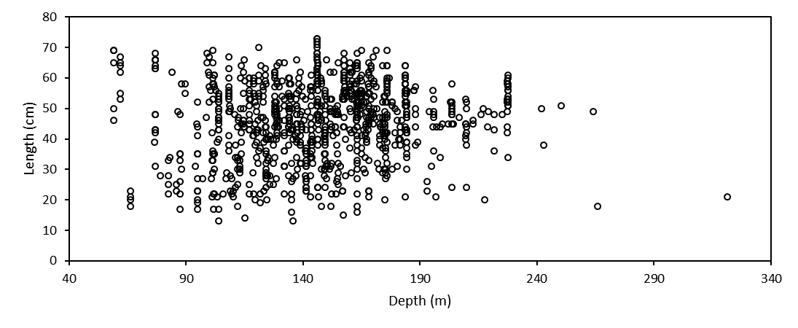

Figure . Distribution of length of yelloweye rockfish by depth, indication lack of ontogenetic movement, when fish migrate to deeper waters as they mature and increase in size and age.

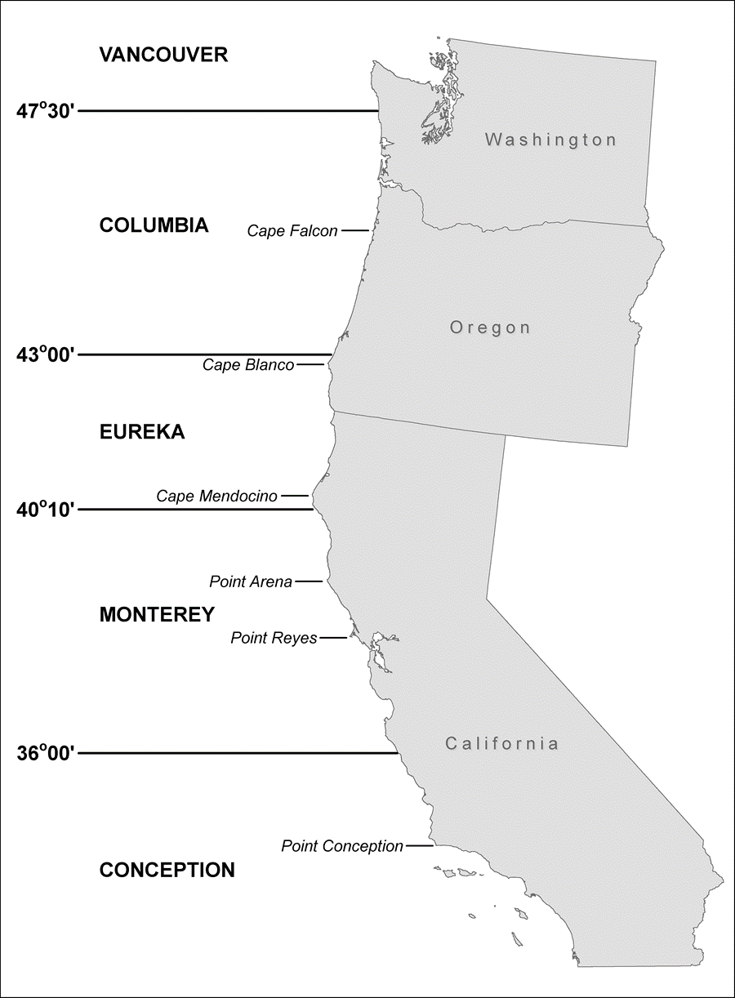

Figure . A map of the assessment area that includes coastal waters off three U.S. West Coast states and five International North Pacific Fisheries Commission (INPFC) areas.

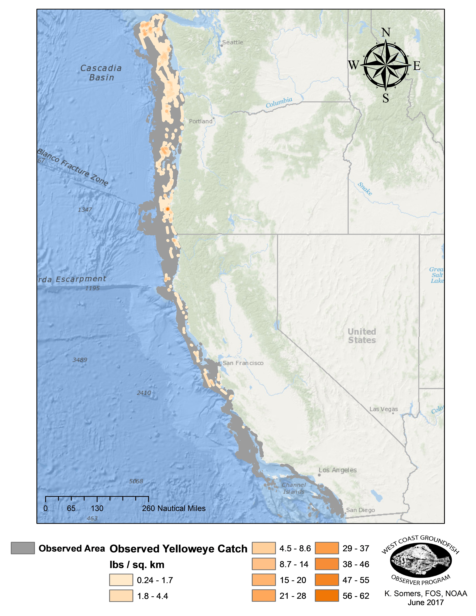

Figure . Spatial distribution of yelloweye rockfish catch along the U.S. West Coast, observed by the West Coast Groundfish Observer Program (WCGOP) and At-Sea Hake Observer Program (A-SHOP) from 2002 to 2015.

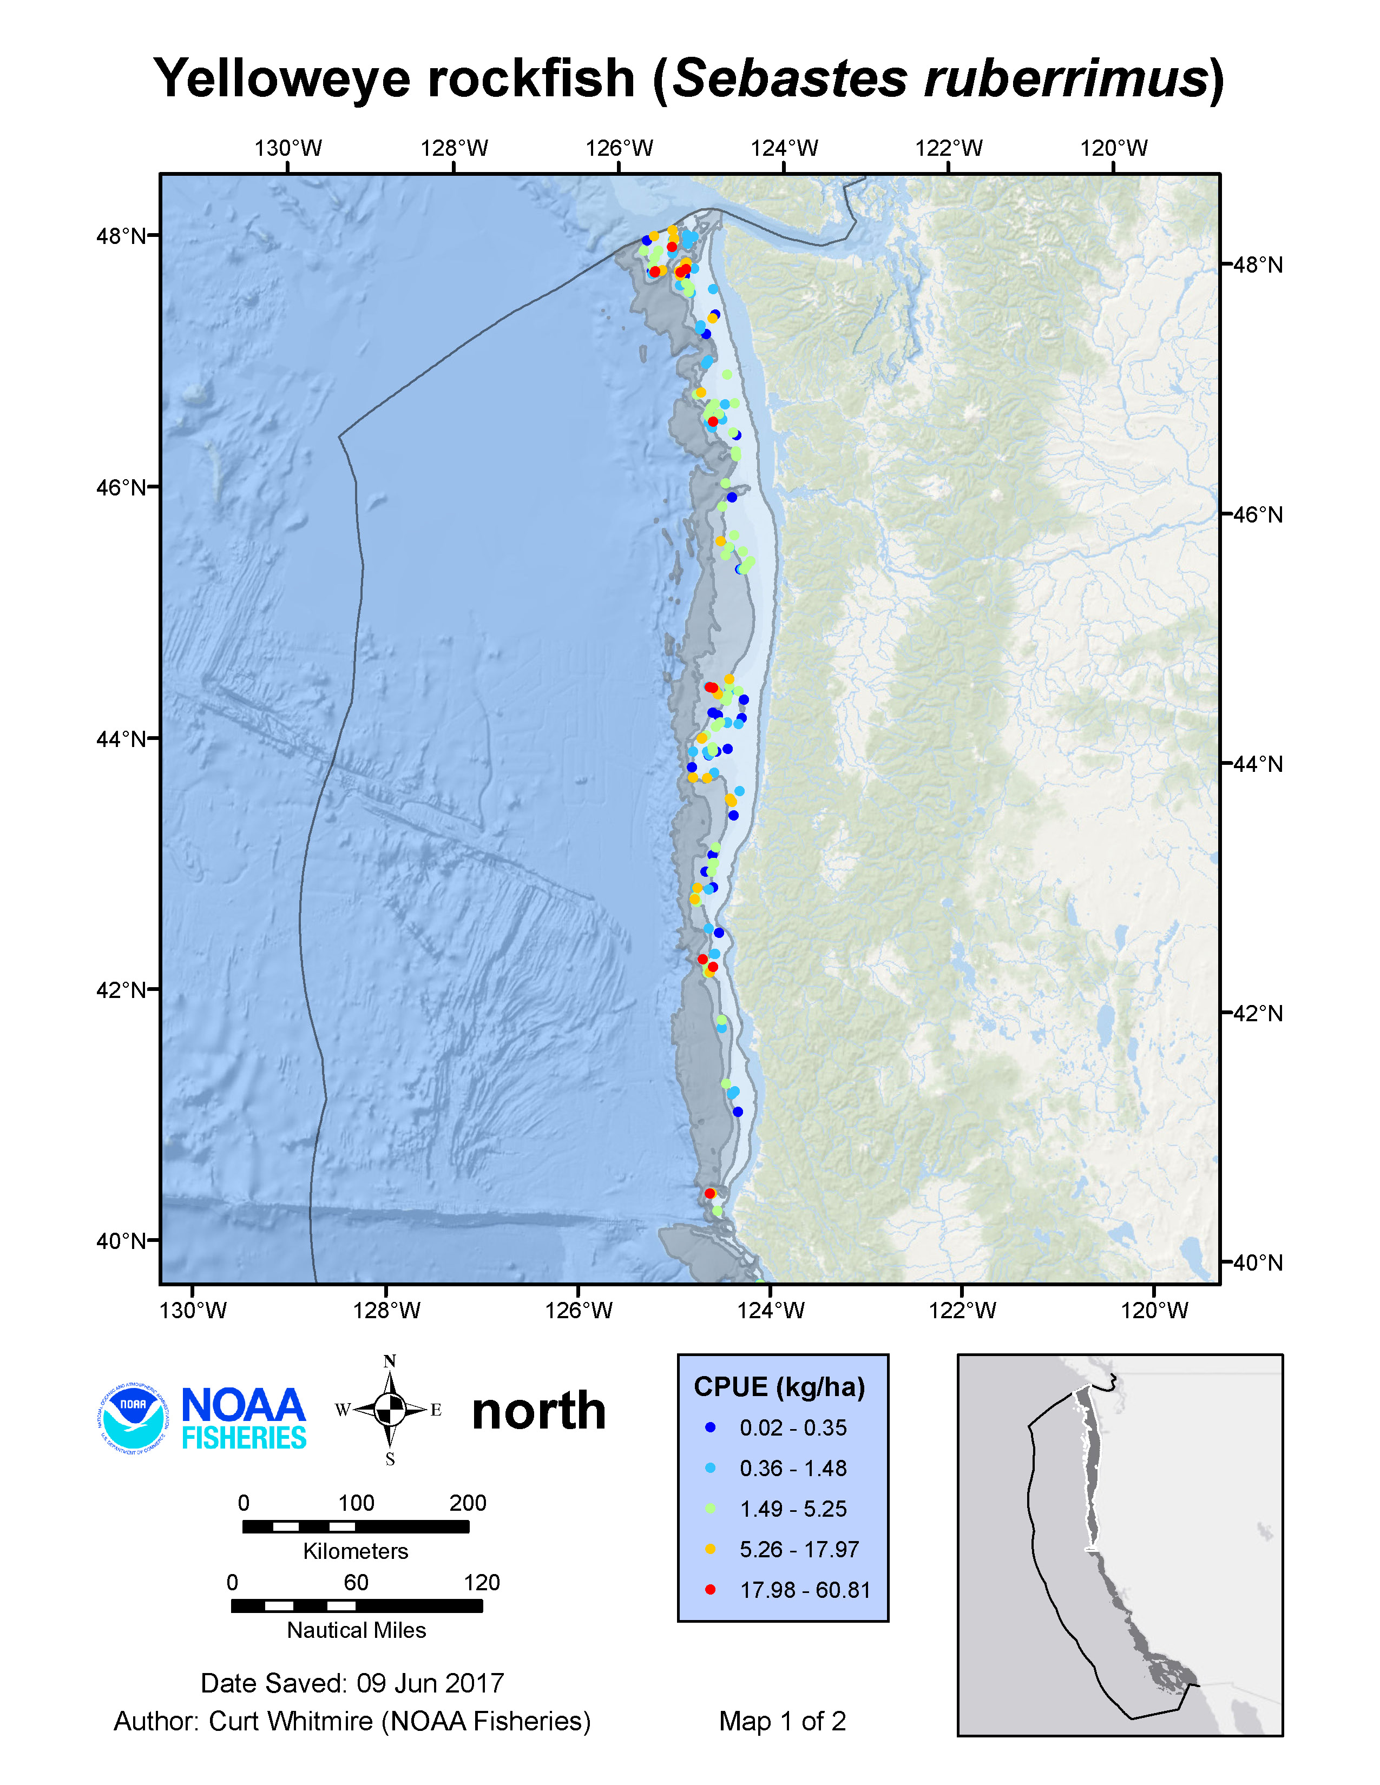

Figure . Spatial distribution of yelloweye rockfish catch off Washington and Oregon in the NWFSC West Coast Groundfish Bottom Trawl Survey between 2003 and 2015.

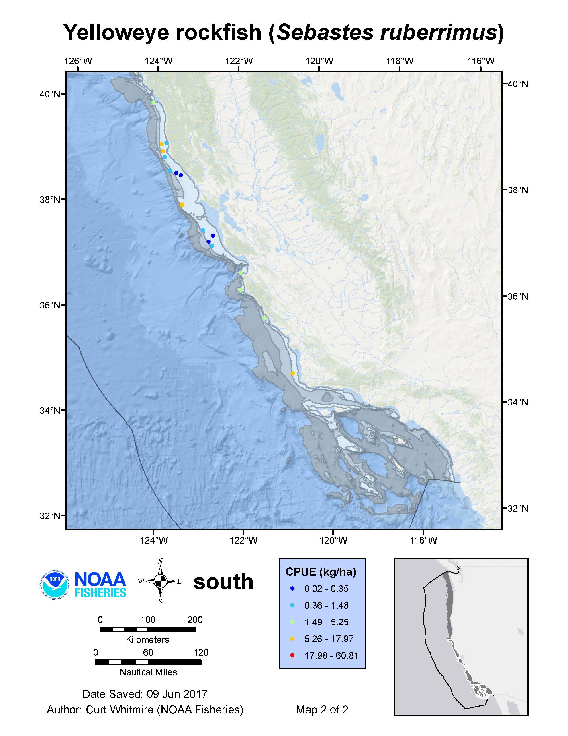

Figure . Spatial distribution of yelloweye rockfish catch off California in the NWFSC West Coast Groundfish Bottom Trawl Survey between 2003 and 2015.



Yelloweye rockfish catch (mt)

CA trawl

CA non-trawl

CA recreational

OR-WA trawl

OR-WA non-trawl

OR recreational

WA recreational

Figure . Yelloweye rockfish landings history by fleet.

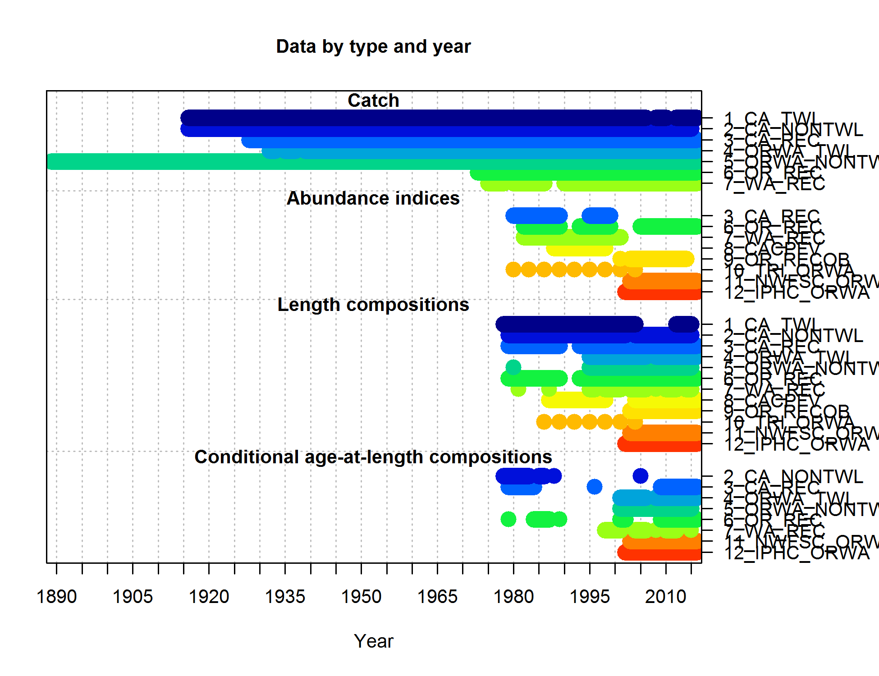

Figure . Summary of sources and data used in the assessment.

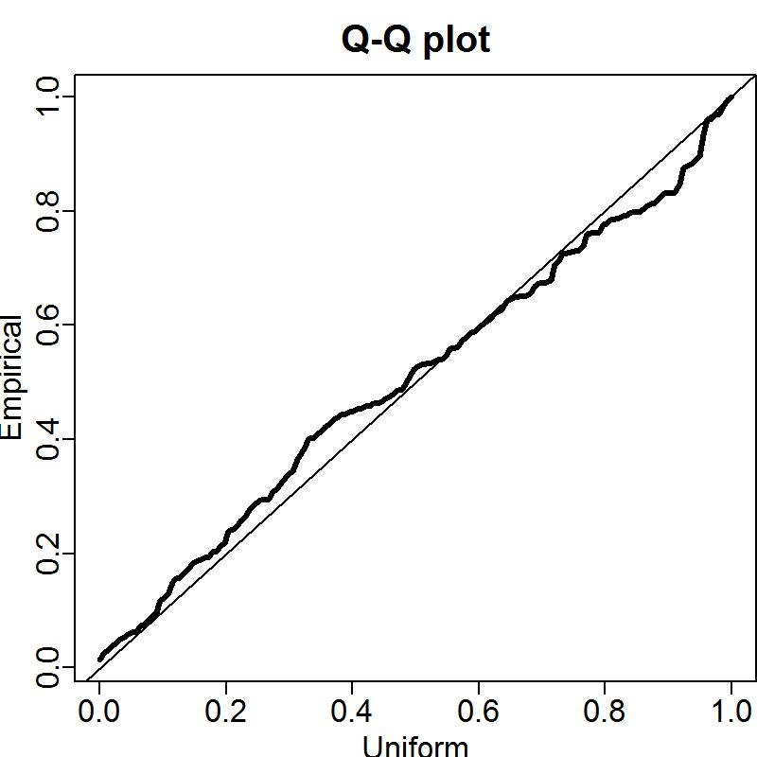

Figure . Q-Q plot for gamma model used in VAST for the AFSC Triennial survey.

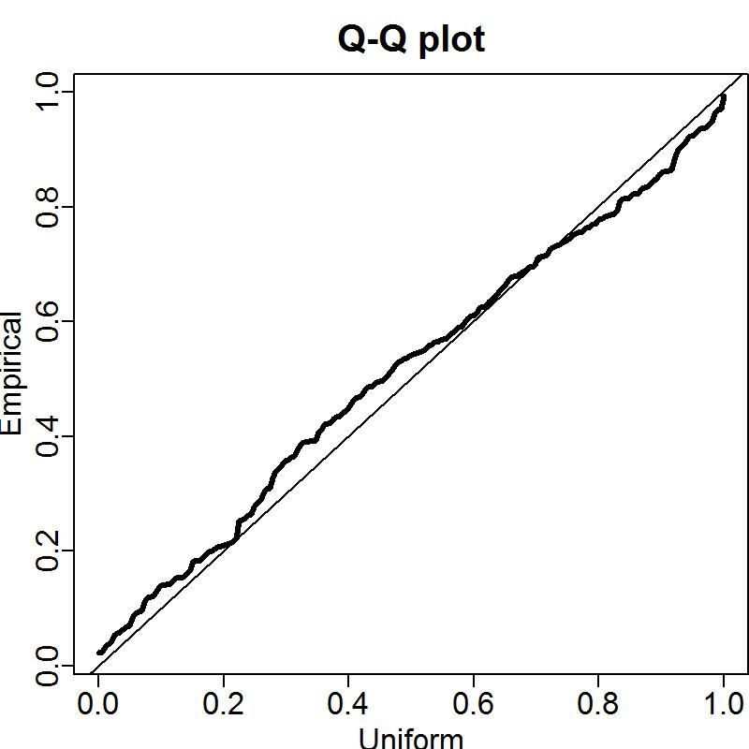

Figure . Q-Q plot for gamma model used in VAST for the NWFSC trawl survey.

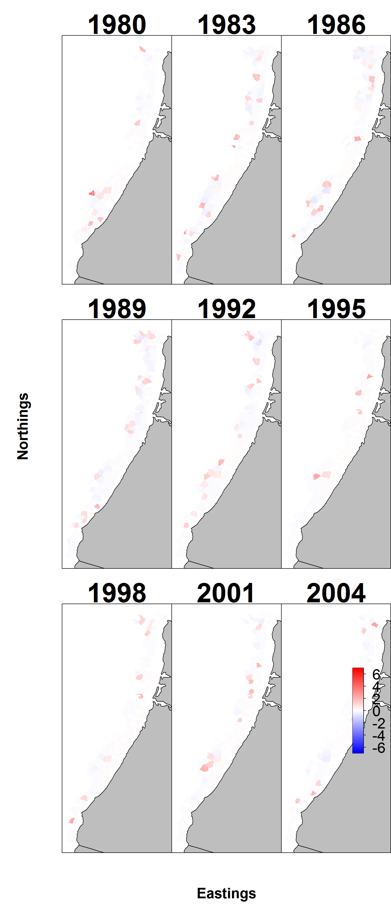

Figure . Pearson residuals for encounter probability of yelloweye rockfish in AFSC triennial survey associated with each knot.

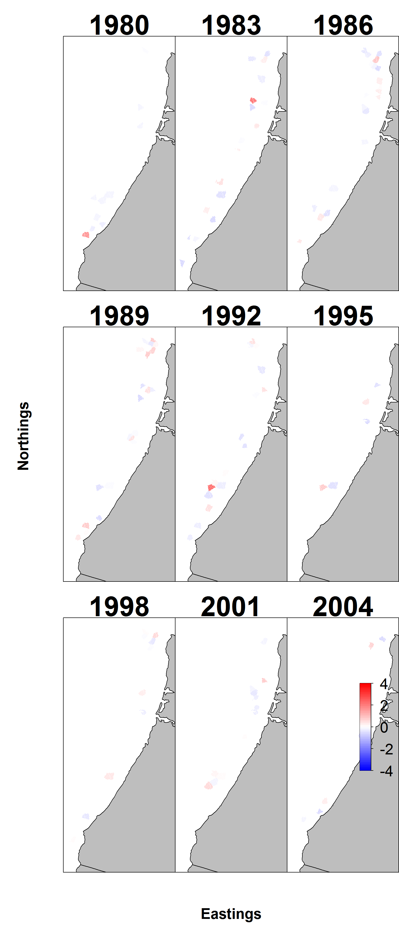

Figure . Pearson residuals for positive catch rates of yelloweye rockfish in AFSC triennial survey associated with each knot.

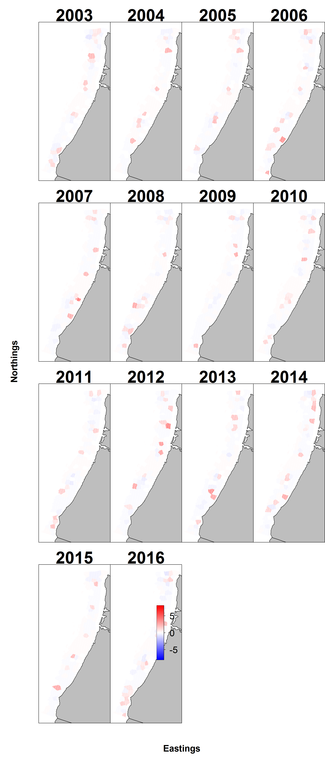

Figure . Pearson residuals for encounter probability of yelloweye rockfish in NWFSC survey associated with each knot.

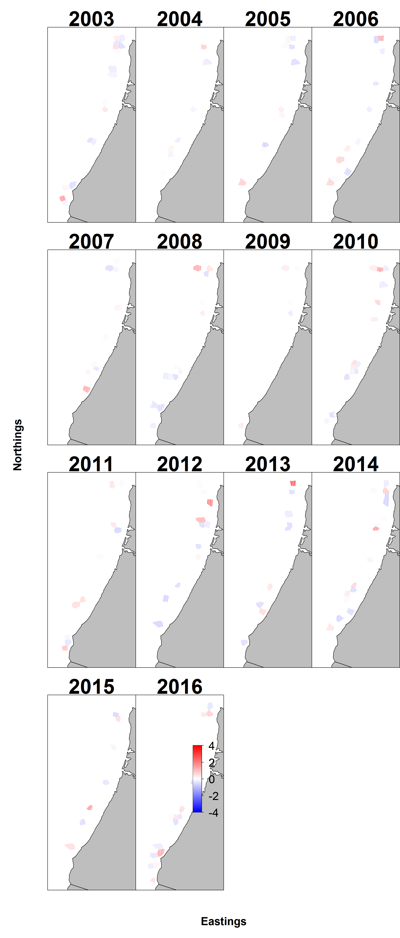

Figure . Pearson residuals for positive catch rates of yelloweye rockfish in NWFSC survey associated with each knot.

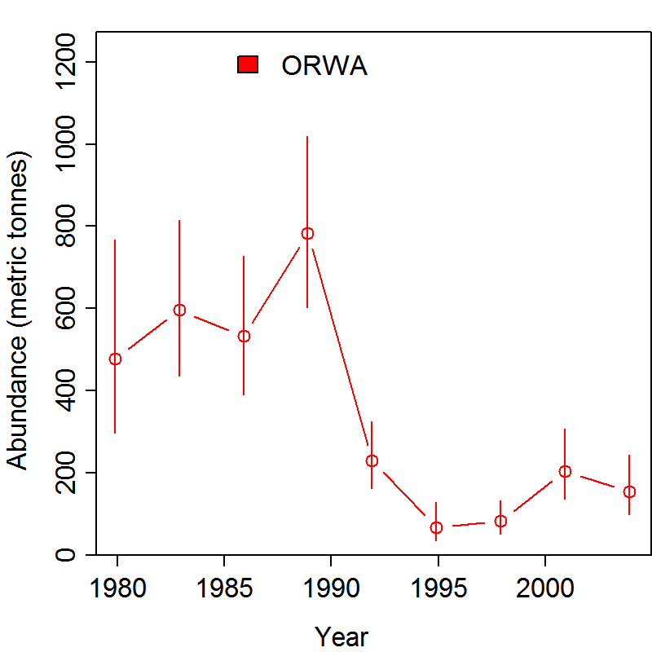

Figure . Estimated index of abundance for AFSC Triennial survey.

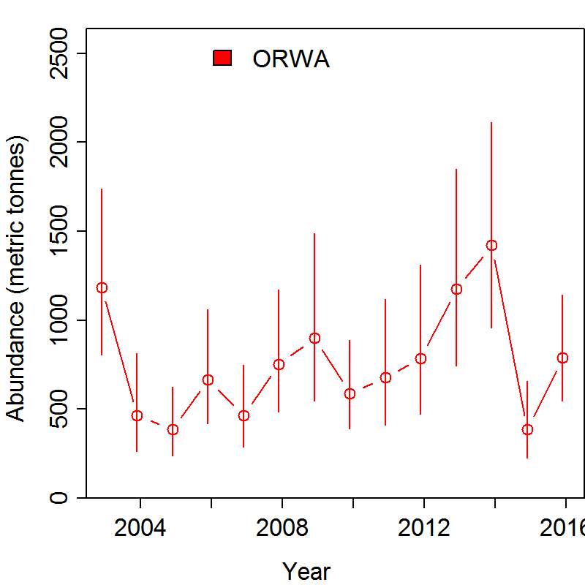

Figure . Estimated index of abundance for NWFSC trawl survey.

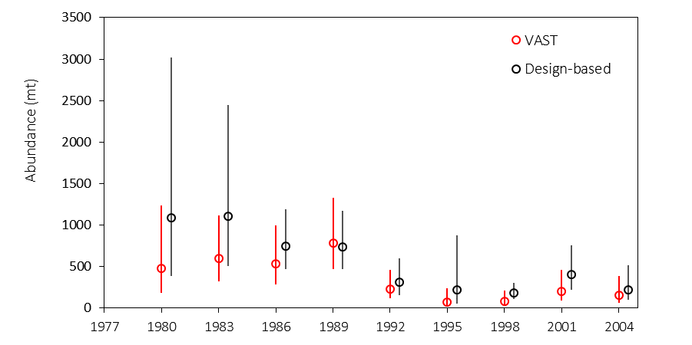

Figure . Comparison of AFSC triennial survey index estimated using VAST with design-based swept area biomass estimates.

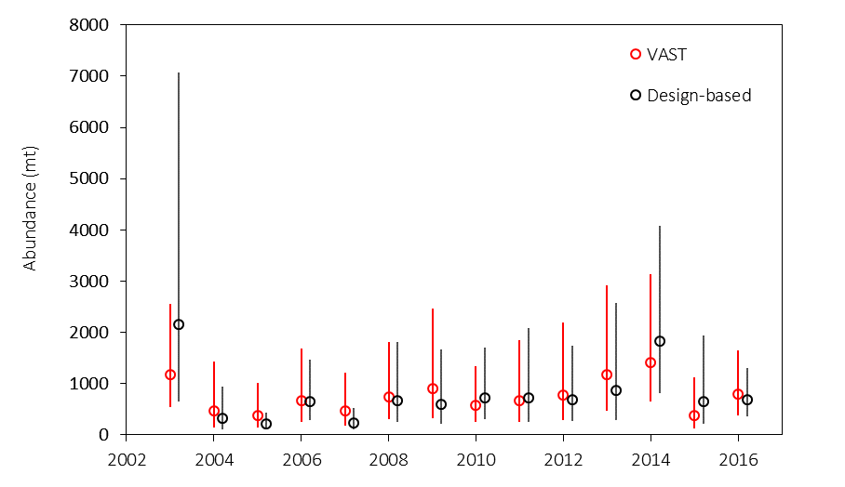

Figure . Comparison of NWFSC survey index estimated using VAST with design-based swept area biomass estimates.

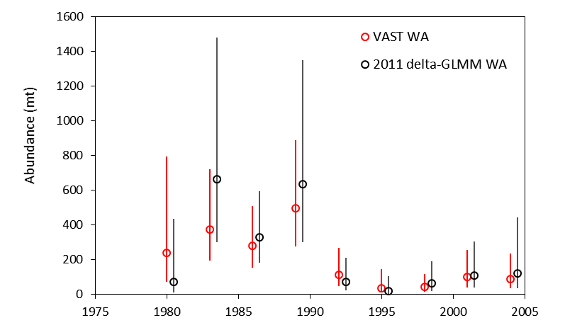

Figure . Comparison of AFSC triennial survey index estimated using VAST with non-spatial GLMM biomass estimates used in 2011 assessment.

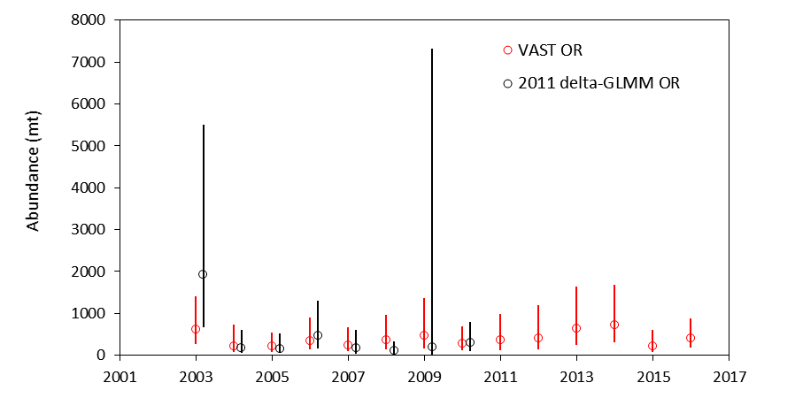

Figure . Comparison of NWFSC survey index estimated using VAST with non-spatial GLMM biomass estimates used in 2011 assessment.

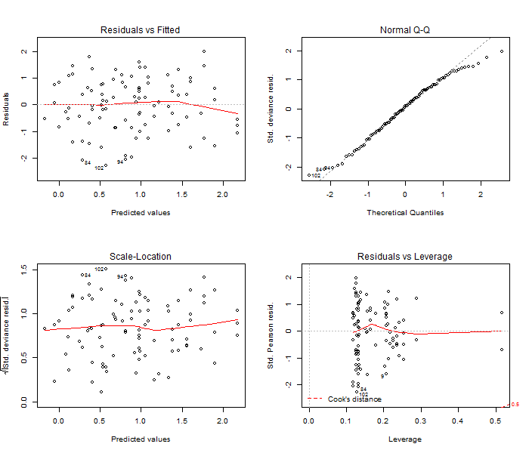

Figure . Diagnostic plots for the positive yelloweye rockfish catch component in the delta-GLM model assuming a lognormal distribution for the IPHC halibut survey. These are used to evaluate model fit (top left), assumptions of normality (top right), assumptions of constant variance (bottom left), and the presence of outliers (bottom right).

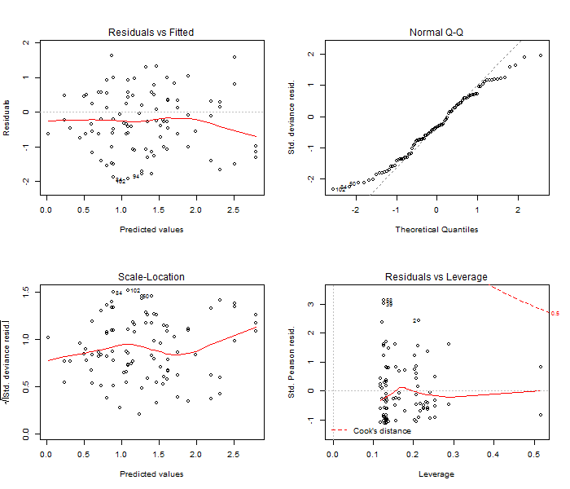

Figure . Diagnostic plots for the positive yelloweye rockfish catch component in the delta-GLM model assuming a gamma distribution for the IPHC halibut survey. These are used to evaluate model fit (top left), assumptions of normality (top right), assumptions of constant variance (bottom left), and the presence of outliers (bottom right).

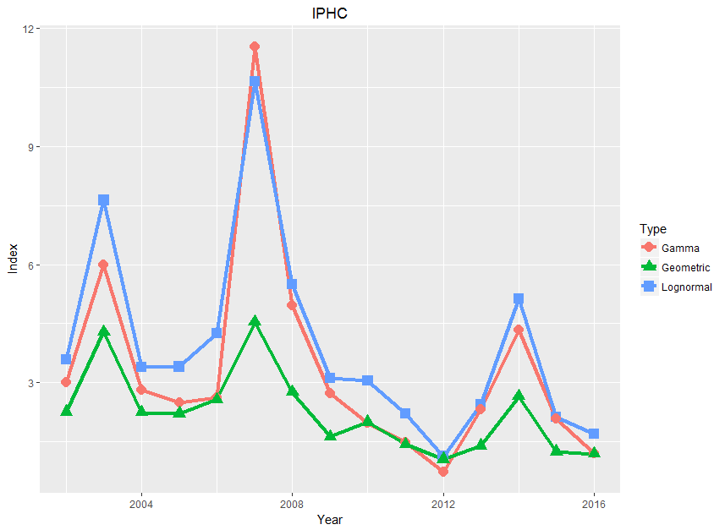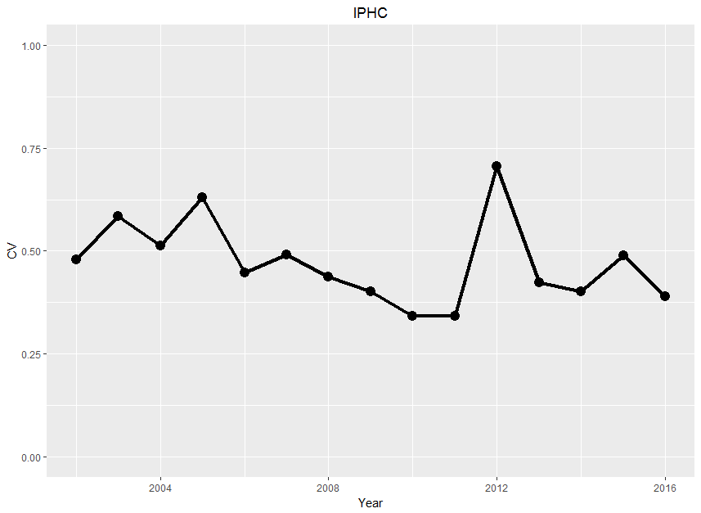

Figure . Top panel: Comparison of index fits for three approaches (geometric average and the delta-GLM assuming either gamma or lognormal distributions) for positive catches of yelloweye rockfish in the IPHC survey. The chosen model uses the lognormal distribution. Bottom panel: Uncertainty (reported as the coefficient of variation (CV)) by year in the chosen model.

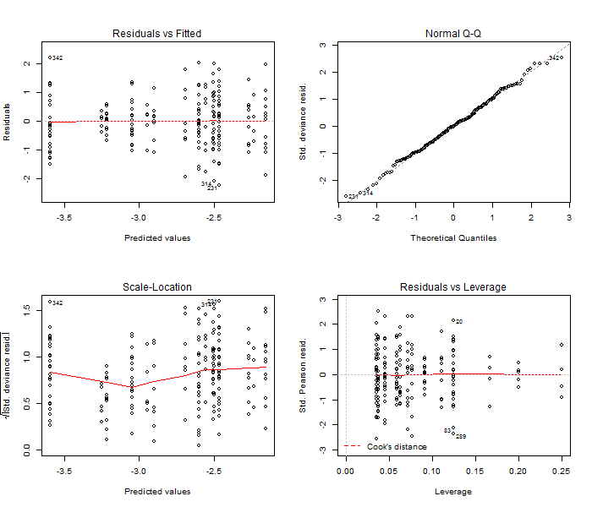

Figure . Diagnostic plots for the positive yelloweye rockfish catch component in the delta-GLM model assuming a lognormal distribution for the California MRFSS recreational index. These are used to evaluate model fit (top left), assumptions of normality (top right), assumptions of constant variance (bottom left), and the presence of outliers (bottom right).

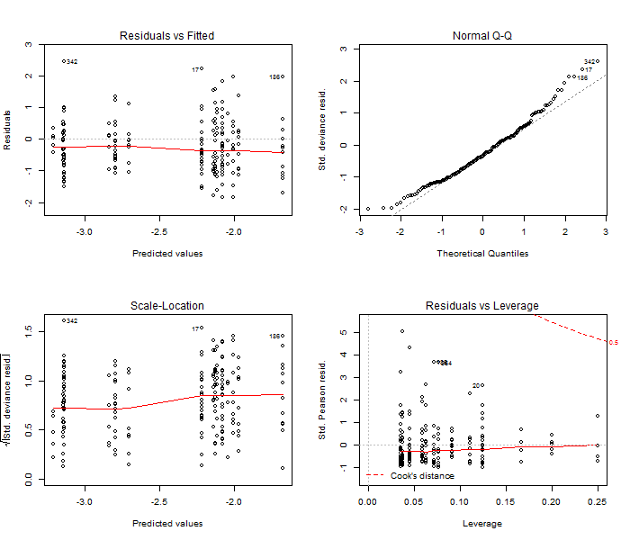

Figure . Diagnostic plots for the positive yelloweye rockfish catch component in the delta-GLM model assuming a gamma distribution for the California MRFSS recreational index. These are used to evaluate model fit (top left), assumptions of normality (top right), assumptions of constant variance (bottom left), and the presence of outliers (bottom right).

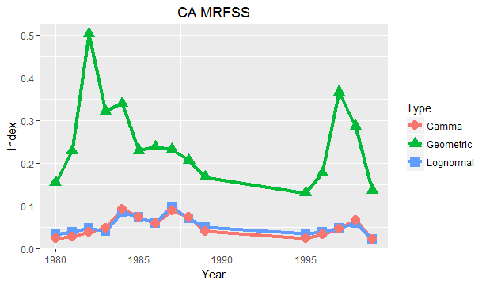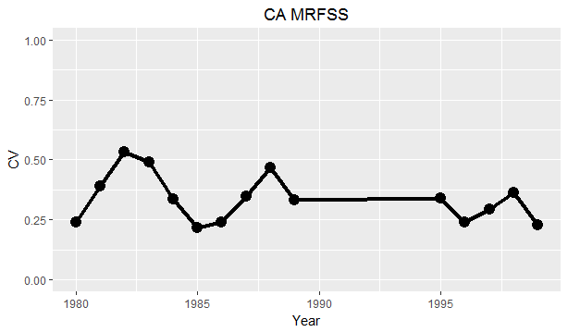

Figure . Top panel: Comparison of index fits for three approaches (geometric average and the delta-GLM assuming either gamma or lognormal distributions) for positive catches of yelloweye rockfish in the California MRFSS recreational index. The chosen model uses the lognormal distribution. Bottom panel: Uncertainty (reported as the coefficient of variation (CV)) by year in the chosen model.

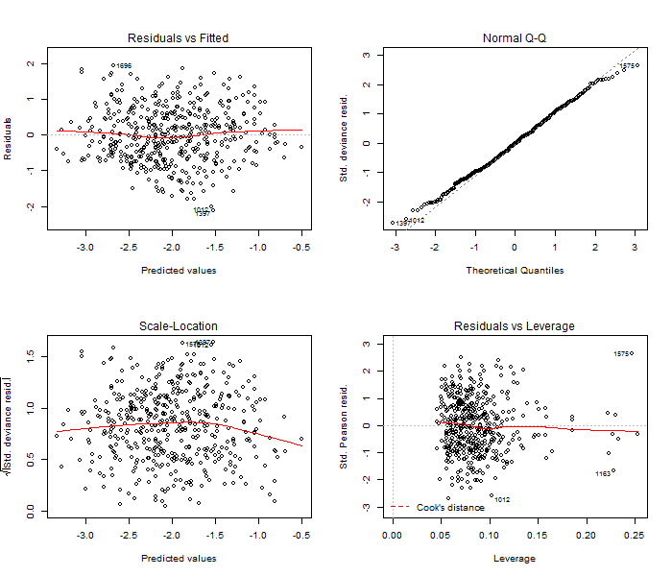

Figure . Diagnostic plots for the positive yelloweye rockfish catch component in the delta-GLM model assuming a lognormal distribution for the California CPFV recreational index. These are used to evaluate model fit (top left), assumptions of normality (top right), assumptions of constant variance (bottom left), and the presence of outliers (bottom right).

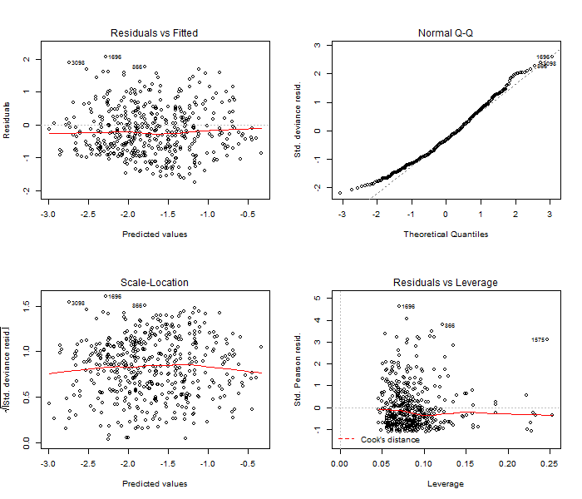

Figure . Diagnostic plots for the positive yelloweye rockfish catch component in the delta-GLM model assuming a gamma distribution for the California CPFV recreational index. These are used to evaluate model fit (top left), assumptions of normality (top right), assumptions of constant variance (bottom left), and the presence of outliers (bottom right).

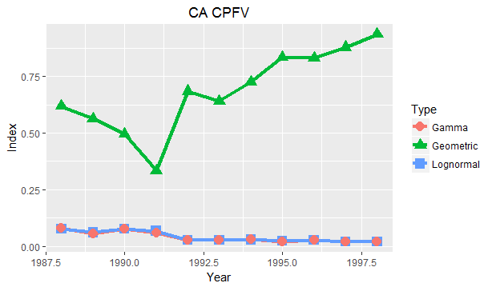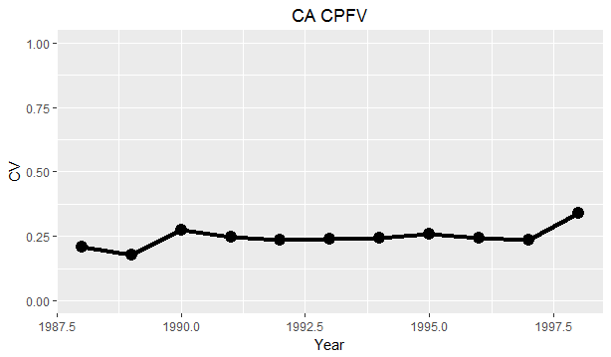

Figure . Top panel: Comparison of index fits for three approaches (geometric average and the delta-GLM assuming either gamma or lognormal distributions) for positive catches of yelloweye rockfish in the California CPFV recreational index. The chosen model uses the lognormal distribution. Bottom panel: Uncertainty (reported as the coefficient of variation (CV)) by year in the chosen model.

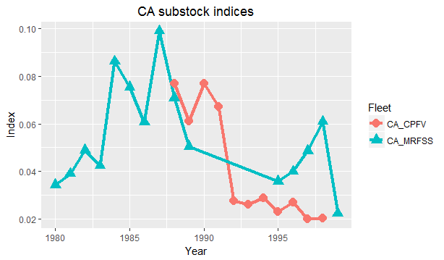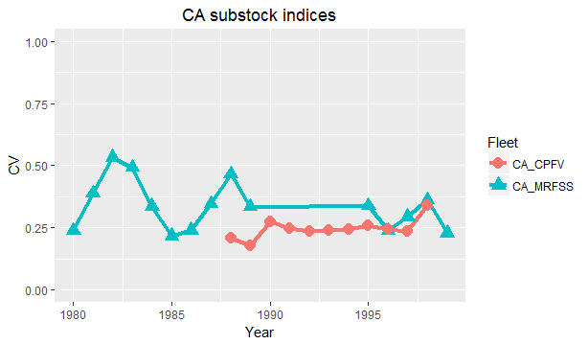

Figure . Comparison of index time series (top panel) and uncertainty (bottom panel) for the abundance indices relevant to the California substock of yelloweye rockfish.

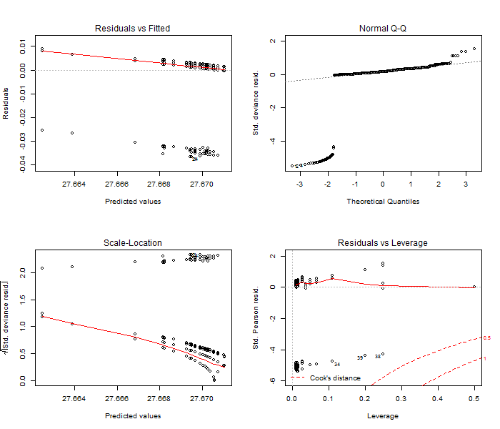

Figure . Diagnostic plots for the positive yelloweye rockfish catch component in the delta-GLM model assuming a lognormal distribution for the OR onboard recreational index. These are used to evaluate model fit (top left), assumptions of normality (top right), assumptions of constant variance (bottom left), and the presence of outliers (bottom right).

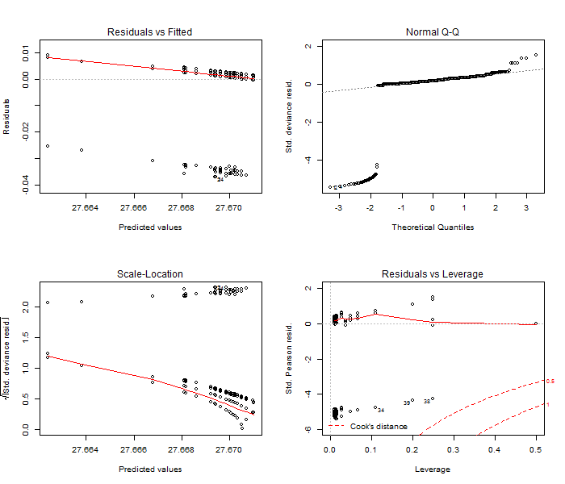

Figure . Diagnostic plots for the positive yelloweye rockfish catch component in the delta-GLM model assuming a gamma distribution for the OR onboard recreational index. These are used to evaluate model fit (top left), assumptions of normality (top right), assumptions of constant variance (bottom left), and the presence of outliers (bottom right).

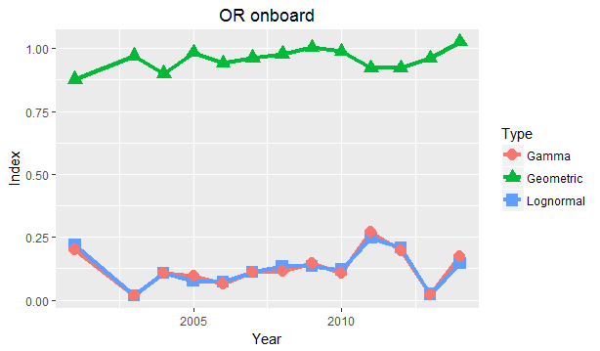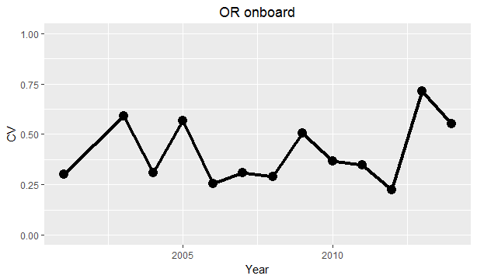

Figure . Comparison of index fits for three approaches (geometric average and the delta-GLM assuming either gamma or lognormal distributions) for positive catches of yelloweye rockfish in the Oregon onboard recreational index. The chosen model uses the lognormal distribution. Bottom panel: Uncertainty (reported as the coefficient of variation (CV)) by year in the chosen model.

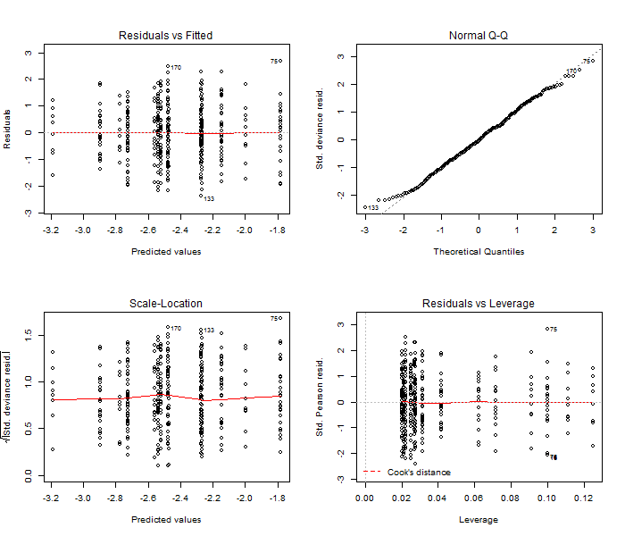

Figure . Diagnostic plots for the positive yelloweye rockfish catch component in the delta-GLM model assuming a lognormal distribution for the OR MRFSS recreational index. These are used to evaluate model fit (top left), assumptions of normality (top right), assumptions of constant variance (bottom left), and the presence of outliers (bottom right).

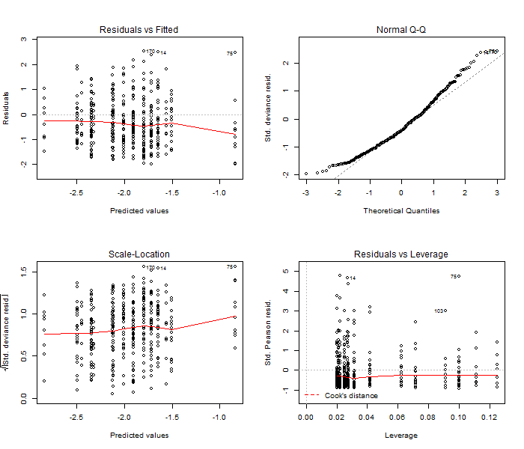

Figure . Diagnostic plots for the positive yelloweye rockfish catch component in the delta-GLM model assuming a gamma distribution for the OR MRFSS recreational index. These are used to evaluate model fit (top left), assumptions of normality (top right), assumptions of constant variance (bottom left), and the presence of outliers (bottom right).

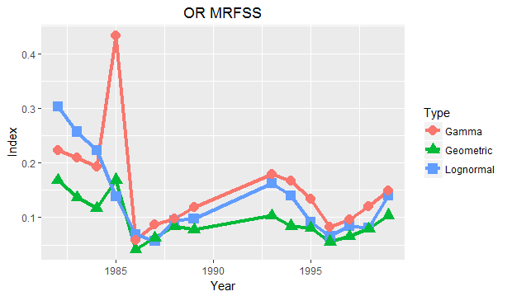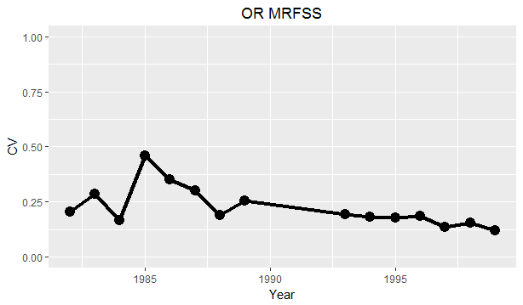

Figure . Comparison of index fits for three approaches (geometric average and the delta-GLM assuming either gamma or lognormal distributions) for positive catches of yelloweye rockfish in the Oregon MRFSS recreational index. The chosen model uses the lognormal distribution. Bottom panel: Uncertainty (reported as the coefficient of variation (CV)) by year in the chosen model.

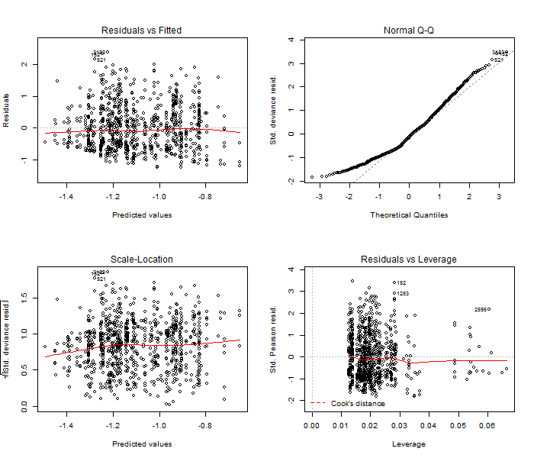

Figure . Diagnostic plots for the positive yelloweye rockfish catch component in the delta-GLM model assuming a lognormal distribution for the ORBS recreational index. These are used to evaluate model fit (top left), assumptions of normality (top right), assumptions of constant variance (bottom left), and the presence of outliers (bottom right).

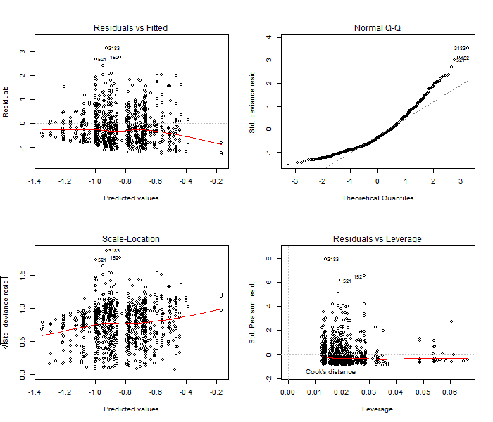

Figure . Diagnostic plots for the positive yelloweye rockfish catch component in the delta-GLM model assuming a gamma distribution for the ORBS recreational index. These are used to evaluate model fit (top left), assumptions of normality (top right), assumptions of constant variance (bottom left), and the presence of outliers (bottom right).

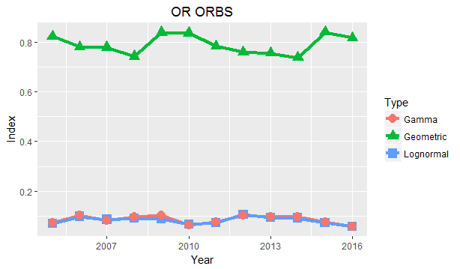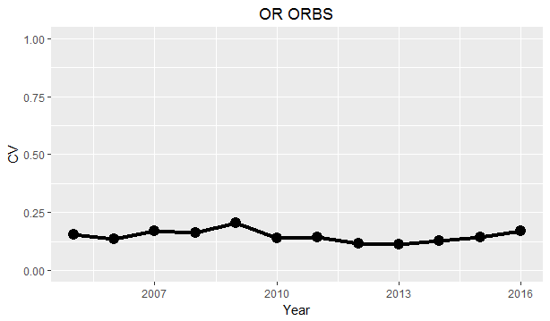

Figure . Comparison of index fits for three approaches (geometric average and the delta-GLM assuming either gamma or lognormal distributions) for positive catches of yelloweye rockfish in the ORBS recreational index. The chosen model uses the lognormal distribution. Bottom panel: Uncertainty (reported as the coefficient of variation (CV)) by year in the chosen model.

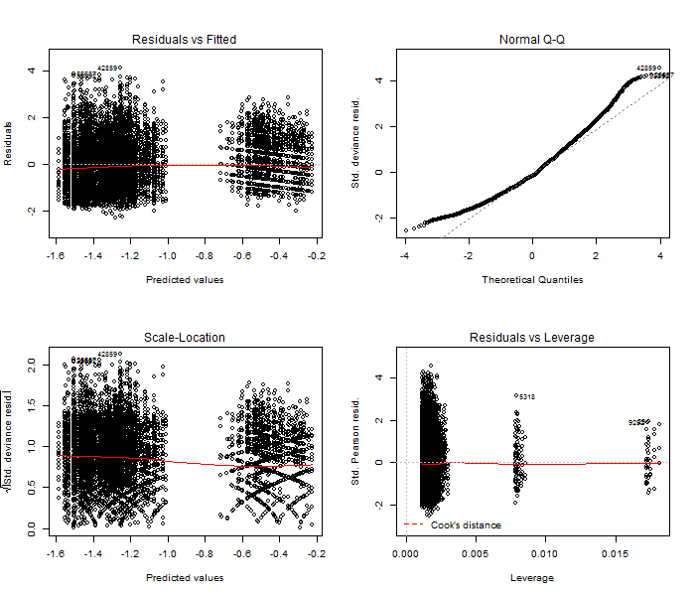

Figure . Diagnostic plots for the positive yelloweye rockfish catch component in the delta-GLM model assuming a lognormal distribution for the WA dockside recreational index. These are used to evaluate model fit (top left), assumptions of normality (top right), assumptions of constant variance (bottom left), and the presence of outliers (bottom right).

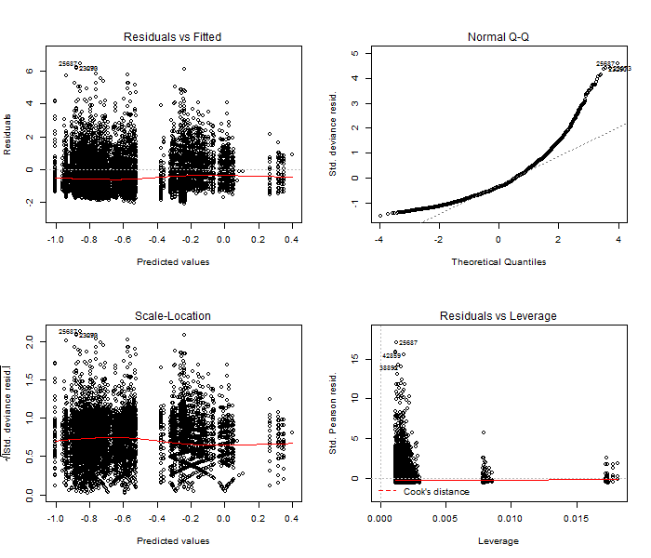

Figure . Diagnostic plots for the positive yelloweye rockfish catch component in the delta-GLM model assuming a gamma distribution for the WA dockside recreational index. These are used to evaluate model fit (top left), assumptions of normality (top right), assumptions of constant variance (bottom left), and the presence of outliers (bottom right).

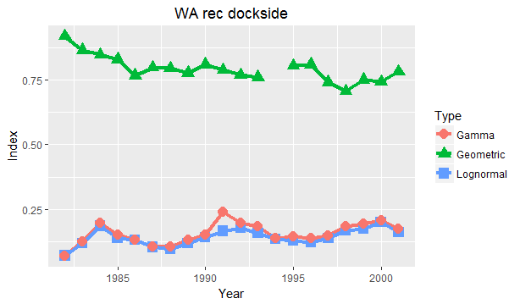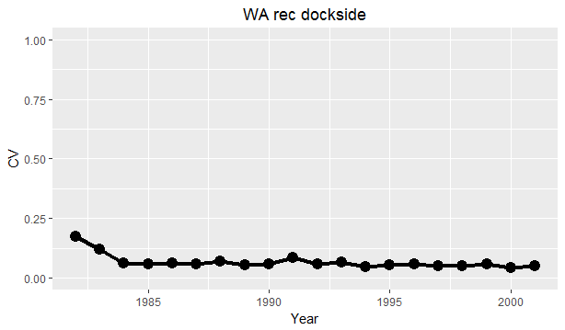

Figure . Comparison of index fits for three approaches (geometric average and the delta-GLM assuming either gamma or lognormal distributions) for positive catches of yelloweye rockfish in the Washington dockside recreational index. The chosen model uses the lognormal distribution. Bottom panel: Uncertainty (reported as the coefficient of variation (CV)) by year in the chosen model.

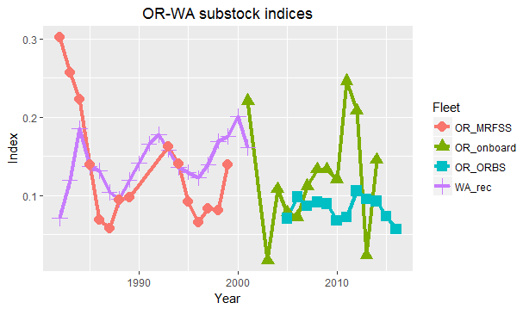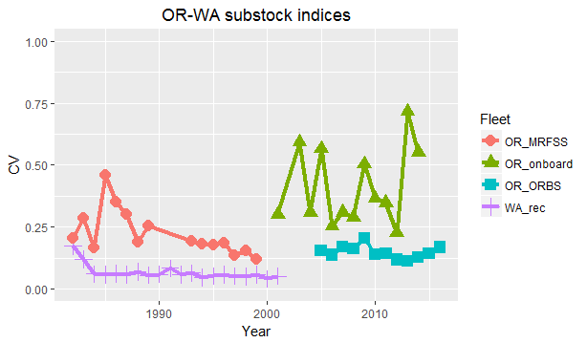

Figure . Comparison of index time series (top panel) and uncertainty (bottom panel) for the abundance indices relevant to the Oregon-Washington substock of yelloweye rockfish.

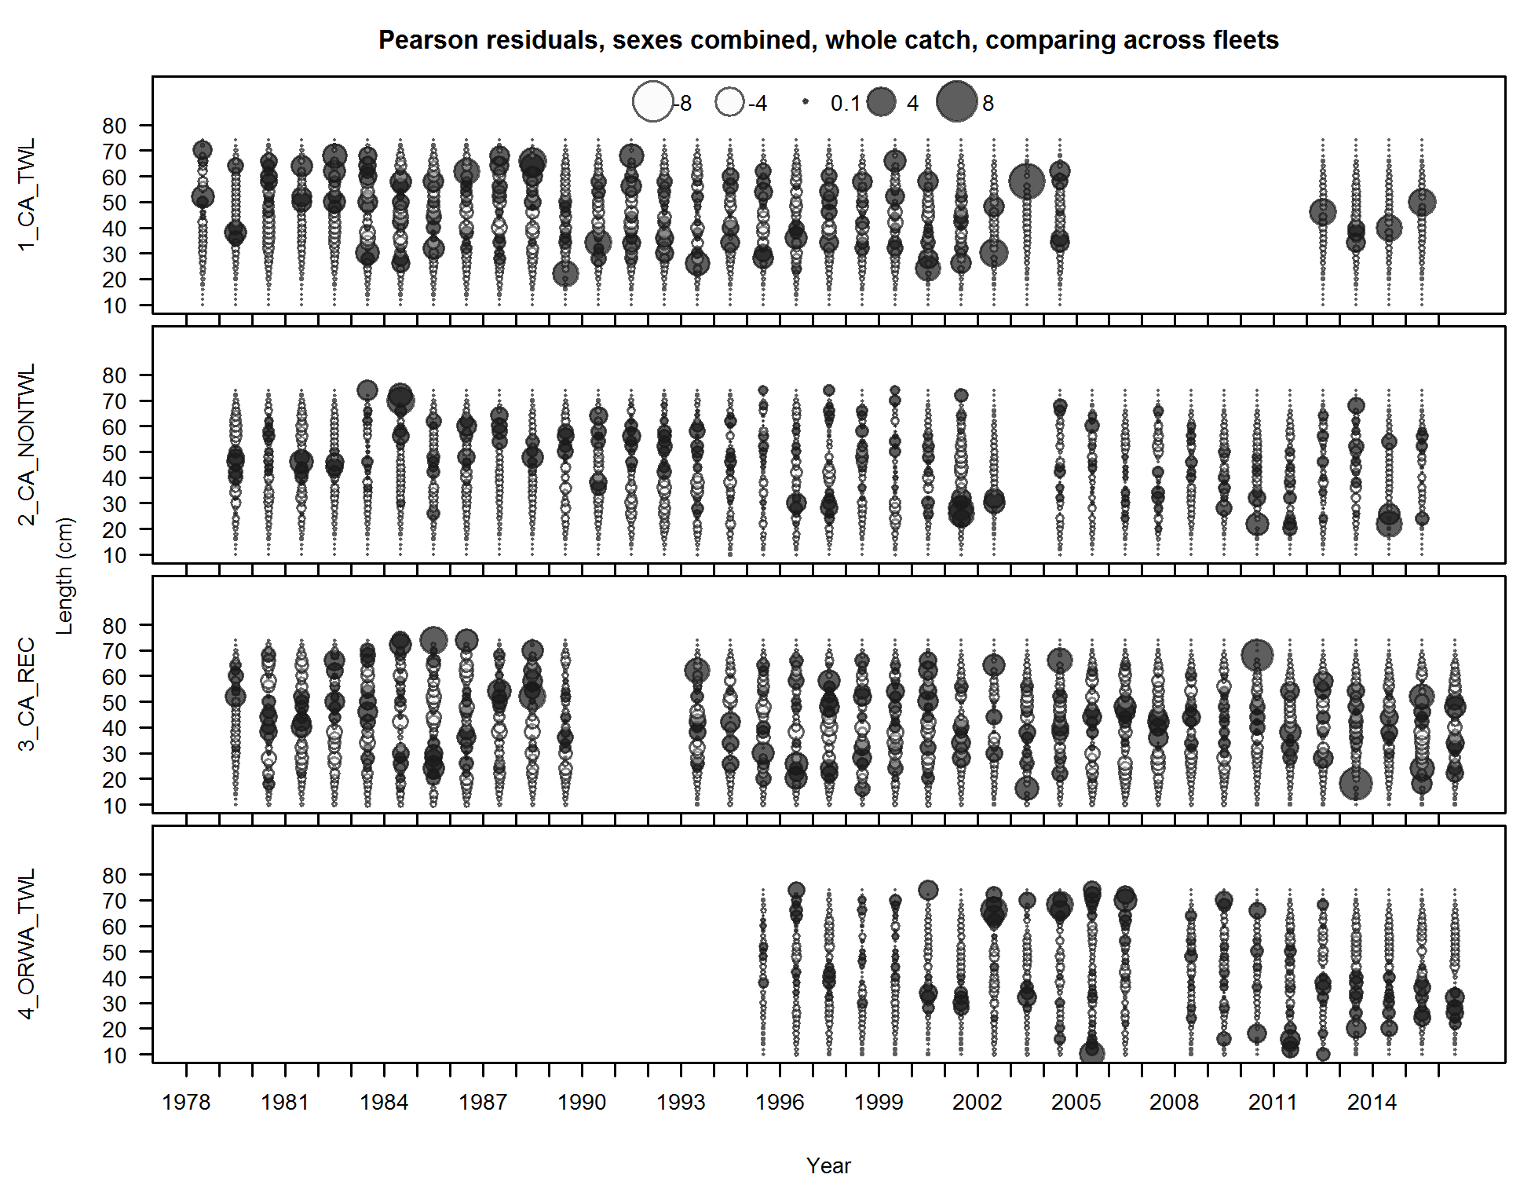

Figure . Length-frequency distributions for yelloweye rockfish catch by year from California trawl, non-trawl and recreational fleets and from Oregon-Washington trawl fleet.

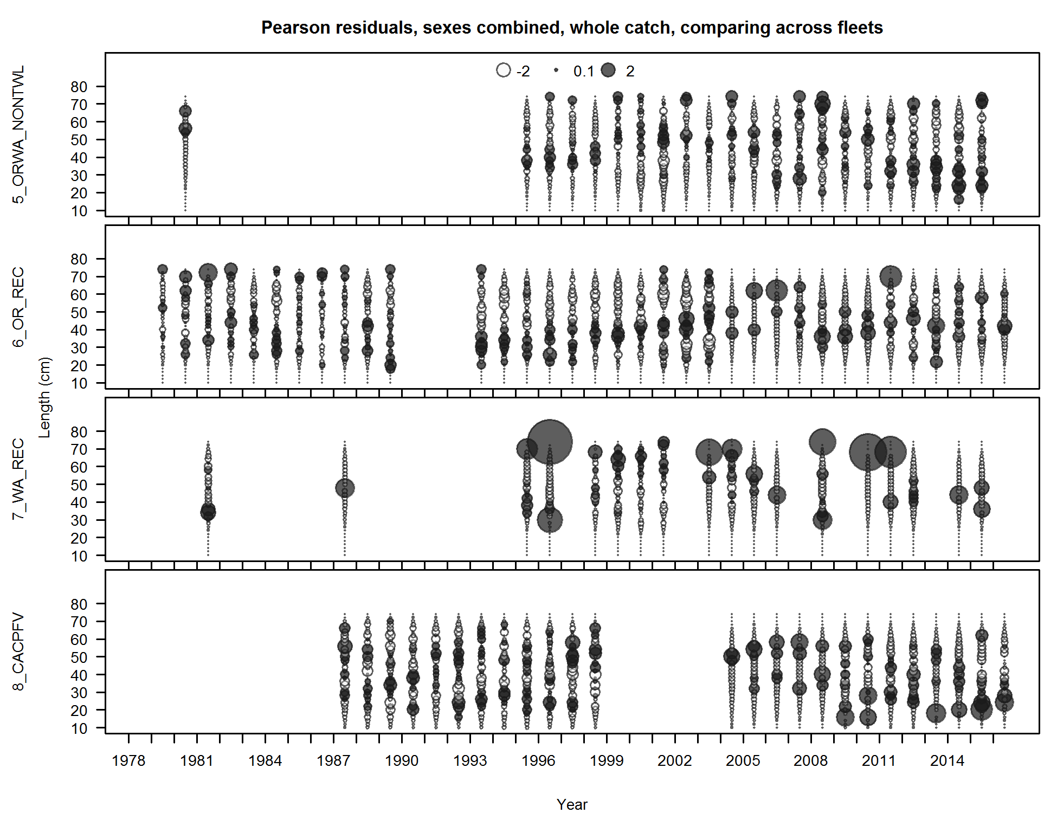

Figure . Length-frequency distributions for yelloweye rockfish catch by year from Oregon-Washington trawl, Oregon recreational and Washington recreation fleets as well as California recreational observer program.

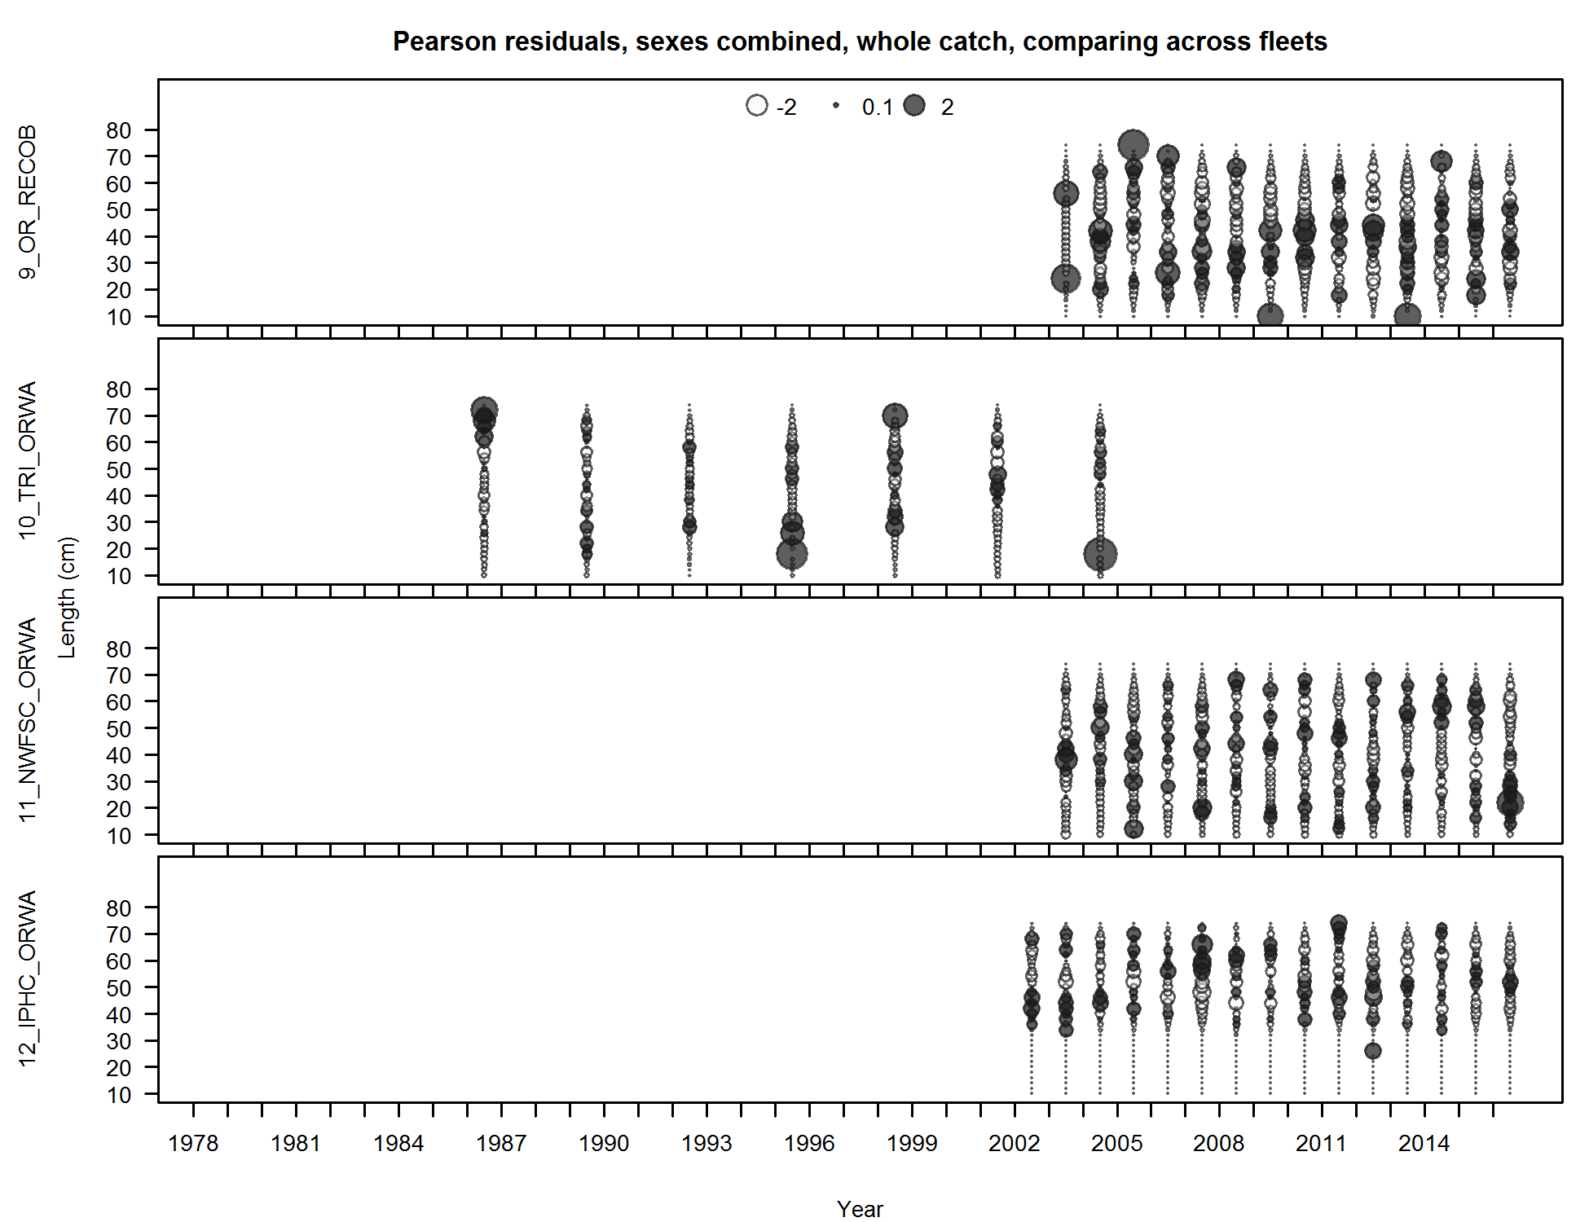

Figure . Length-frequency distributions for yelloweye rockfish catches by year from Oregon recreational observer program and from triennial, NWFSC NWFSC trawl survey and IPHC surveys.

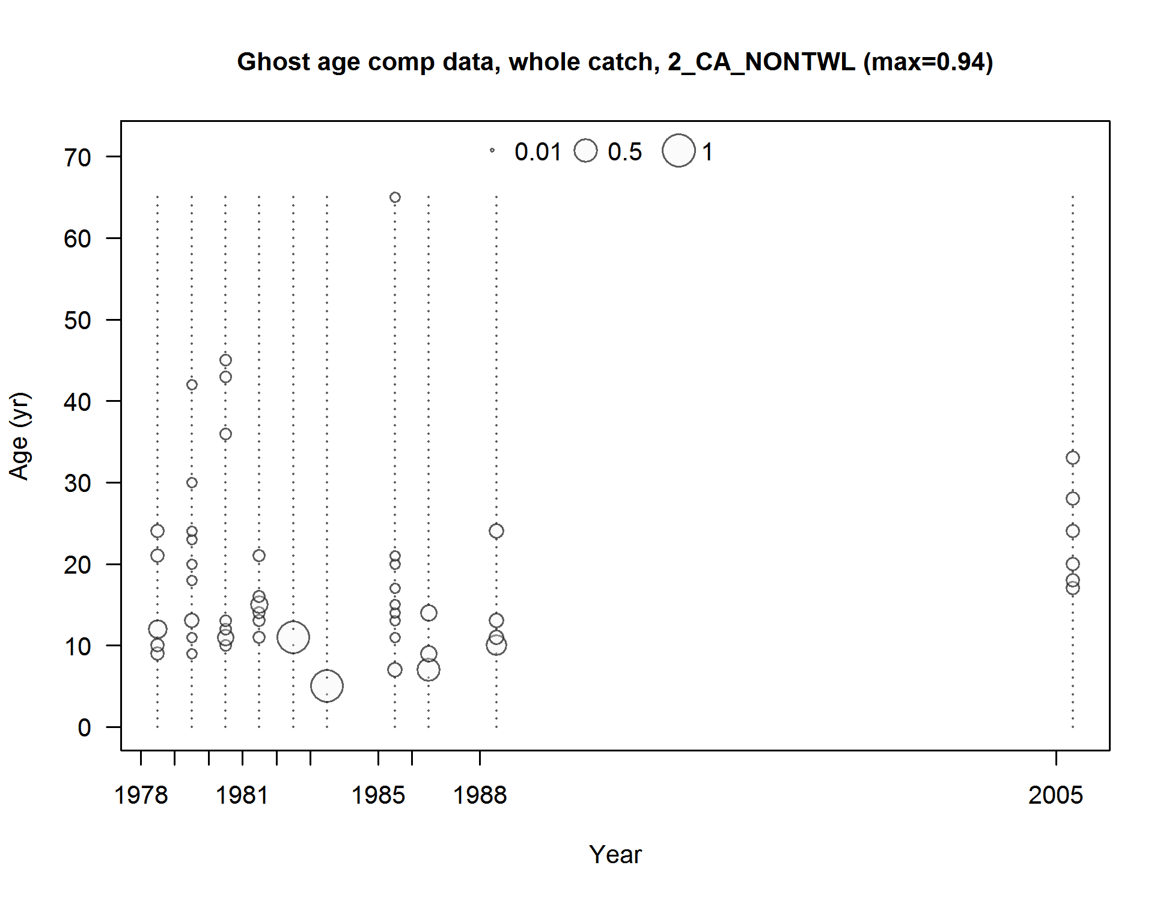

Figure . Age-frequency distributions for yelloweye rockfish catches by year from California non-trawl fleet.

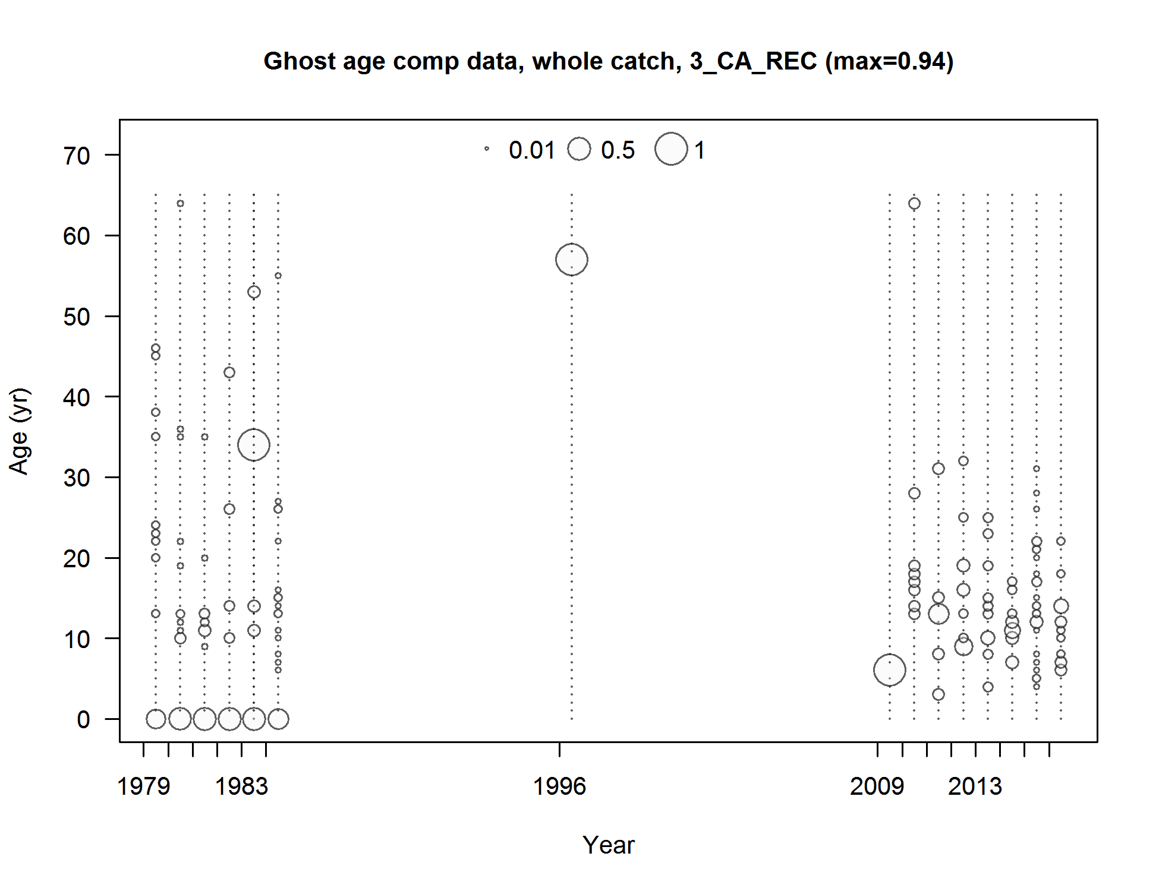

Figure . Age-frequency distributions for yelloweye rockfish catches by year from California recreational fleet.

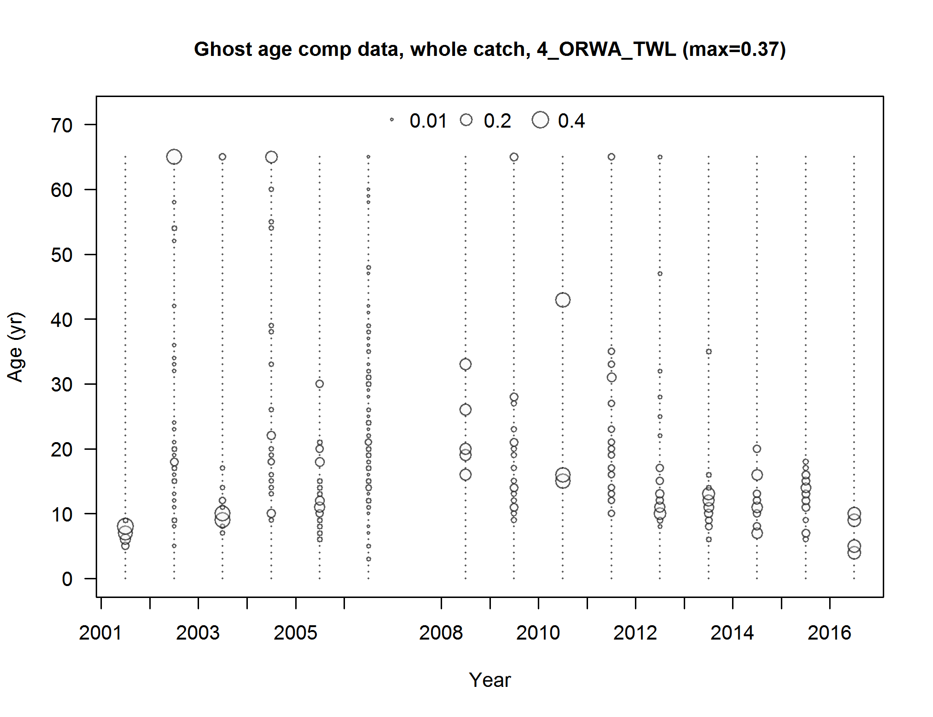

Figure . Age-frequency distributions for yelloweye rockfish catches by year from Oregon-Washington trawl fleet.

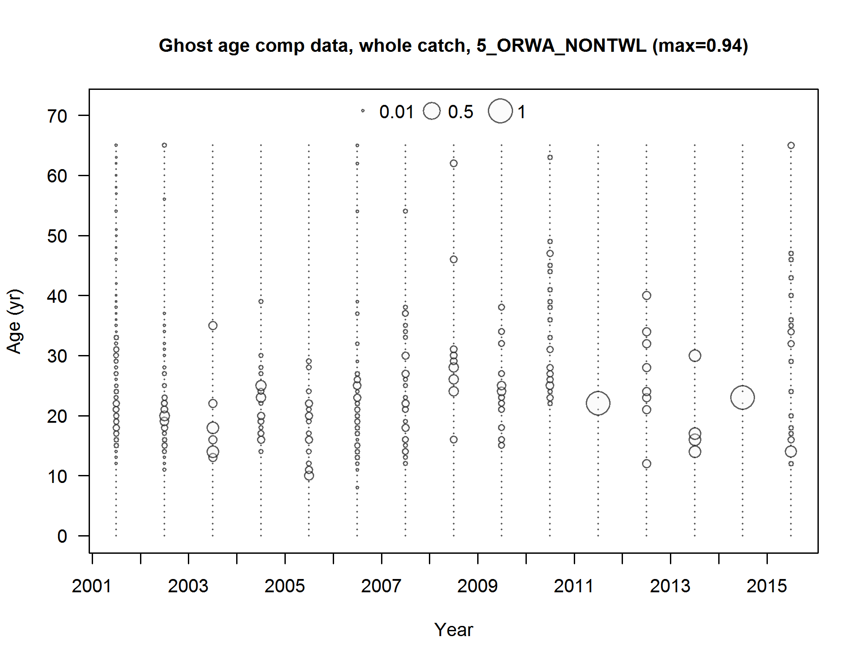

Figure . Age-frequency distributions for yelloweye rockfish catches by year from Oregon-Washington non-trawl fleet.

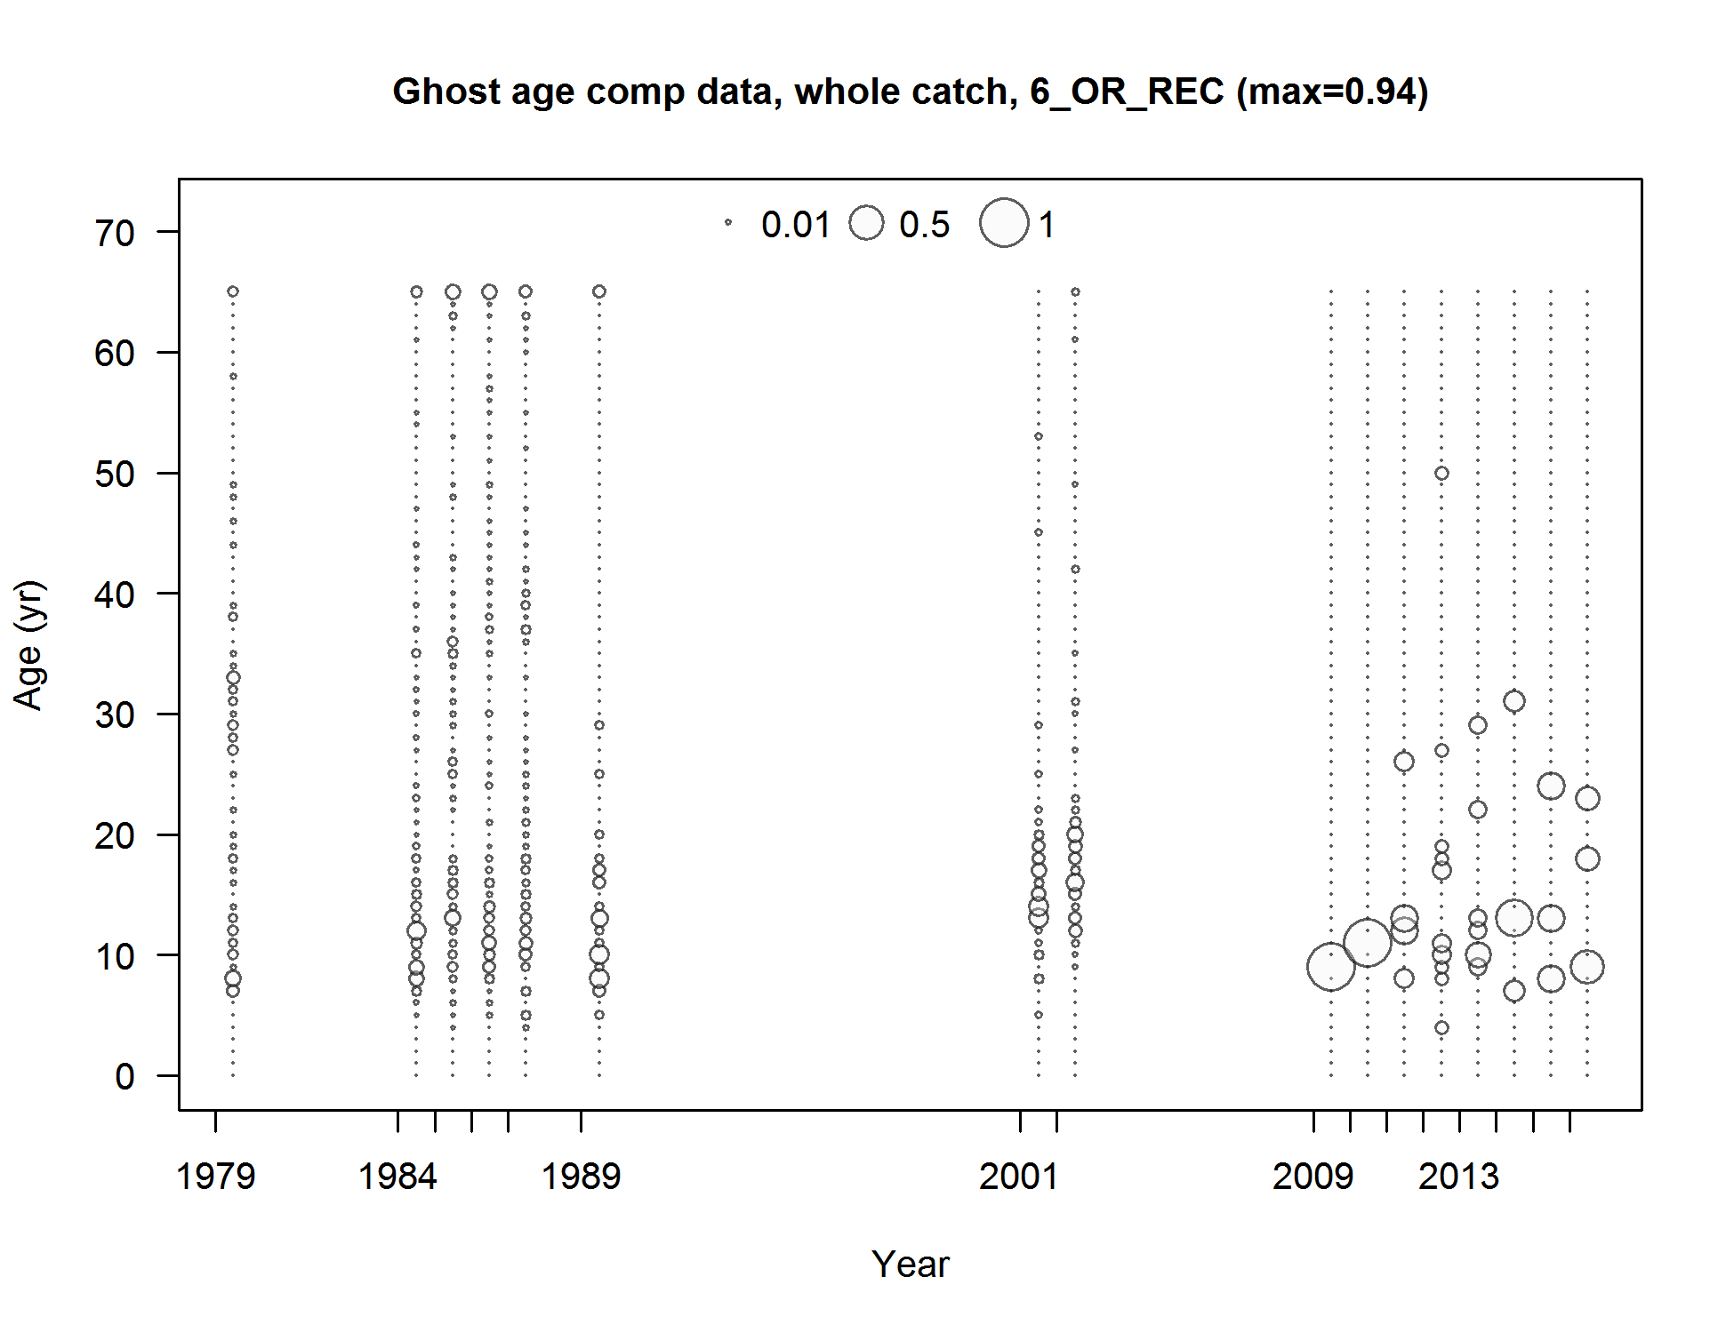

Figure . Age-frequency distributions for yelloweye rockfish catches by year from Oregon recreational fleet.

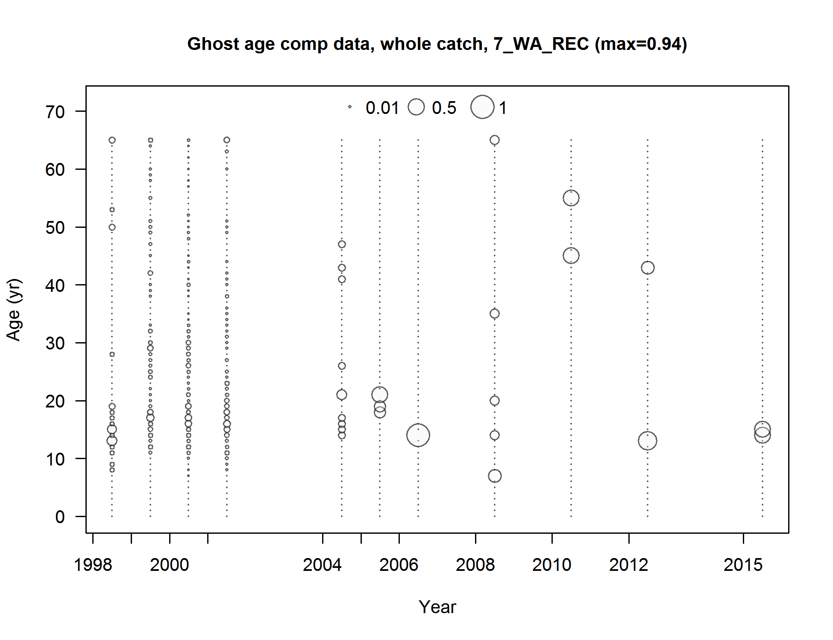

Figure . Age-frequency distributions for yelloweye rockfish catches by year from Washington recreational fleet.

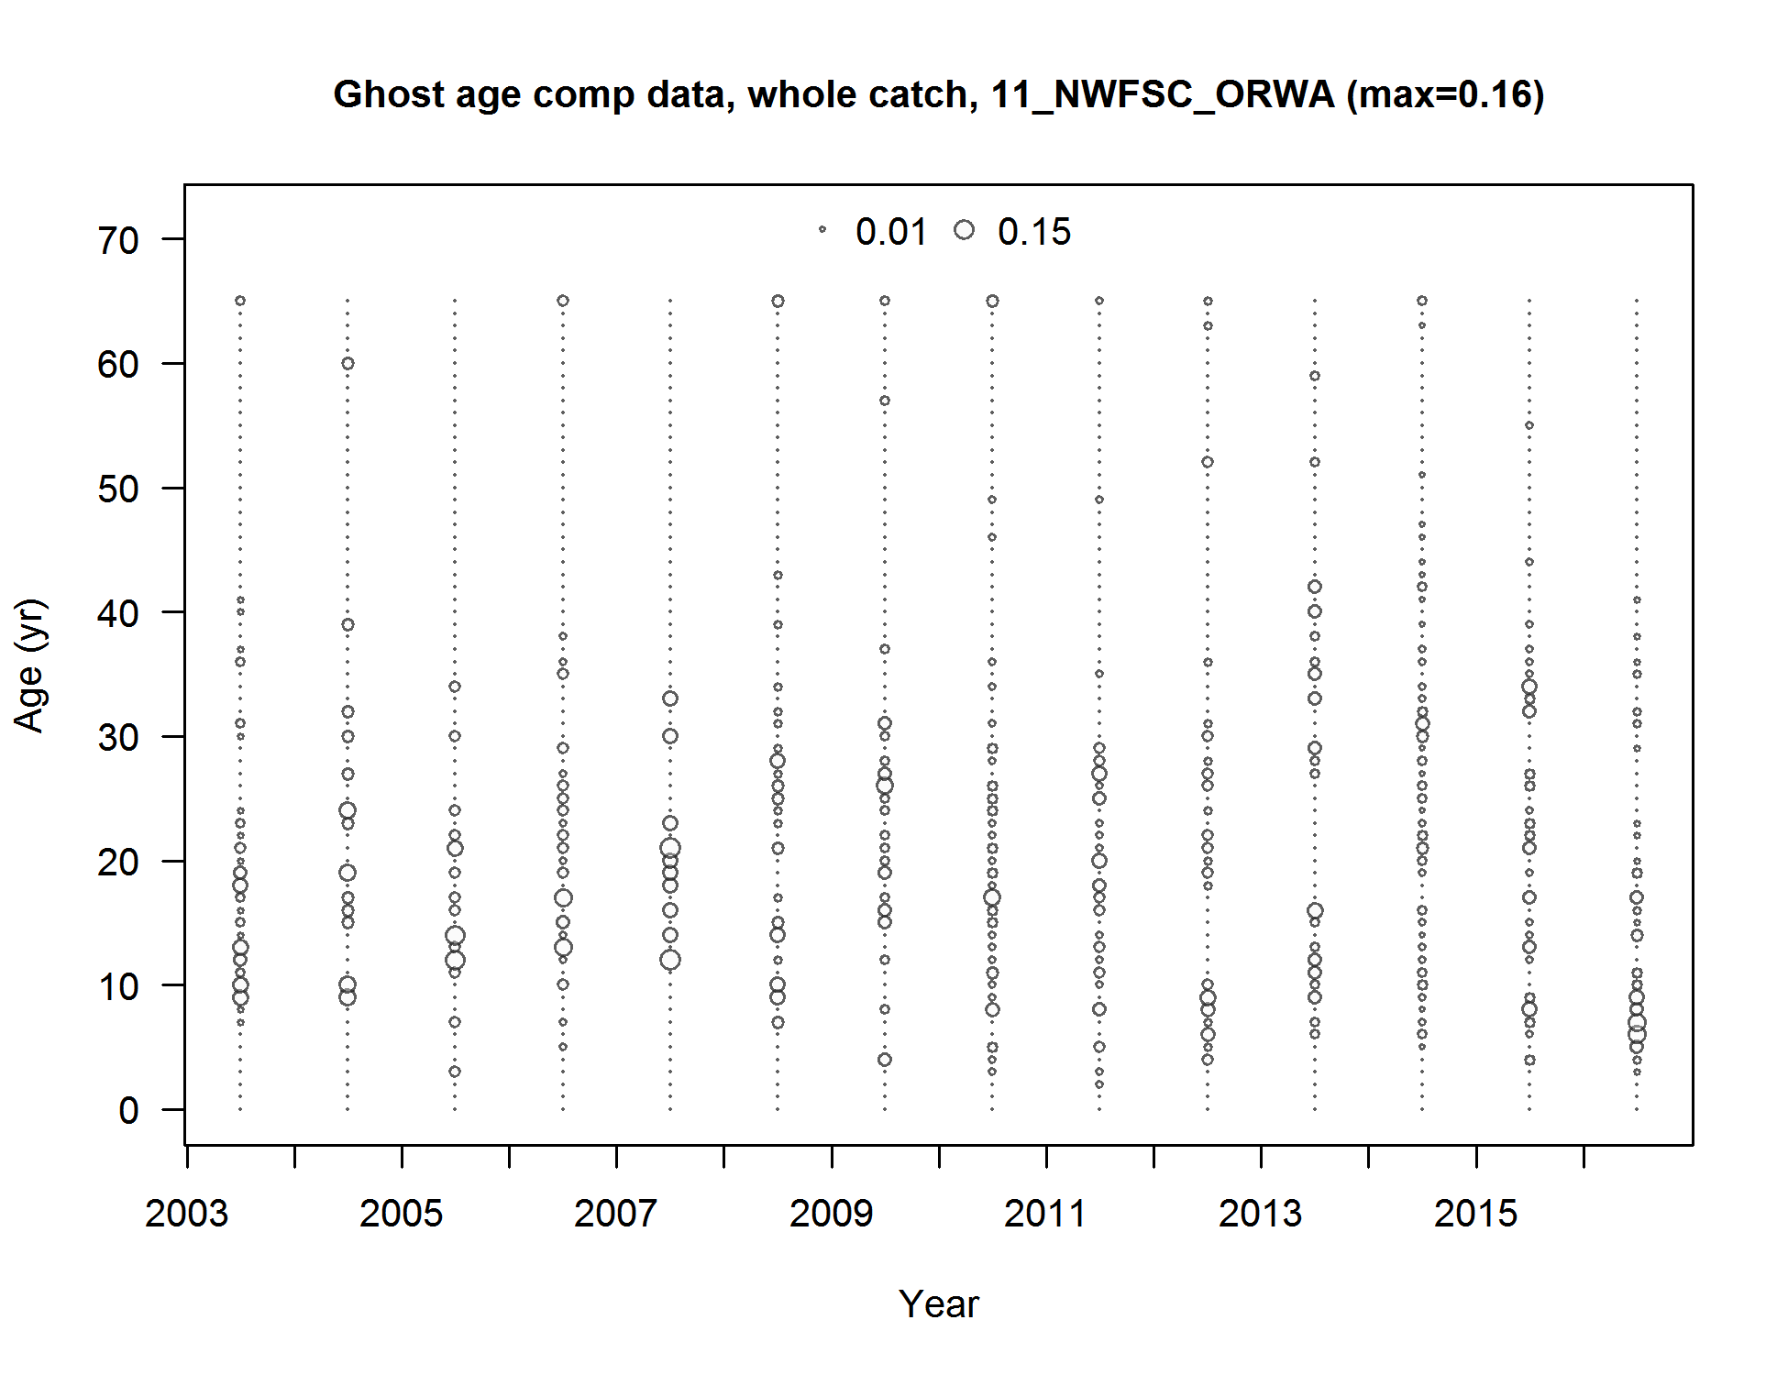

Figure . Age-frequency distributions for yelloweye rockfish catches by year from NWFSC NWFSC TRAWL SURVEY.

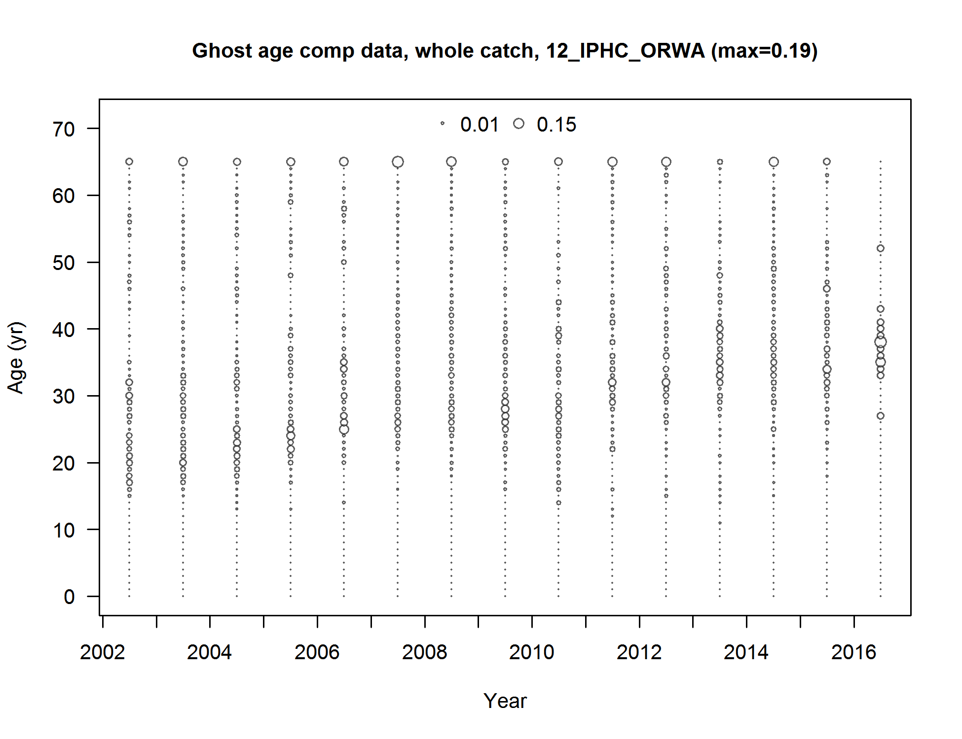

Figure . Age-frequency distributions for yelloweye rockfish catches by year from IPHC survey.

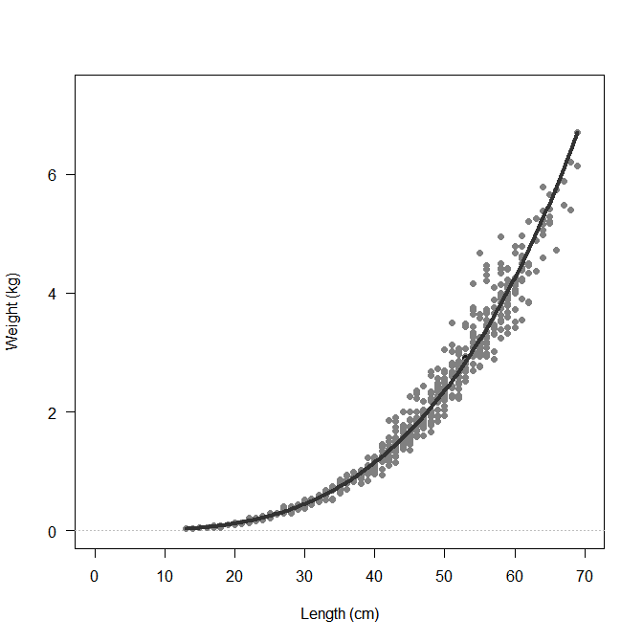

Figure . Length-weight relationship used in the base model for yelloweye rockfish.

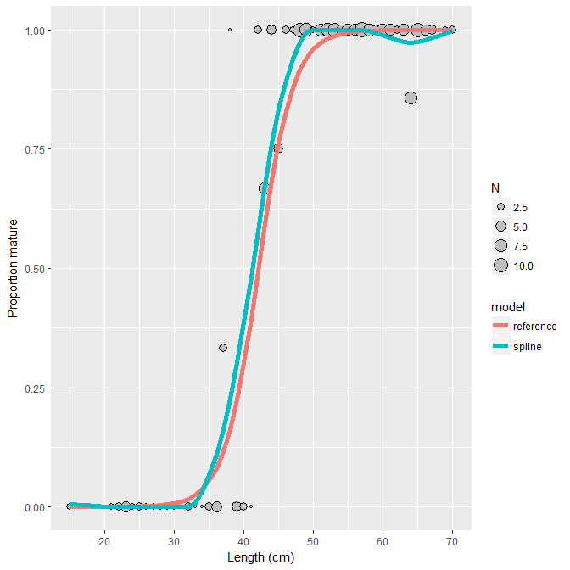

Figure . Maturity at length relationship used in the base model for yelloweye rockfish

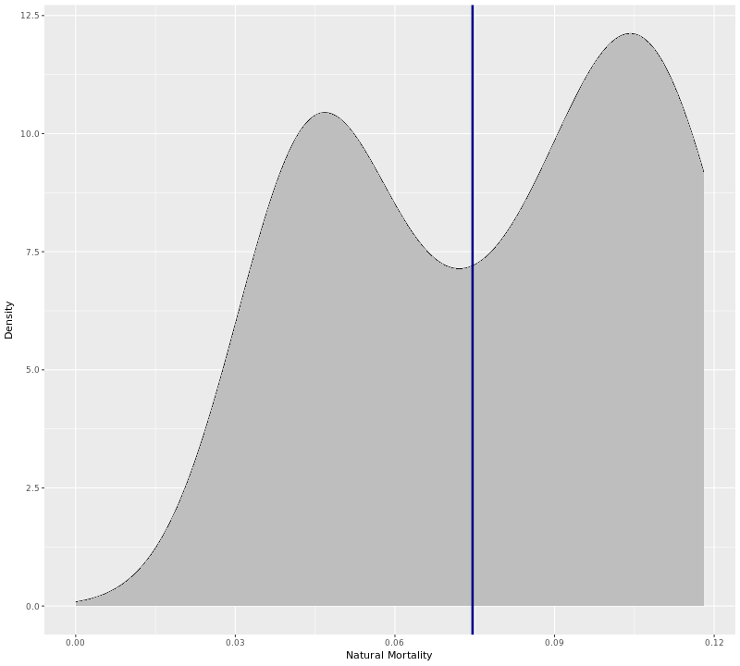

Figure . Prior distribution for natural mortality based on the Natural Mortality Tool. Blue line is the median value.

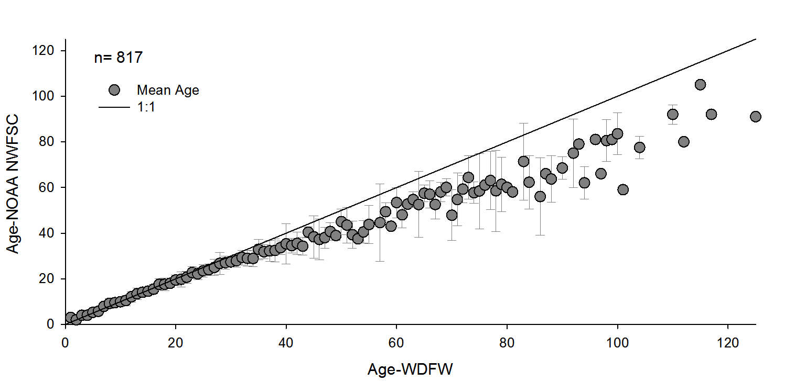

Figure . Inter-lab comparison of yelloweye ages estimated by WDFW and NWFSC ageing laboratories.

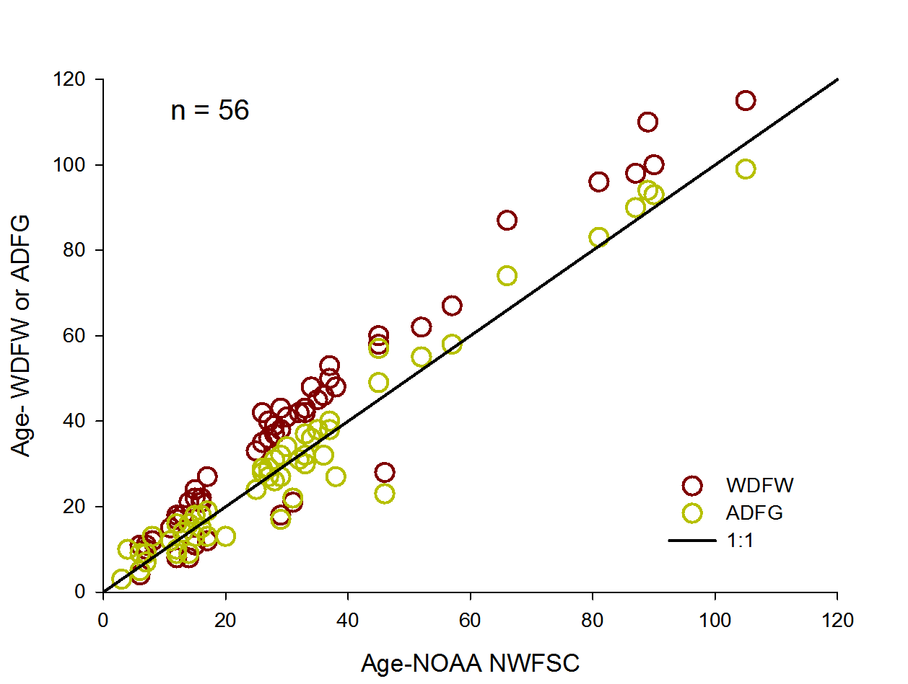

Figure . Comparison of yelloweye ages generated by WDFW and NWFSC labs with ages generated by Alaska Department Fish and Game (ADFG).

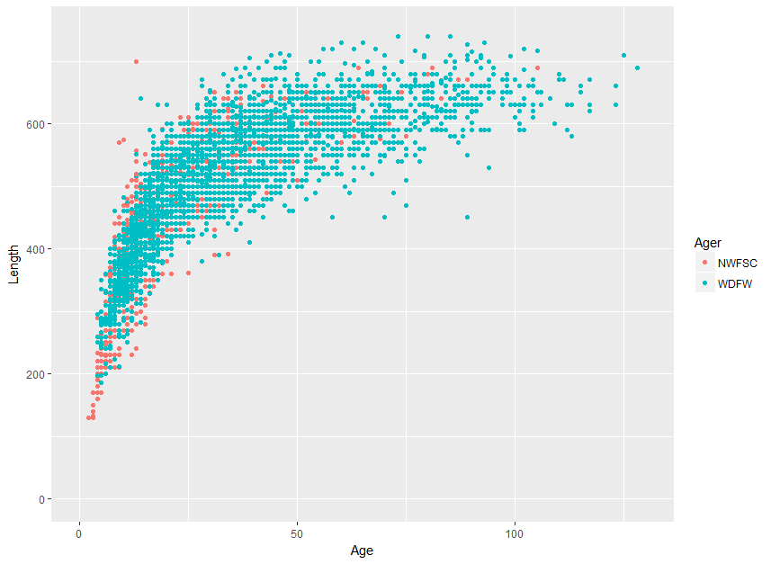

Figure . Overlaid comparison of ages and lengths for yelloweye rockfish for two different ageing labs.

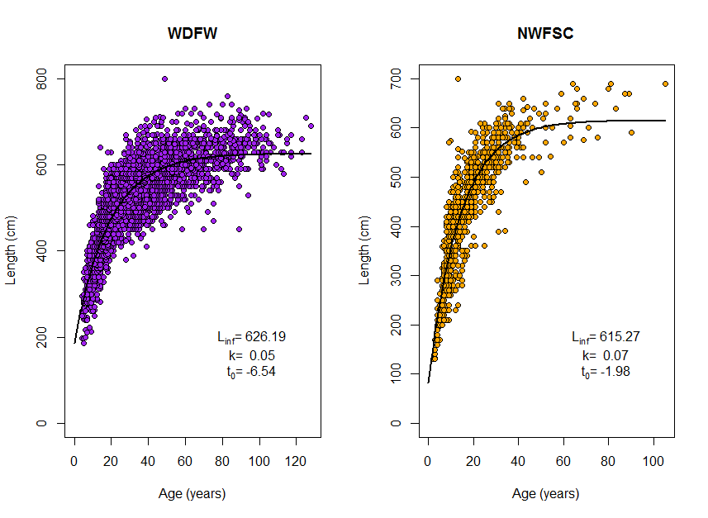

Figure . Comparison of von Bertalanffy growth estimates for yelloweye rockfish from two different ageing labs.

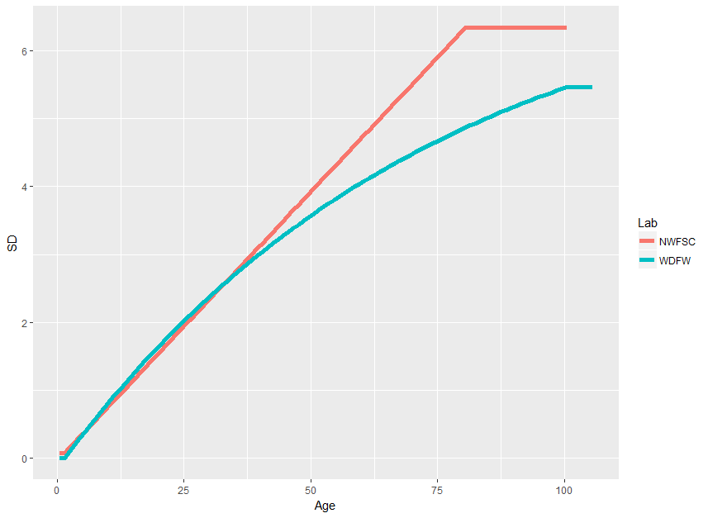

Figure . Ageing error matrices for the primary readers from each lab used in the yelloweye rockfish stock assessment.

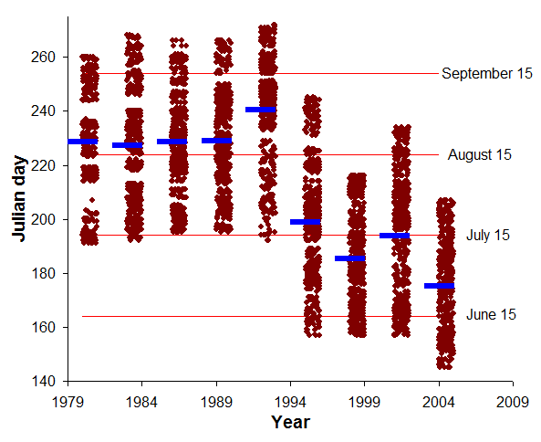

Figure . Distribution of dates of operation for the AFSC triennial survey. Solid bars show the mean date for each survey year, points represent individual hauls dates, but are jittered to allow better delineation of the distribution of individual points.

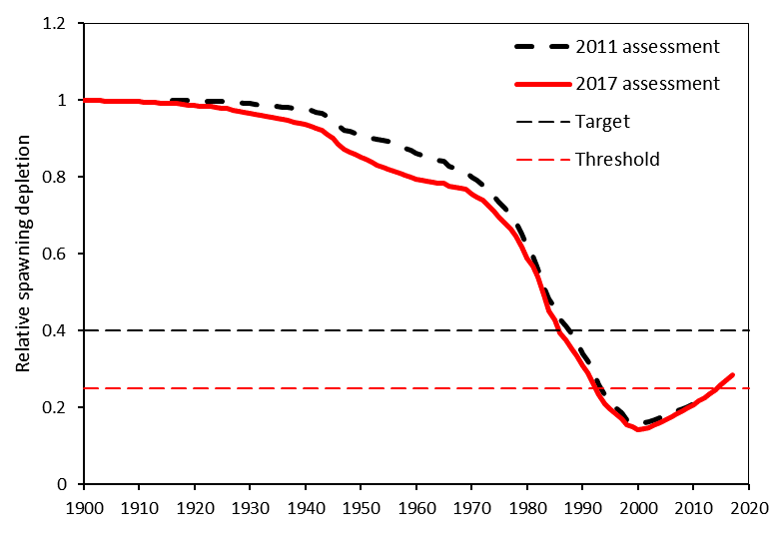

Figure . Time series of relative spawning output from this and 2011 assessments.

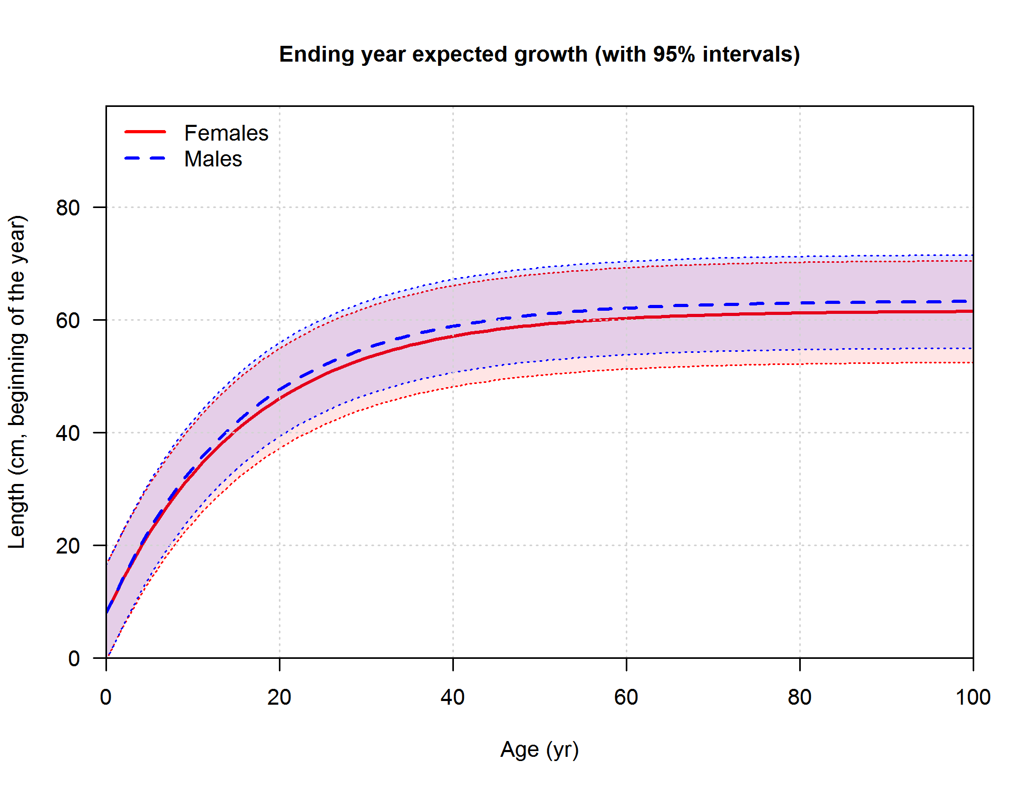

Figure . Estimated growth curves for female and male yelloweye rockfish in two-sex 2011 assessment. This 2017 assessment is based on a single sex model, and estimated growth curve in shown in Figure 66.

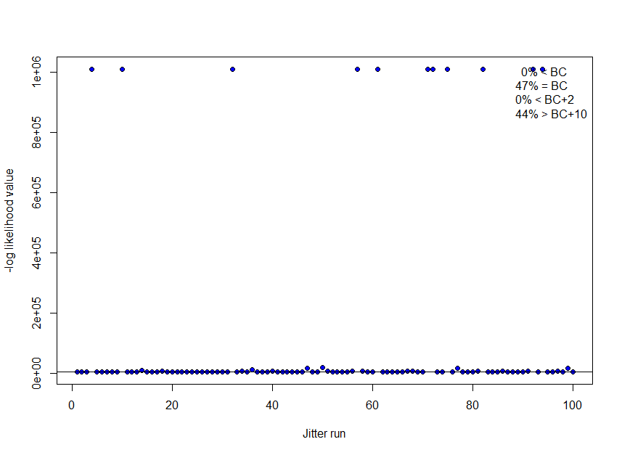

Figure . Results from 100 base model runs when starting parameters values are jittered by 0.1 units. Horizontal line indicates base model value.

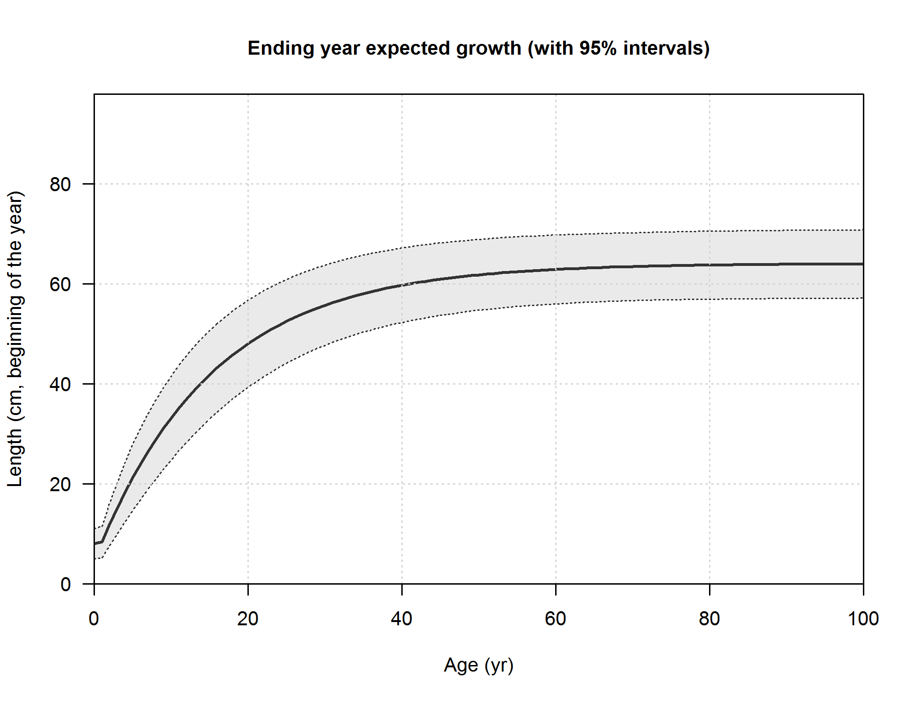

Figure . Base model estimates of individual growth by age and length. Shading indicates 95% confidence intervals.

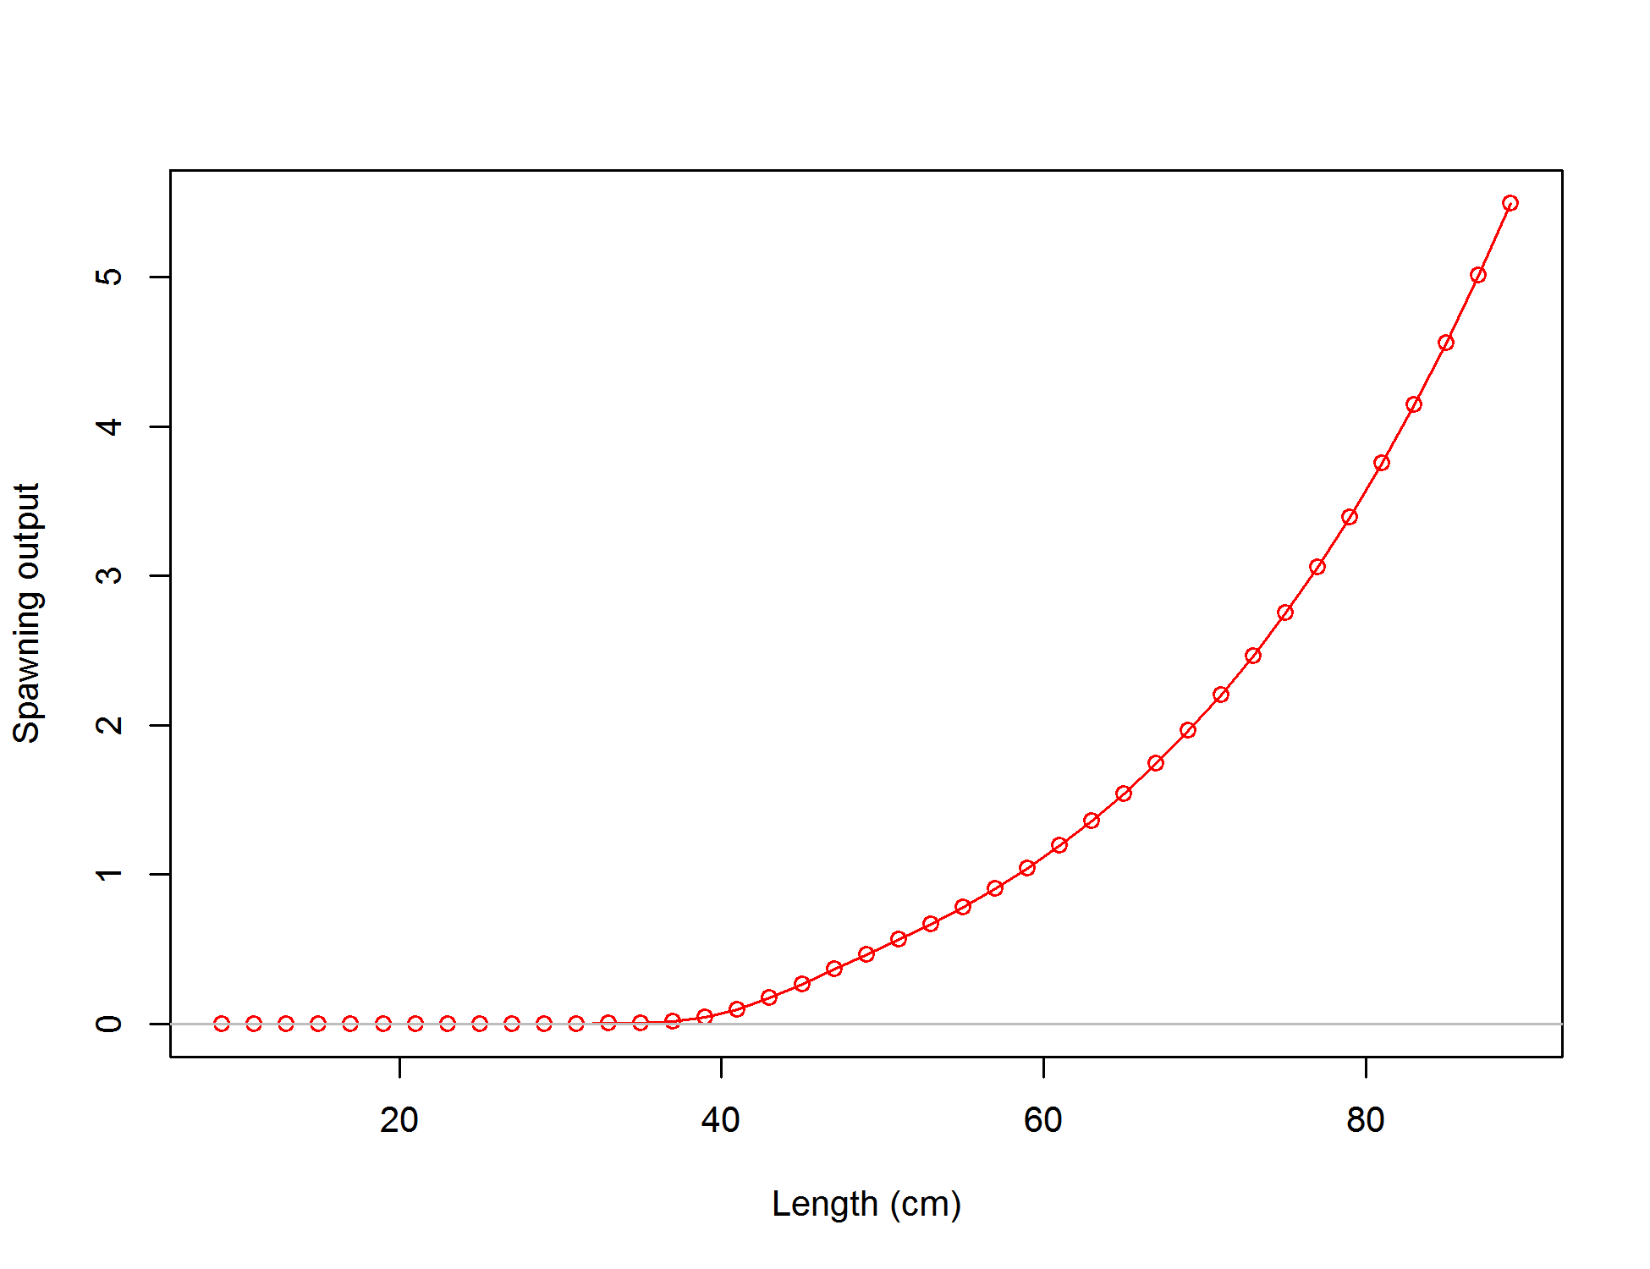

Figure .Spawning output at length

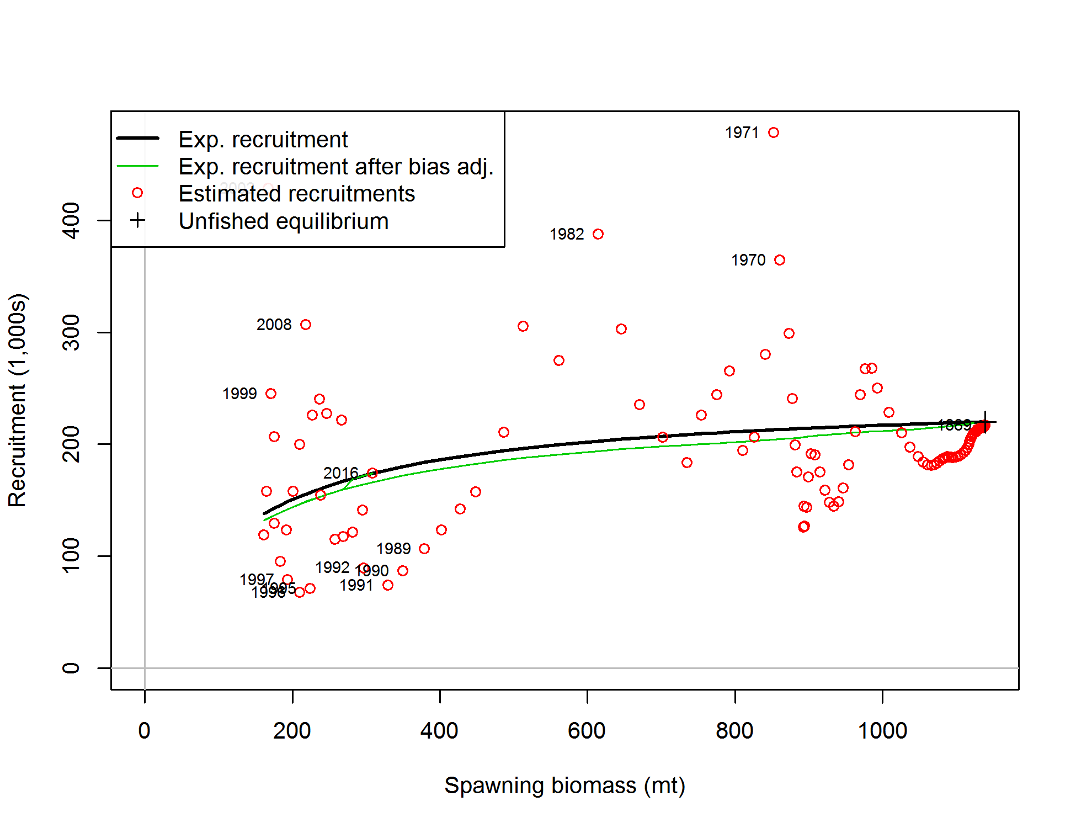

Figure . Estimated stock-recruit function for the assessment model.

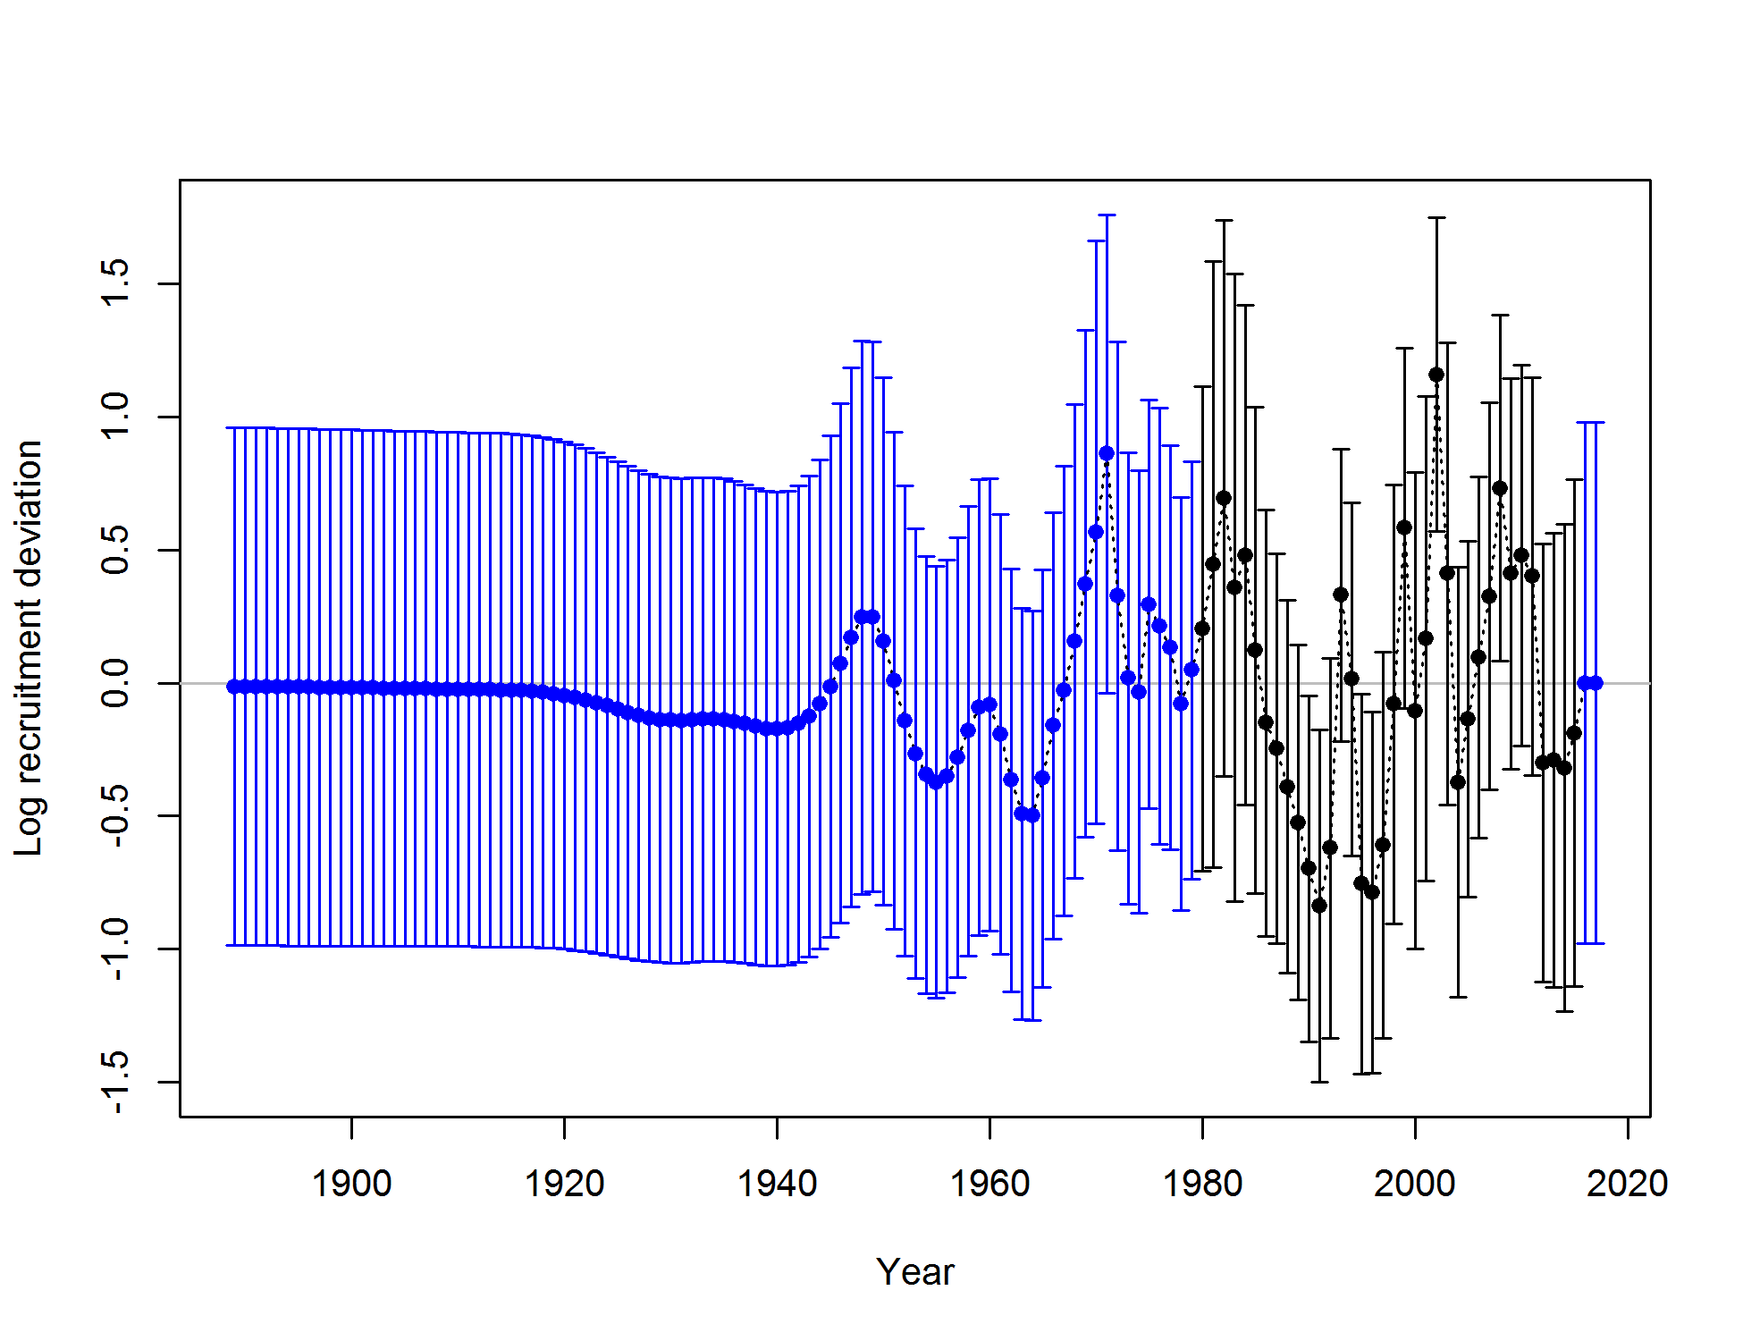

Figure . Recruitment deviation time-series estimated in the base yelloweye model.

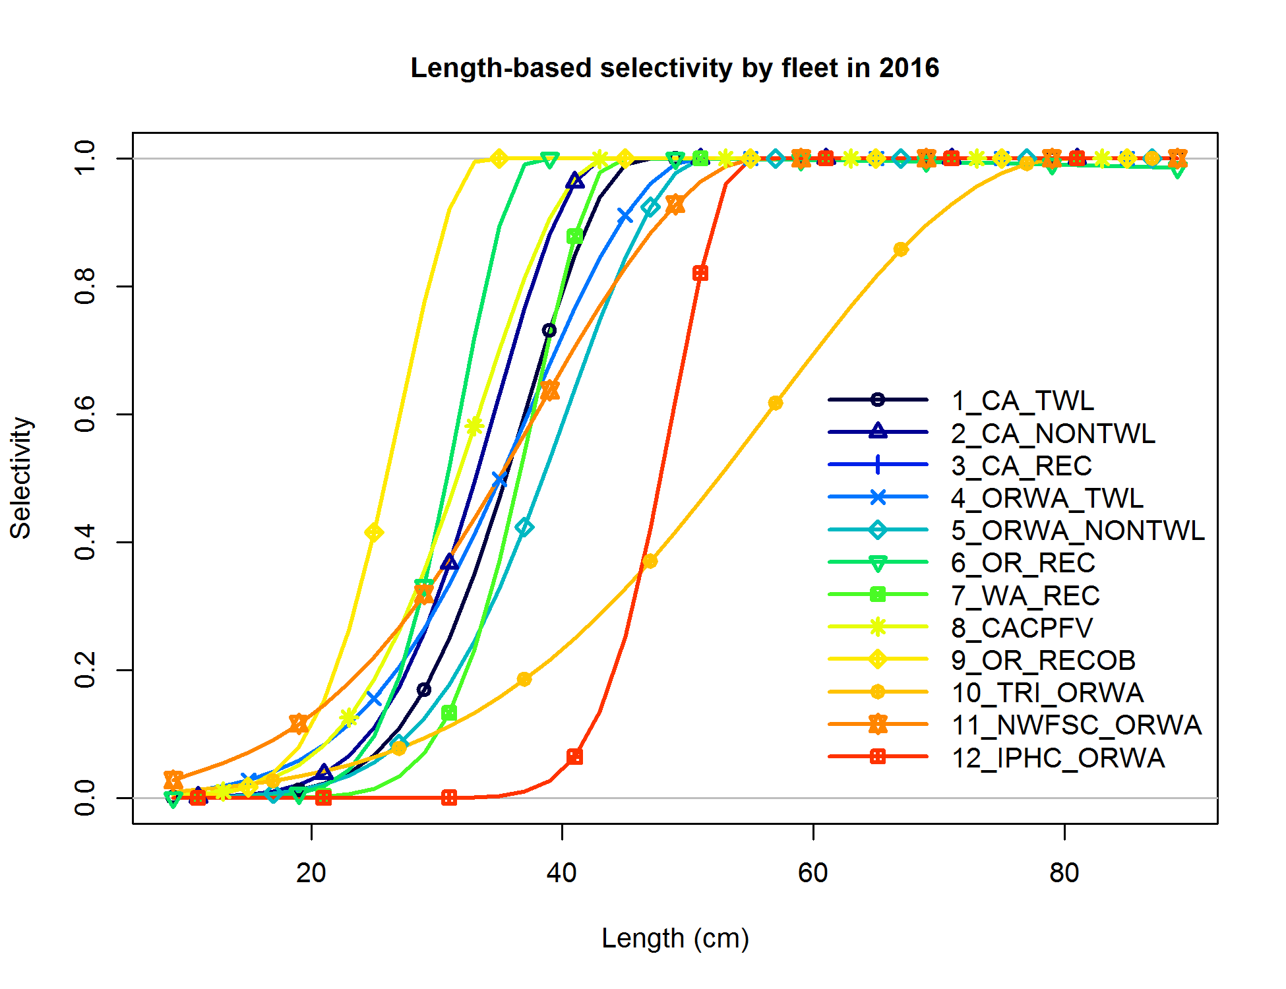

Figure . Base model estimates of length-based selectivity by fleet and survey.

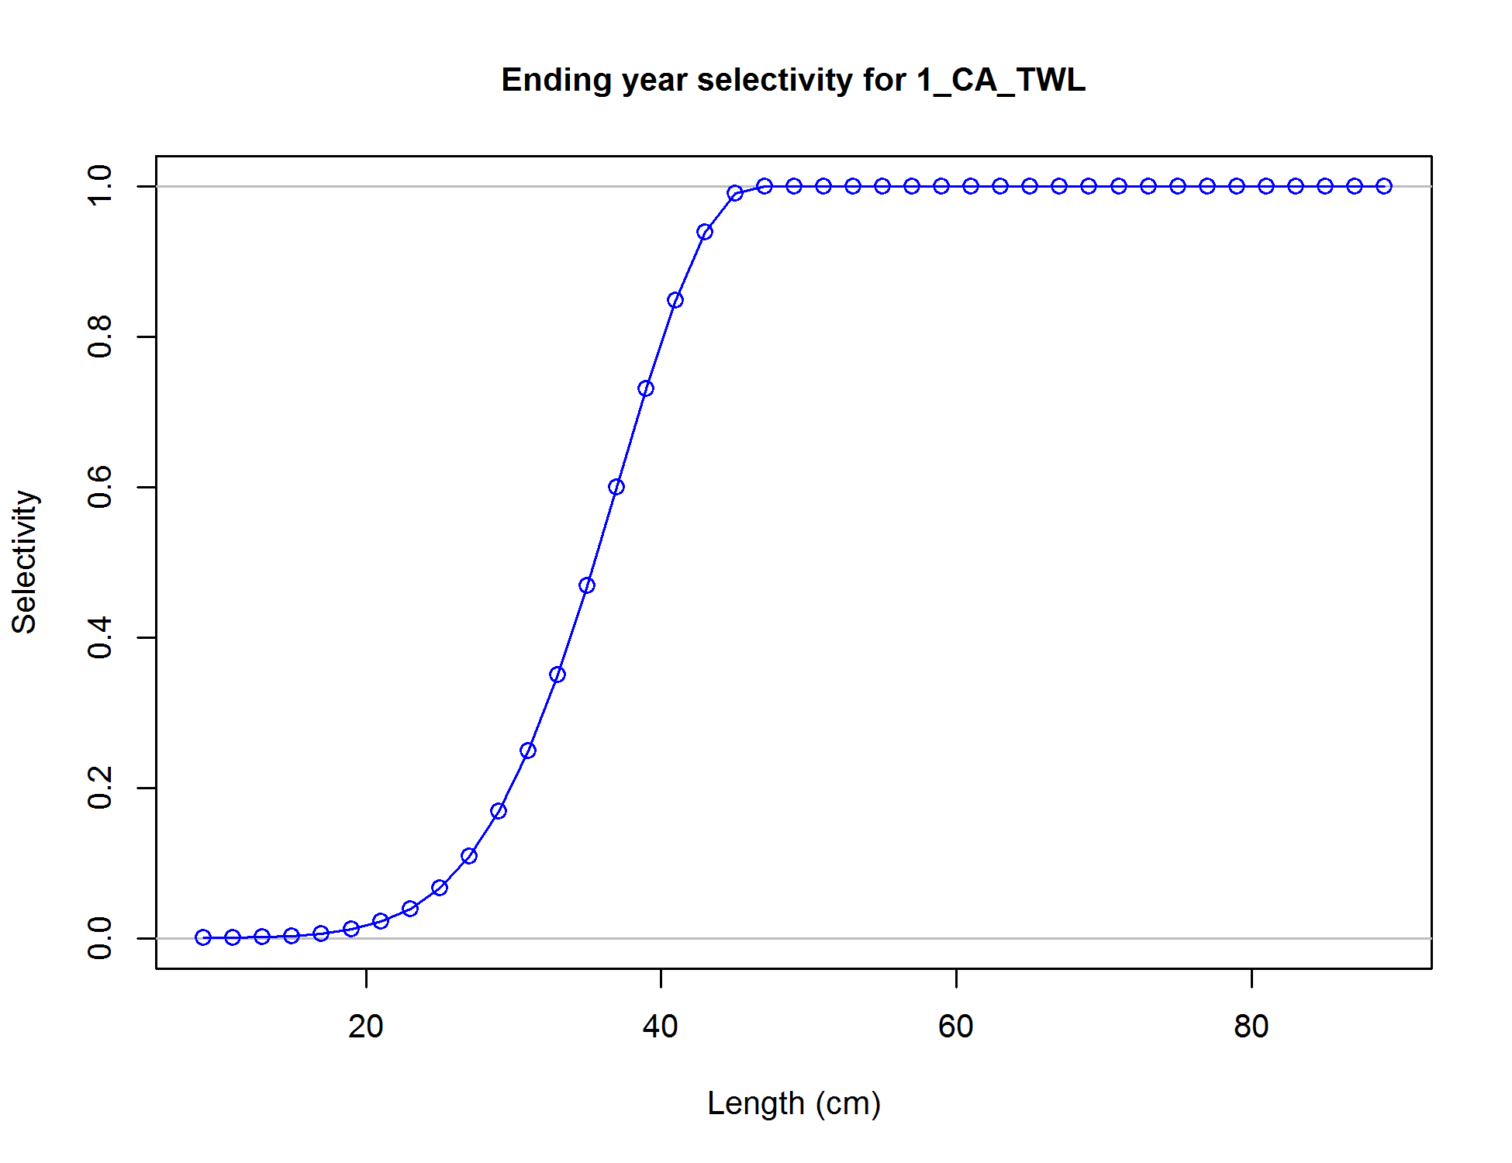

Figure . California trawl fishery selectivity estimated in the base model for yelloweye rockfish.

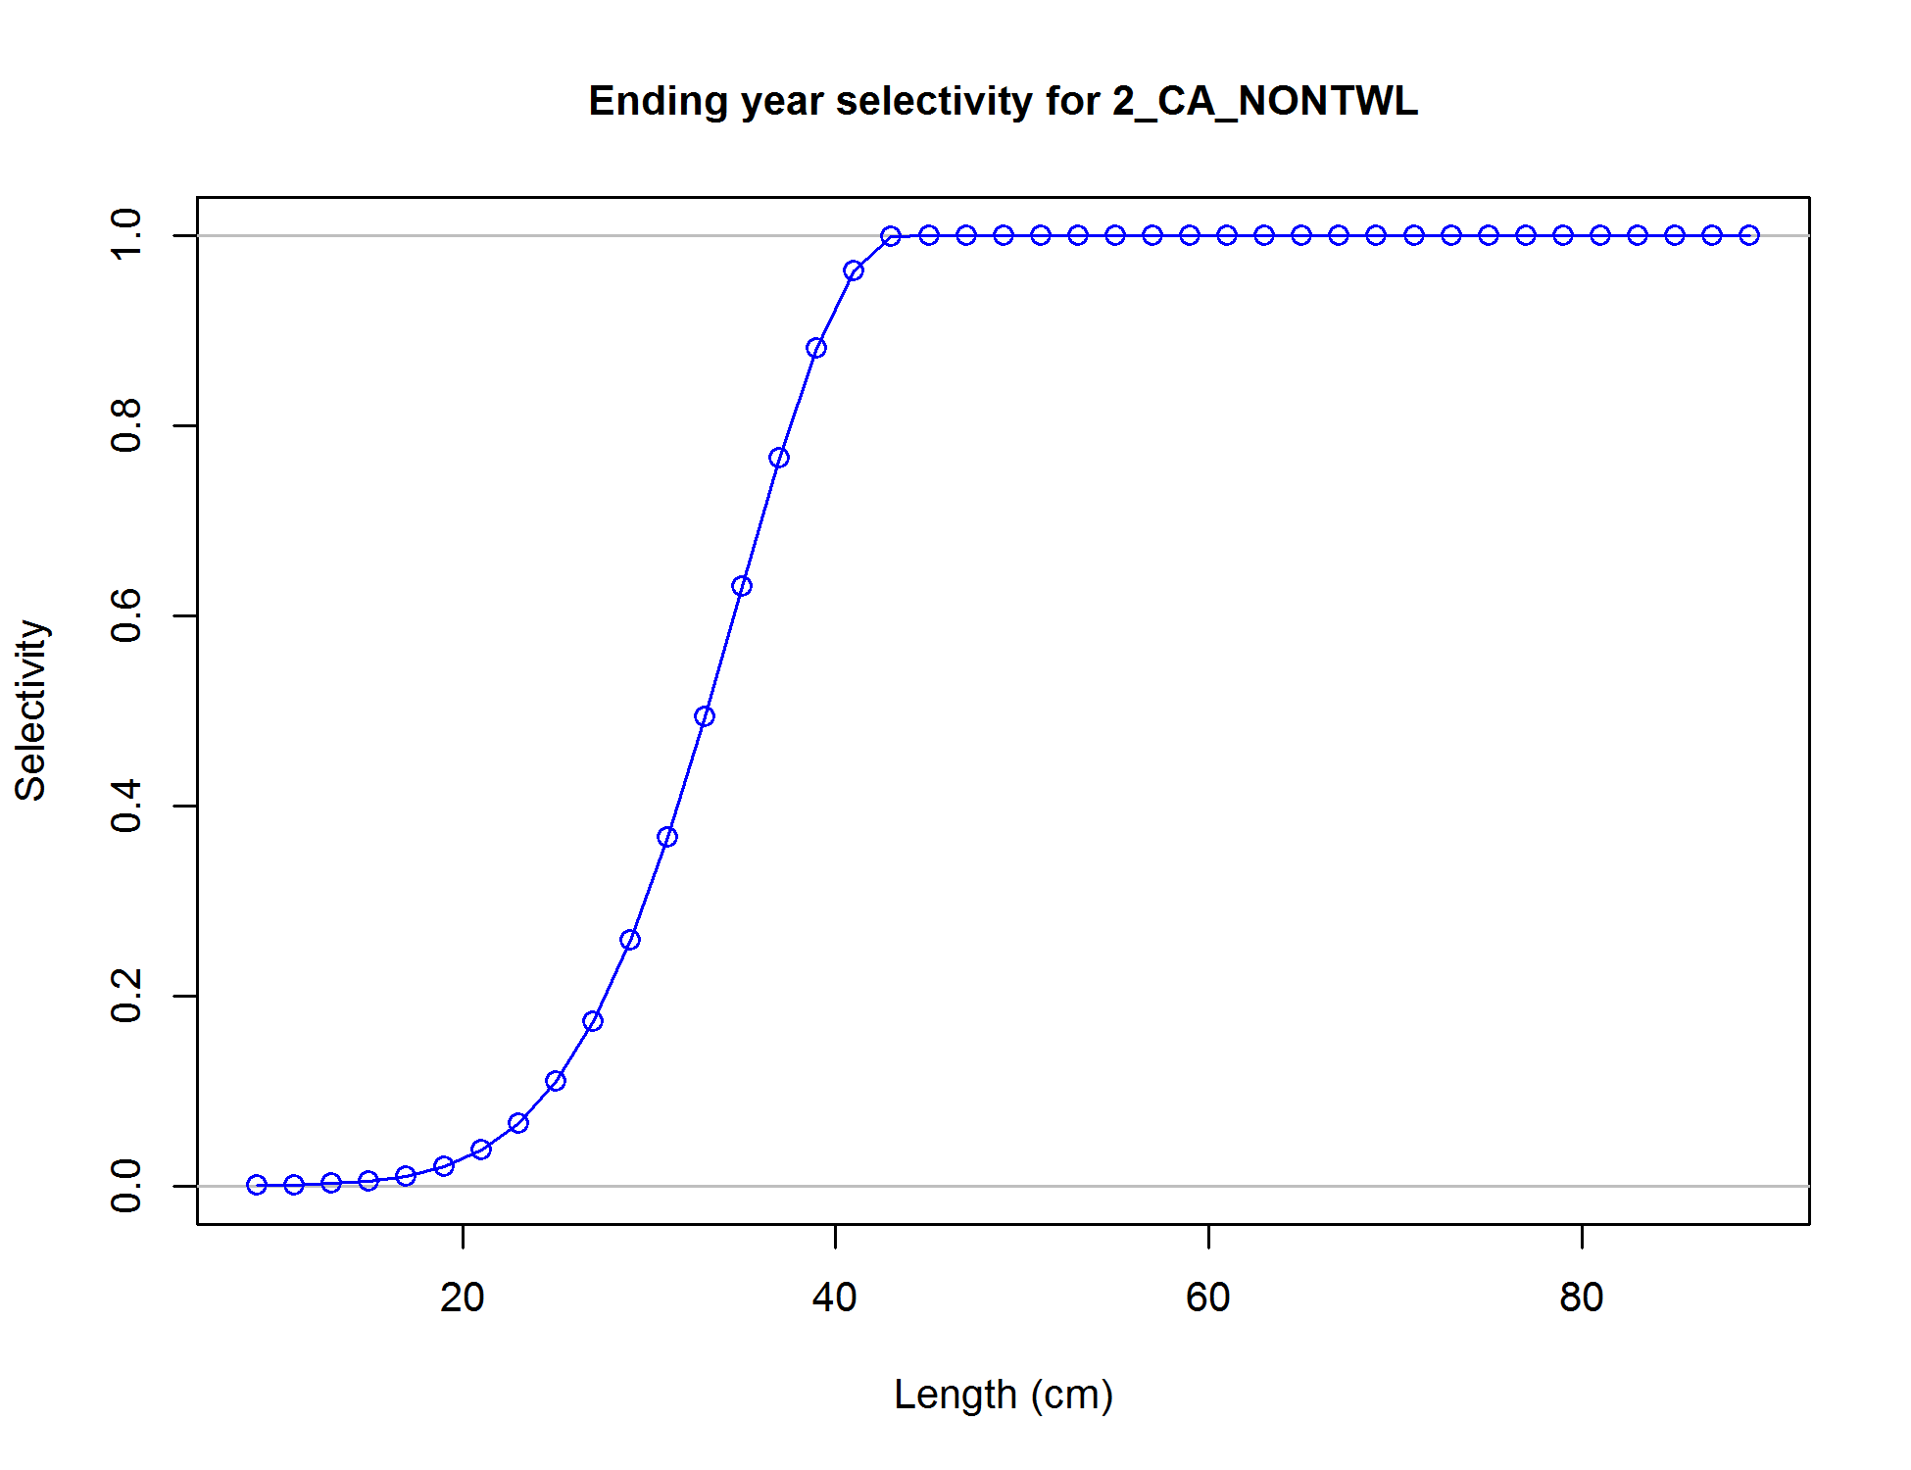

Figure . California non-trawl fishery selectivity estimated in the base model for yelloweye rockfish.

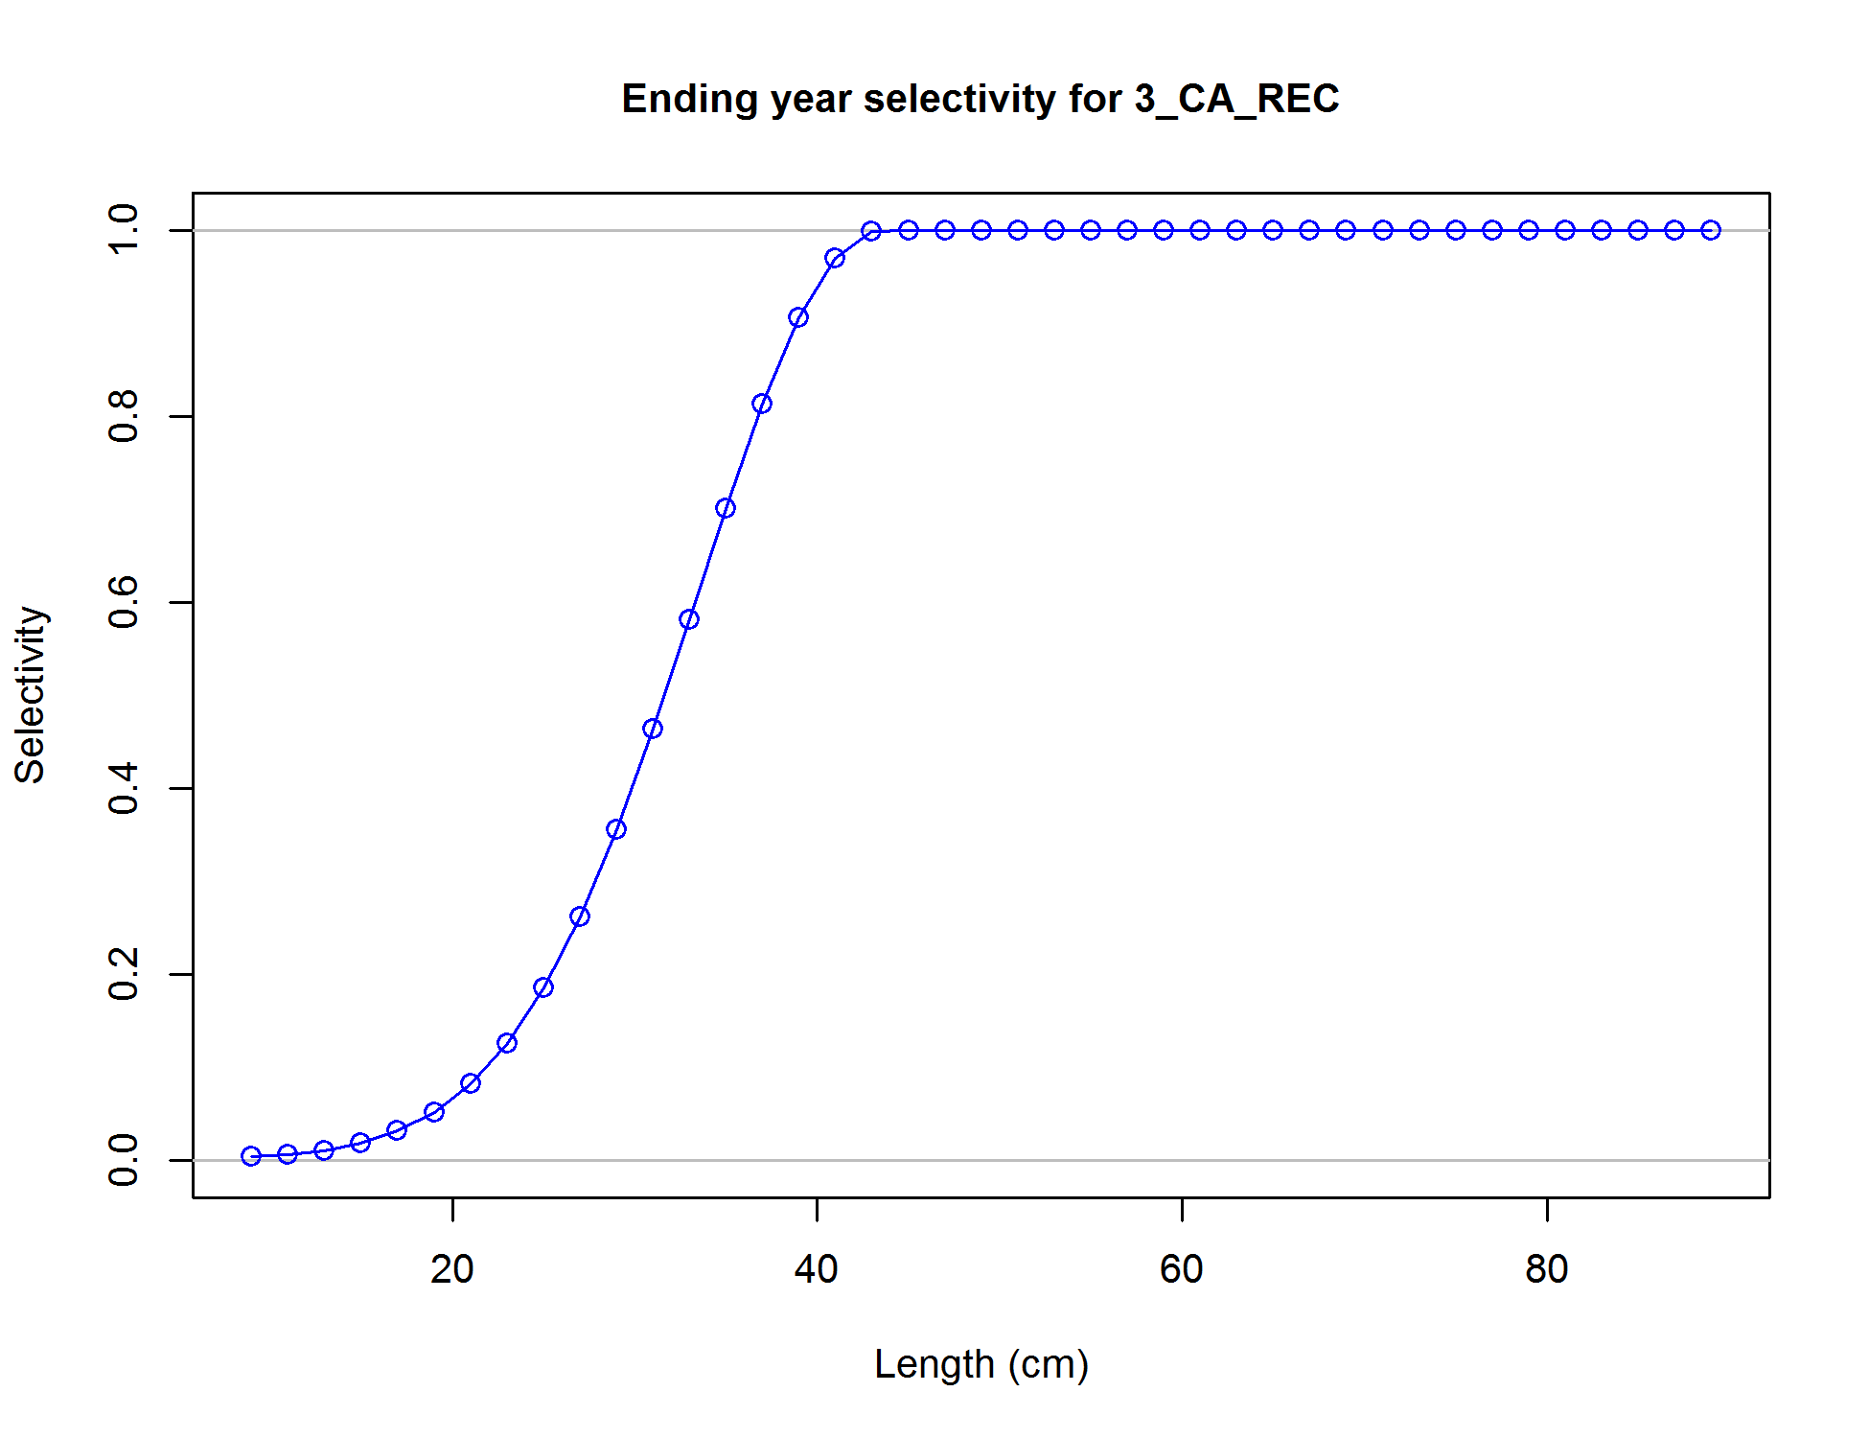

Figure . California recreational fishery selectivity estimated in the base model for yelloweye rockfish.

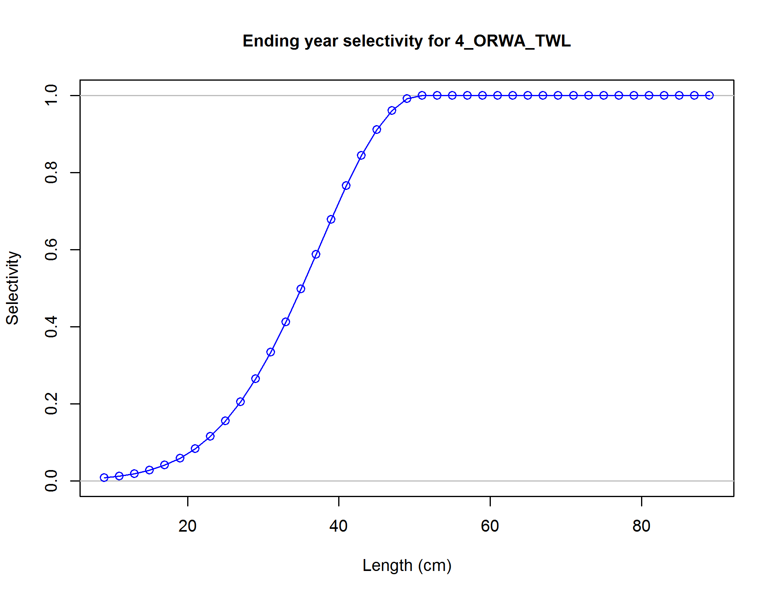

Figure . Oregon-Washington trawl fishery selectivity estimated in the base model for yelloweye rockfish.

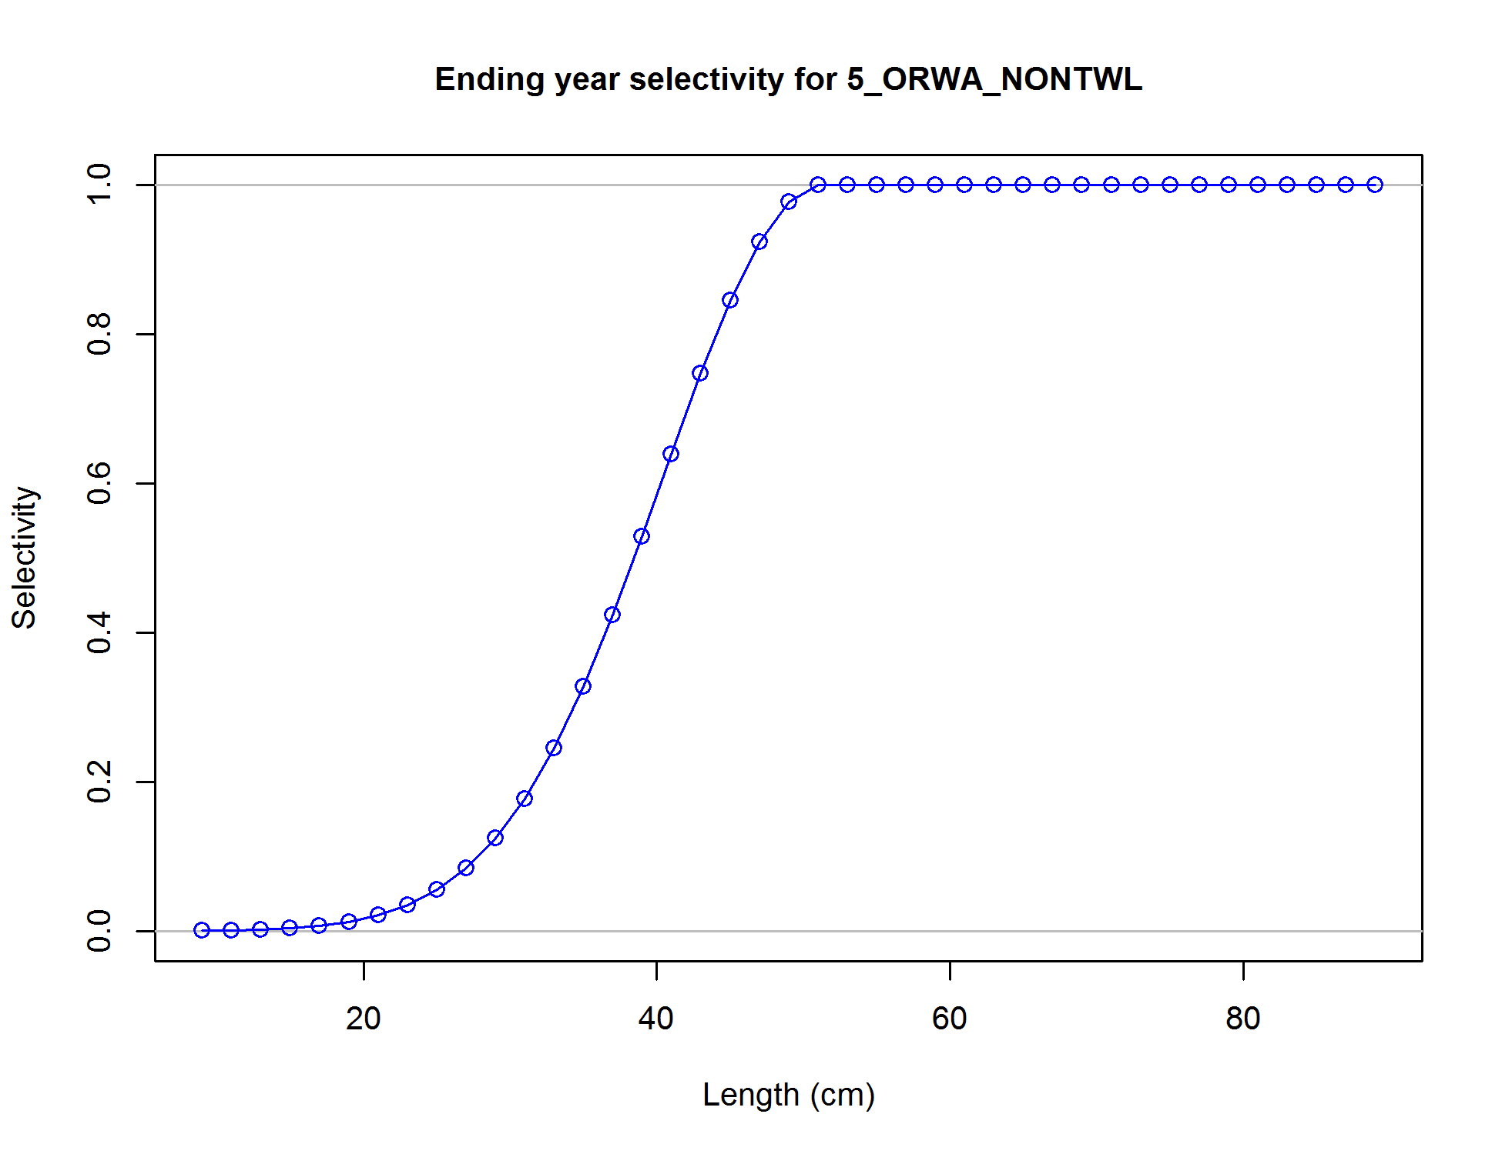

Figure . Oregon-Washington non-trawl fishery selectivity estimated in the base model for yelloweye rockfish.

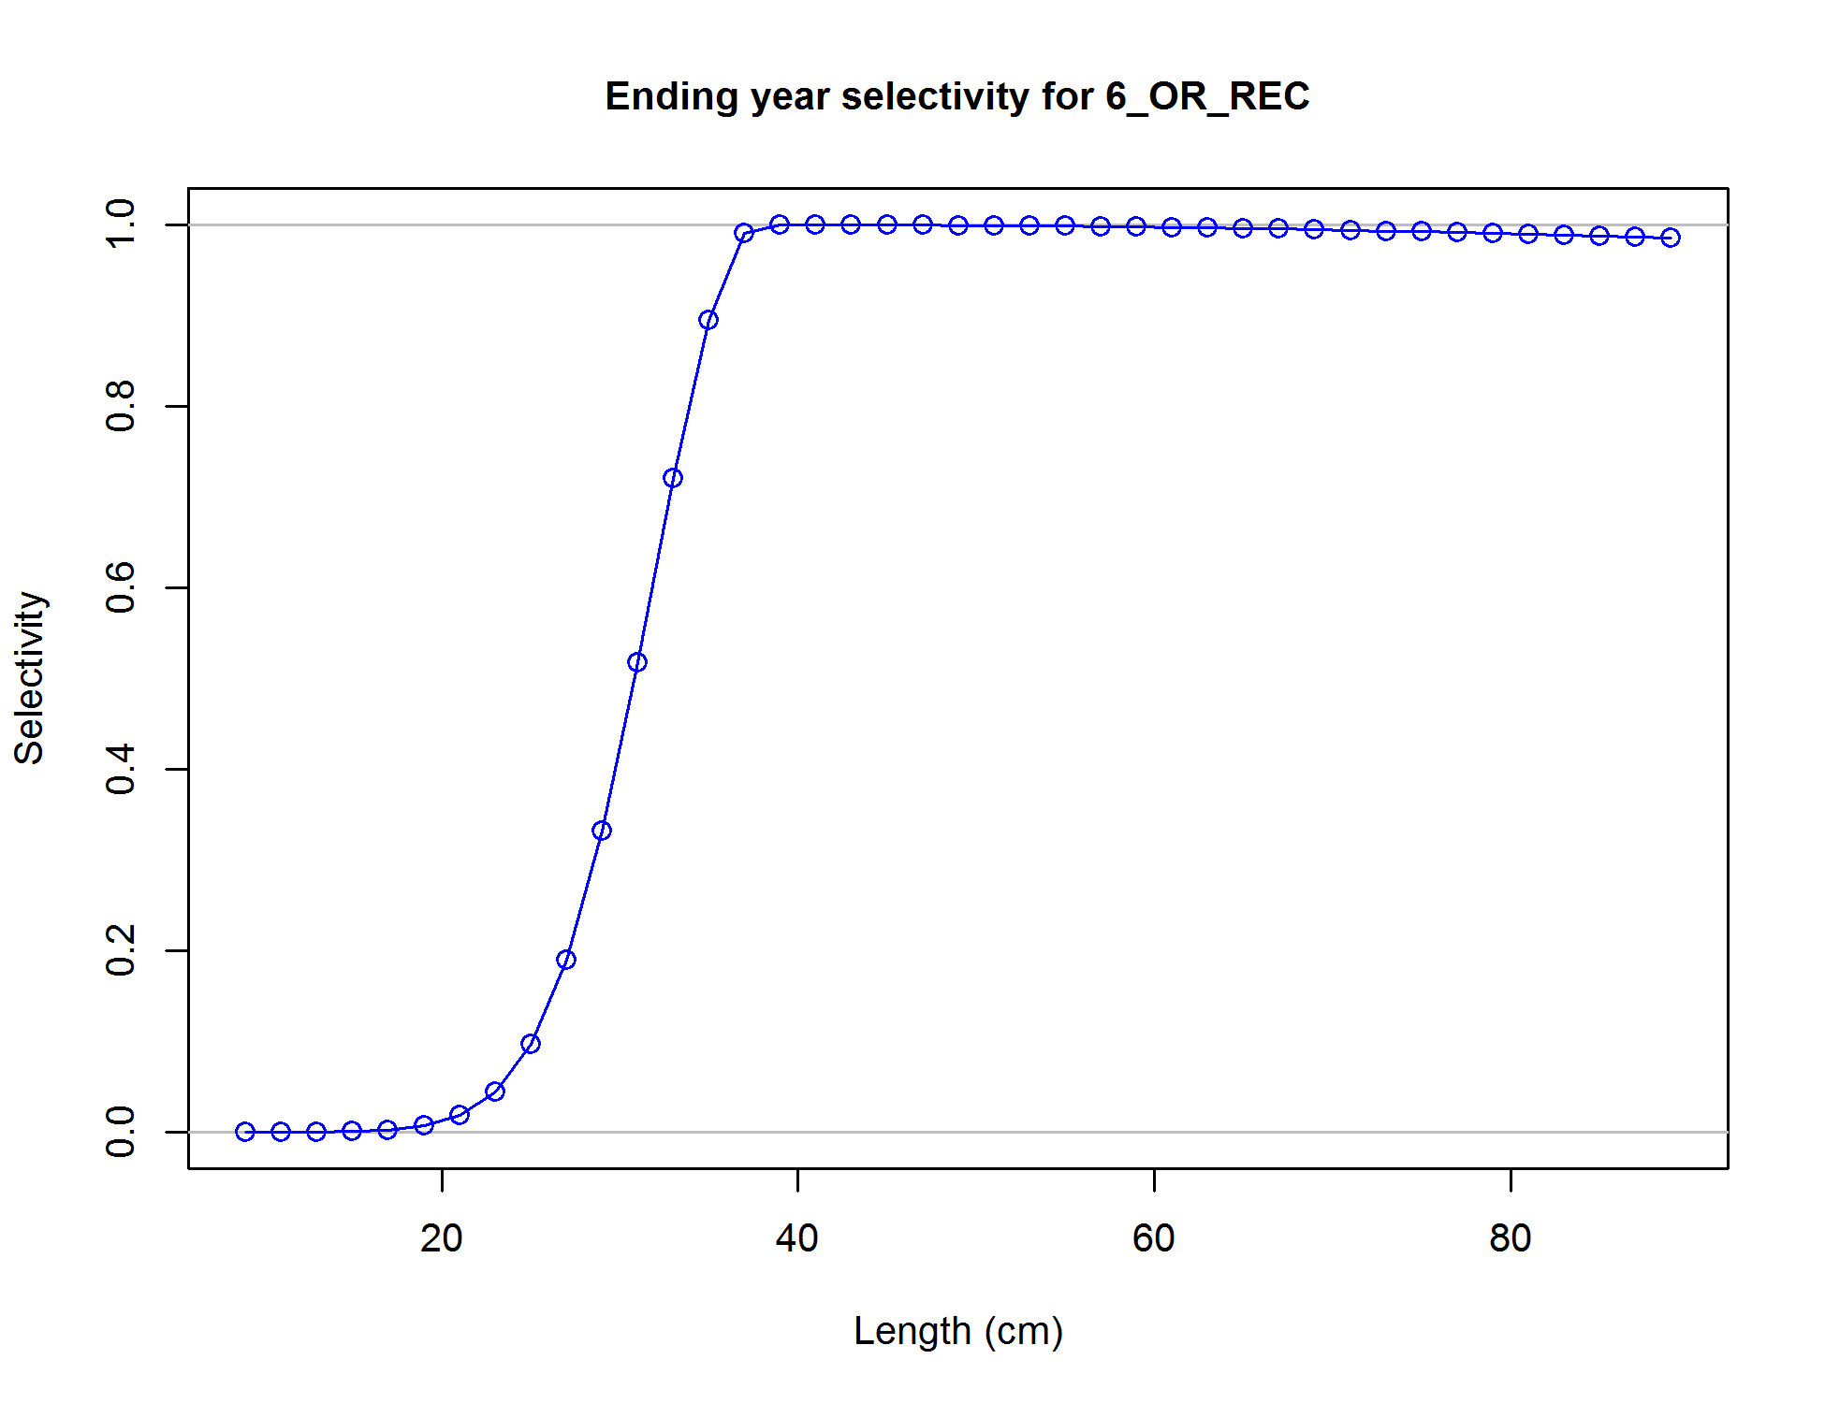

Figure . Oregon recreational fishery selectivity estimated in the base model for yelloweye rockfish.

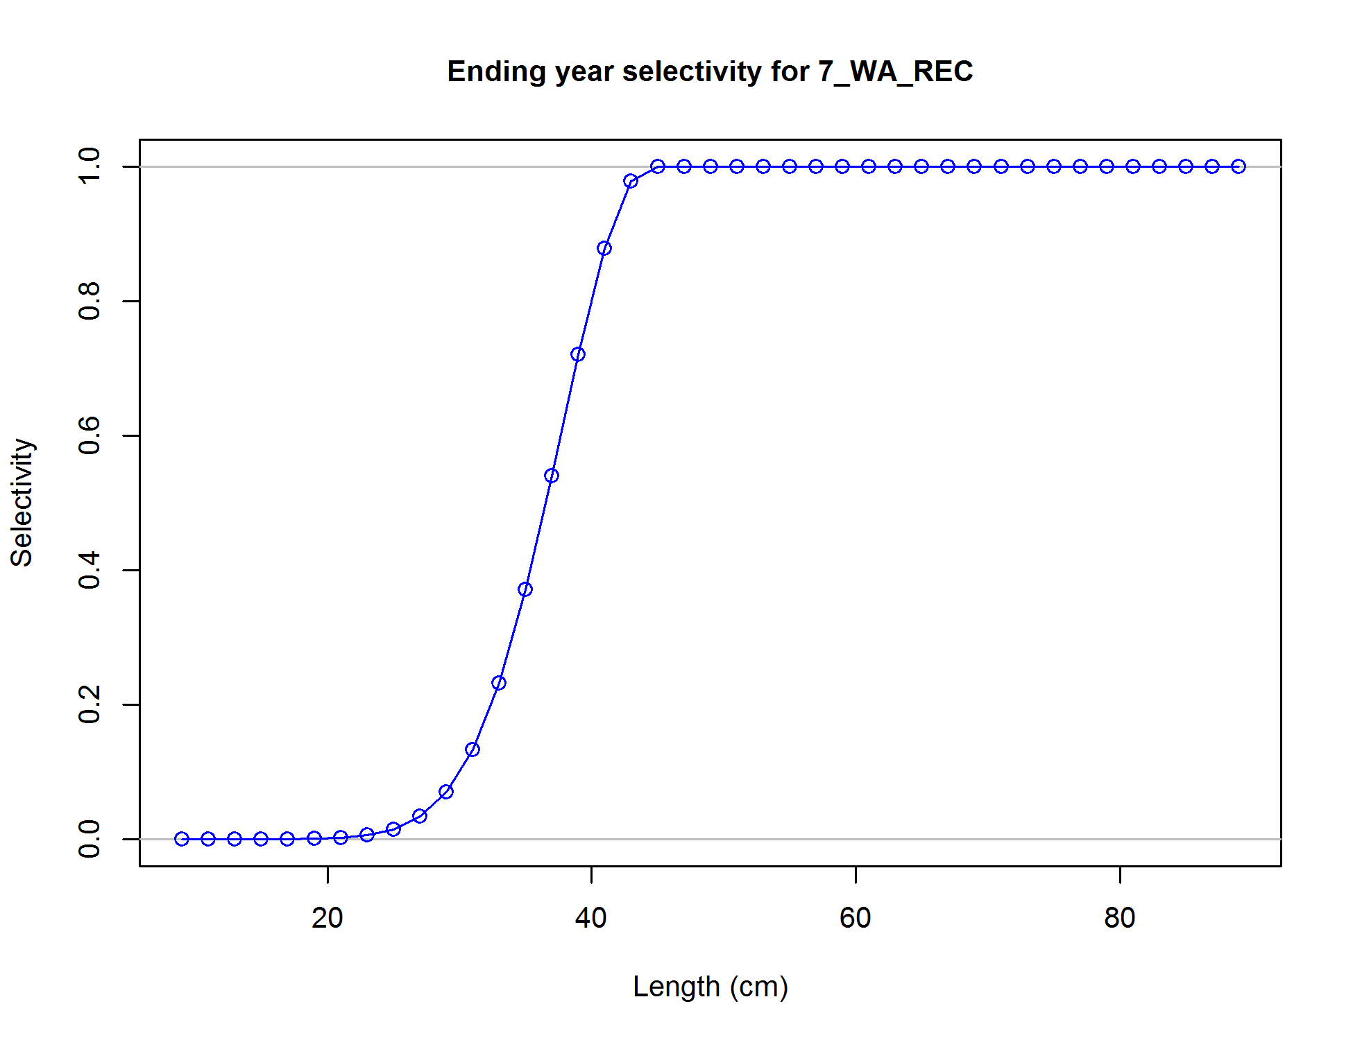

Figure . Washington recreational fishery selectivity estimated in the base model for yelloweye rockfish.

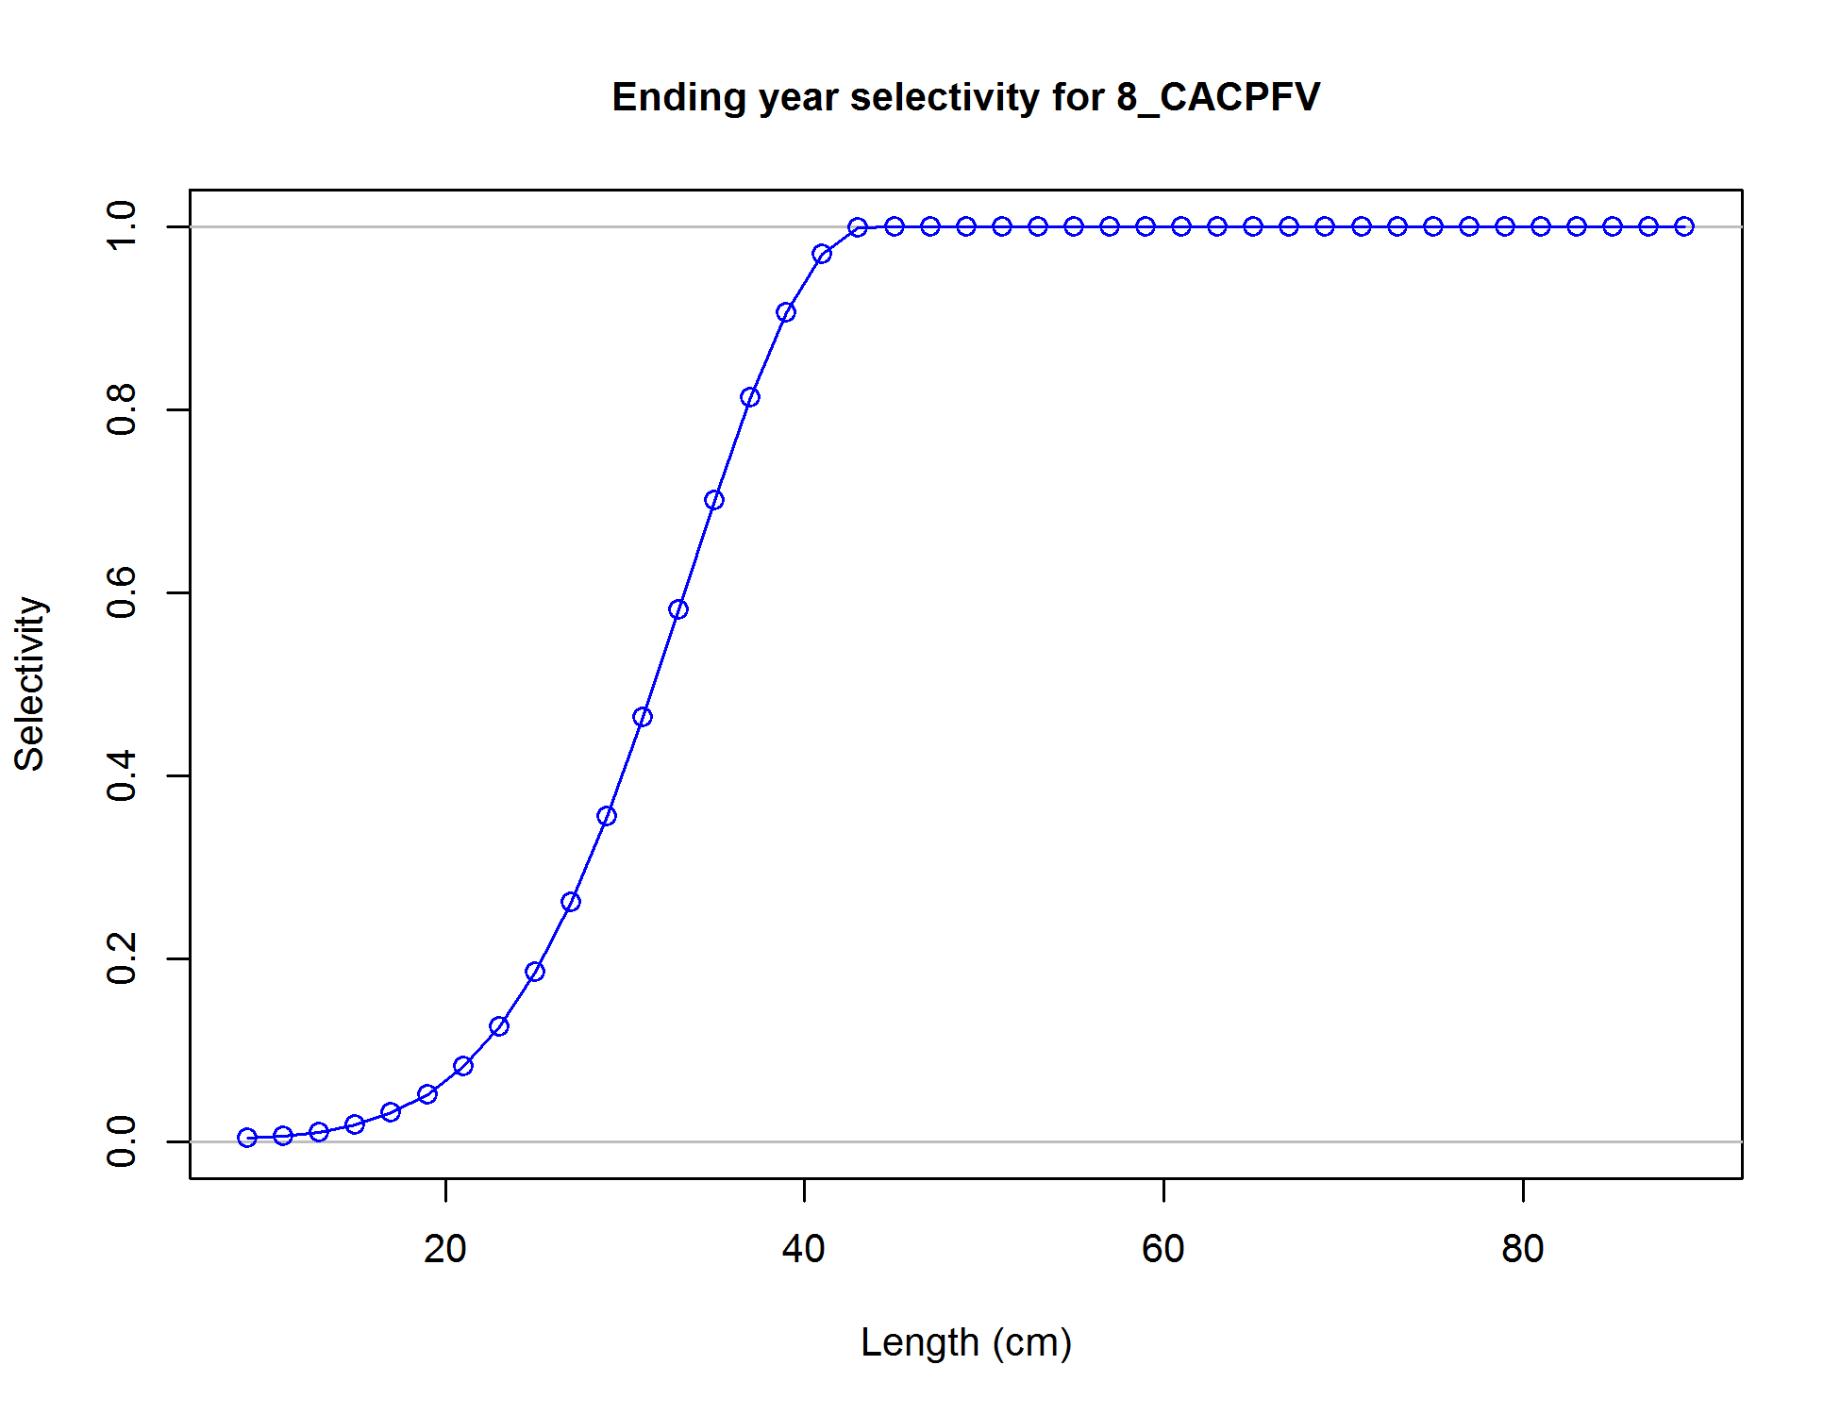

Figure . California CPFV onboard survey selectivity estimated in the base model for yelloweye rockfish.

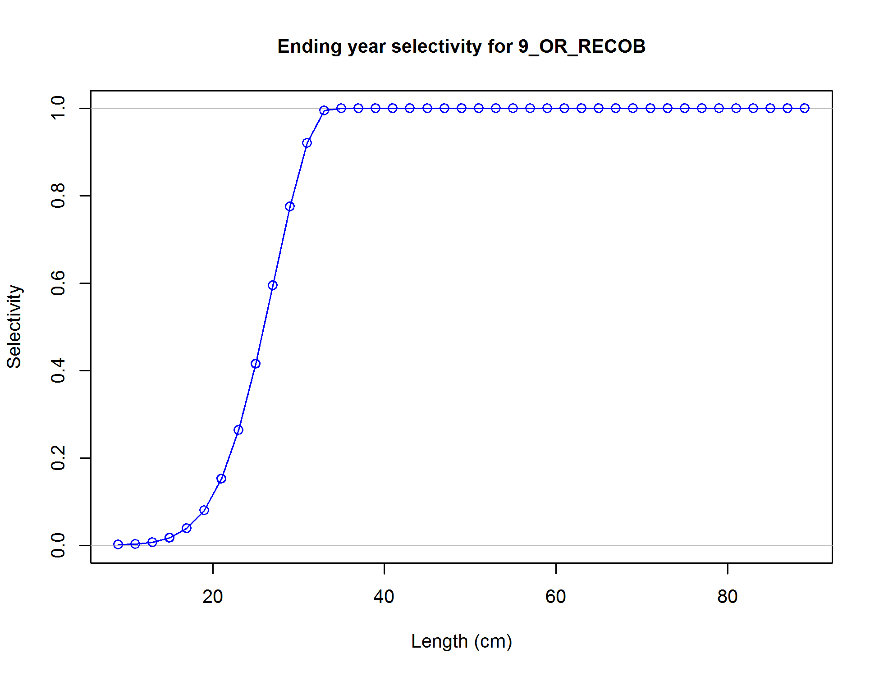

Figure . Oregon onboard recreational survey selectivity estimated in the base model for yelloweye rockfish.

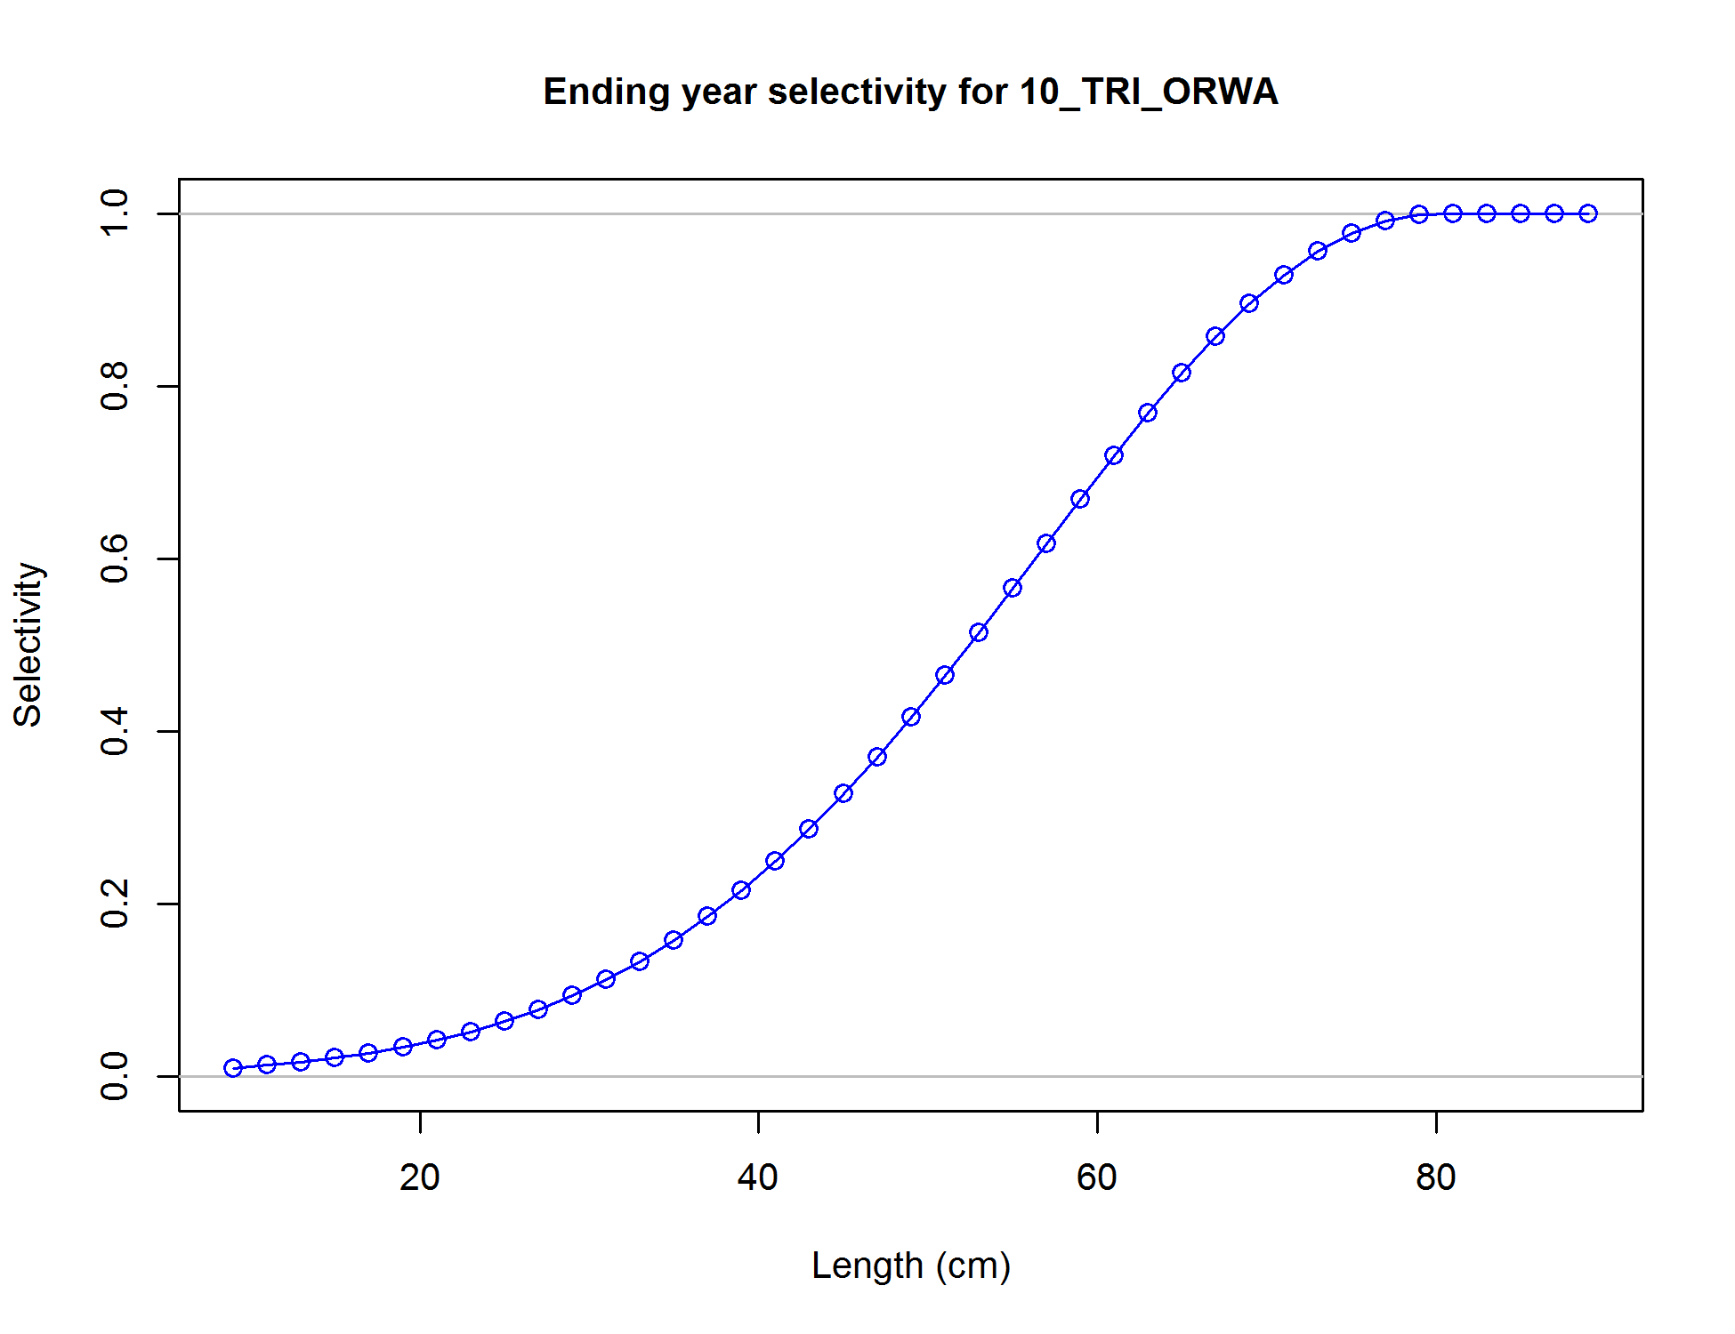

Figure . Oregon-Washington AFSC Triennial survey selectivity estimated in the base model for yelloweye rockfish.

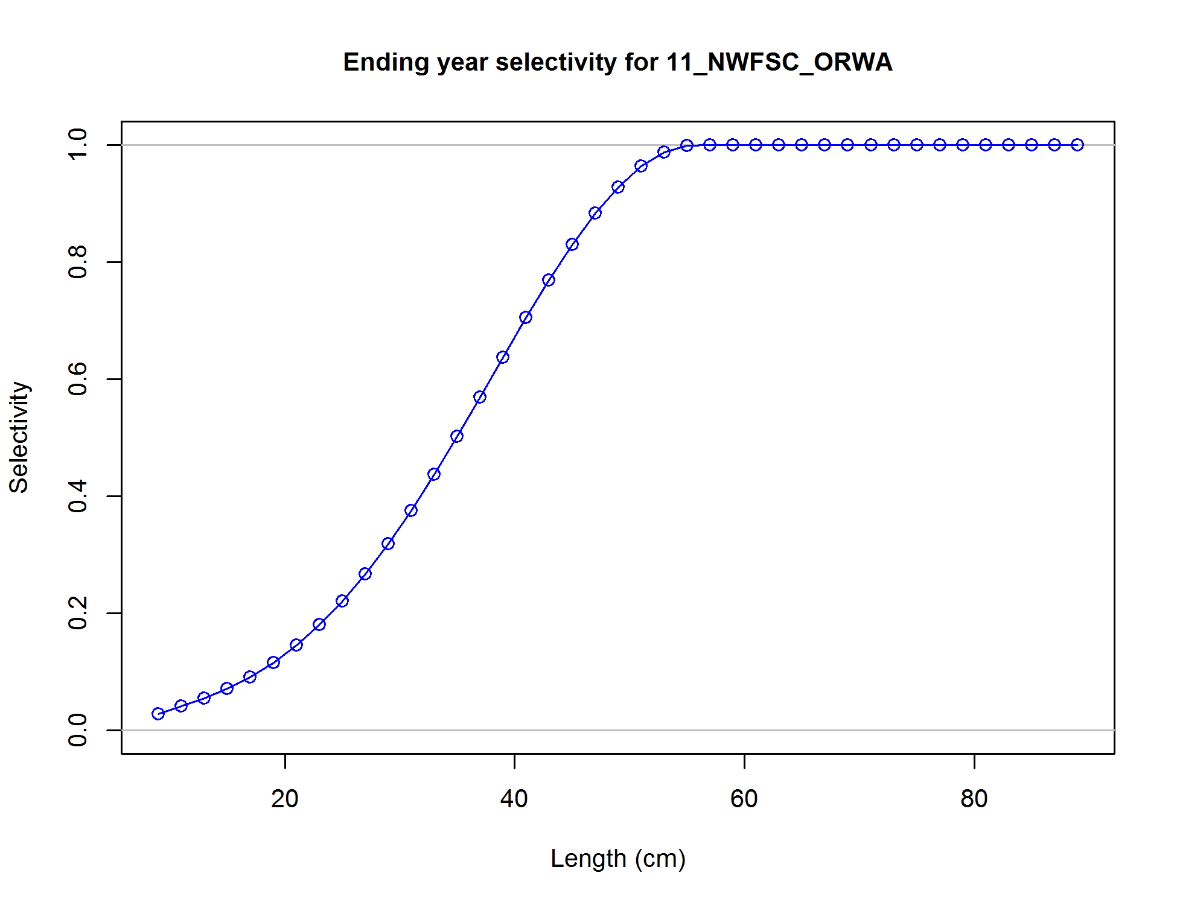

Figure . Oregon-Washington NWFSC WCGTS selectivity estimated in the base model for yelloweye rockfish.

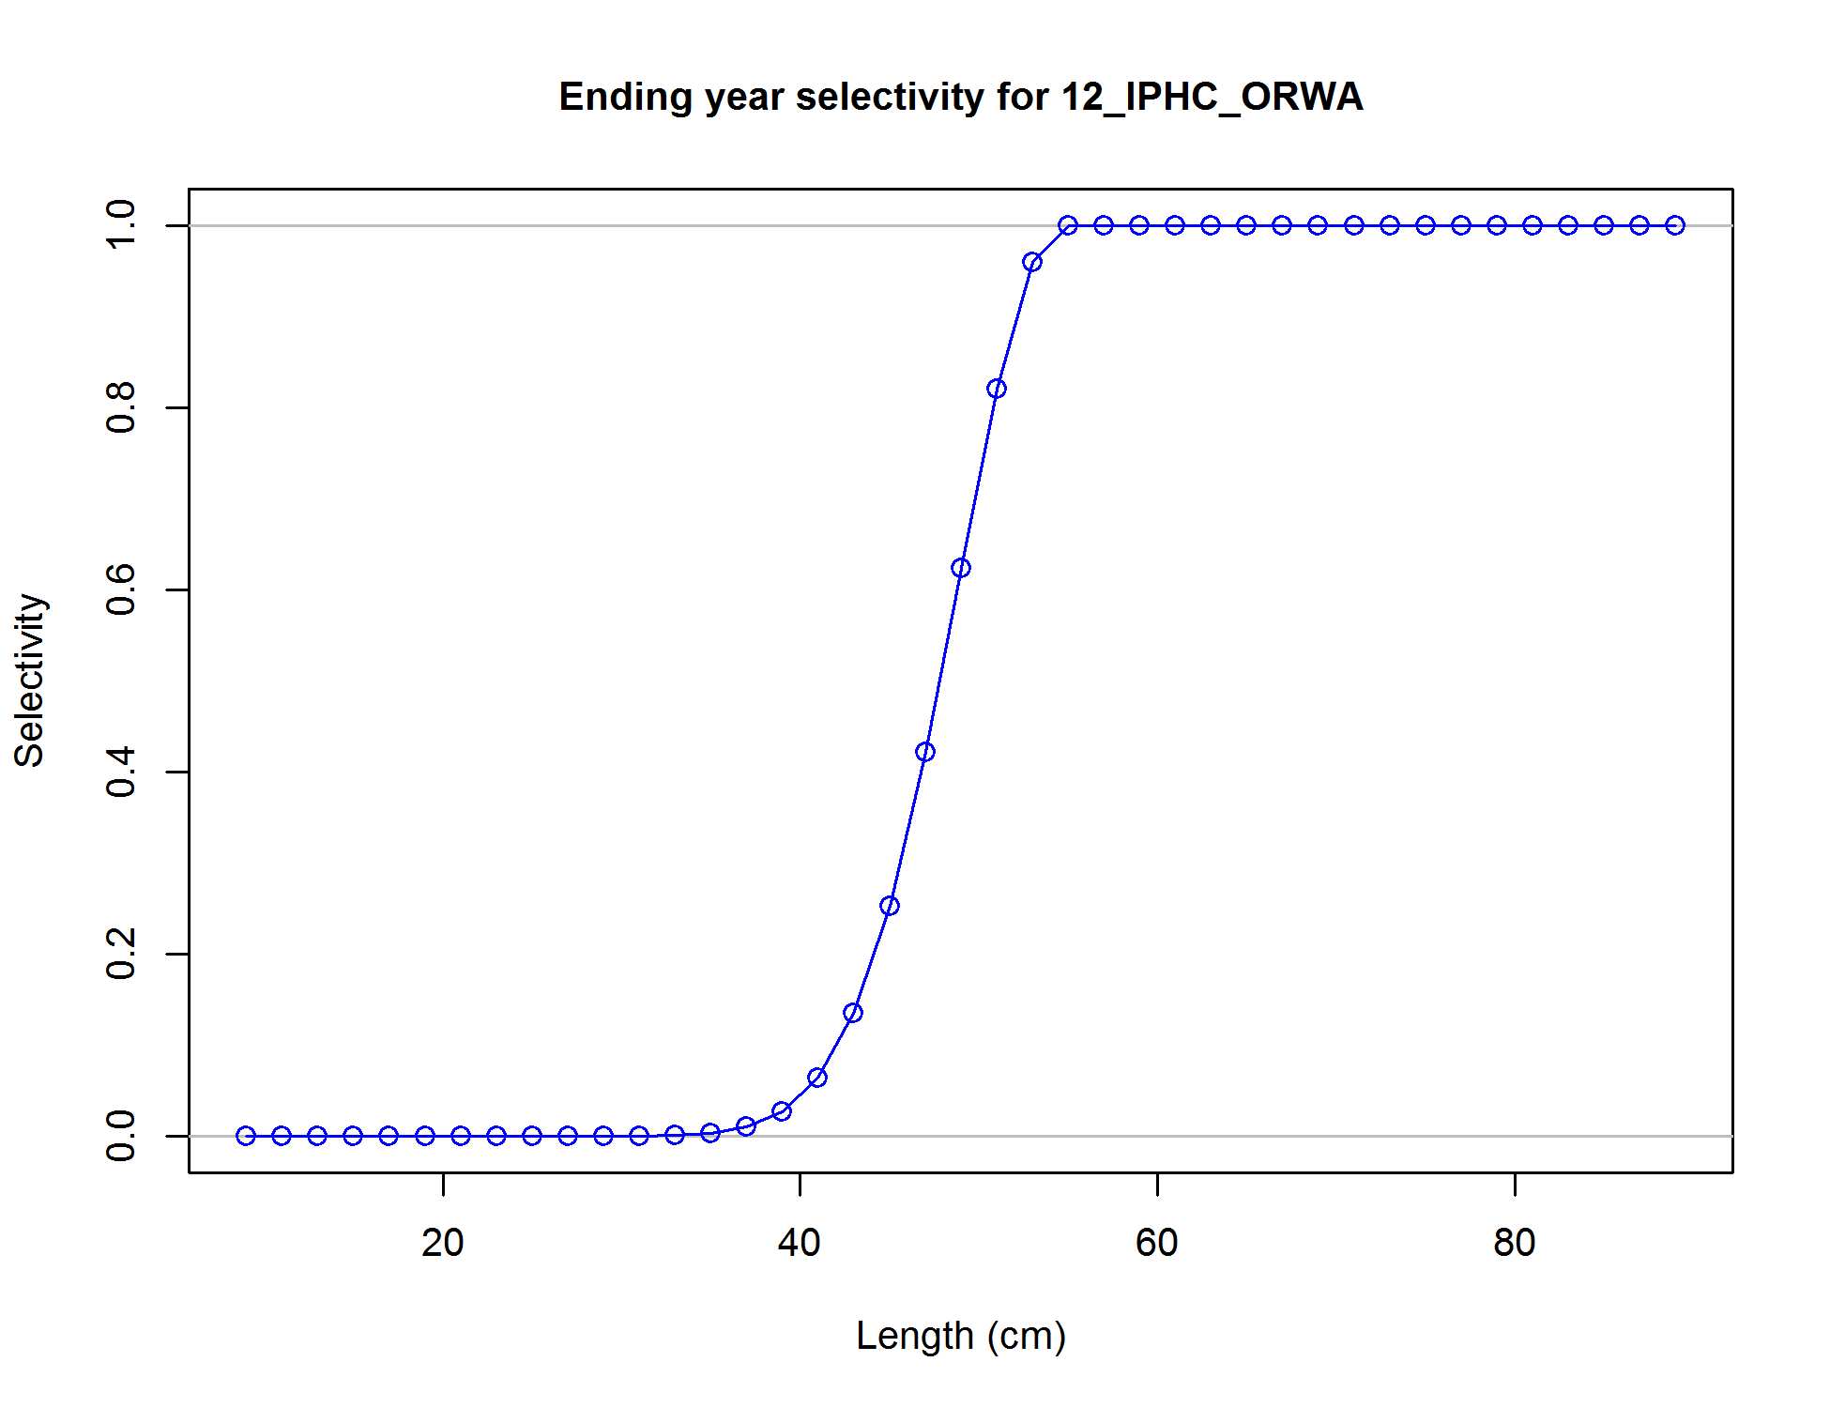

Figure . Oregon-Washington IPHC survey selectivity estimated in the base model for yelloweye rockfish.

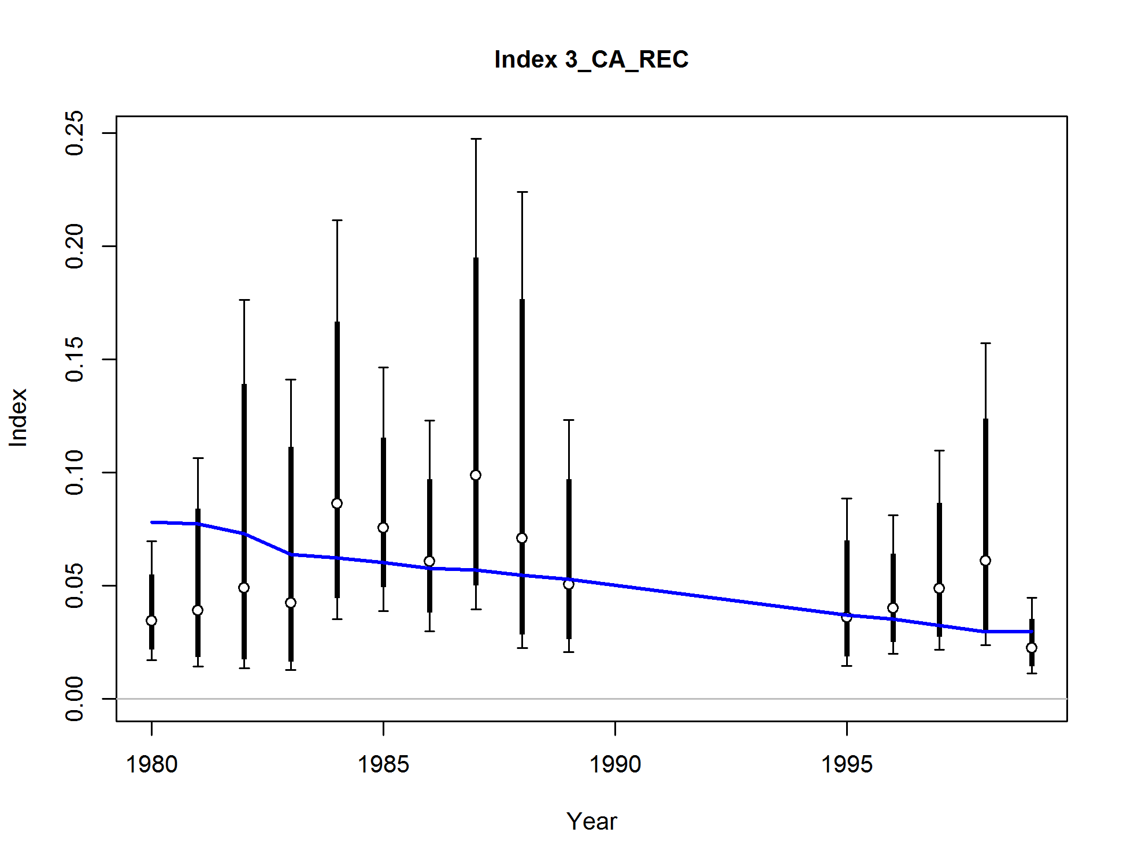

Figure . Base model fit to the California MRFSS recreational index.

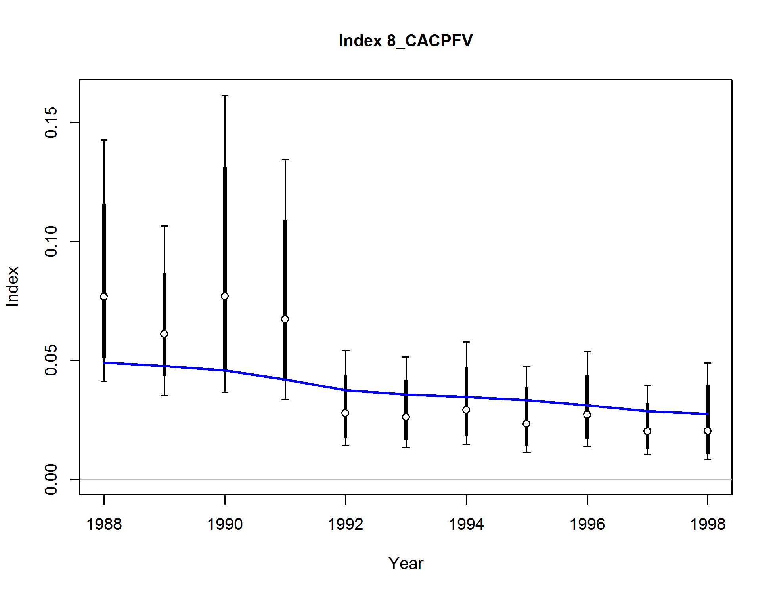

Figure . Base model fit to the California CPFV recreational index.

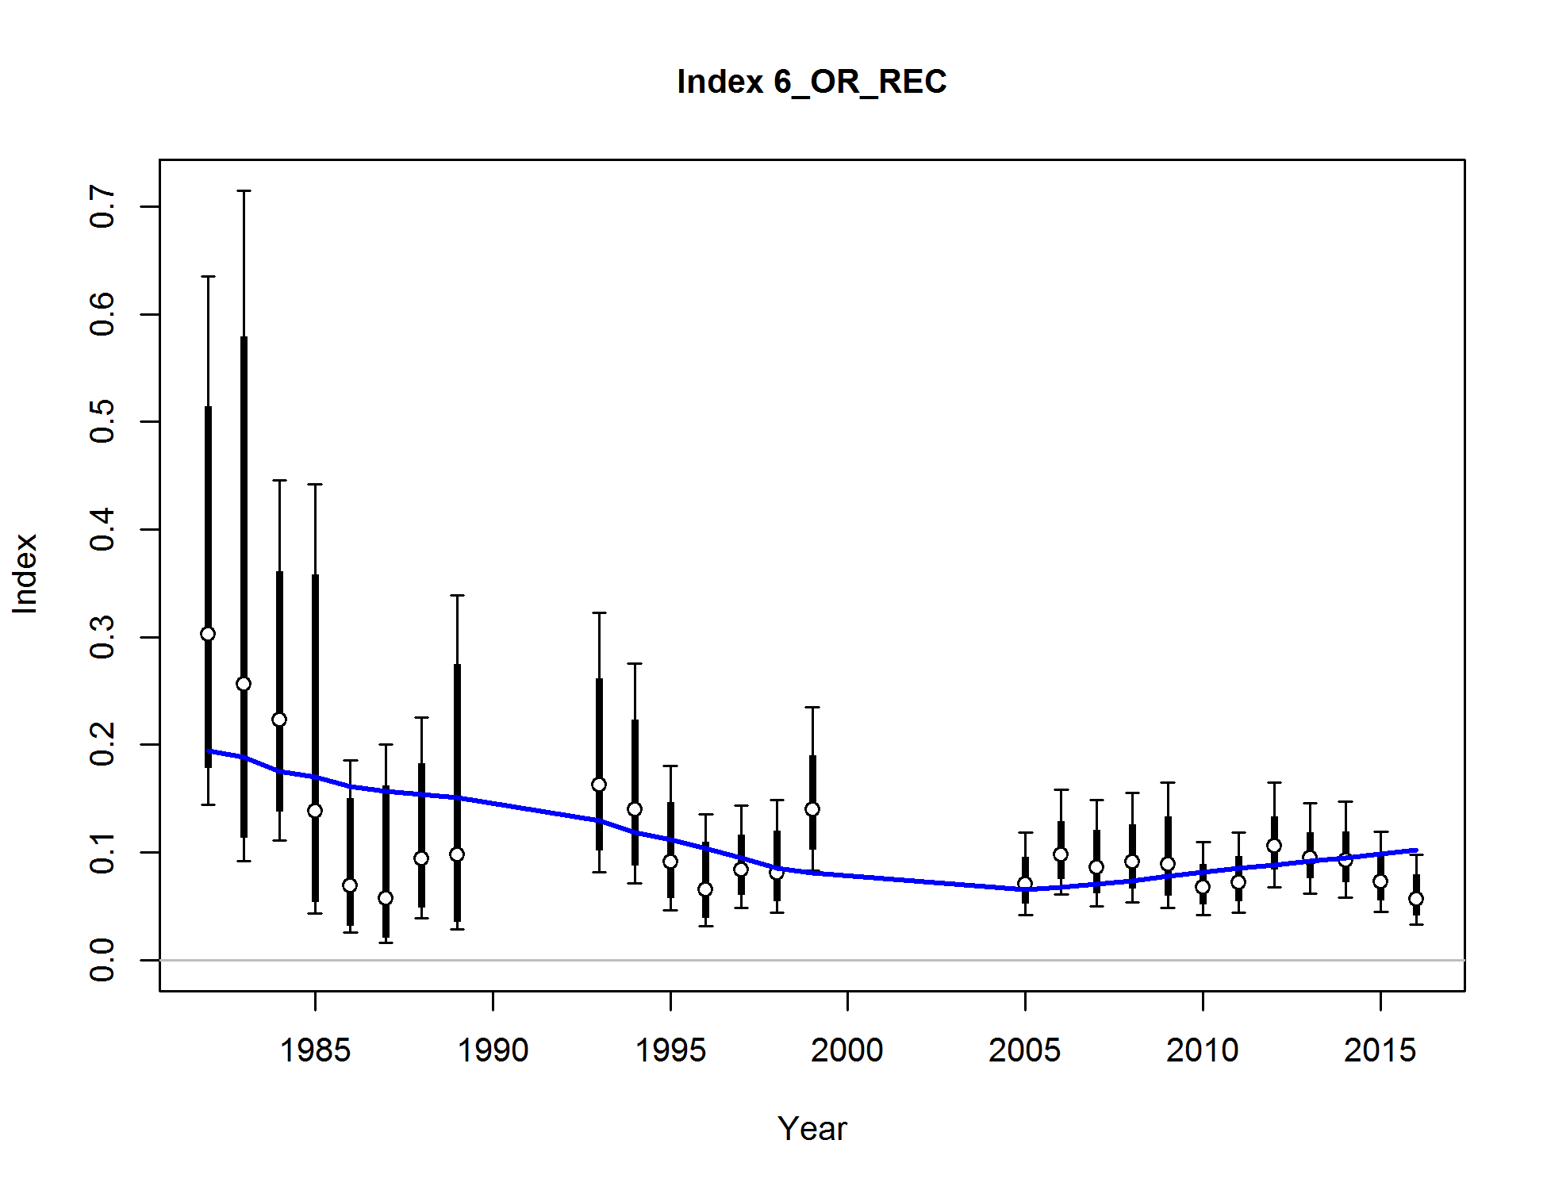

Figure . Base model fit to the Oregon MRFSS/ORBS recreational index.

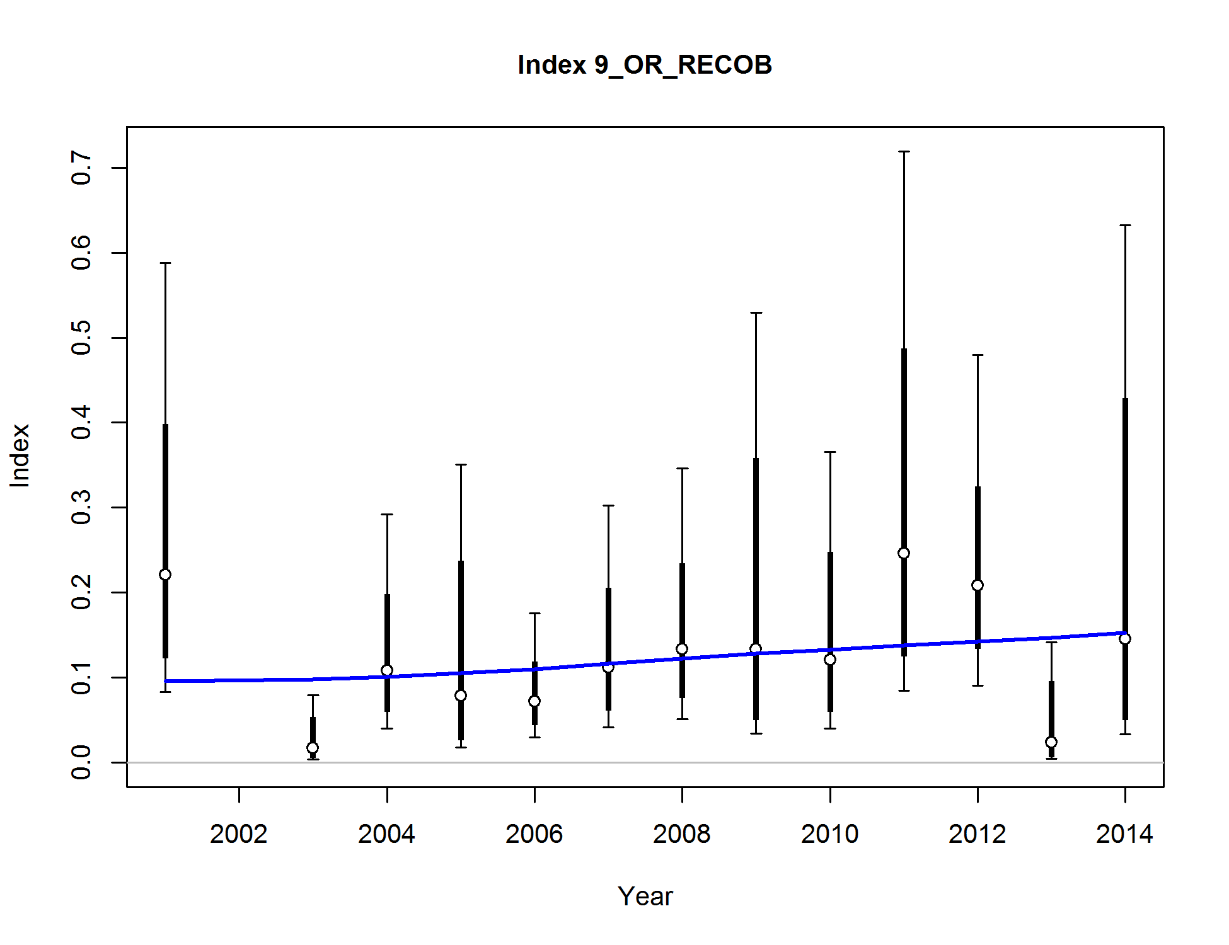

**Figure 86. Base model fit to the Oregon onboard recreational index.**

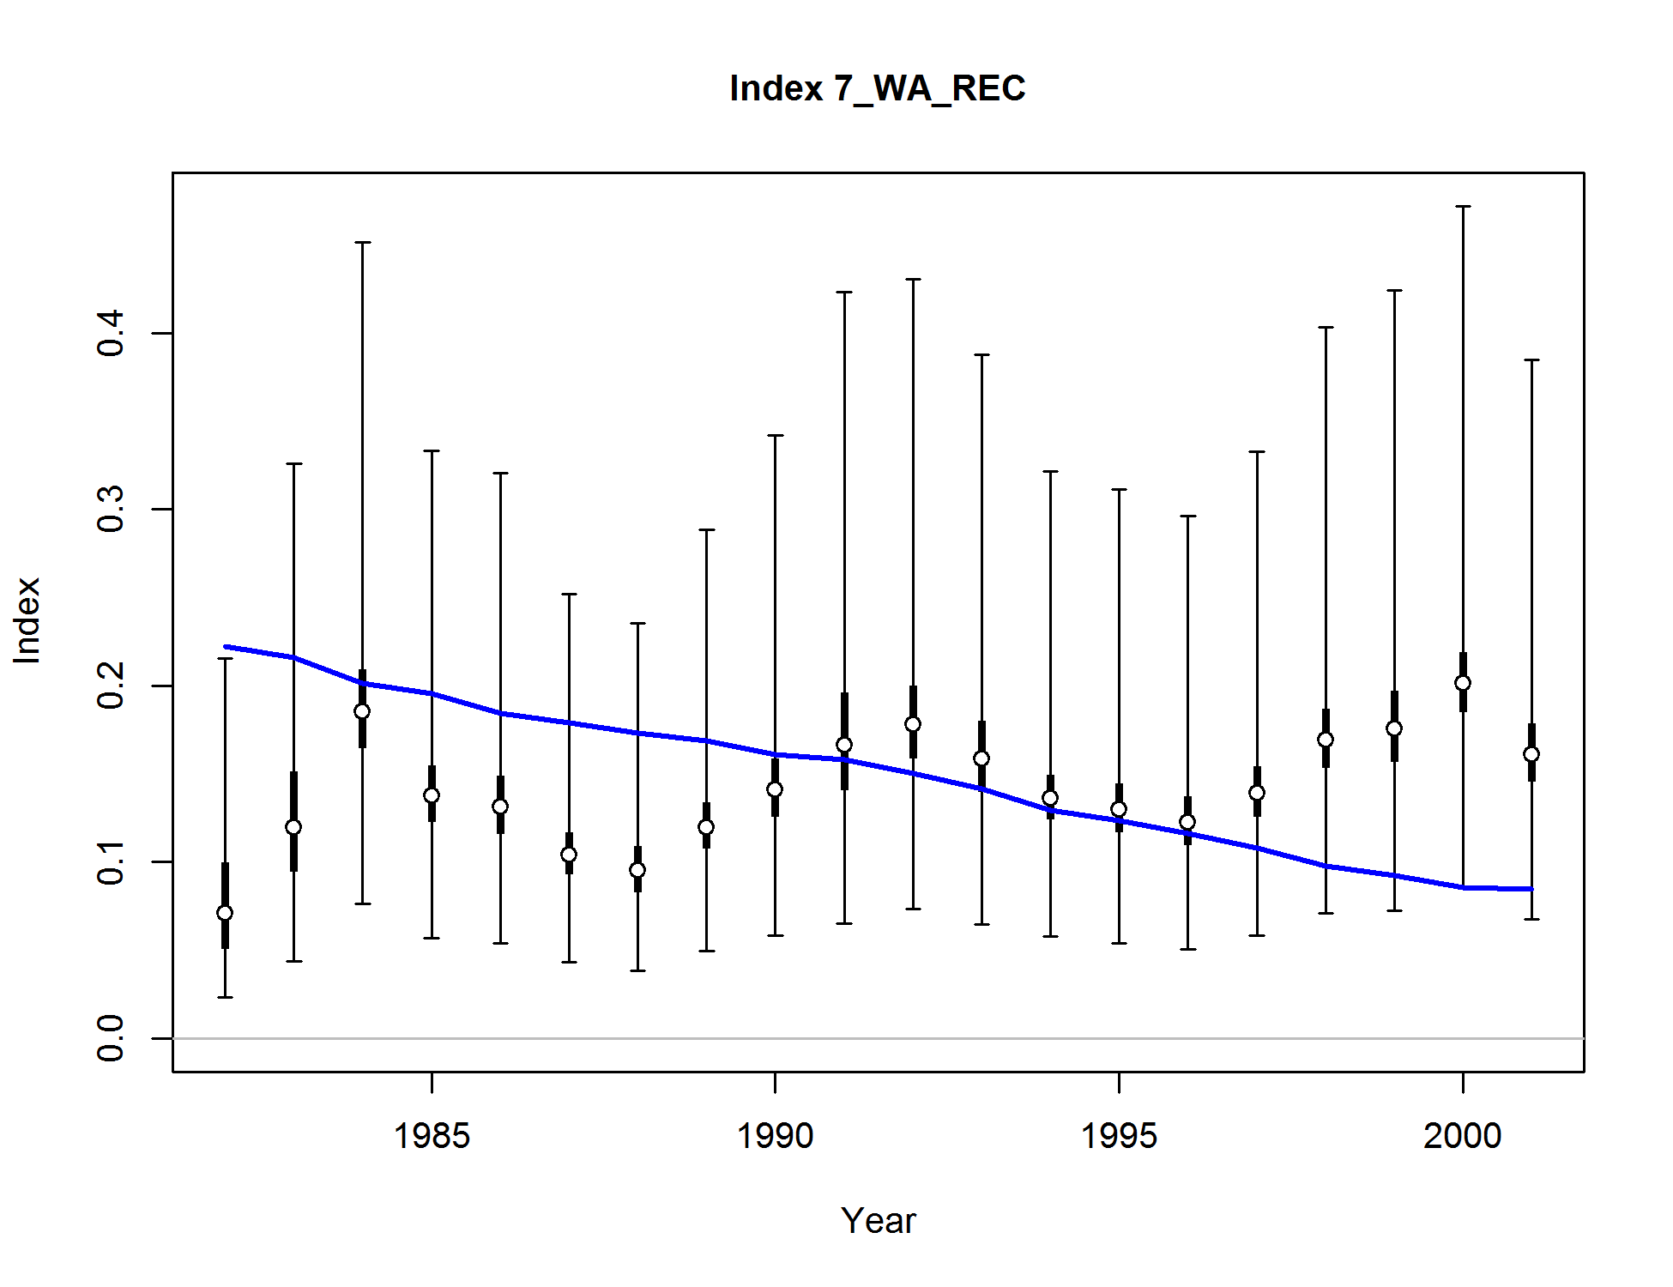

Figure . Base model fit to the Washington dockside recreational index.

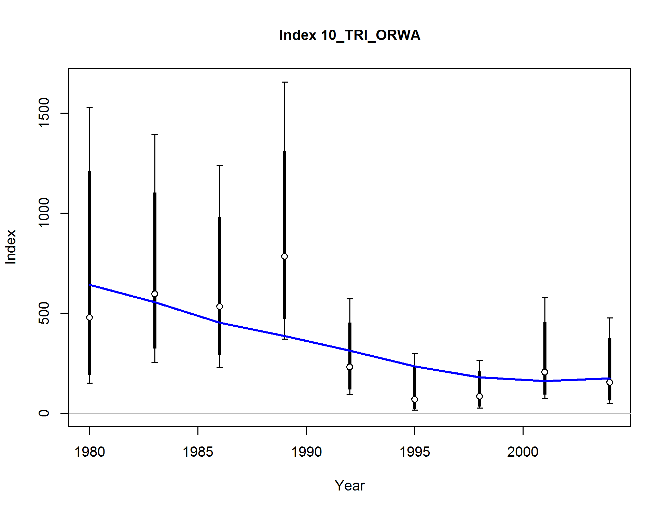

Figure . Base model fit to the AFSC Triennial survey.

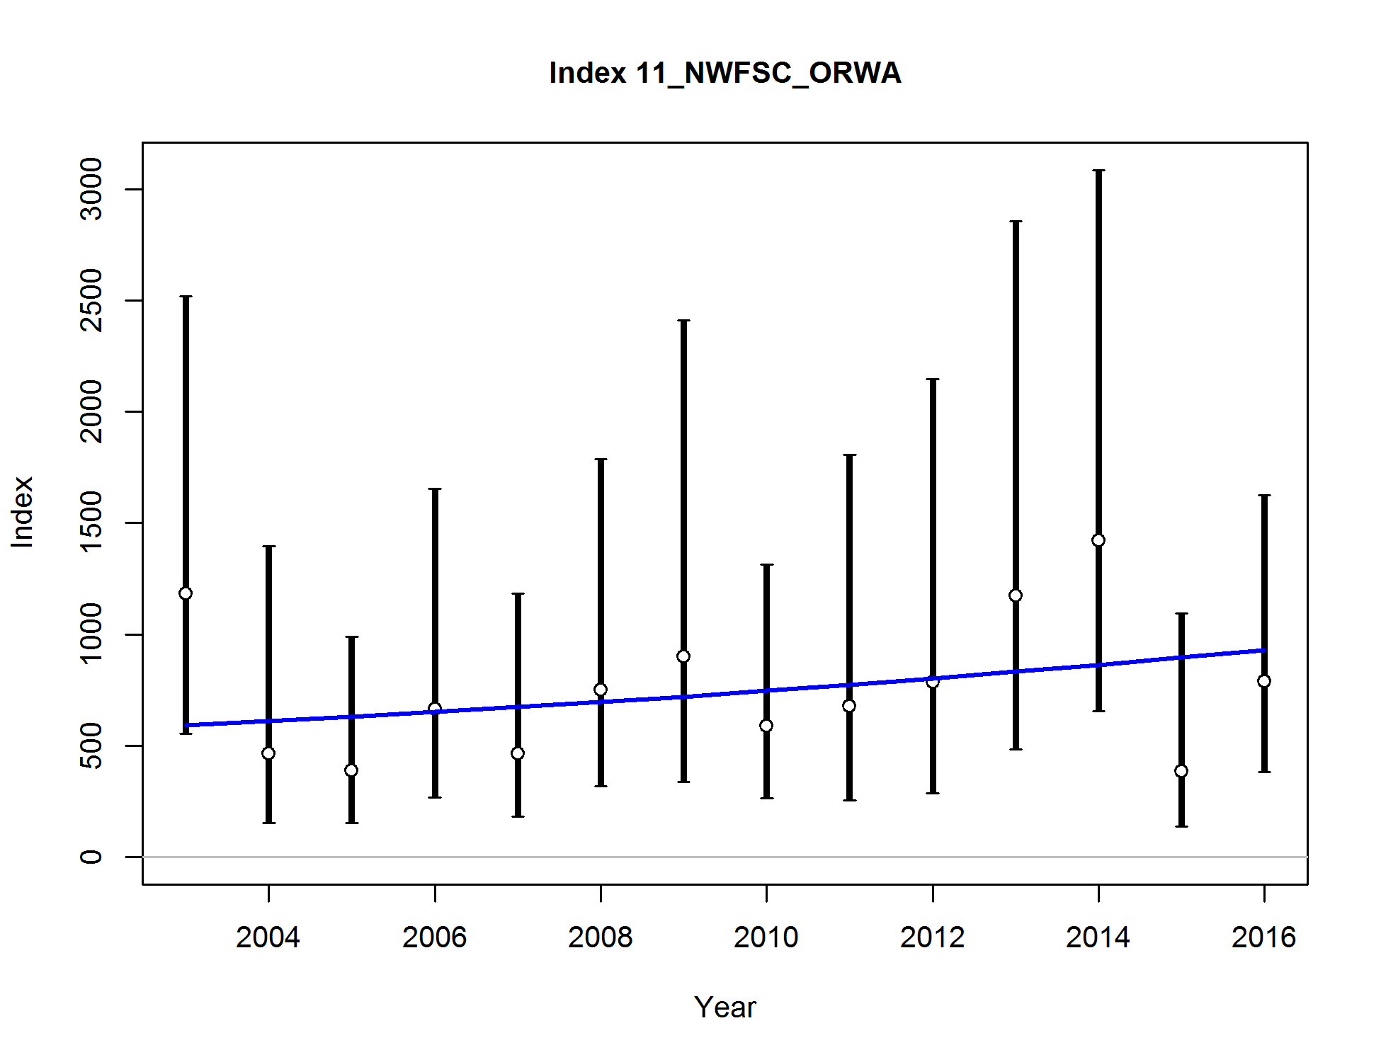

Figure . Base model fit to the NWFSC trawl survey.

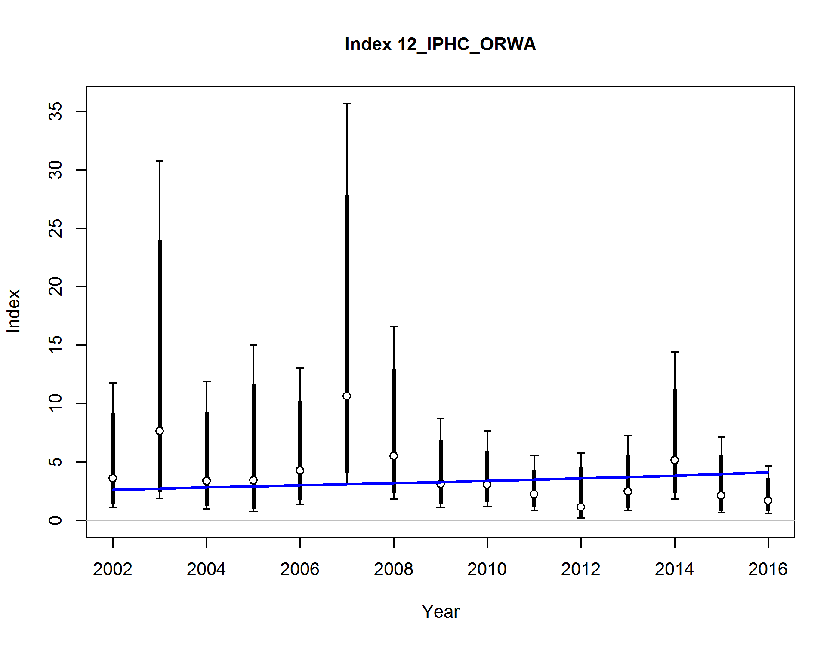

Figure . Base model fit to the IPHC survey.

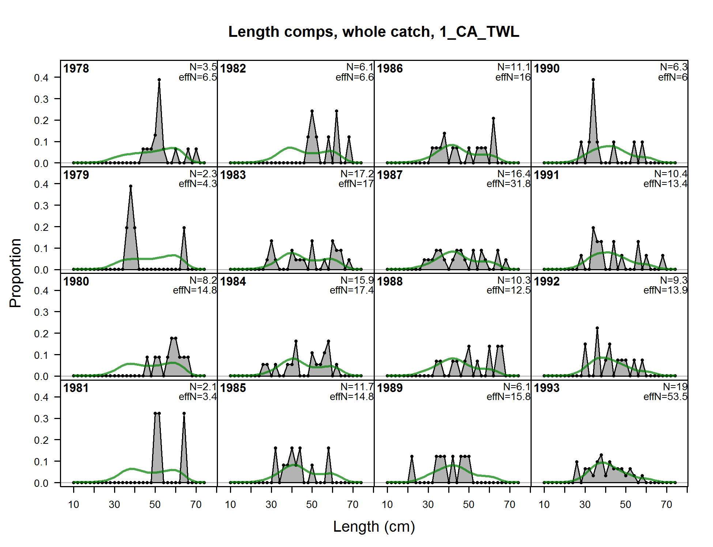

Figure . Fits to the California commercial trawl fishery length compositions, years 1978-1993.

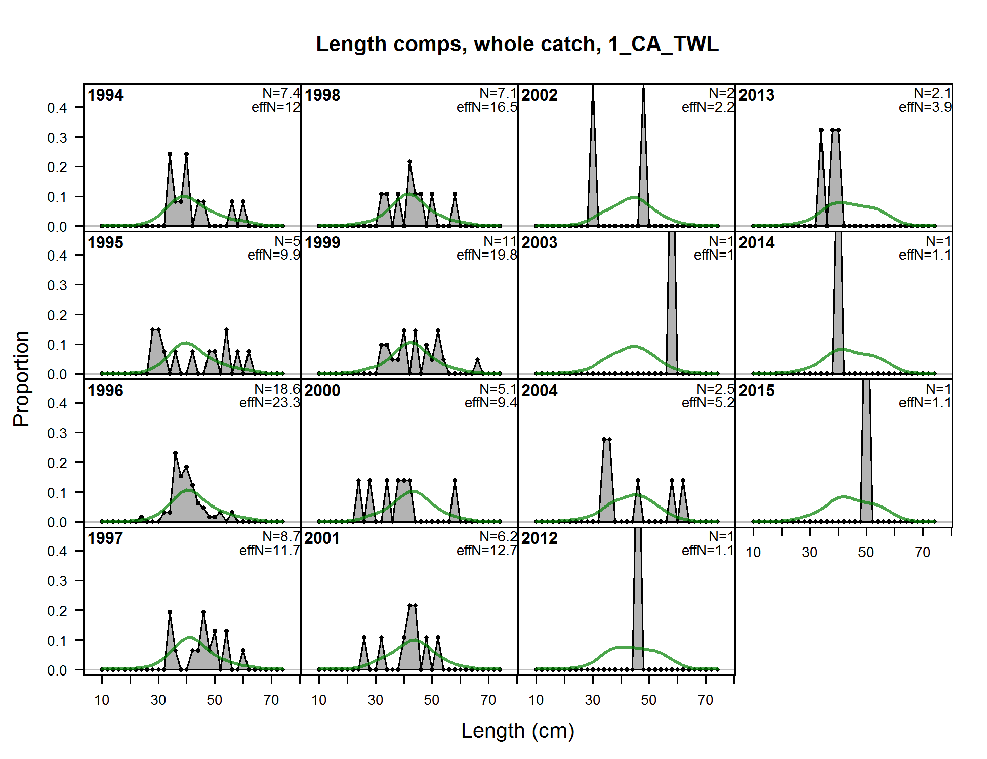

Figure . Fits to the California commercial trawl fishery length compositions, years 1994-2015.

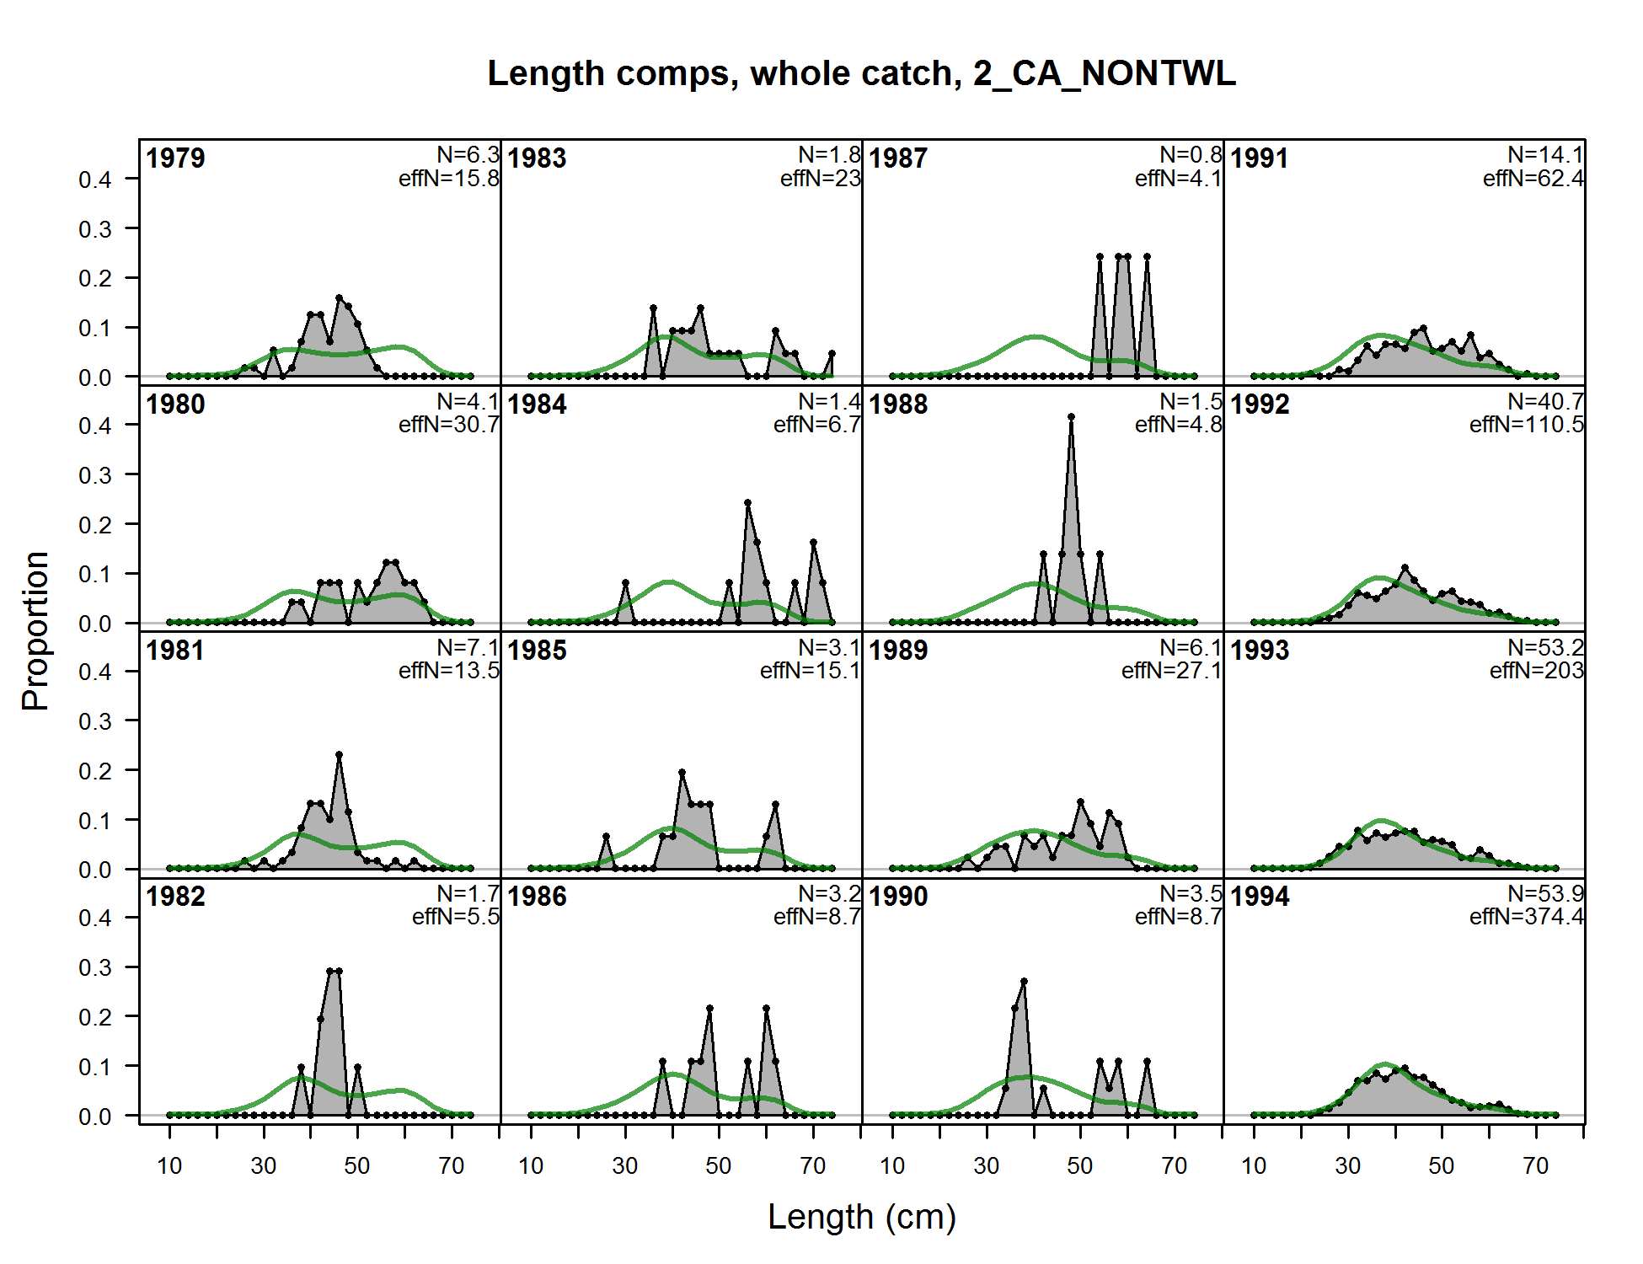

Figure . Fits to the California commercial fishery non-trawl length compositions, years 1979-1994.

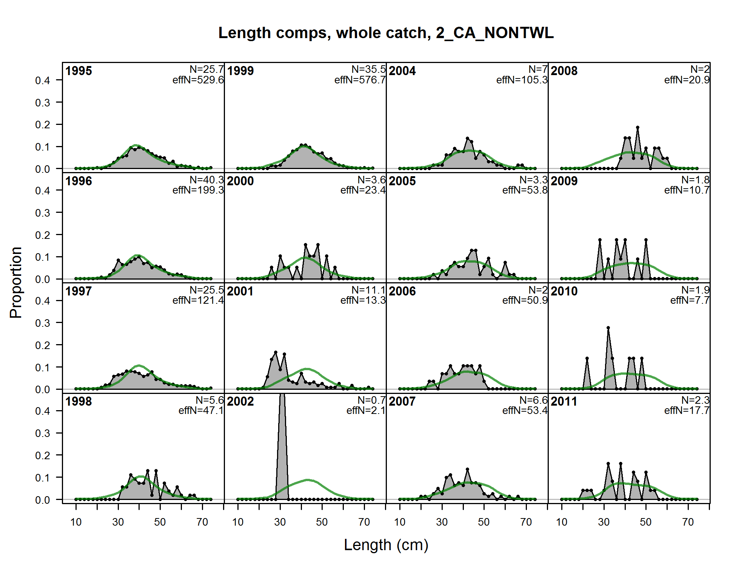

Figure . Fits to the California commercial non-trawl fishery length compositions, years 1995-2011.

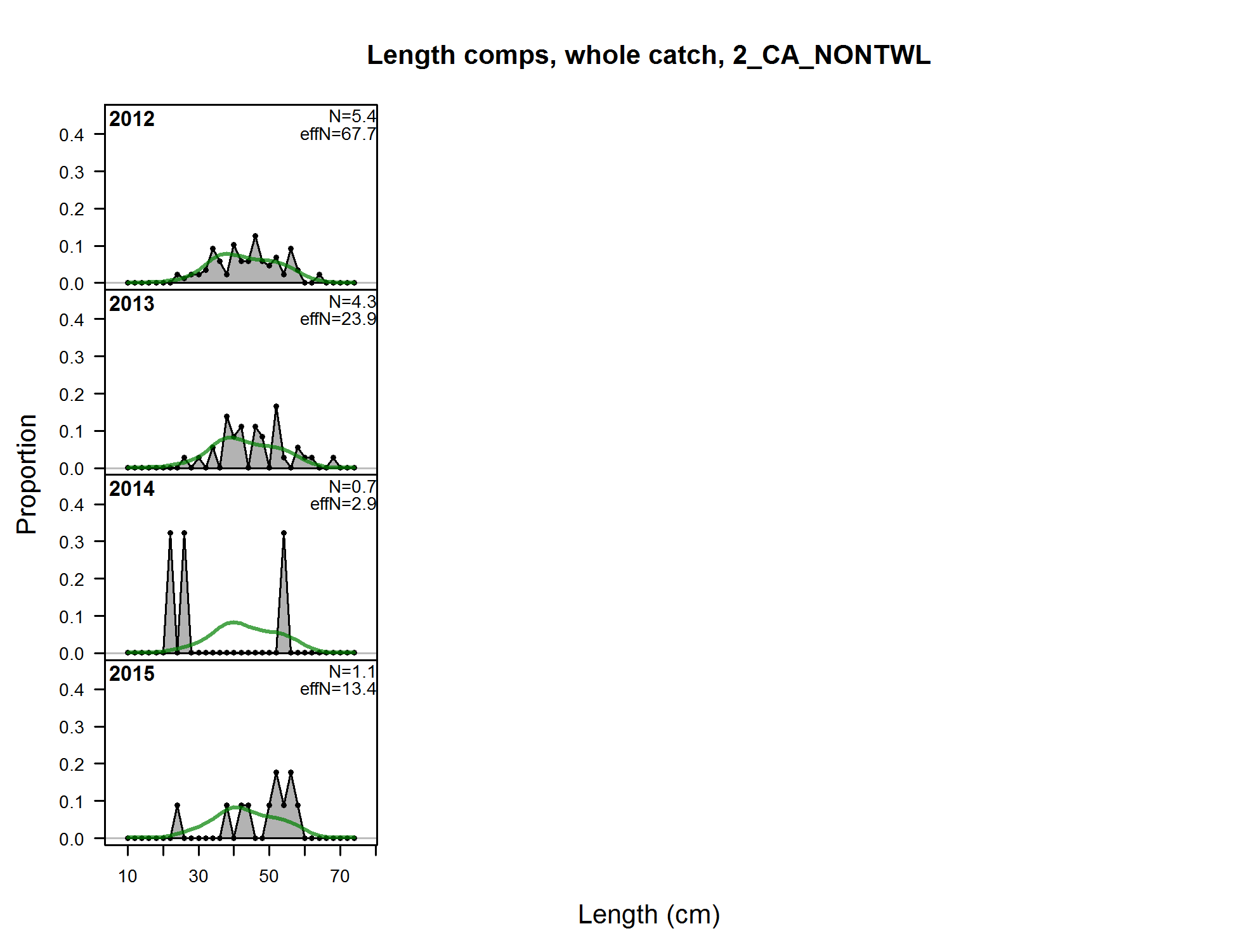

Figure . Fits to the California commercial non-trawl fishery length compositions, years 2012-2015.

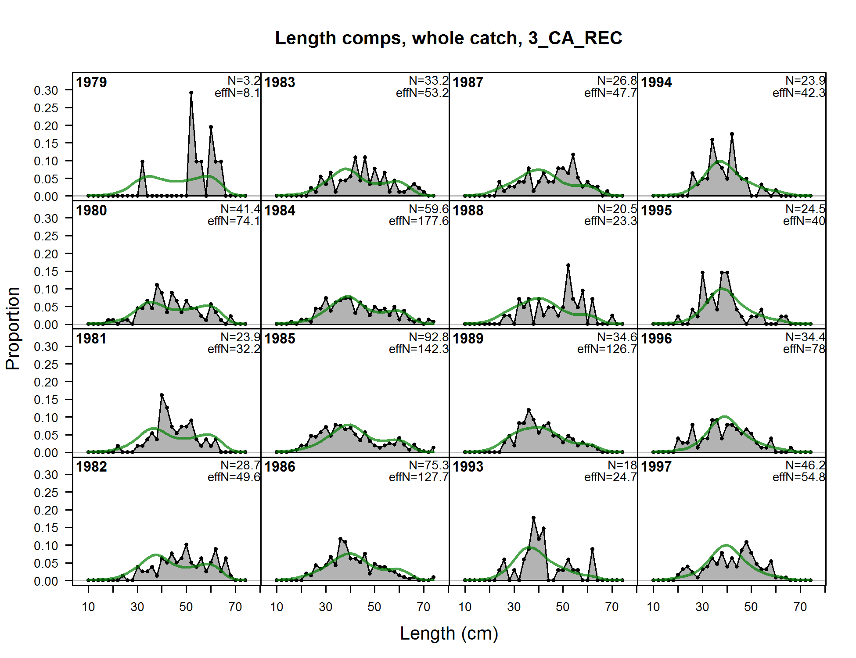

Figure . Fits to the California recreational fishery length compositions, years 1979-1997.

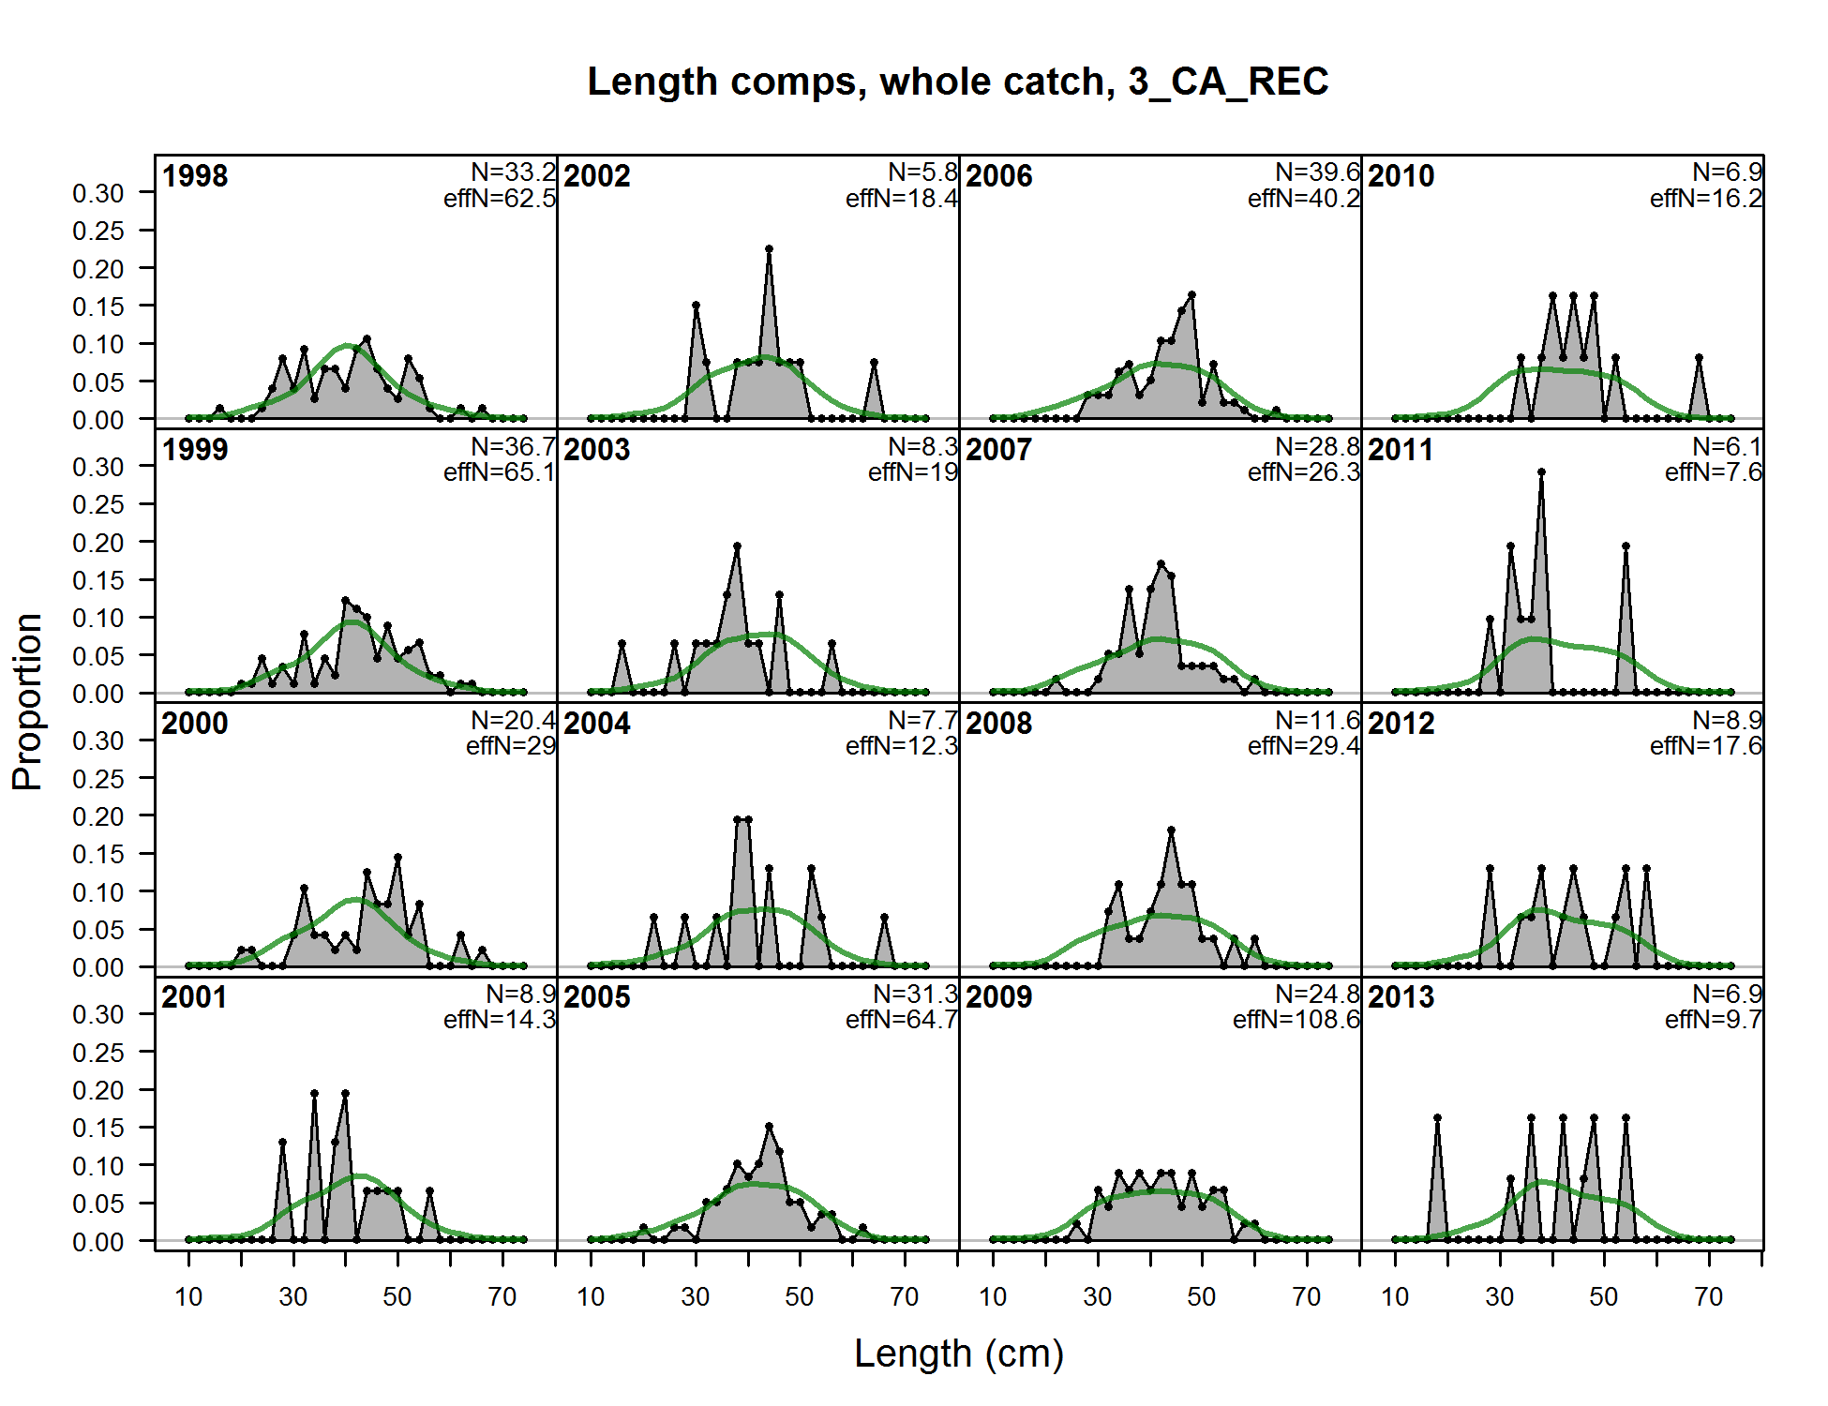

Figure . Fits to the California recreational fishery length compositions, years 1998-2013.

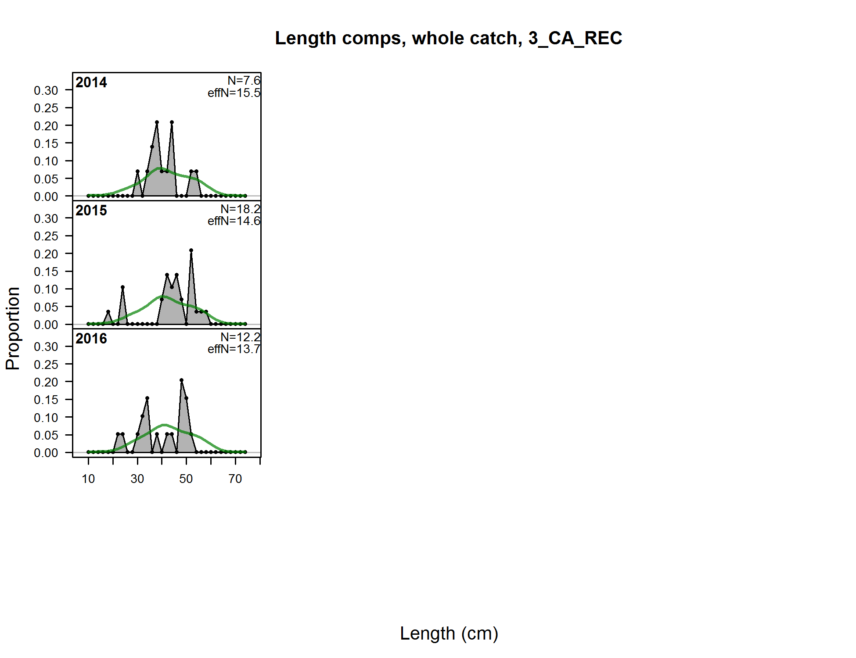

Figure . Fits to the California recreational fishery length compositions, years 2014-2016.

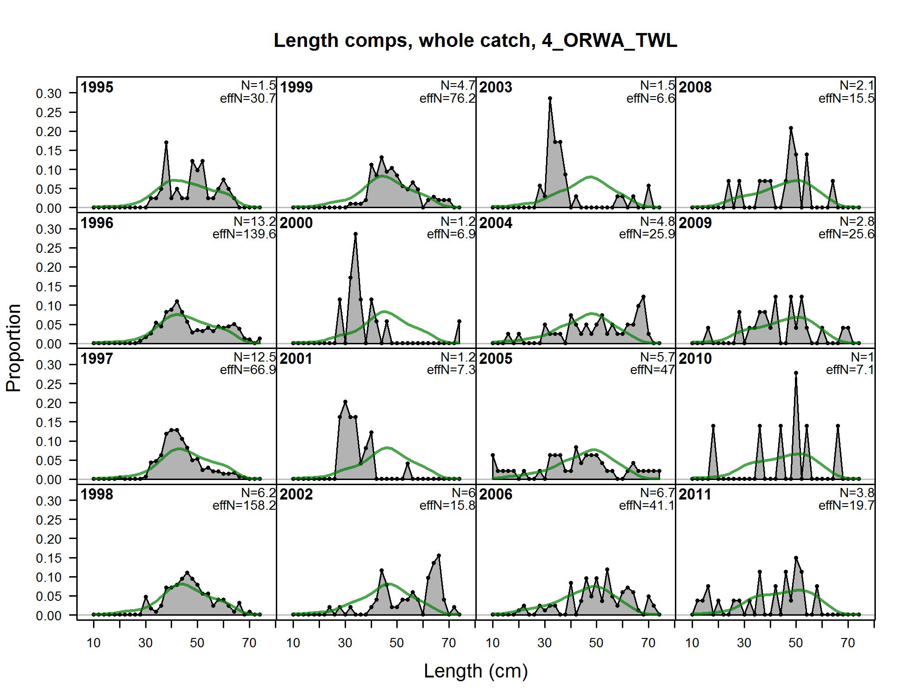

Figure . Fits to the Oregon trawl fishery length compositions, years 1995-2011.

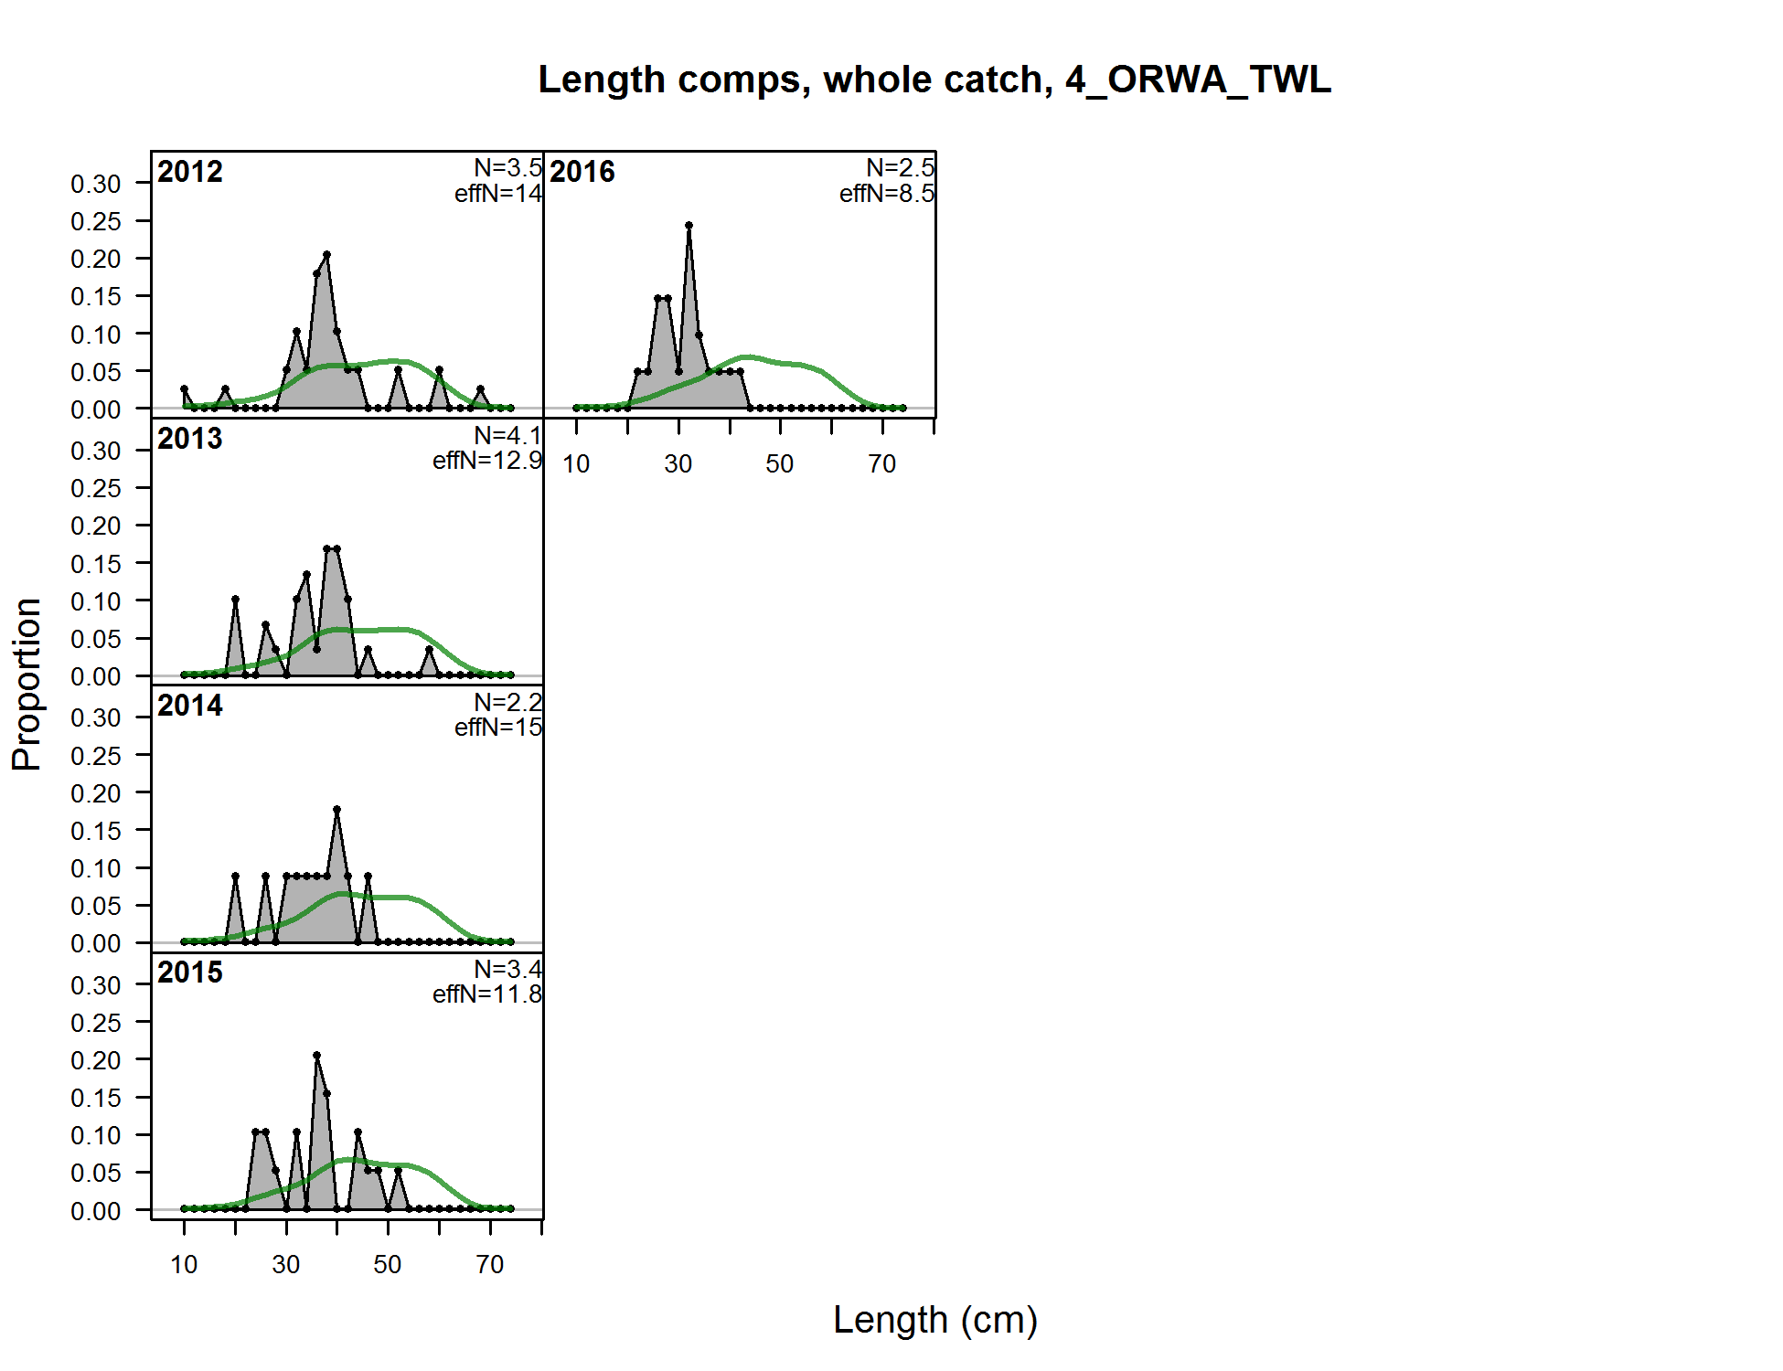

Figure . Fits to the Oregon trawl fishery length compositions, years 2012-2016.

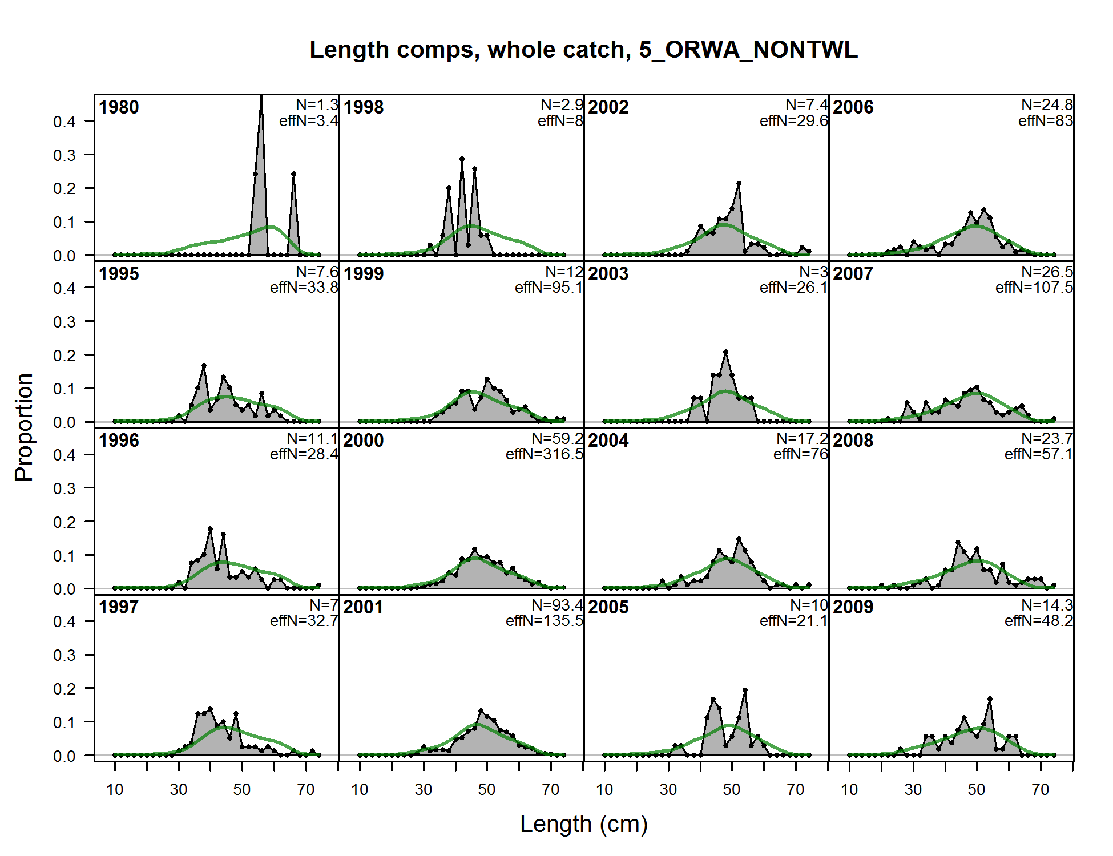

Figure . Fits to the Oregon non-trawl fishery length compositions, years 1980-2009.

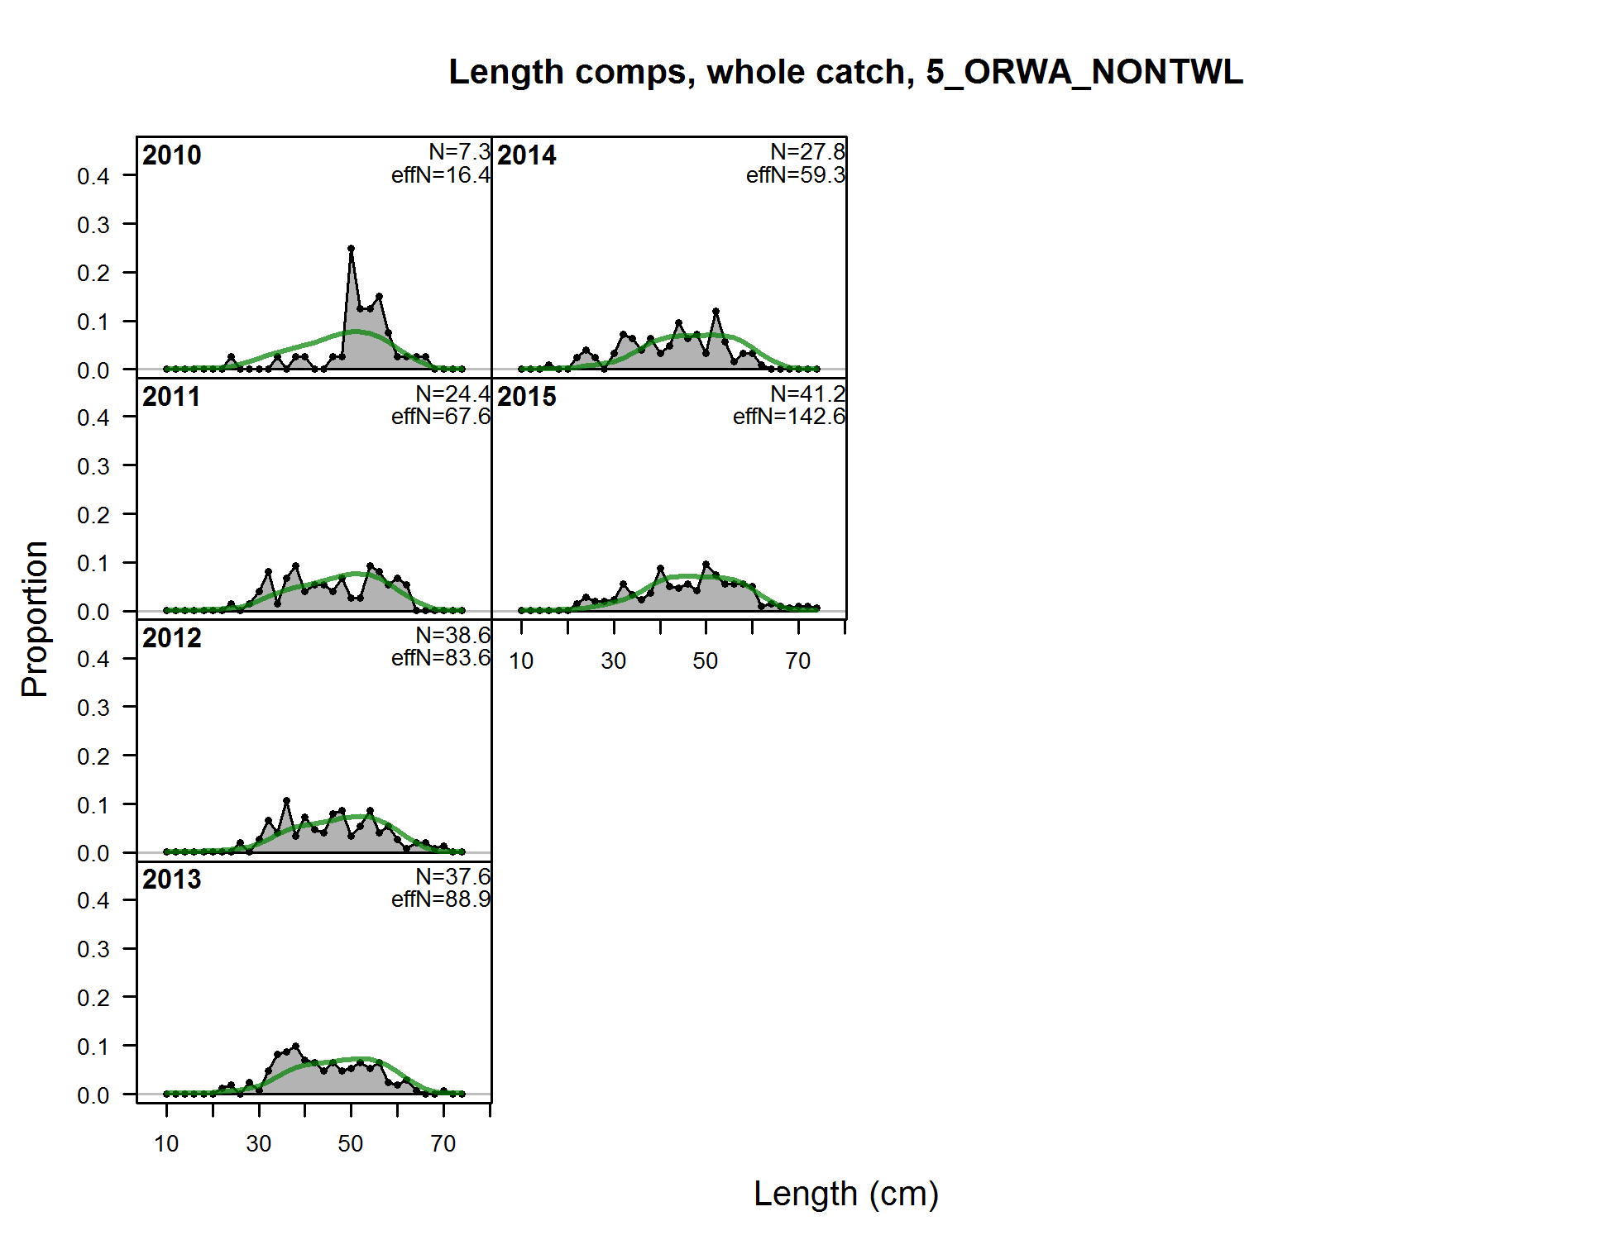

Figure . Fits to the Oregon non-trawl fishery length compositions, years 2010-2015.

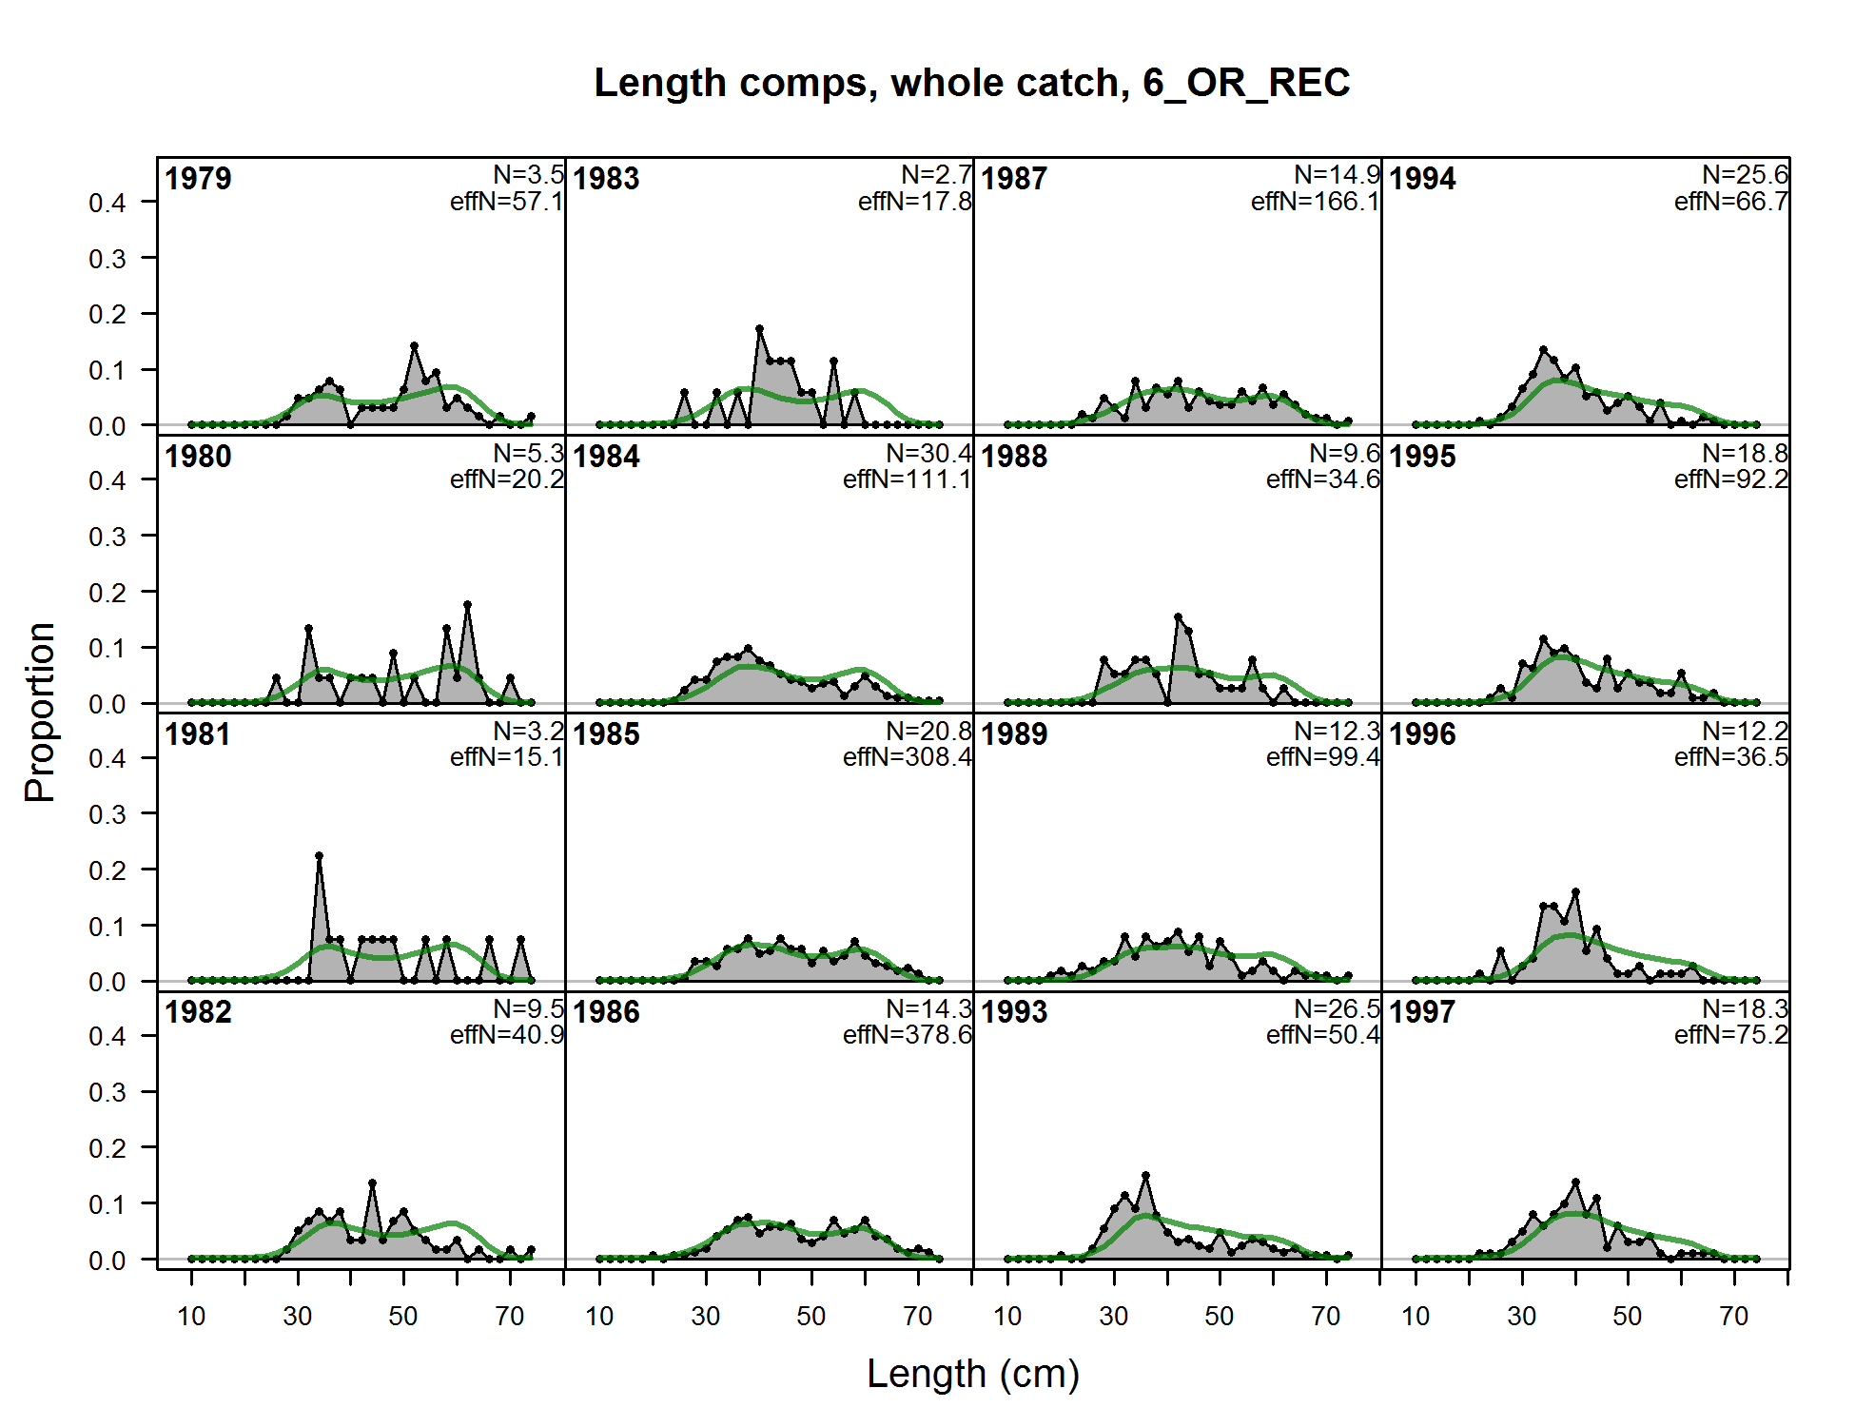

Figure . Fits to the Oregon recreational fishery length compositions, years 1979-1997.

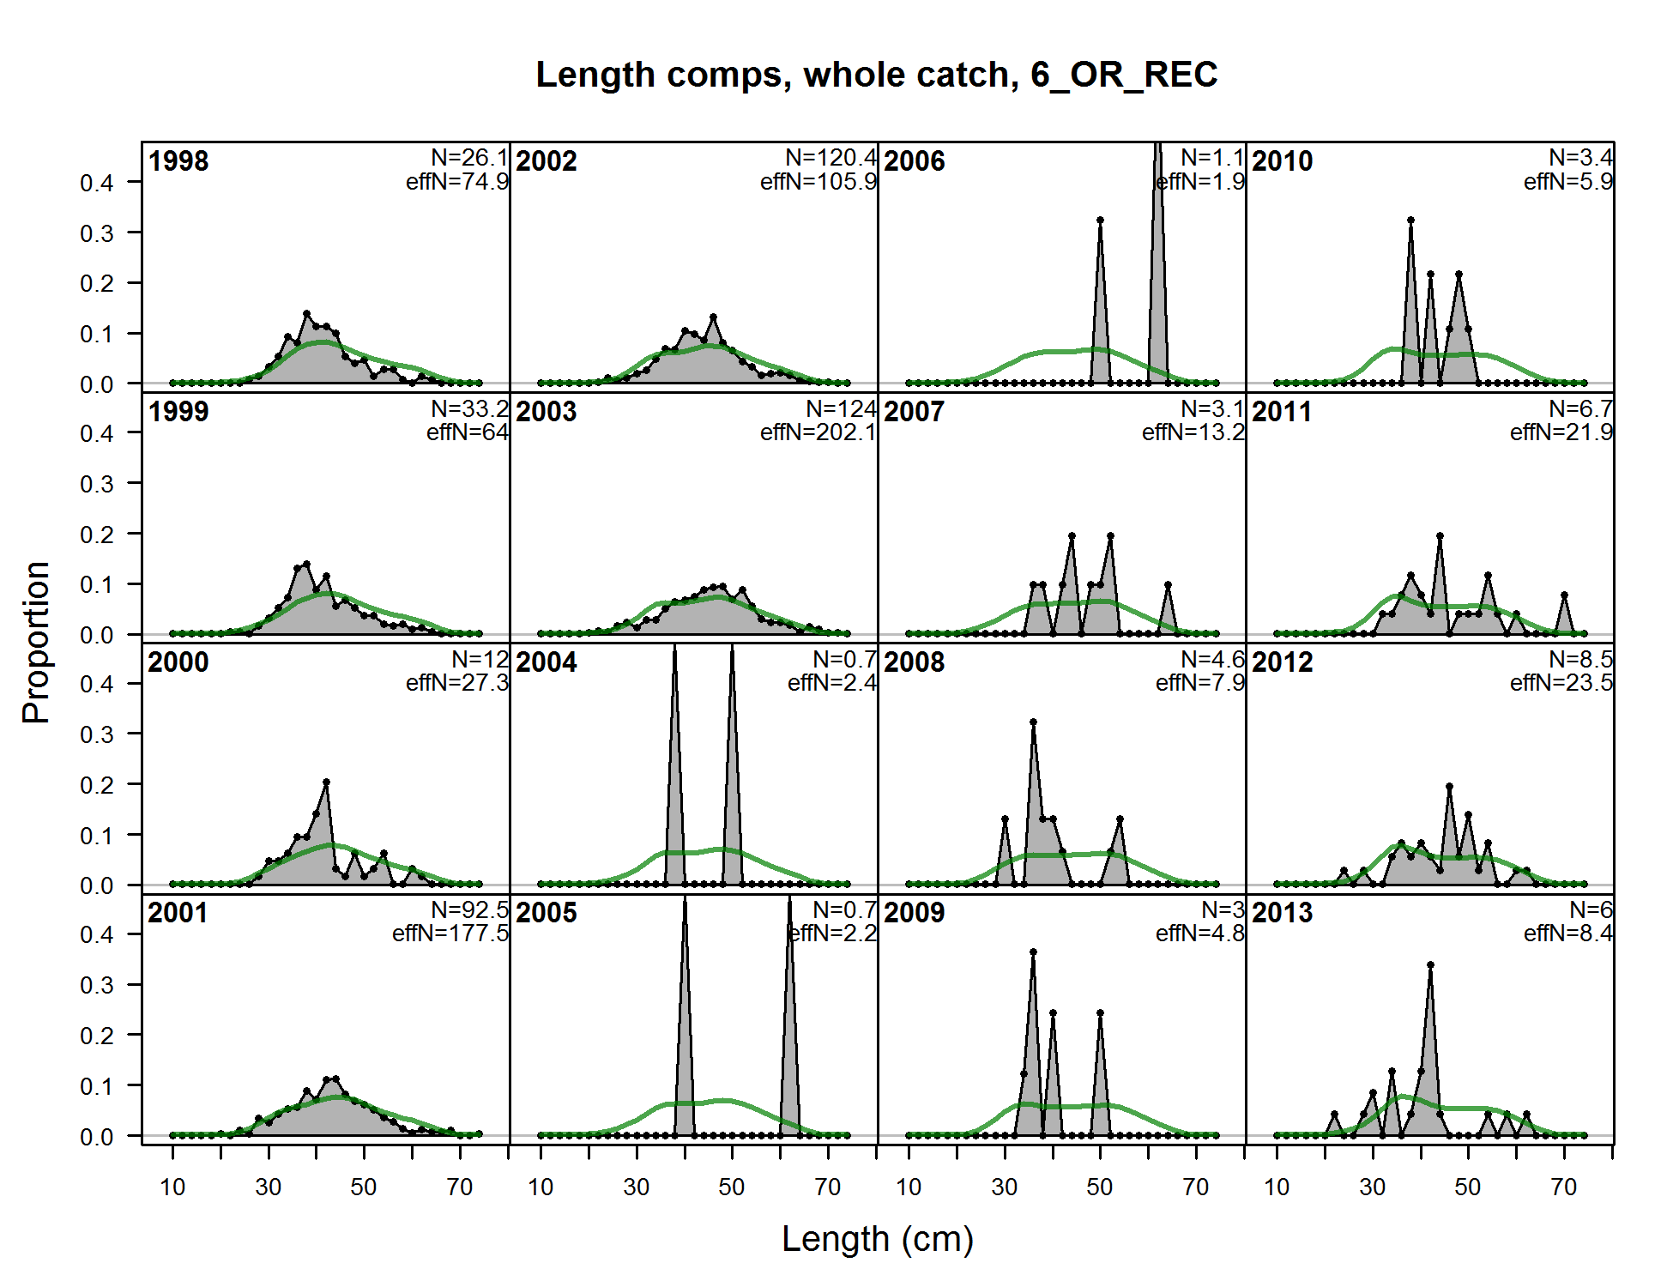

Figure . Fits to the Oregon recreational fishery length compositions, years 1998-2013.

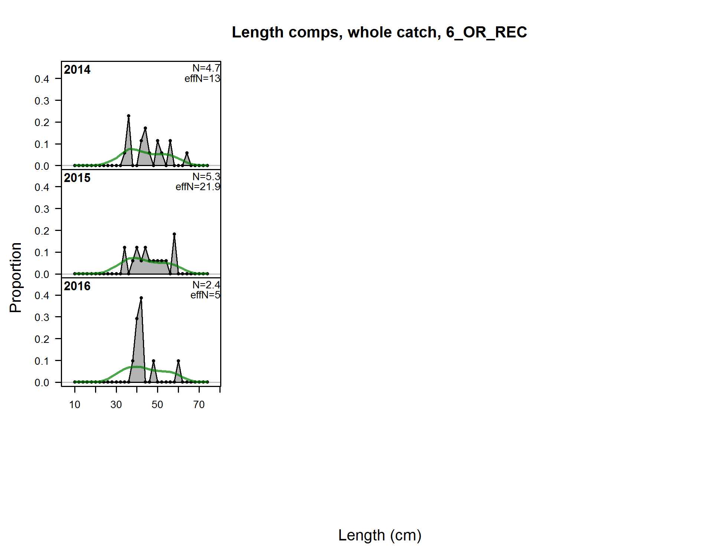

Figure . Fits to the Oregon recreational fishery length compositions, years 2014-2016.

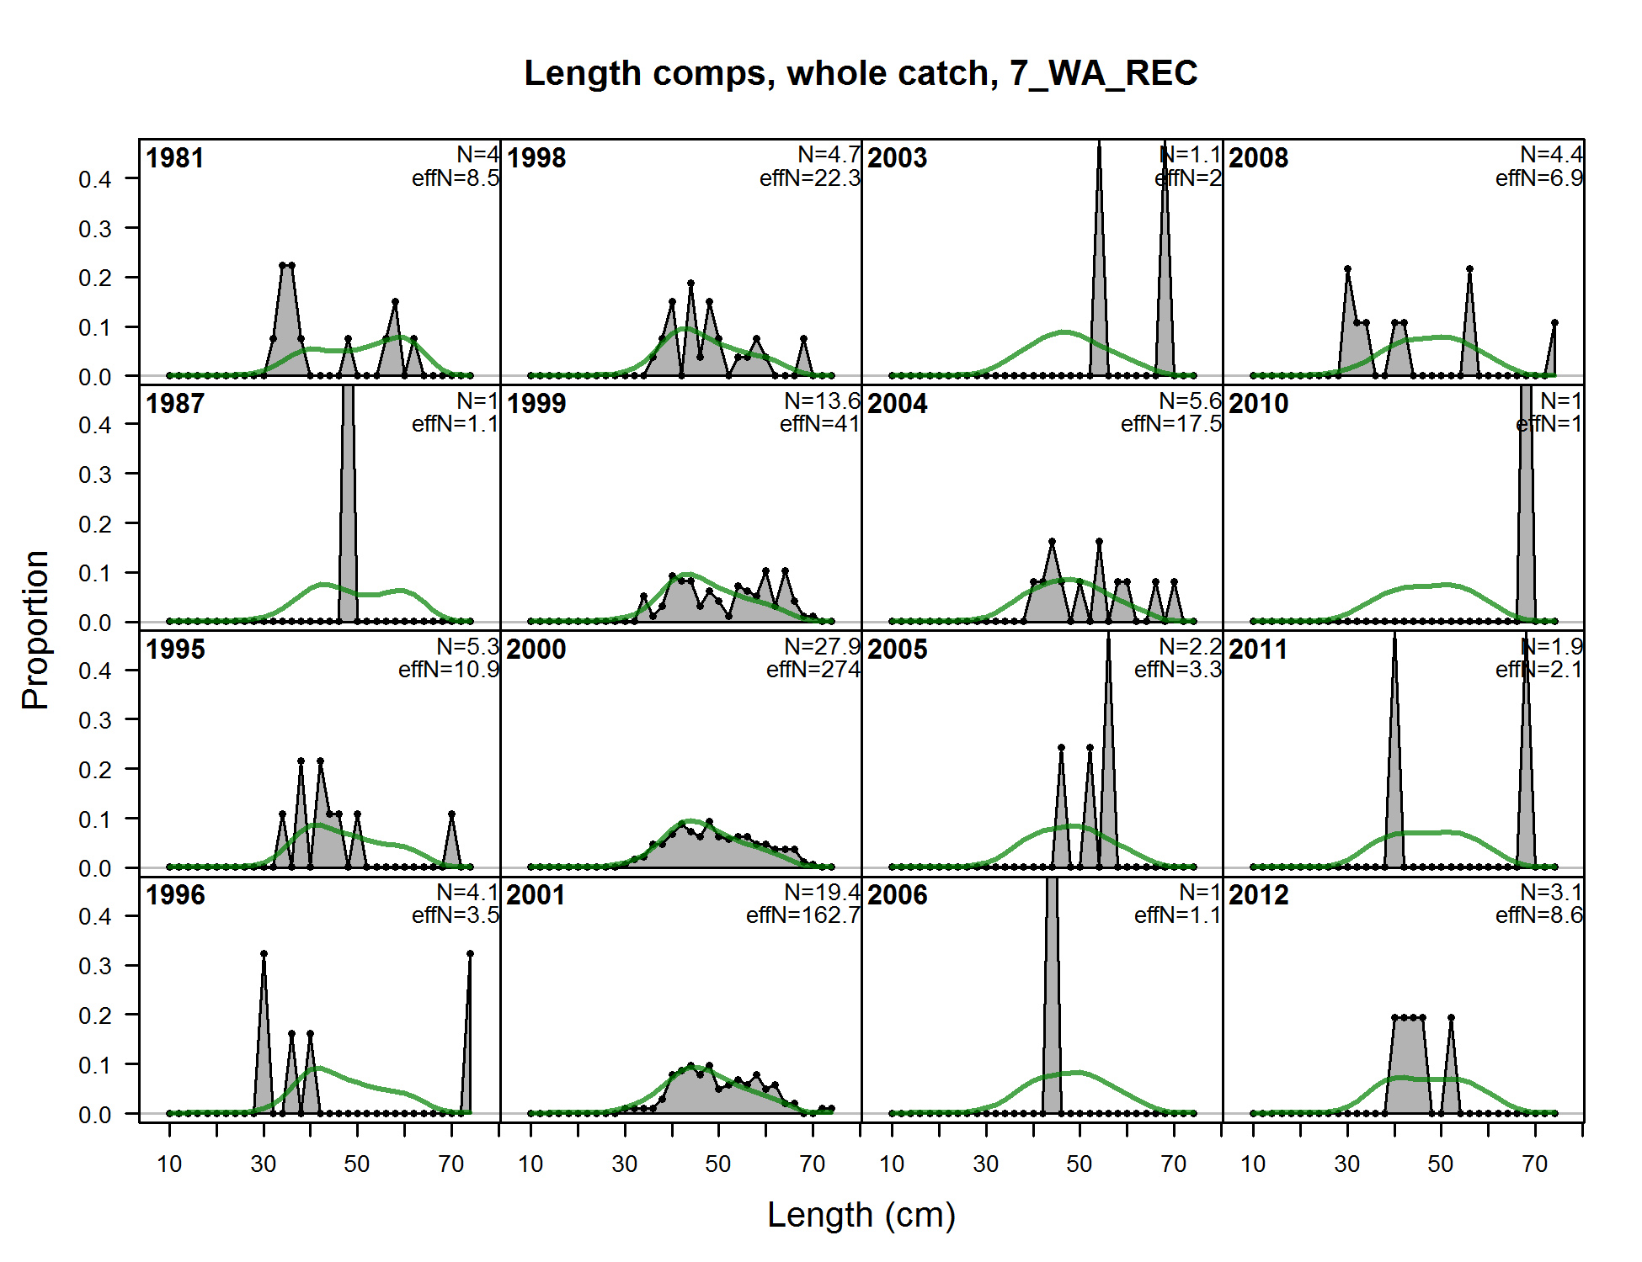

Figure . Fits to the Washington recreational fishery length compositions, years 1981-2012.

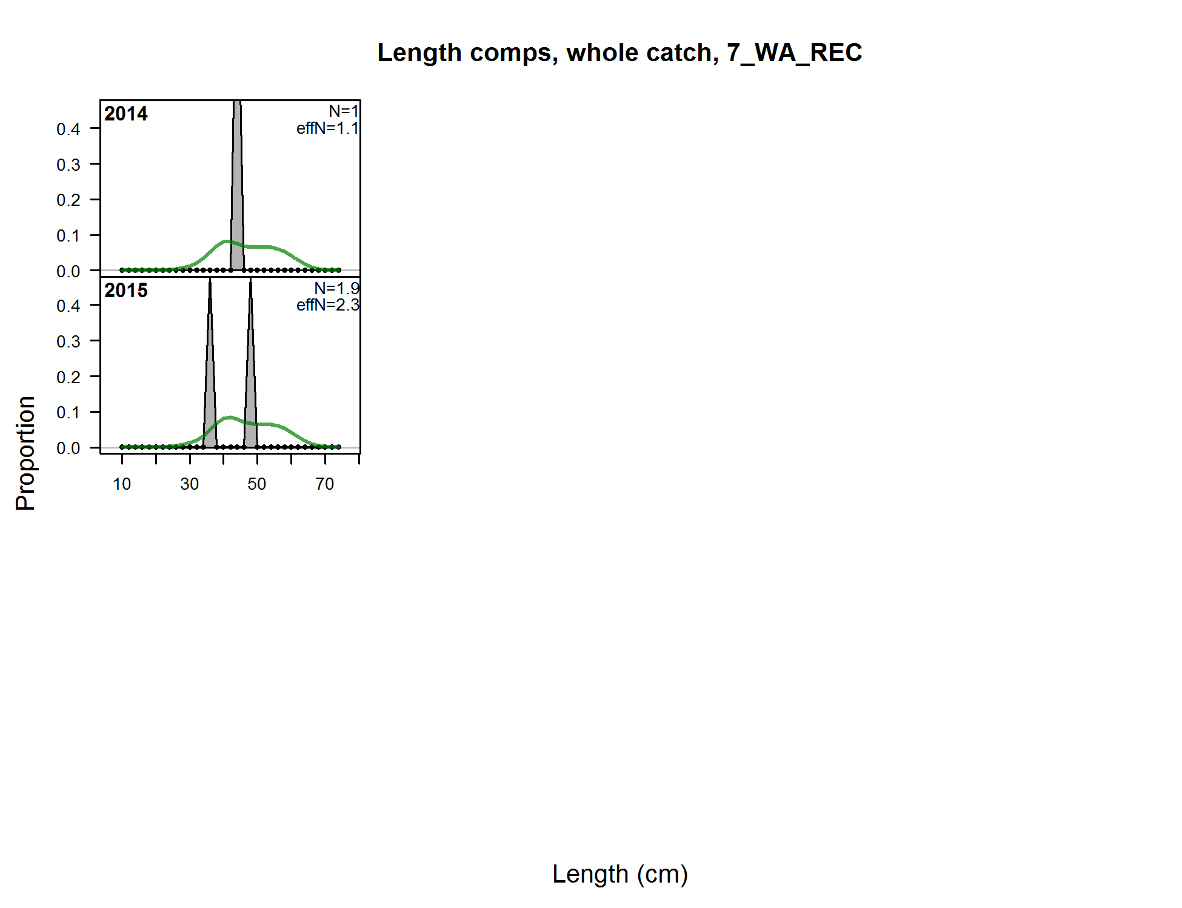

Figure . Fits to the Washington recreational fishery length compositions, years 2014-2015.

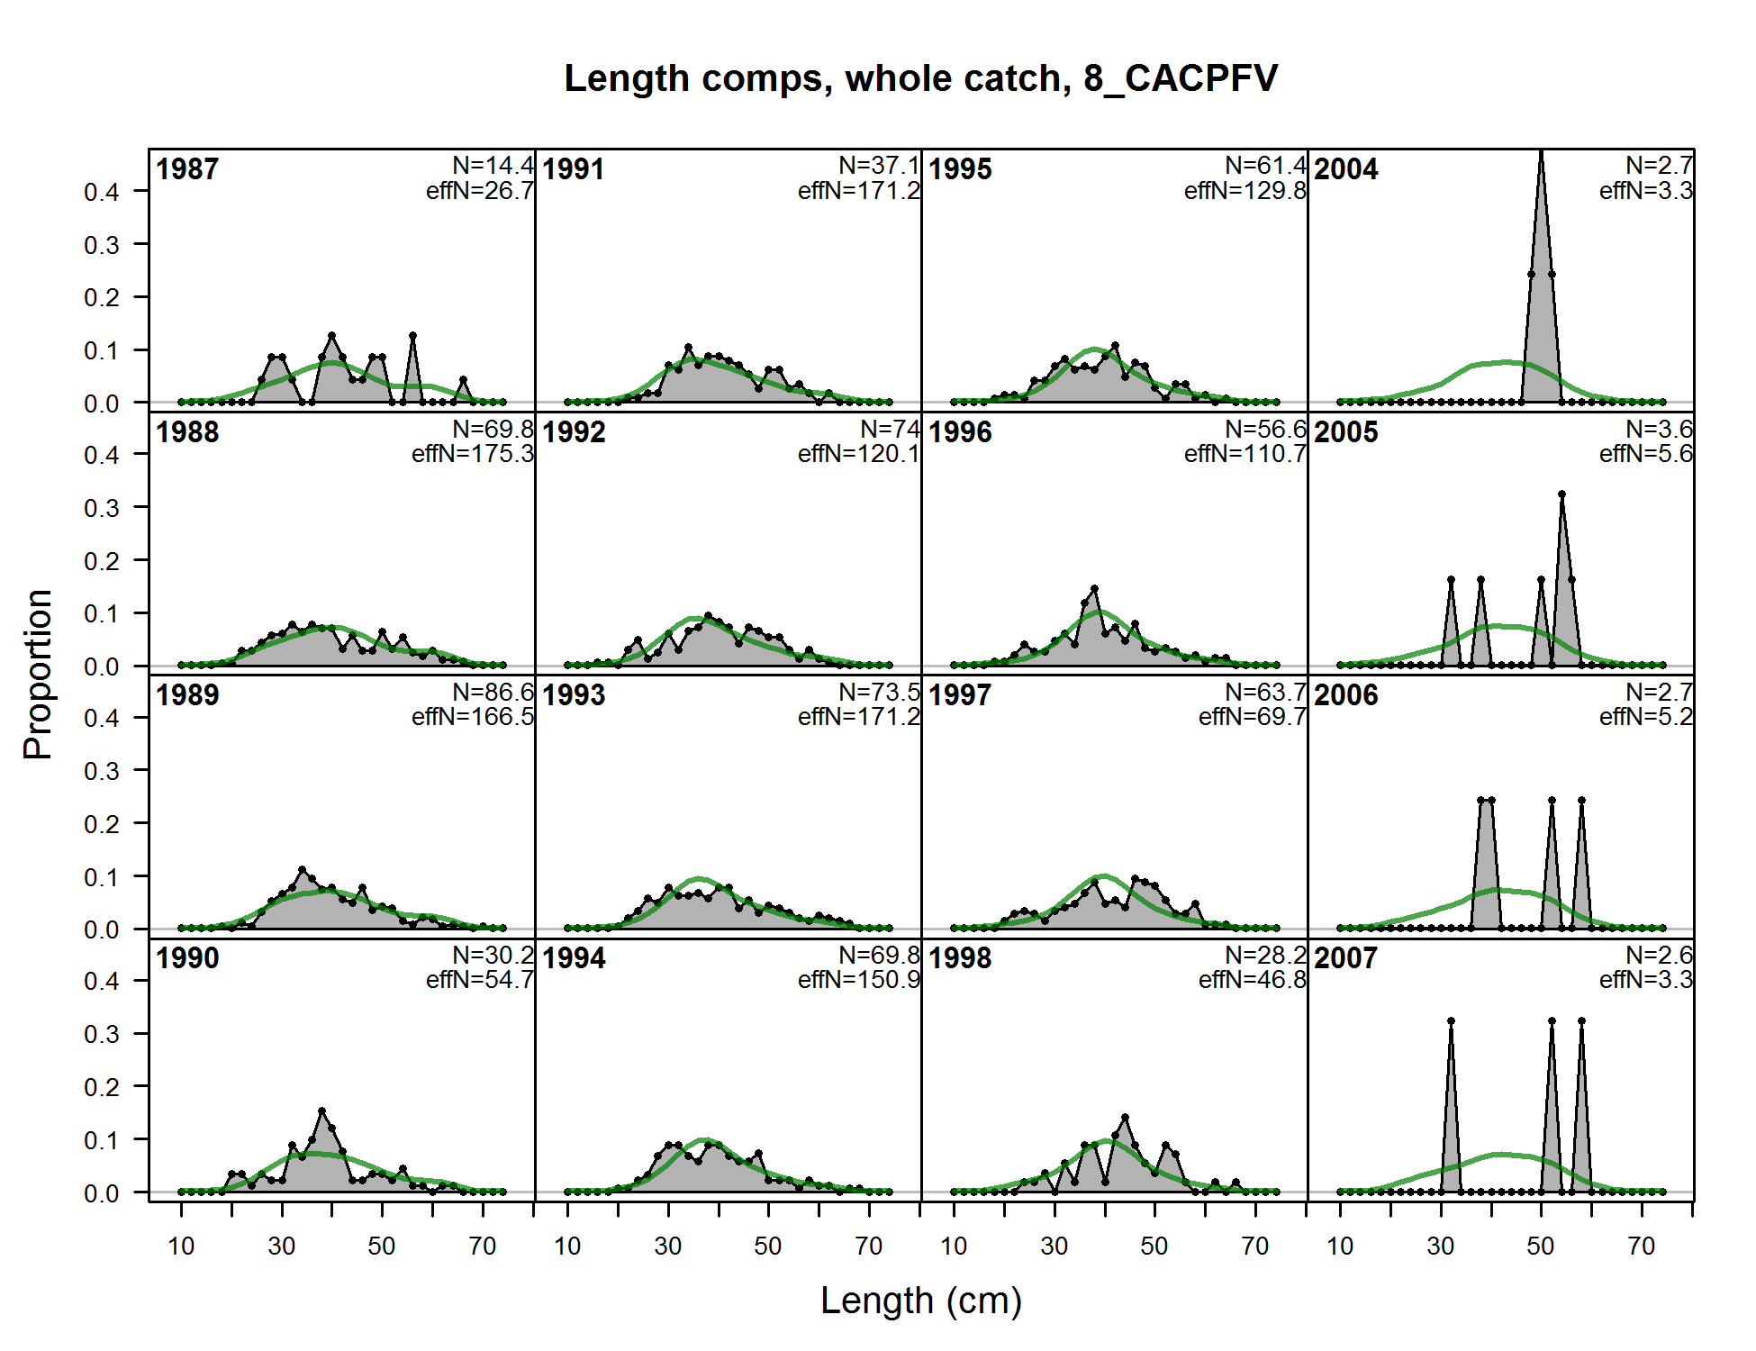

Figure . Fits to the California onboard recreational survey length compositions, years 1987-2007.

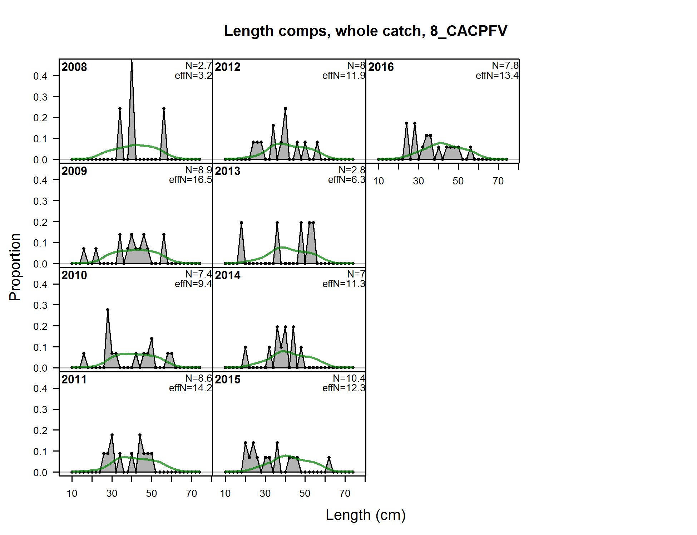

Figure . Fits to the California onboard recreational survey length compositions, years 2008-2016.

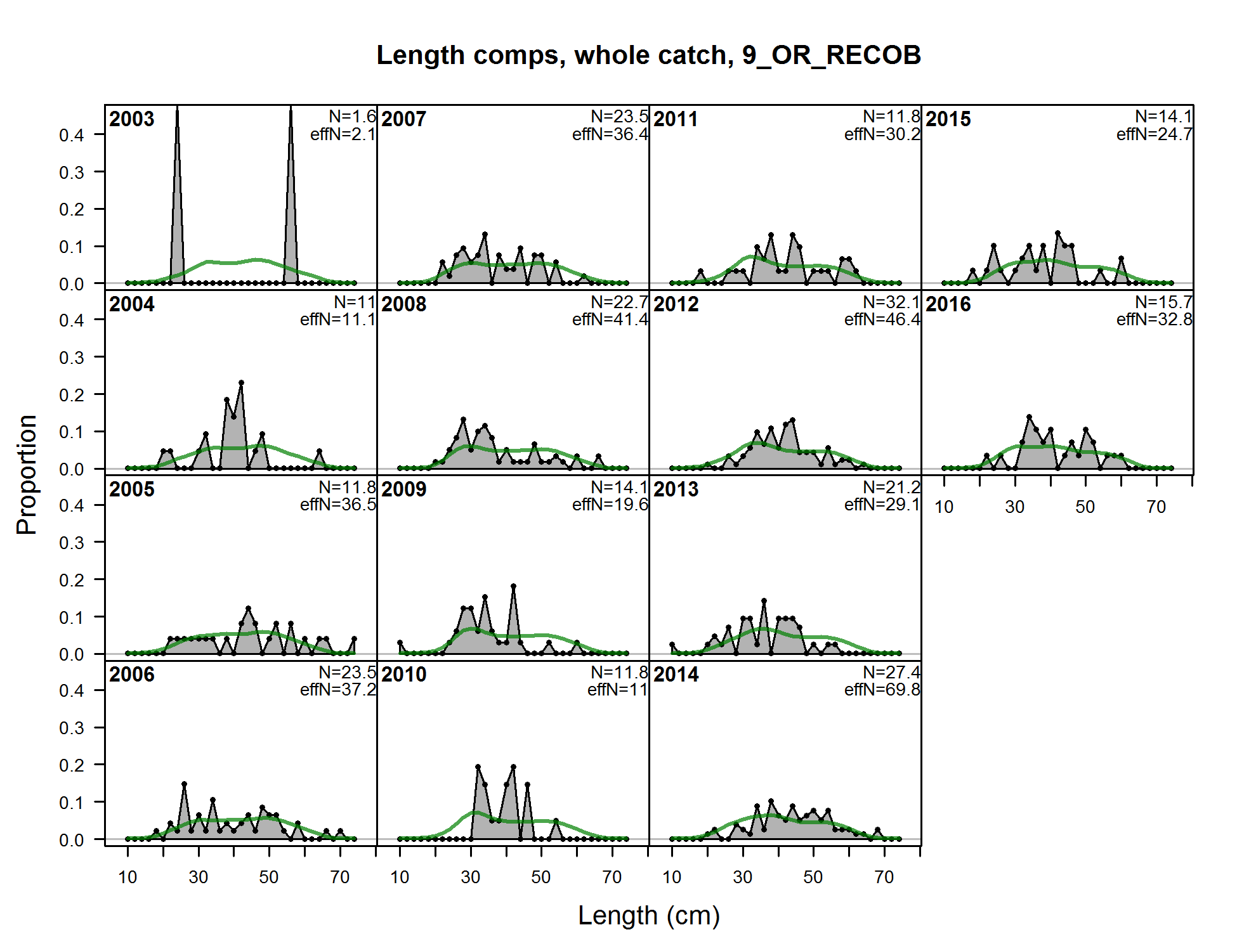

Figure . Fits to the Oregon onboard recreational index length compositions.

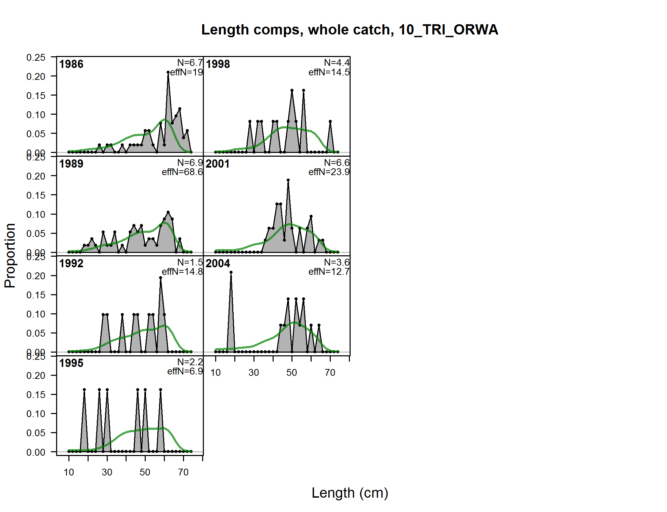

Figure . Fits to the AFSC Triennial survey length compositions.

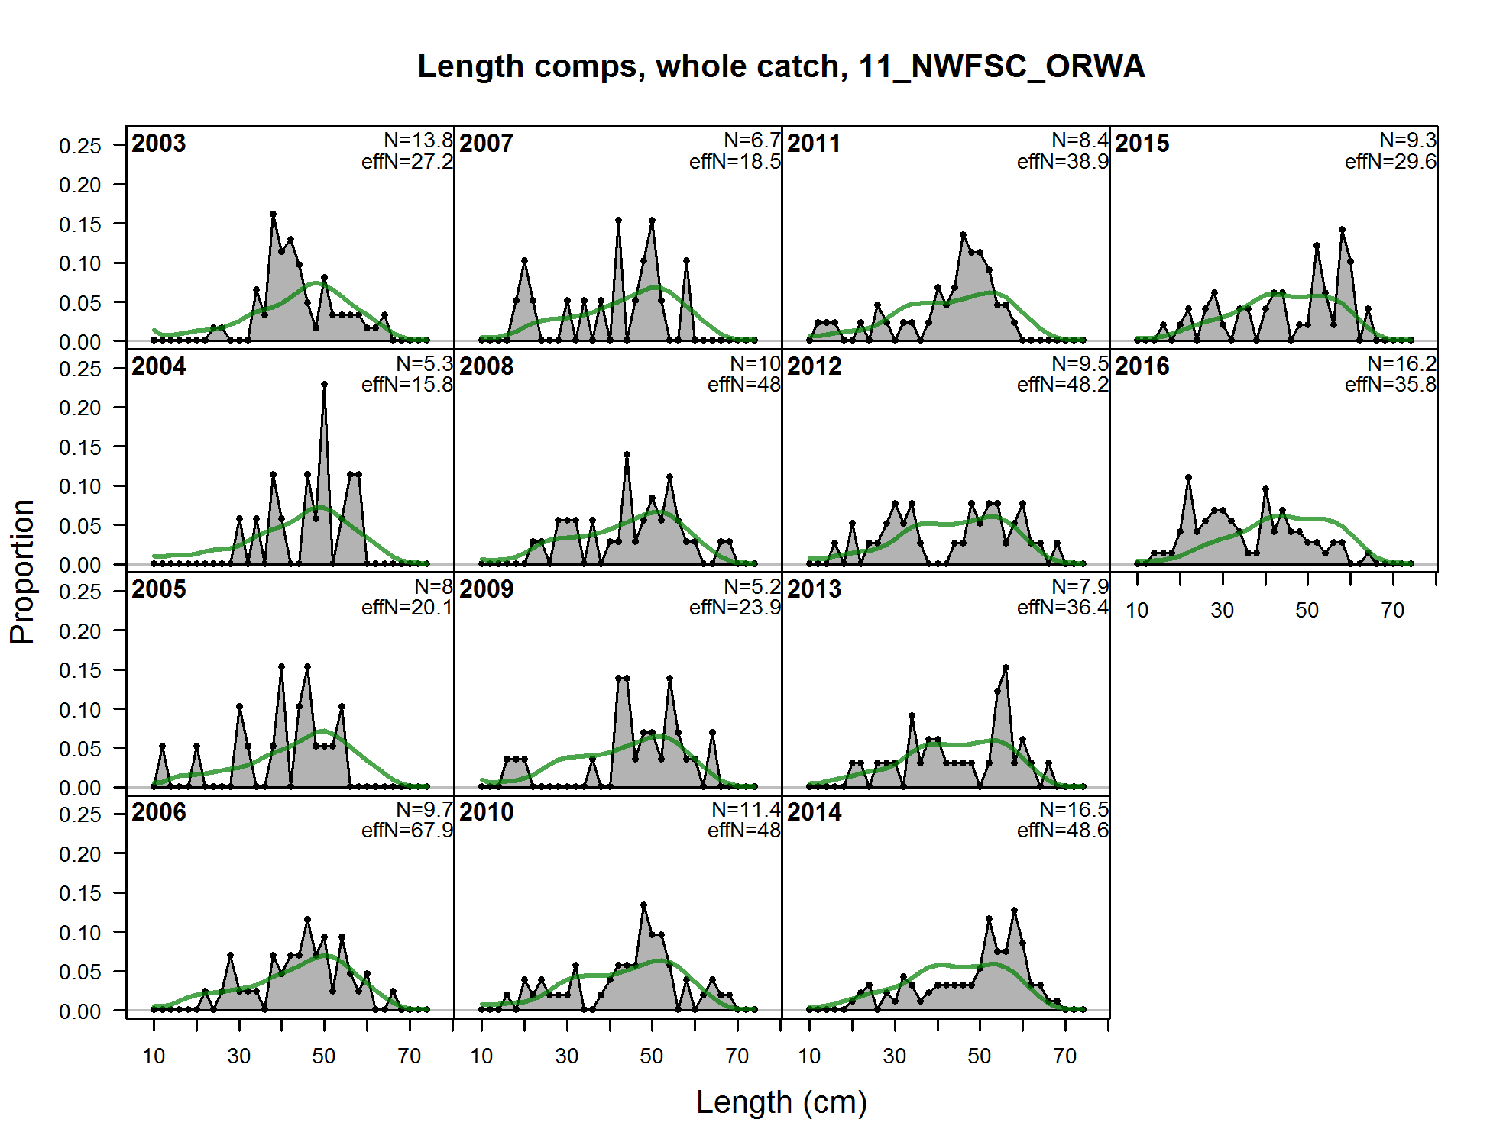

Figure . Fits to the NWFSC NWFSC trawl survey length compositions.

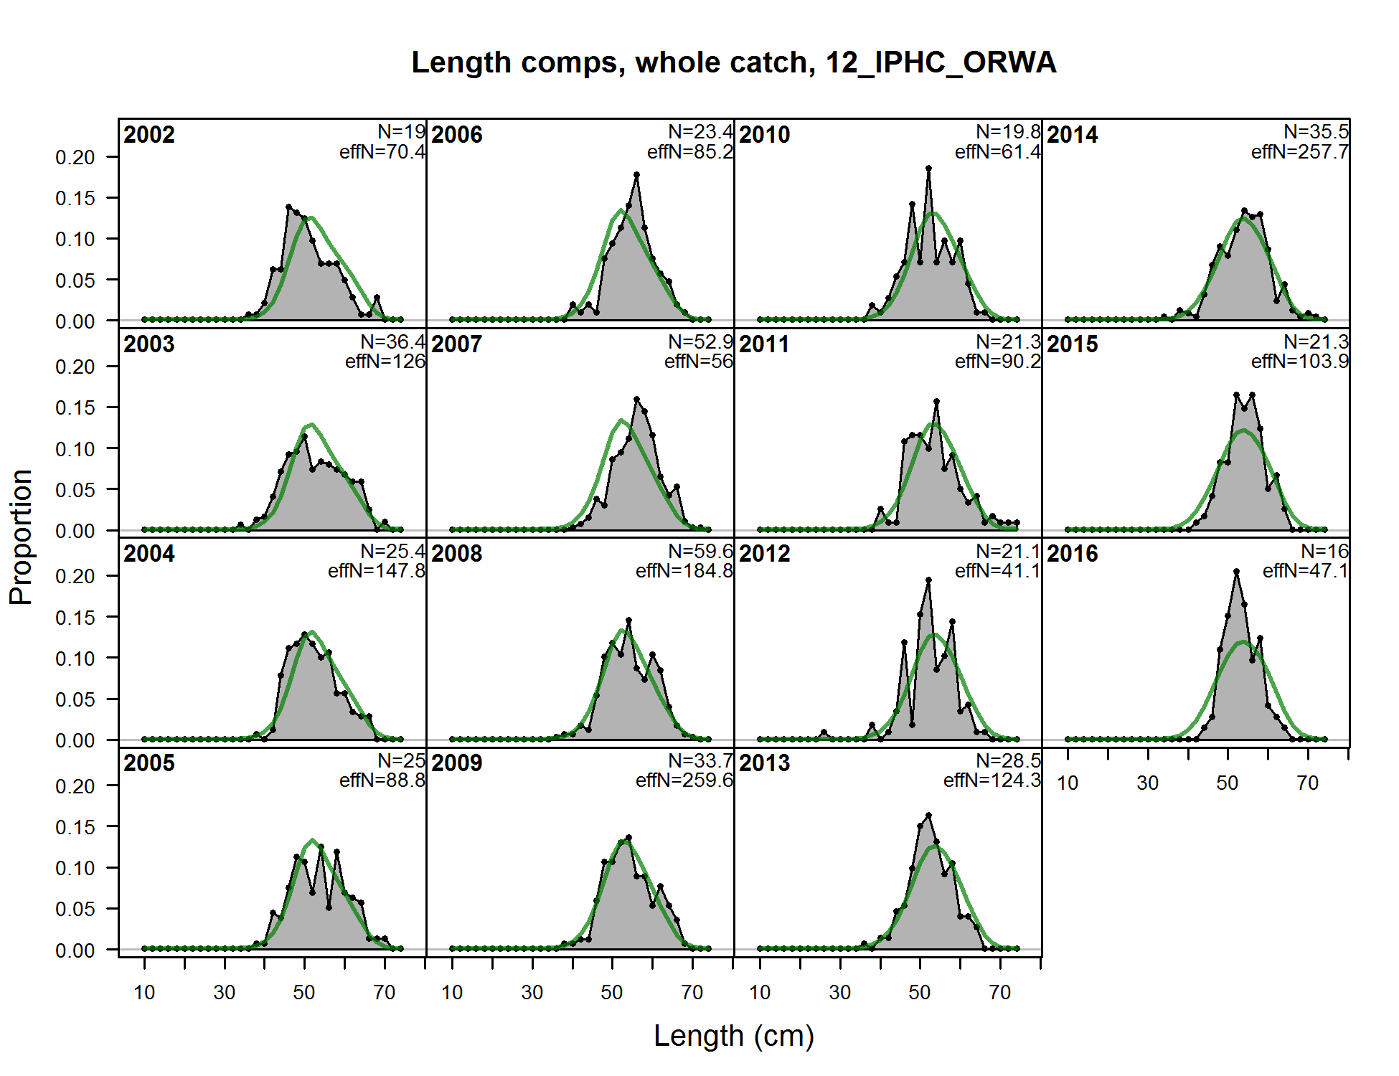

Figure . Fits to the IPHC survey length compositions.

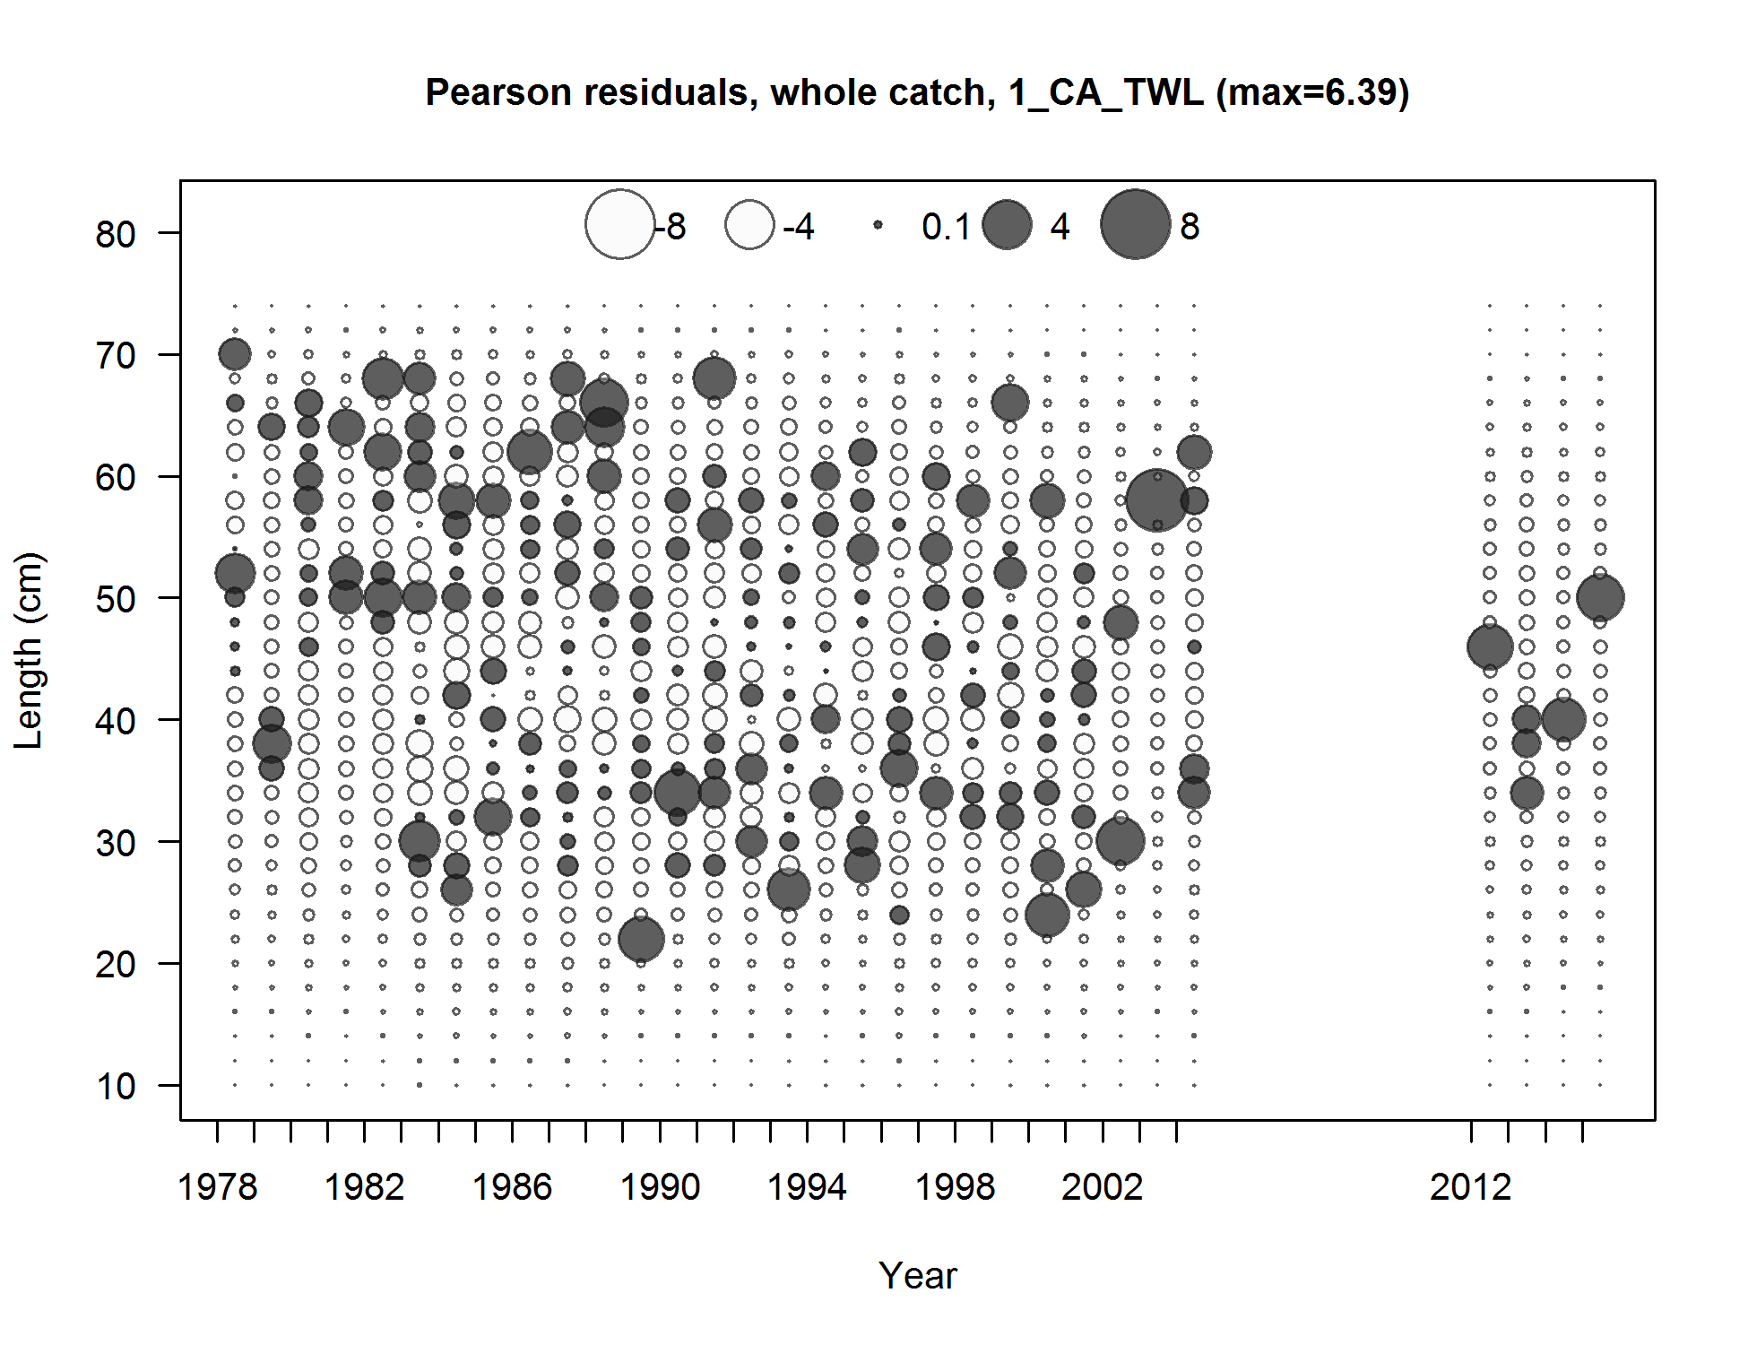

Figure . Pearson residuals plots of length compositions for the California commercial trawl fishery. Residuals <2 are generally considered non-significant.

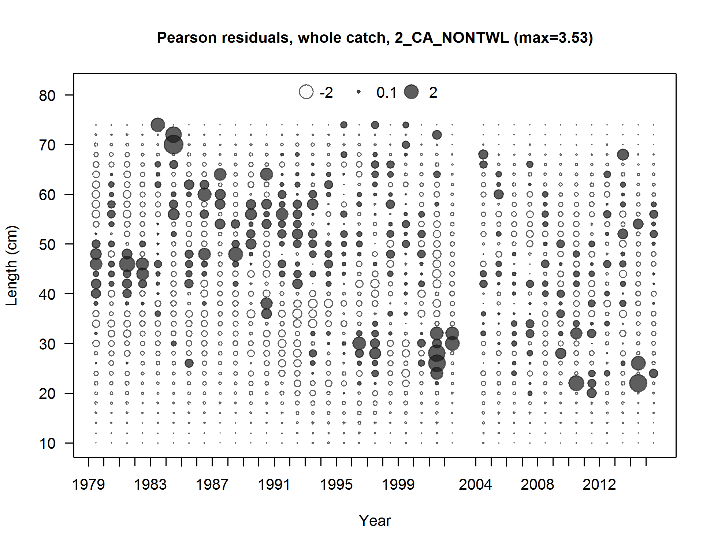

Figure . Pearson residuals plots of length compositions for the California commercial non-trawl fishery. Residuals <2 are generally considered non-significant.

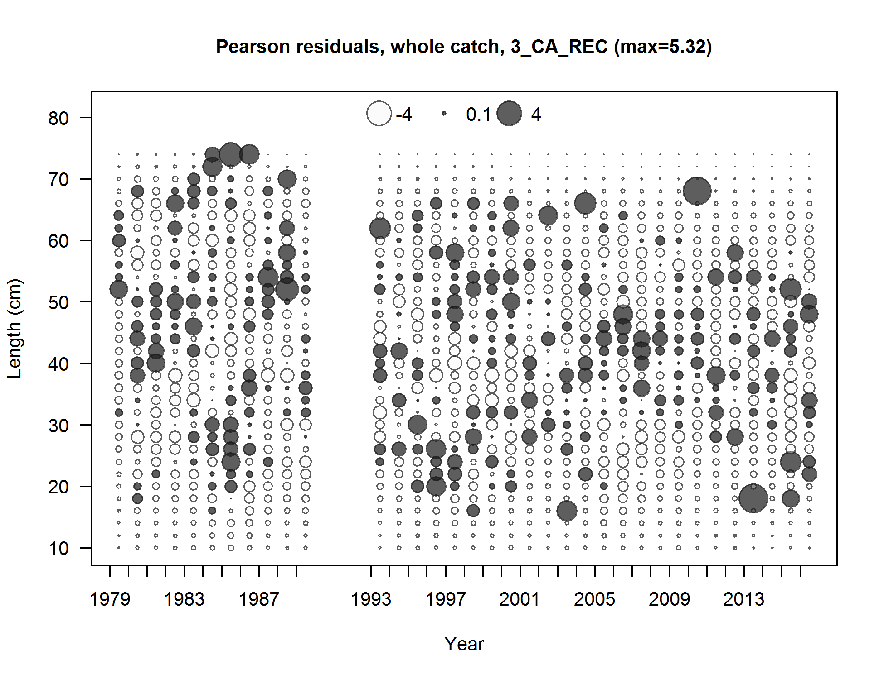

Figure . Pearson residuals plots of length compositions for the California recreational fishery. Residuals <2 are generally considered non-significant.

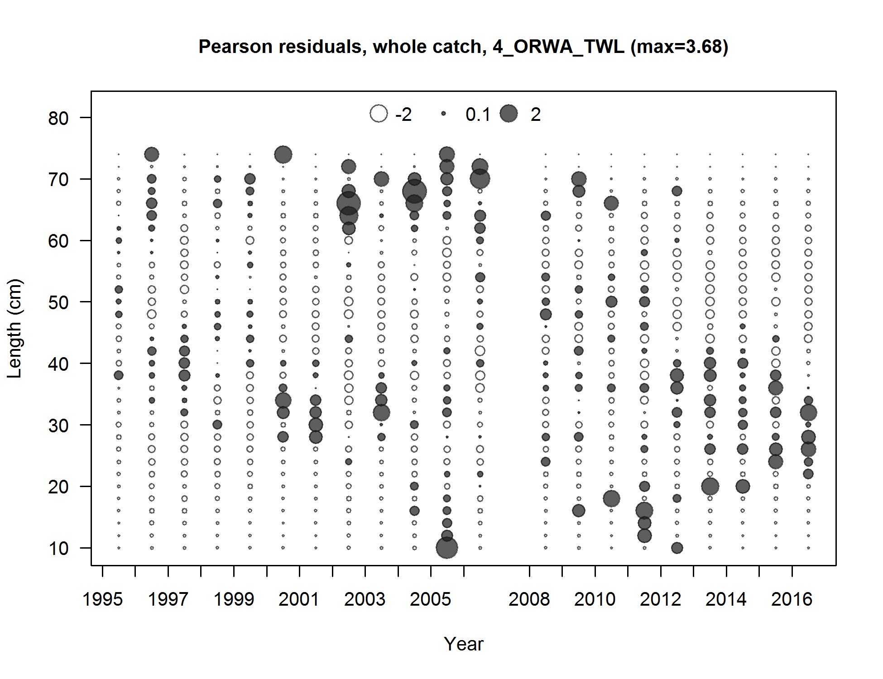

Figure . Pearson residuals plots of length compositions for the Oregon-Washington commercial trawl fishery. Residuals <2 are generally considered non-significant.

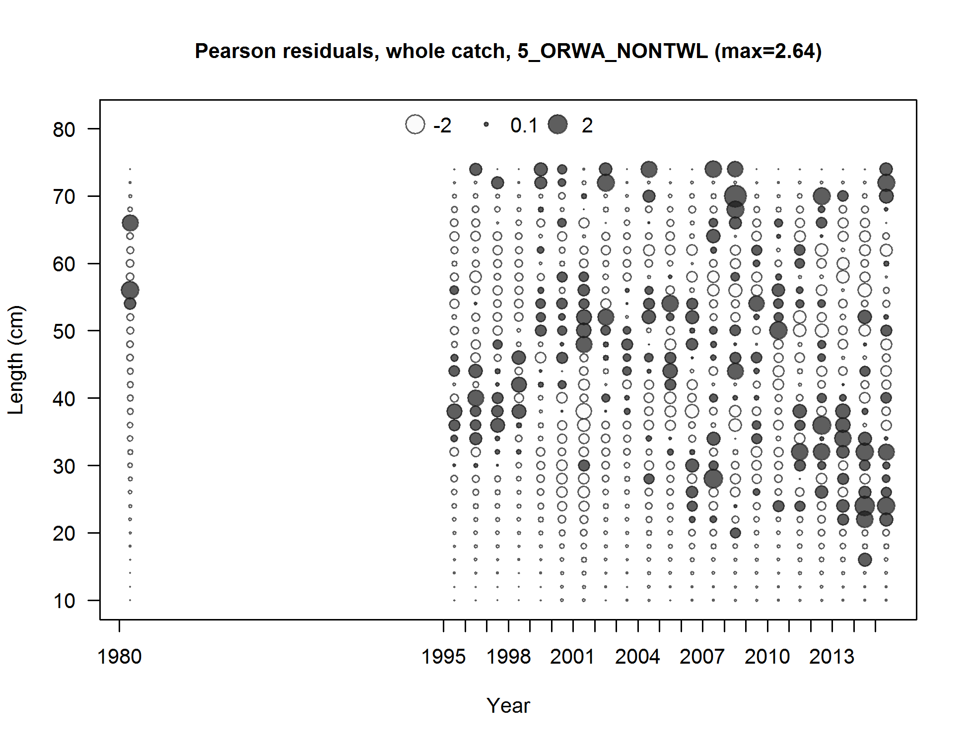

Figure . Pearson residuals plots of length compositions for the Oregon-Washington commercial non-trawl fishery. Residuals <2 are generally considered non-significant.

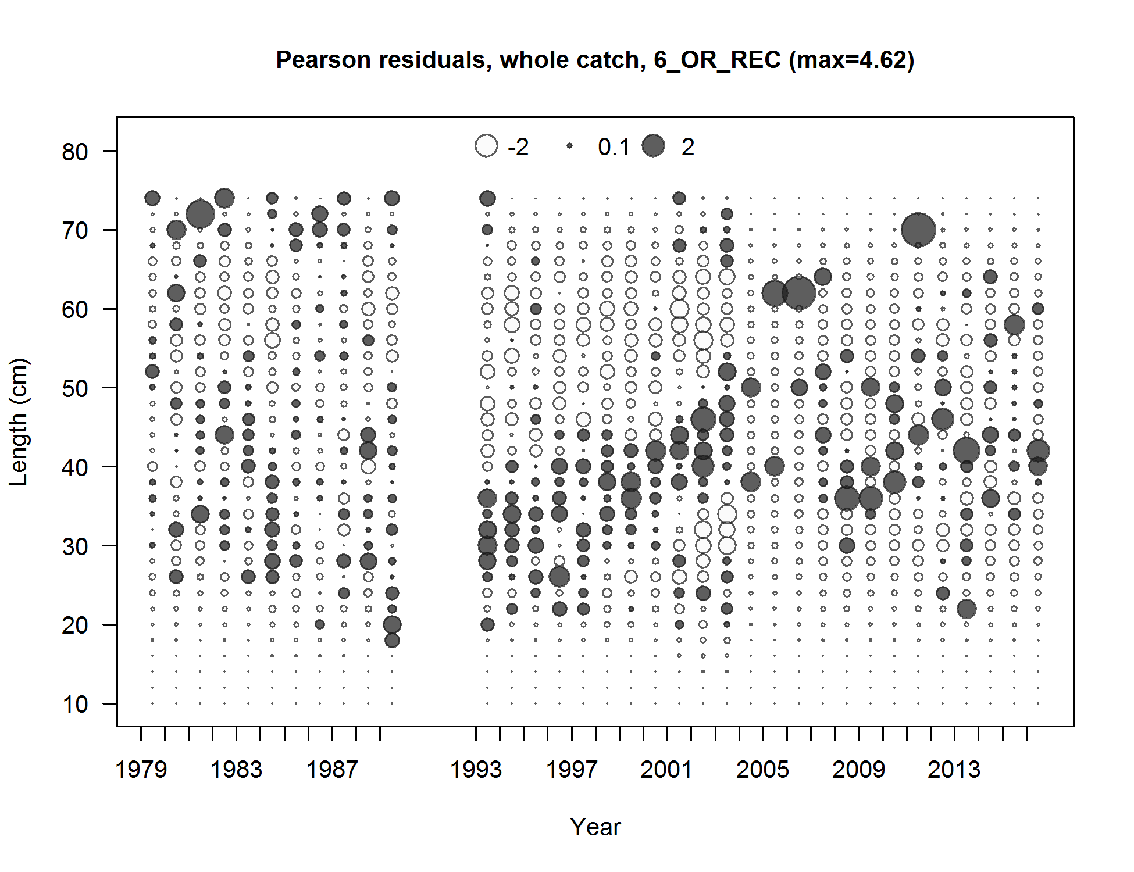

Figure . Pearson residuals plots of length compositions for the Oregon recreational fishery. Residuals <2 are generally considered non-significant.

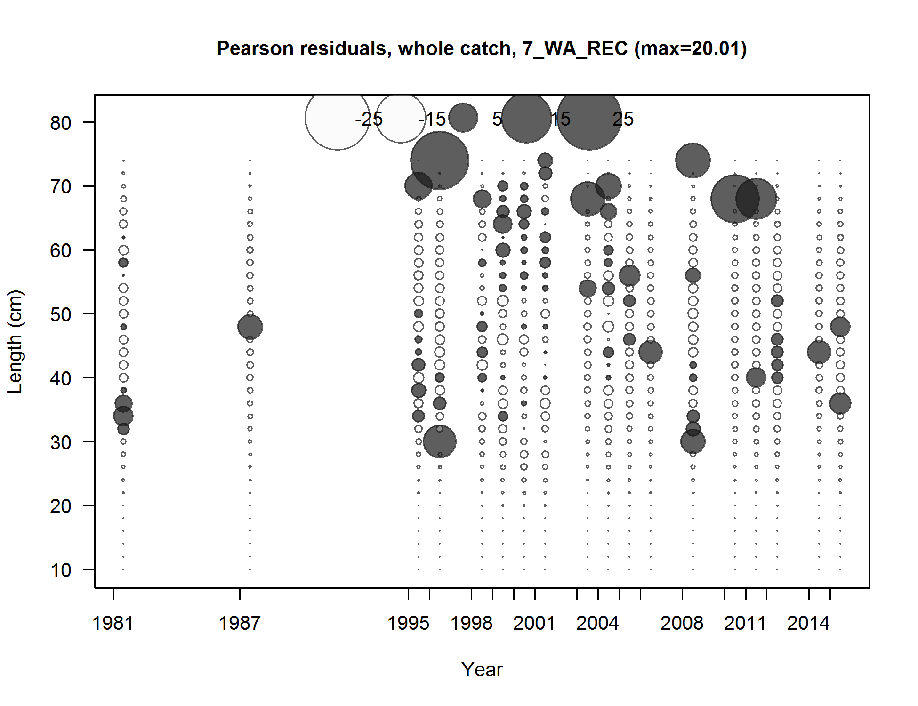

Figure . Pearson residuals plots of length compositions for the Washington recreational fishery. Residuals <2 are generally considered non-significant.

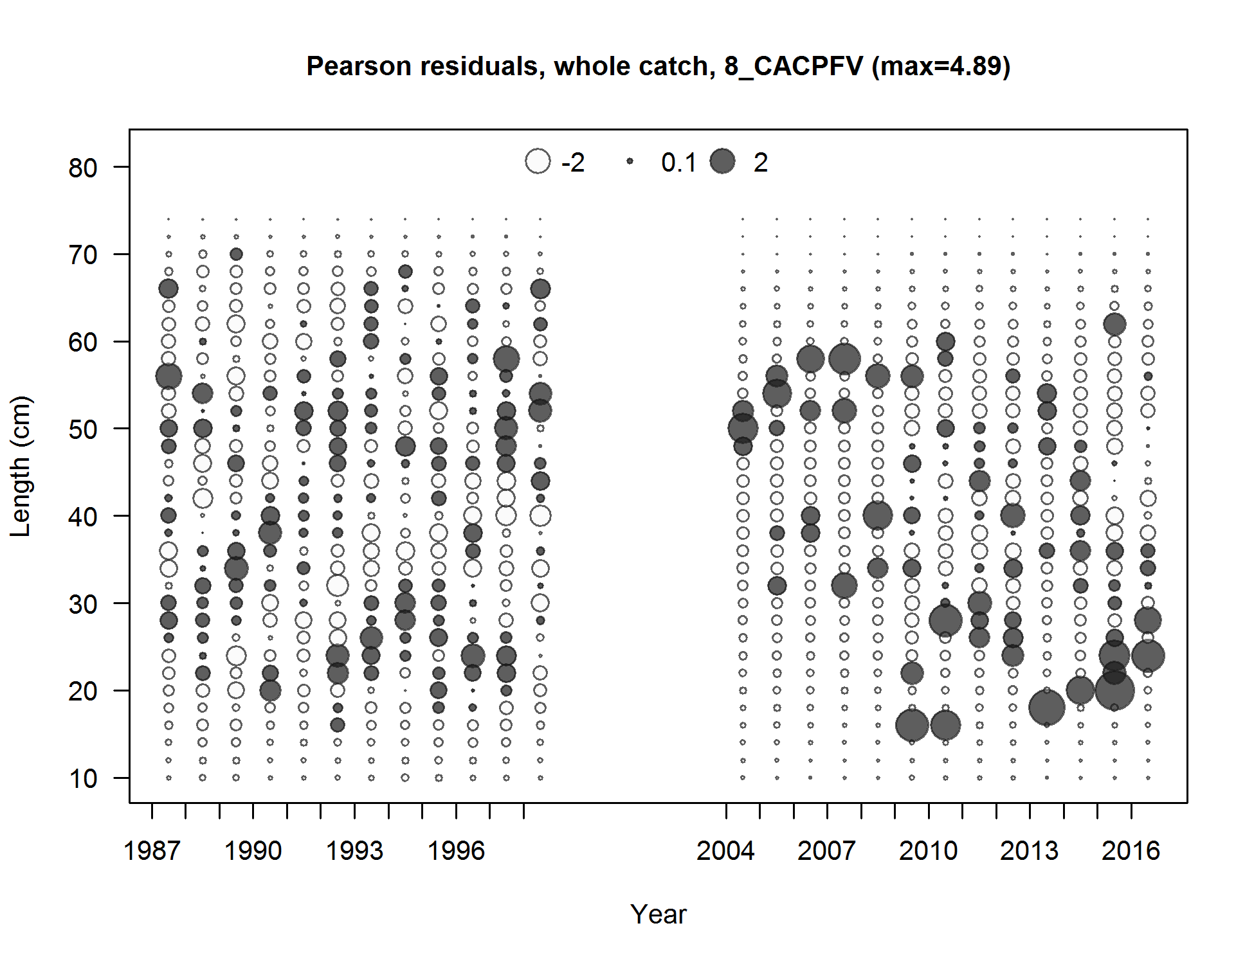

Figure . Pearson residuals plots of length compositions for the California CPFV recreational index. Residuals <2 are generally considered non-significant.

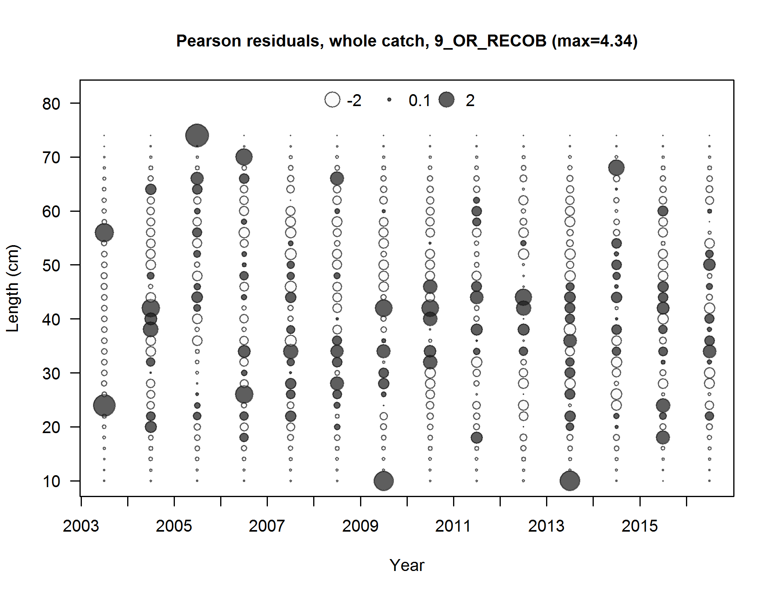

Figure . Pearson residuals plots of length compositions for the Oregon onboard recreational index. Residuals <2 are generally considered non-significant.

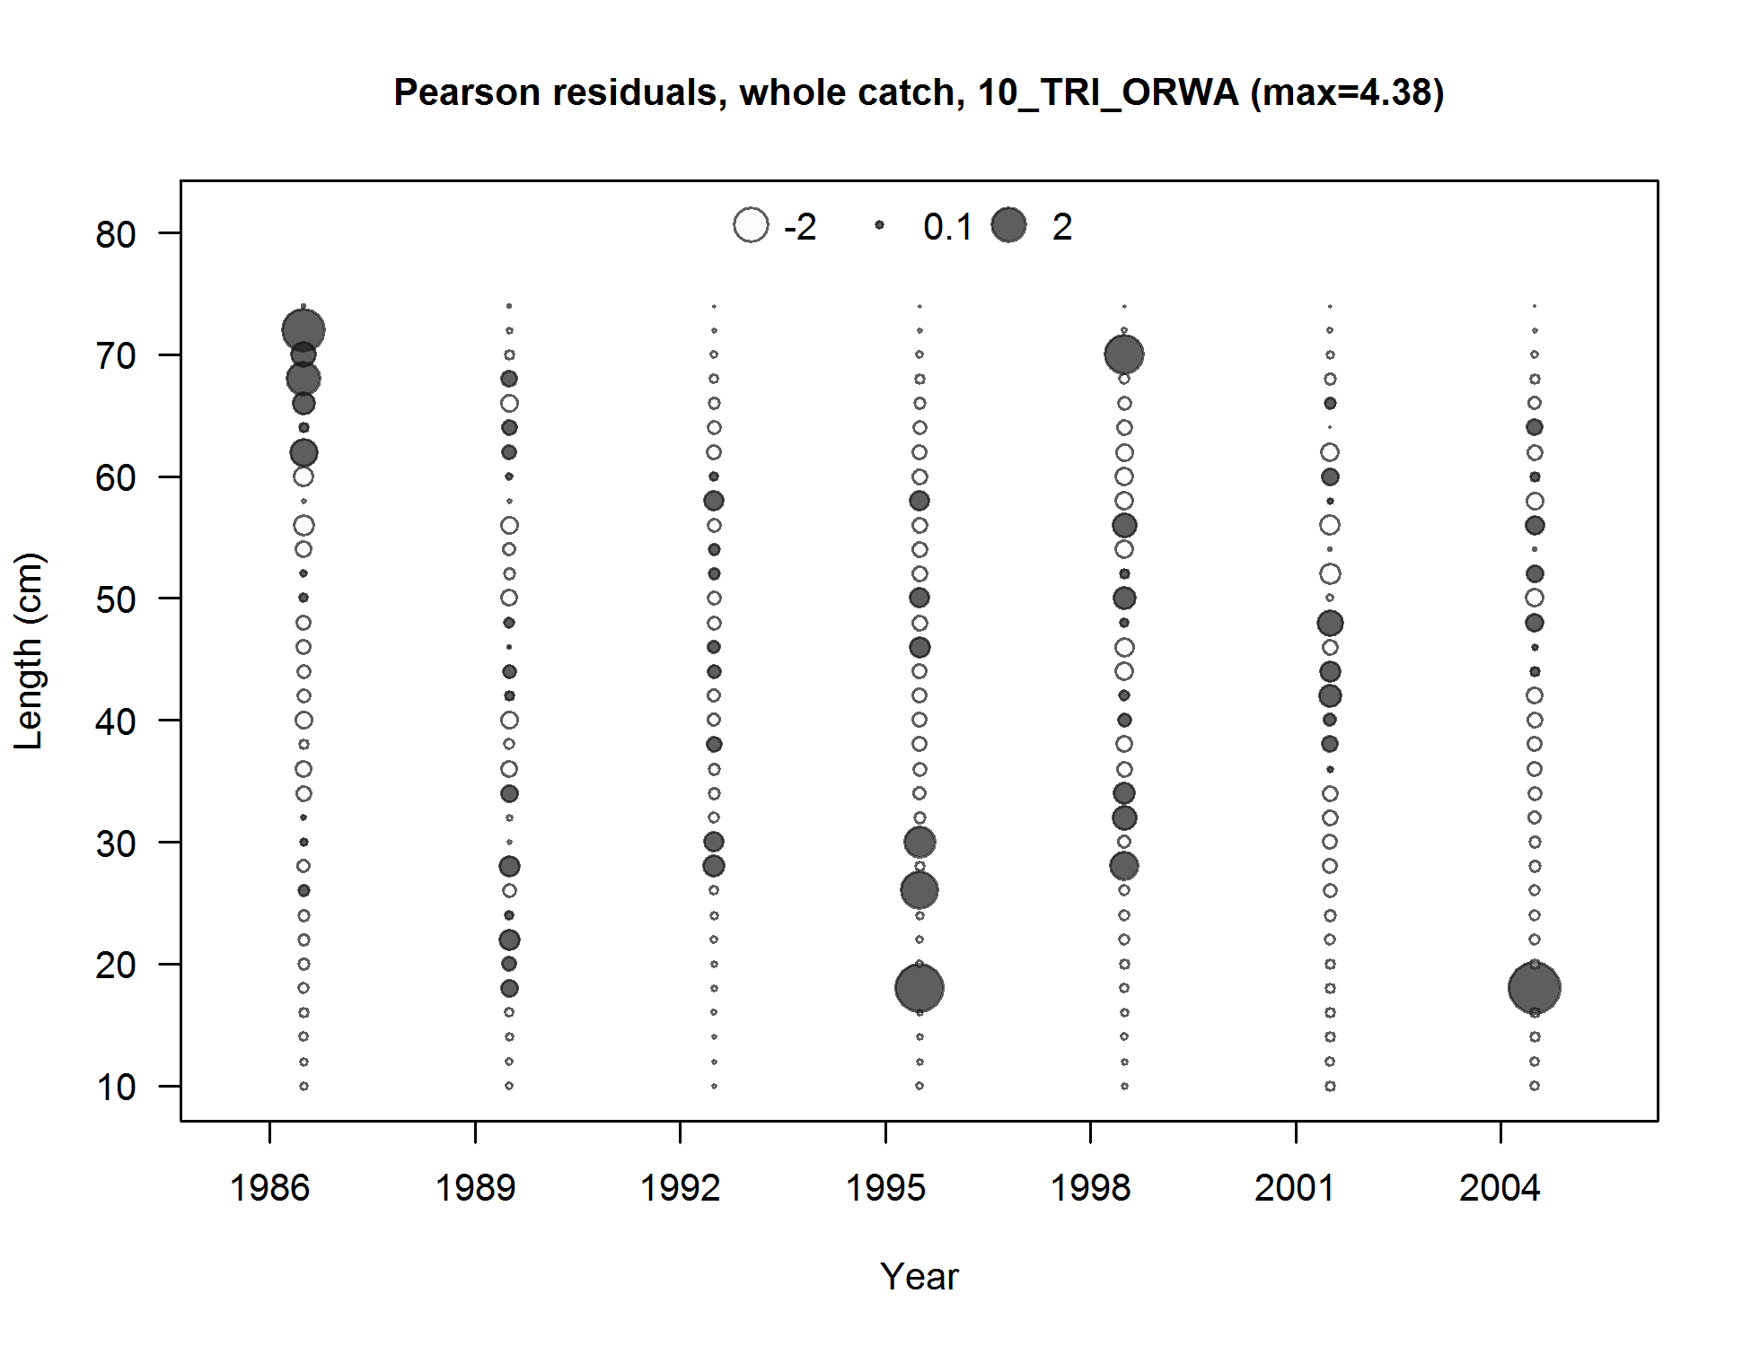

Figure . Pearson residuals plots of length compositions for the AFSC trawl survey. Residuals <2 are generally considered non-significant.

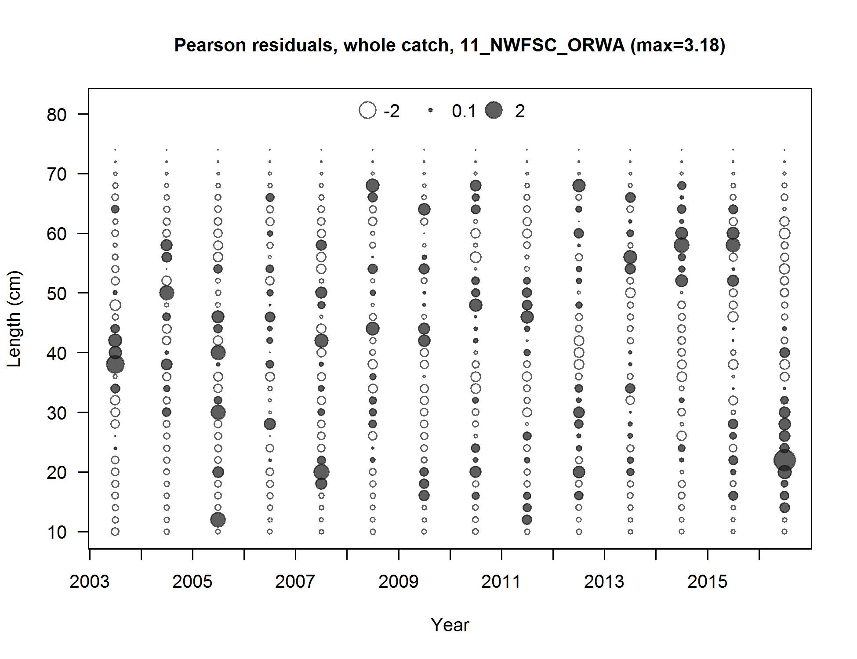

Figure . Pearson residuals plots of length compositions for the NWFSC WCGTS. Residuals <2 are generally considered non-significant.

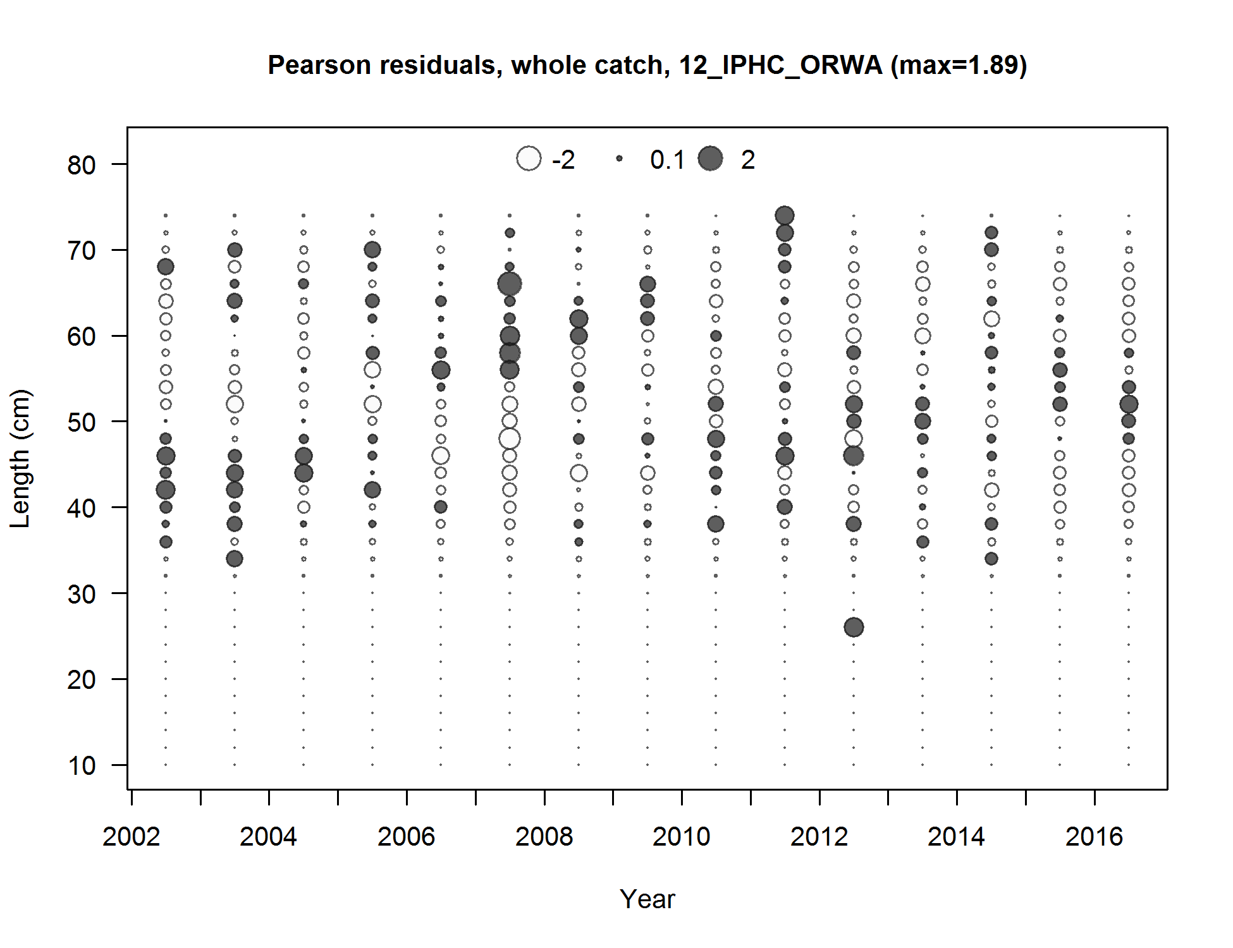

Figure . Pearson residuals plots of length compositions for the IPHC survey. Residuals <2 are generally considered non-significant.

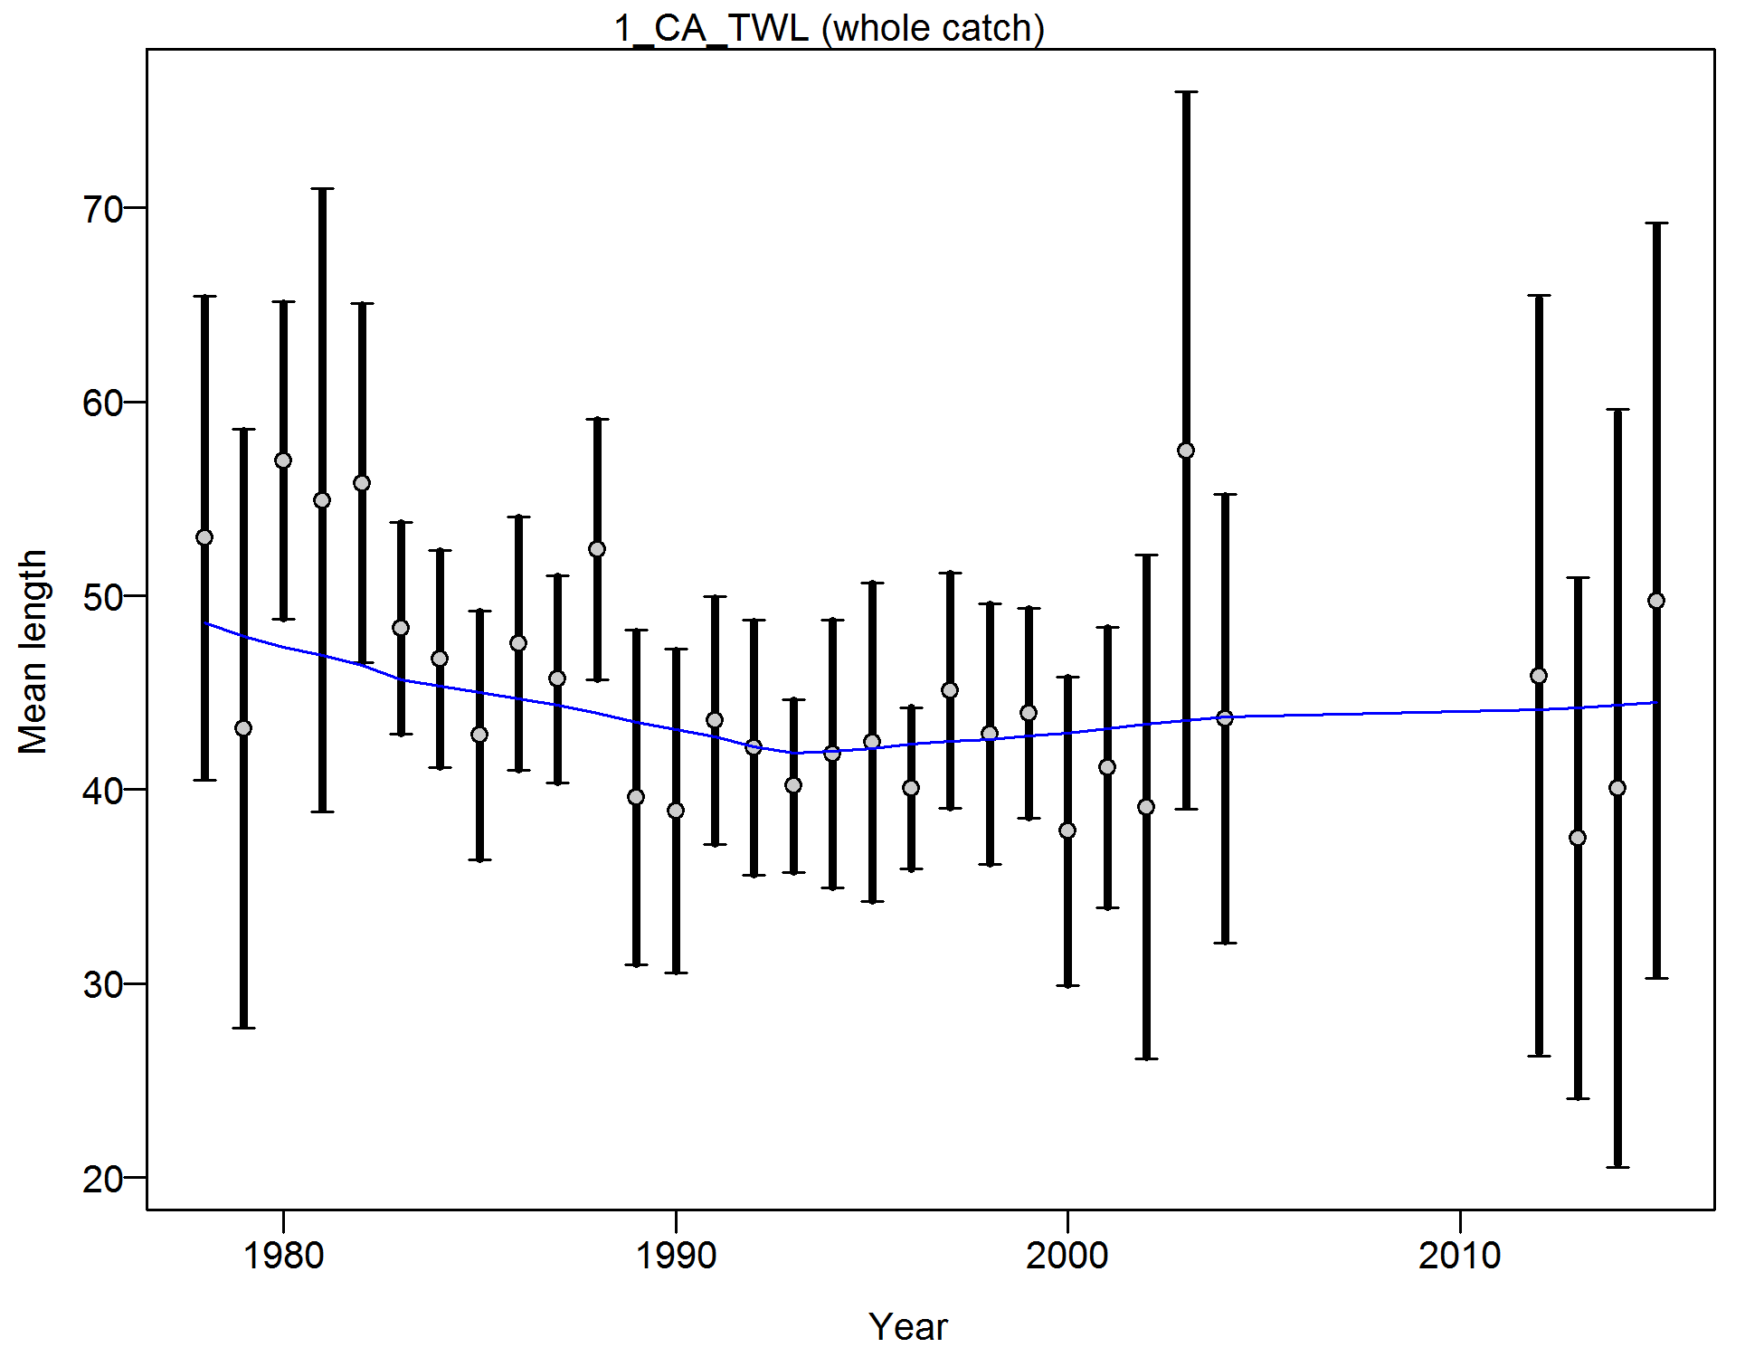

Figure . Francis weighting fits to the mean lengths by year for the California commercial trawl fleet. Vertical lines are 95% confidence intervals.

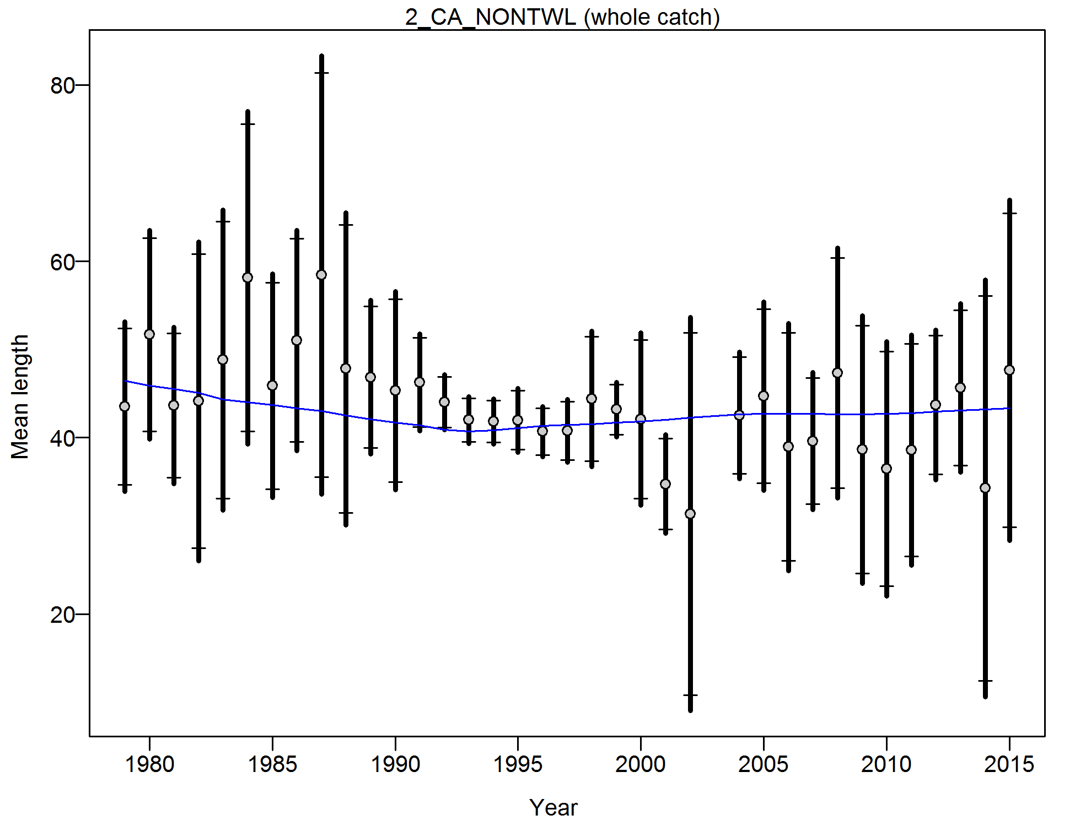

Figure . Francis weighting fits to the mean lengths by year for the California commercial non-trawl fleet. Vertical lines are 95% confidence intervals.

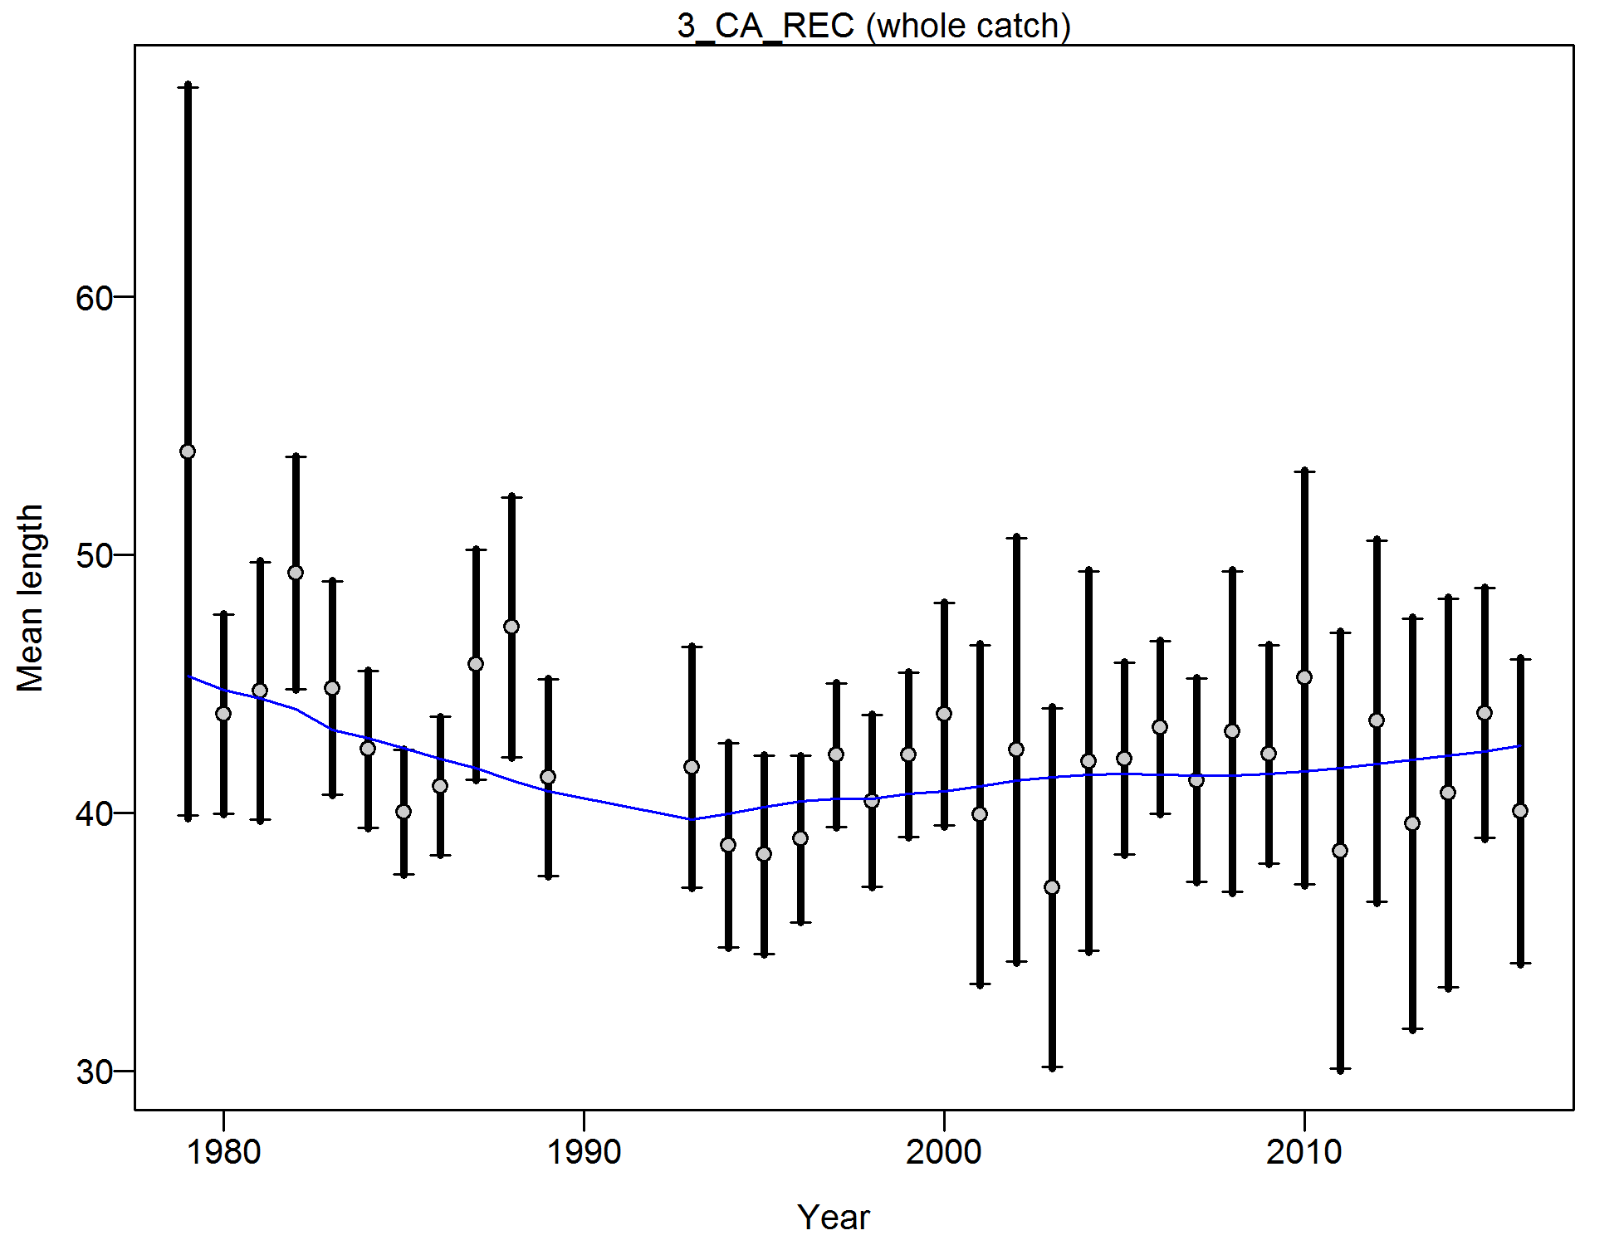

Figure . Francis weighting fits to the mean lengths by year for the California recreational fleet. Vertical lines are 95% confidence intervals.

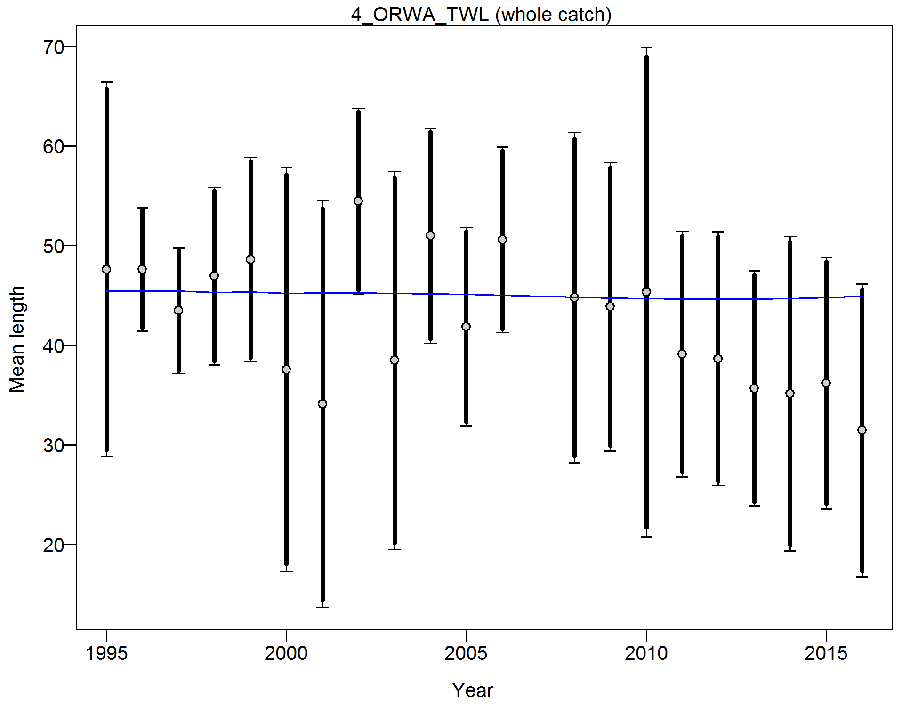

Figure . Francis weighting fits to the mean lengths by year for the Oregon-Washington commercial trawl fleet. Vertical lines are 95% confidence intervals.

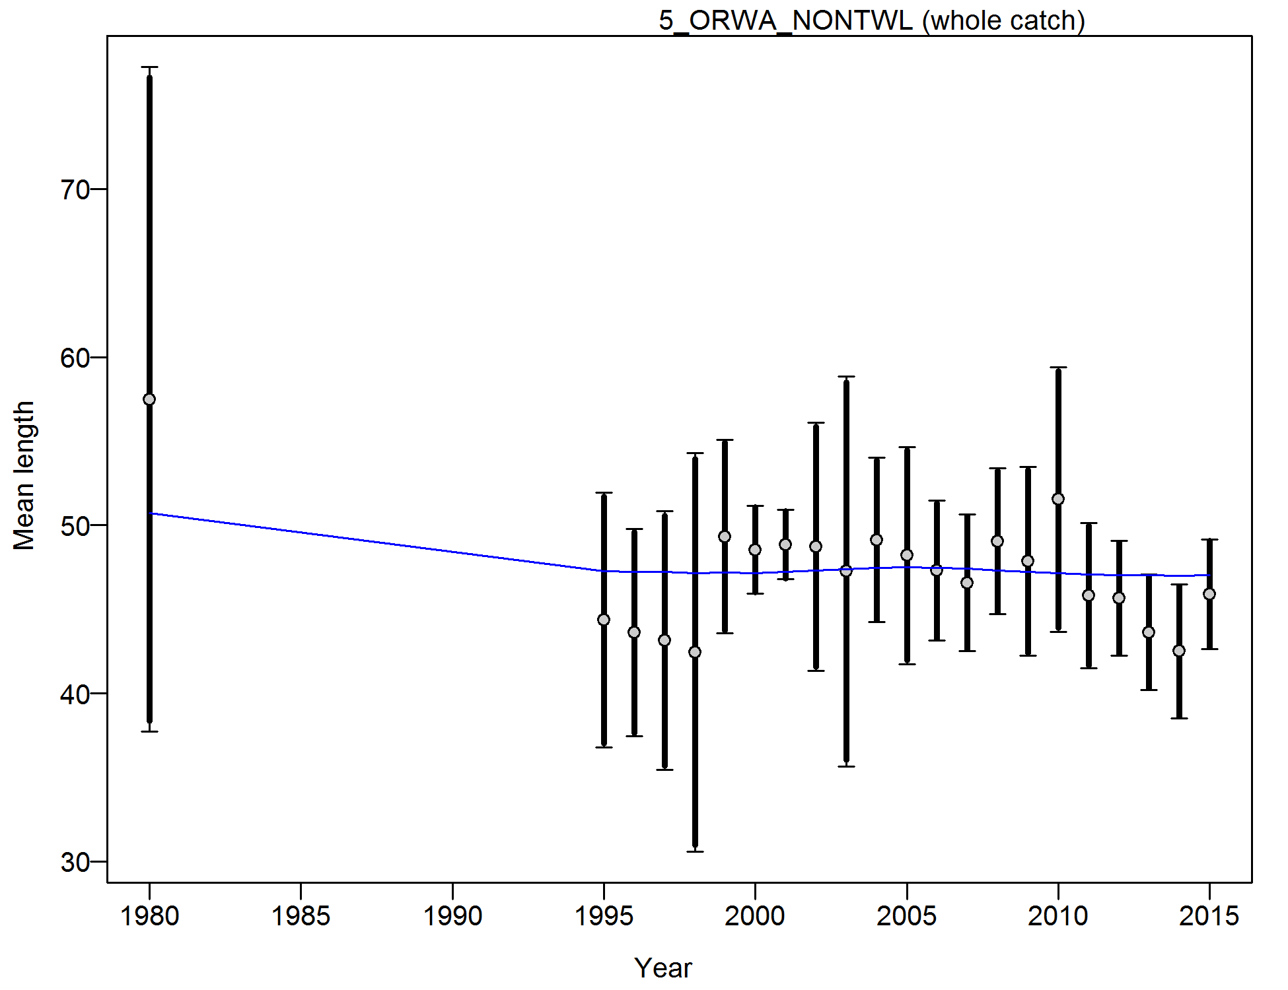

Figure . Francis weighting fits to the mean lengths by year for the Oregon-Washington commercial non-trawl fleet. Vertical lines are 95% confidence intervals.

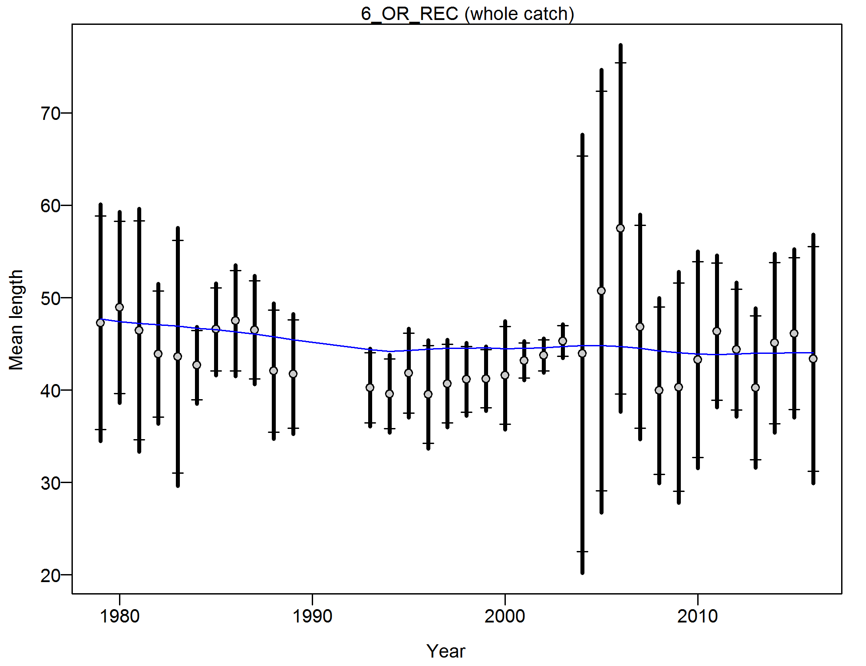

Figure . Francis weighting fits to the mean lengths by year for the Oregon recreational fleet. Vertical lines are 95% confidence intervals.

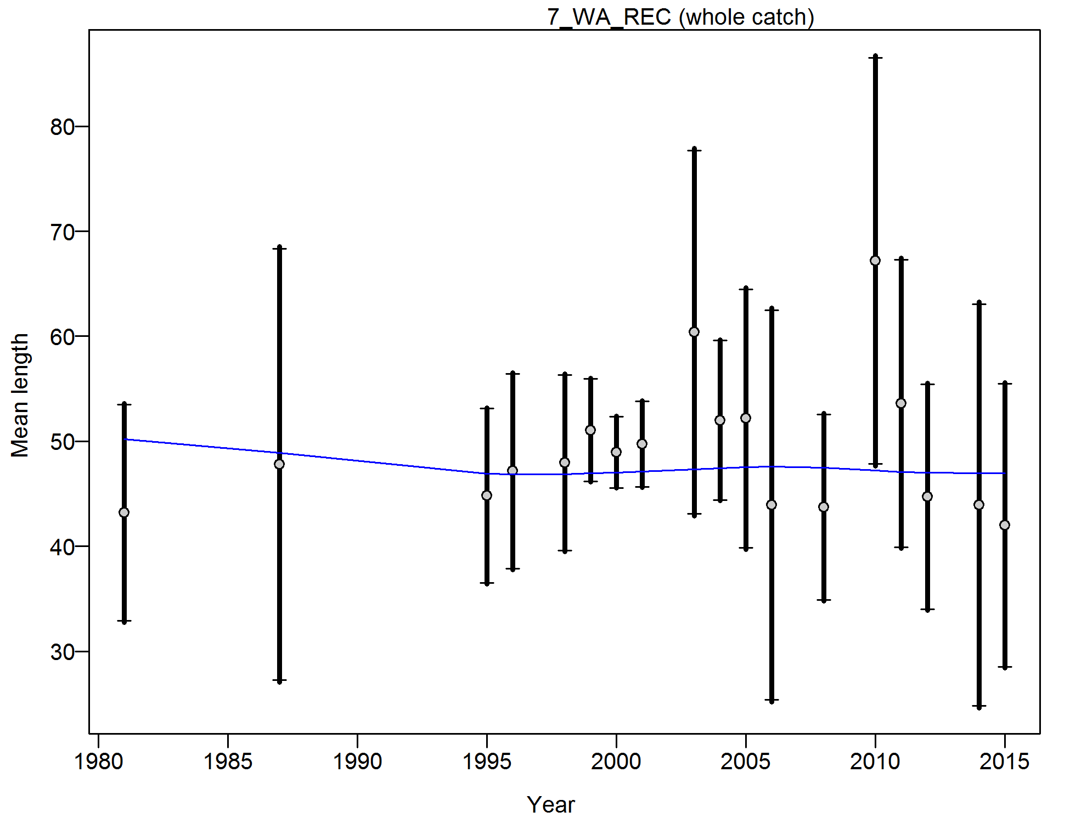

Figure . Francis weighting fits to the mean lengths by year for the Washington recreational fleet. Vertical lines are 95% confidence intervals.

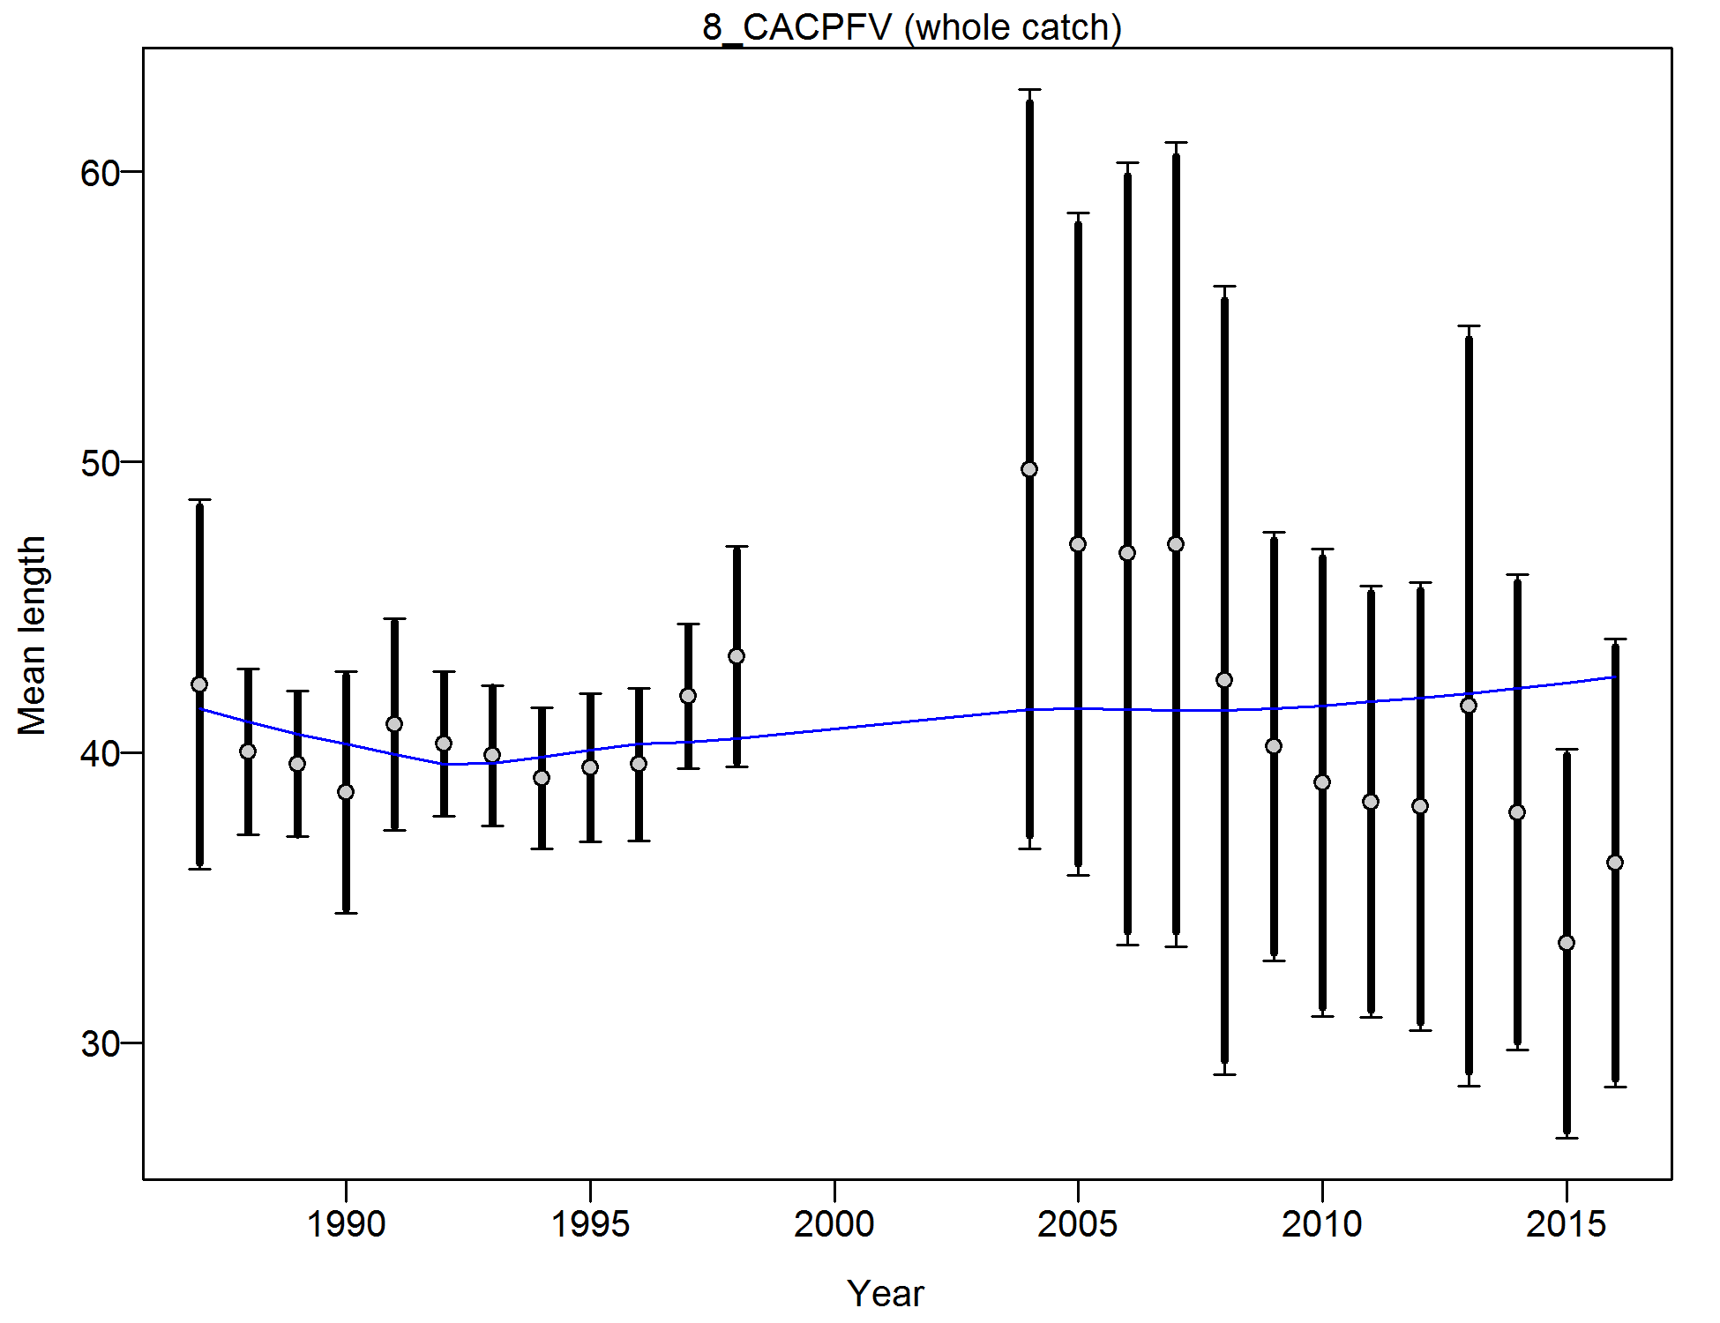

Figure . Francis weighting fits to the mean lengths by year for the California CPFV onboard observer samples. Vertical lines are 95% confidence intervals.

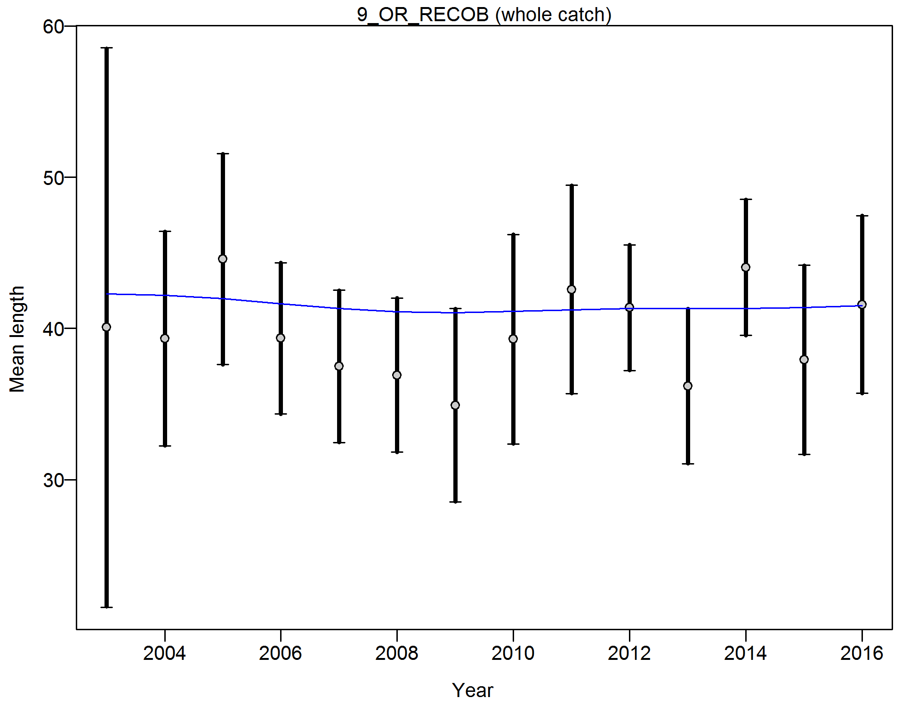

Figure . Francis weighting fits to the mean lengths by year for the Oregon onboard observer samples. Vertical lines are 95% confidence intervals.

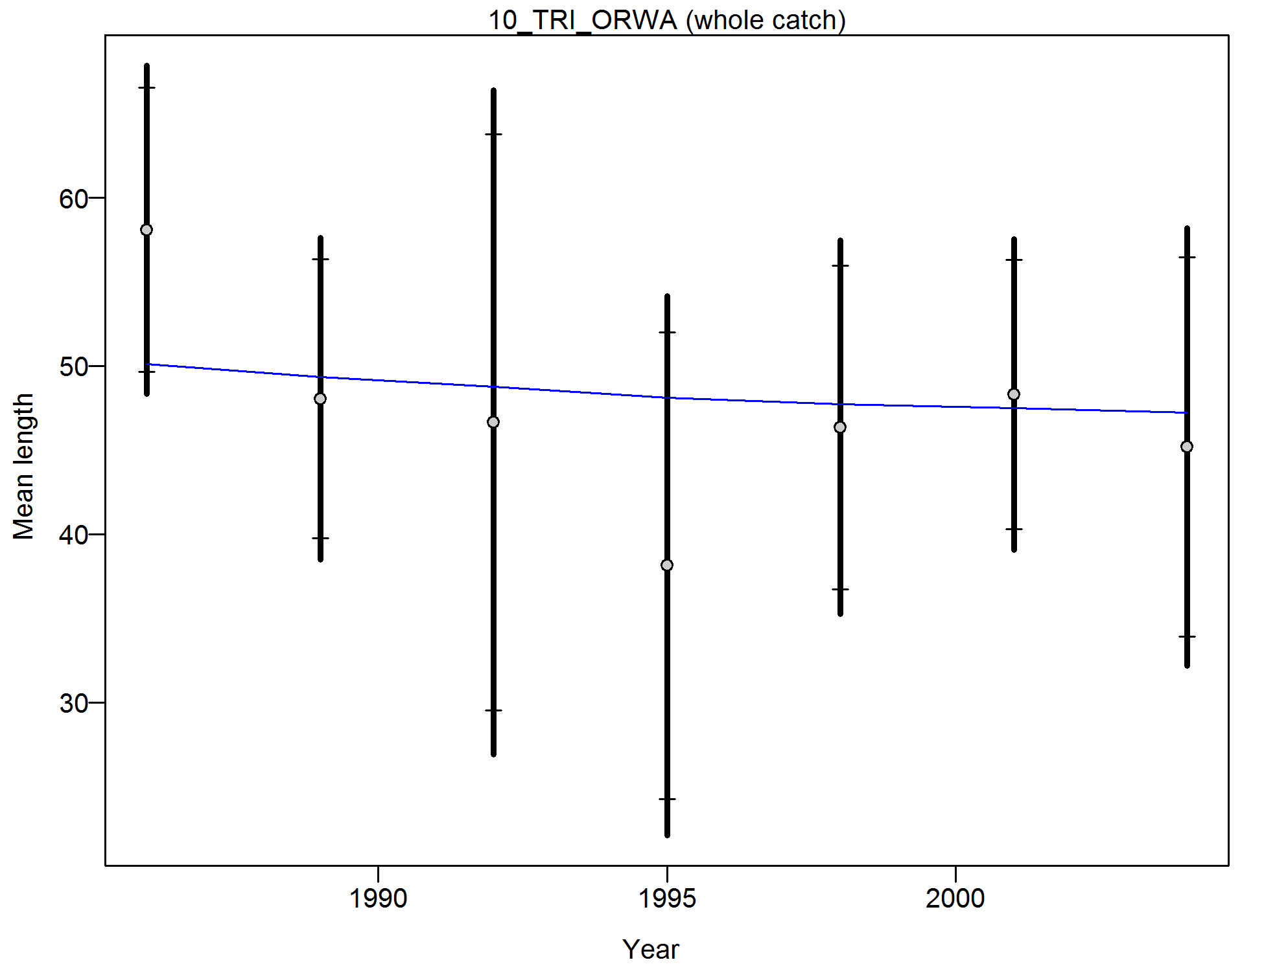

Figure . Francis weighting fits to the mean lengths by year for the AFSC Triennial survey. Vertical lines are 95% confidence intervals.

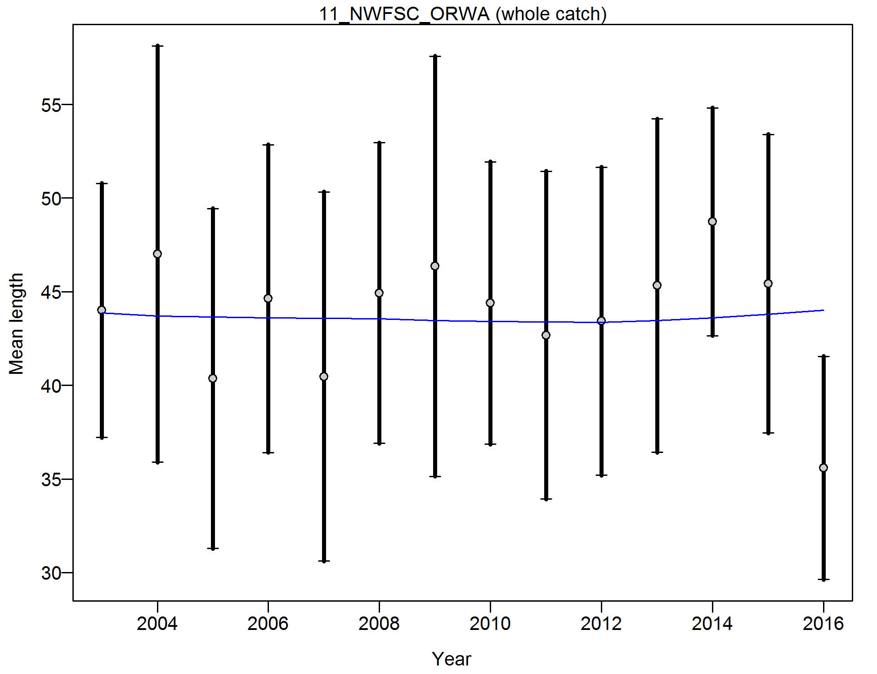

Figure . Francis weighting fits to the mean lengths by year for the NWFSC WCGTS. Vertical lines are 95% confidence intervals.

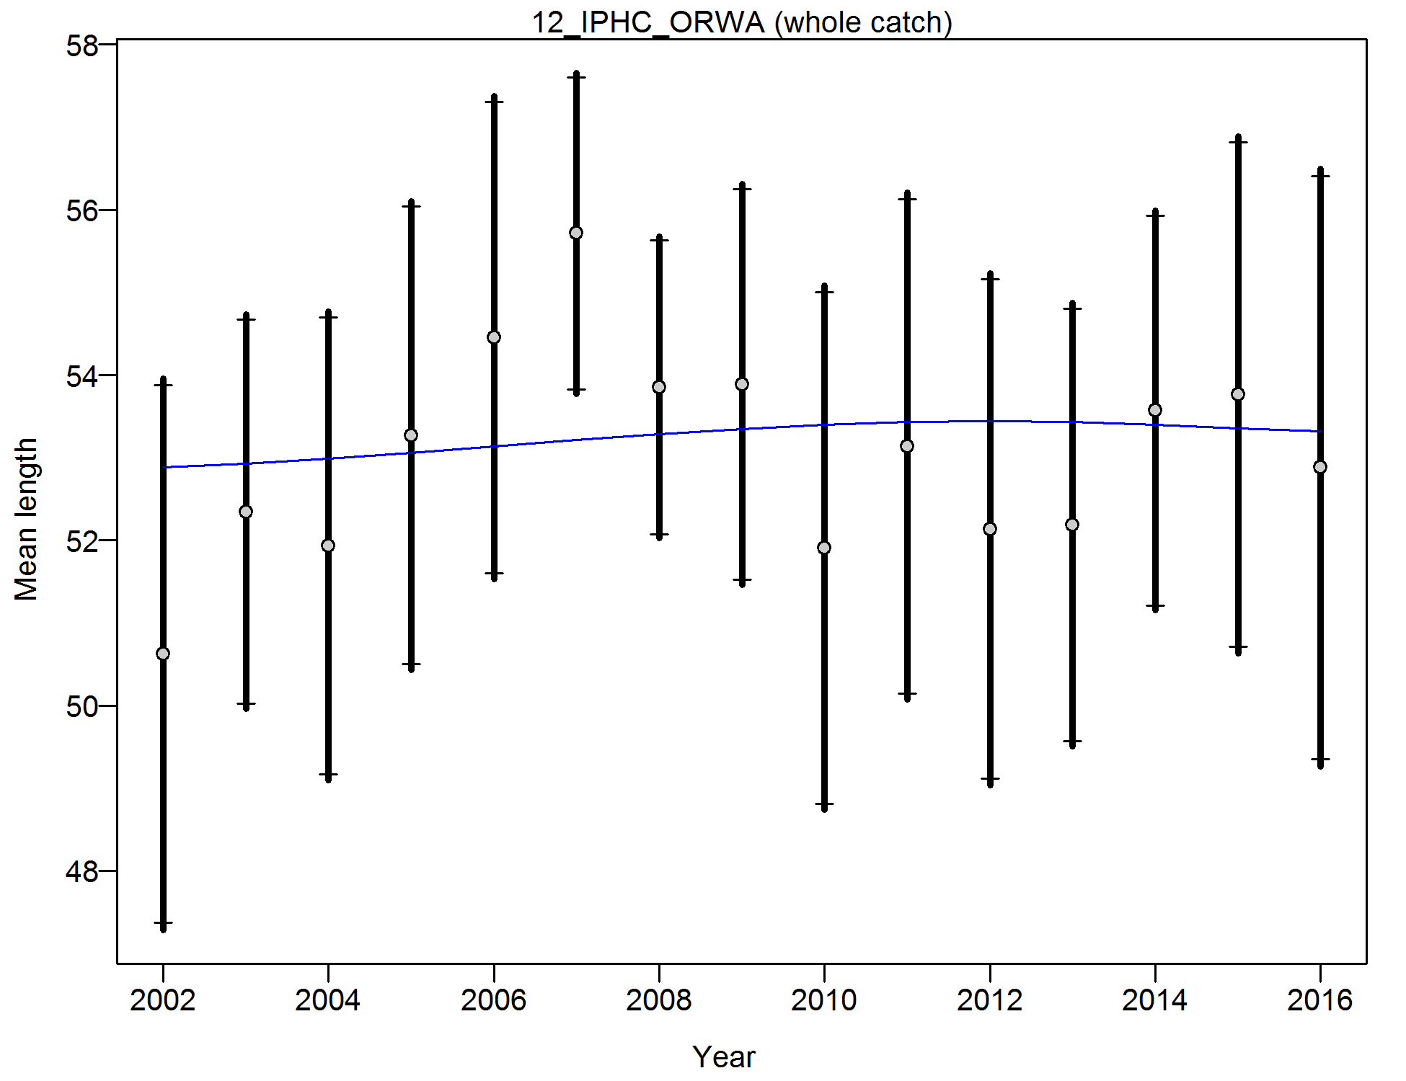

Figure . Francis weighting fits to the mean lengths by year for the IPHC survey. Vertical lines are 95% confidence intervals.

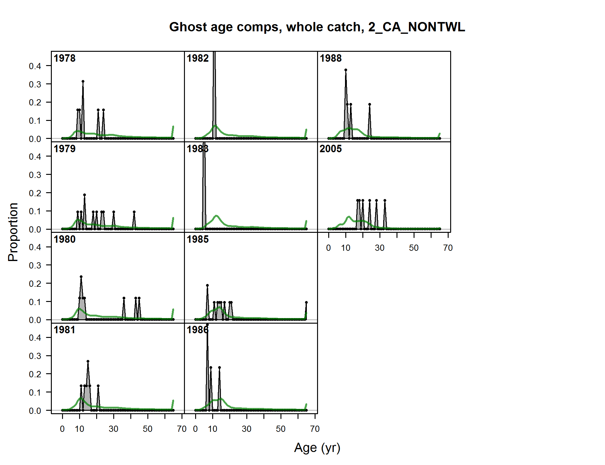

Figure . Implied fit to conditional ages-at-length compositions of yelloweye rockfish from California non-trawl marginal age frequencies. Fits are provided for evaluation only, but not included in the model likelihood.

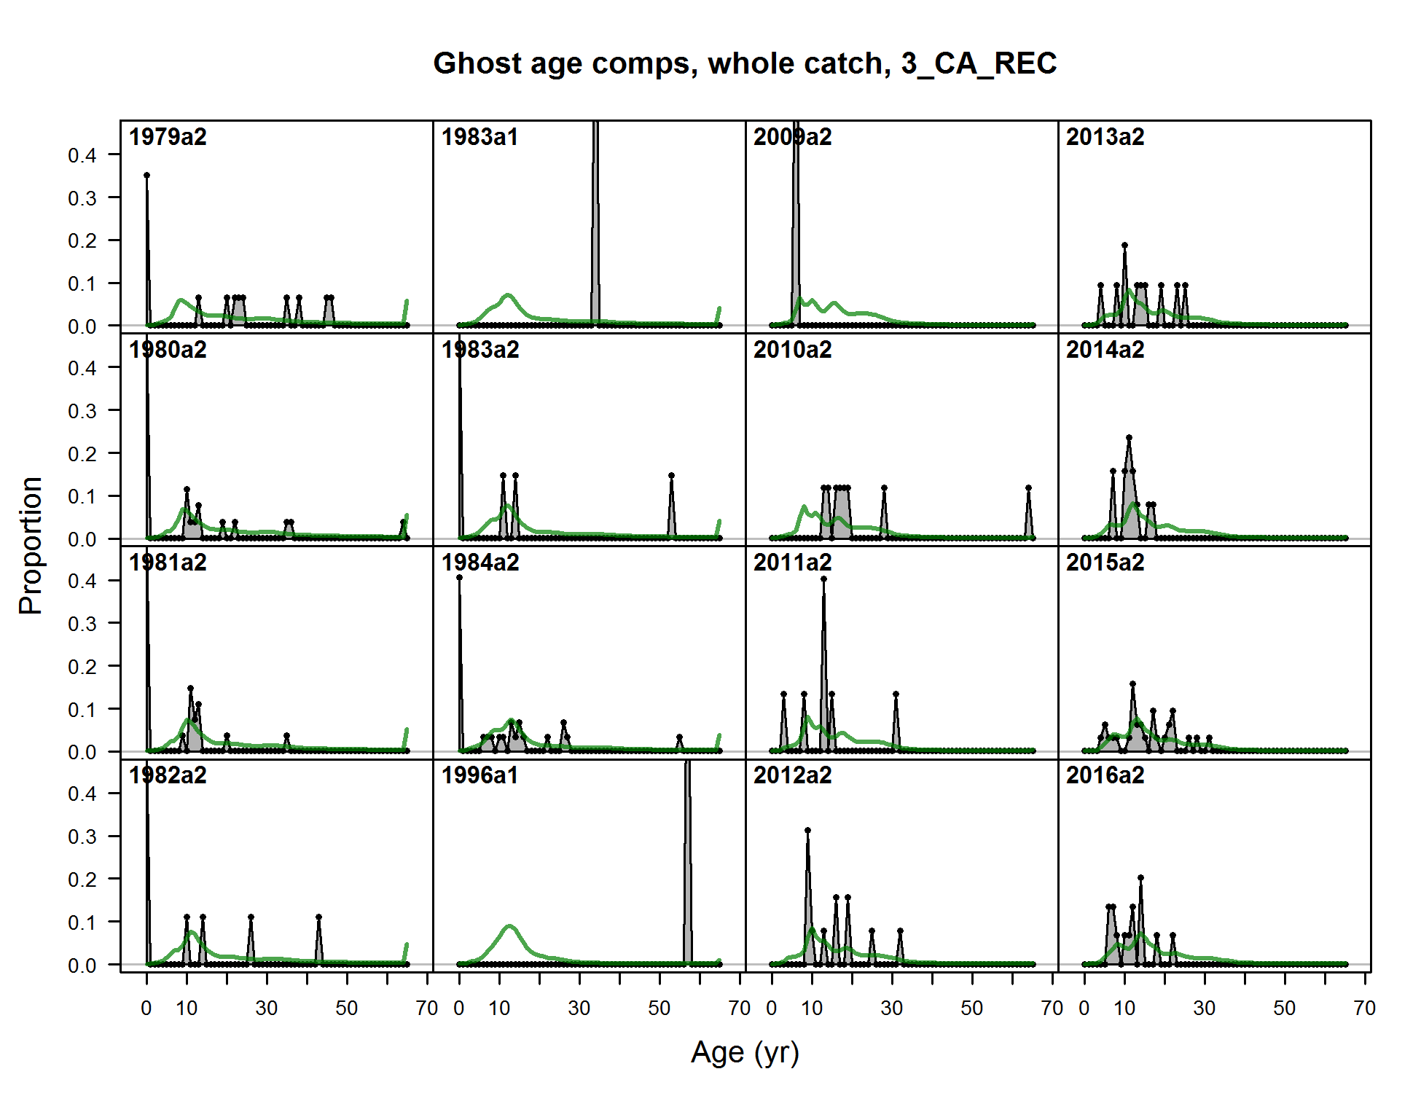

Figure . Implied fit to conditional ages-at-length compositions of yelloweye rockfish from California recreational marginal age frequencies. Fits are provided for evaluation only, but not included in the model likelihood.

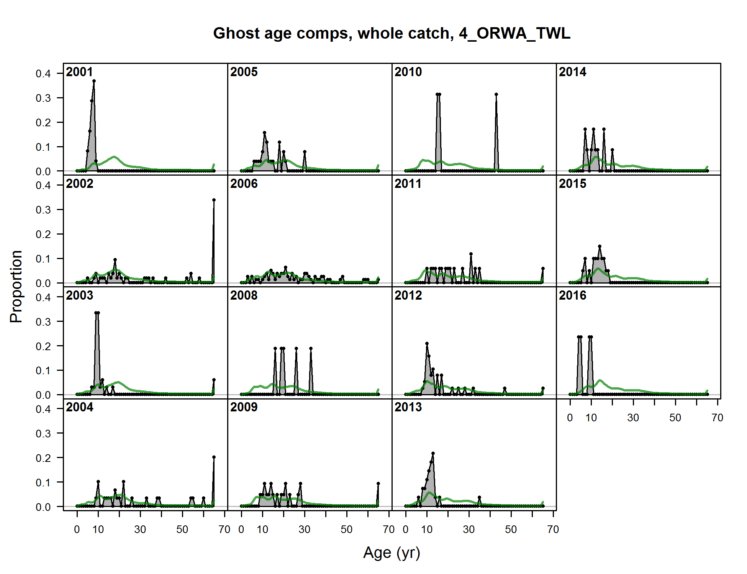

Figure . Implied fit to conditional ages-at-length compositions of yelloweye rockfish from Oregon-Washington trawl marginal age frequencies. Fits are provided for evaluation only, but not included in the model likelihood.

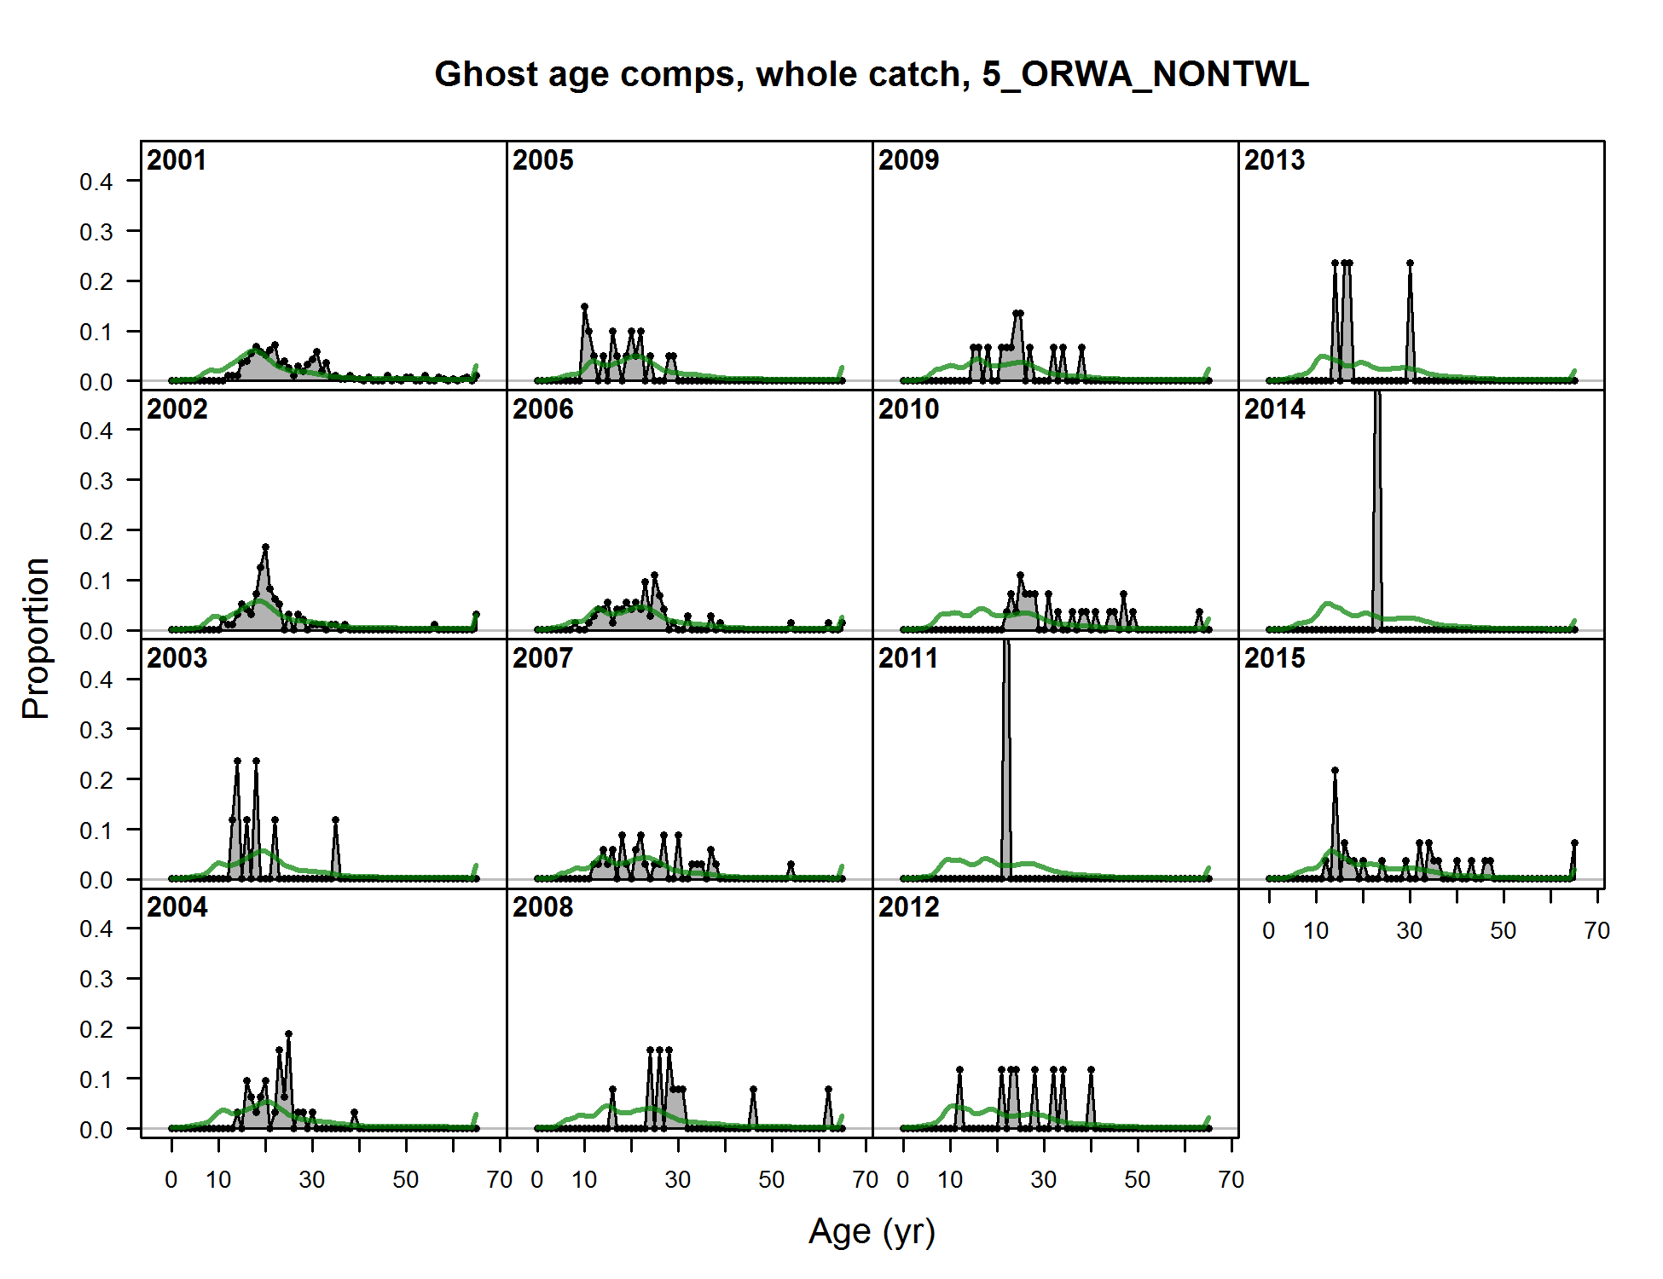

Figure . . Implied fit to conditional ages-at-length compositions of yelloweye rockfish from Oregon-Washington non-trawl marginal age frequencies. Fits are provided for evaluation only, but not included in the model likelihood.

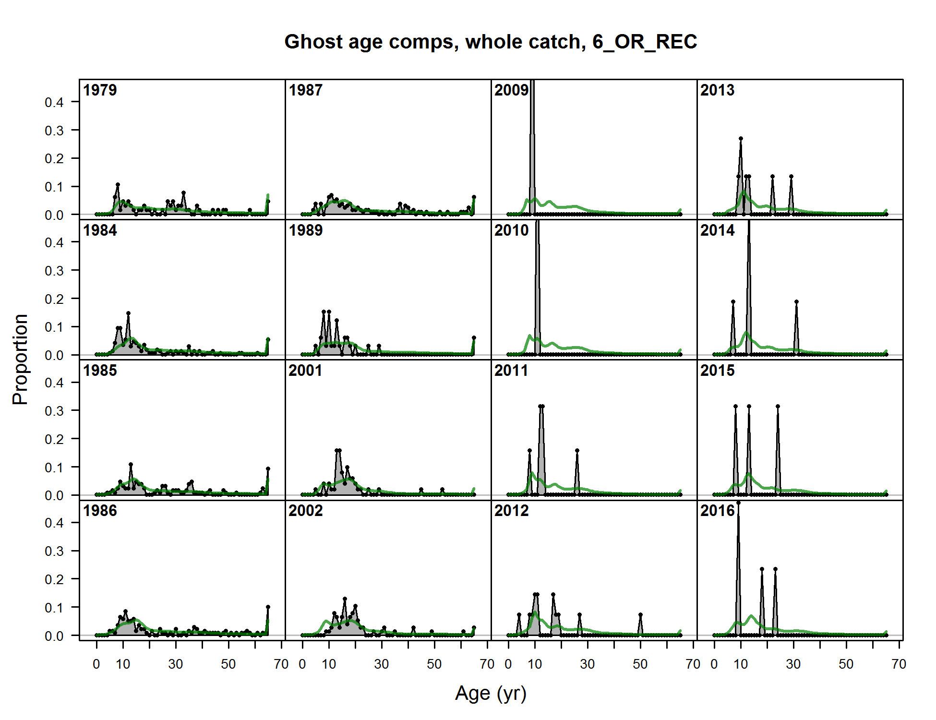

Figure . Implied fit to conditional ages-at-length compositions of yelloweye rockfish from Oregon recreational marginal age frequencies. Fits are provided for evaluation only, but not included in the model likelihood.

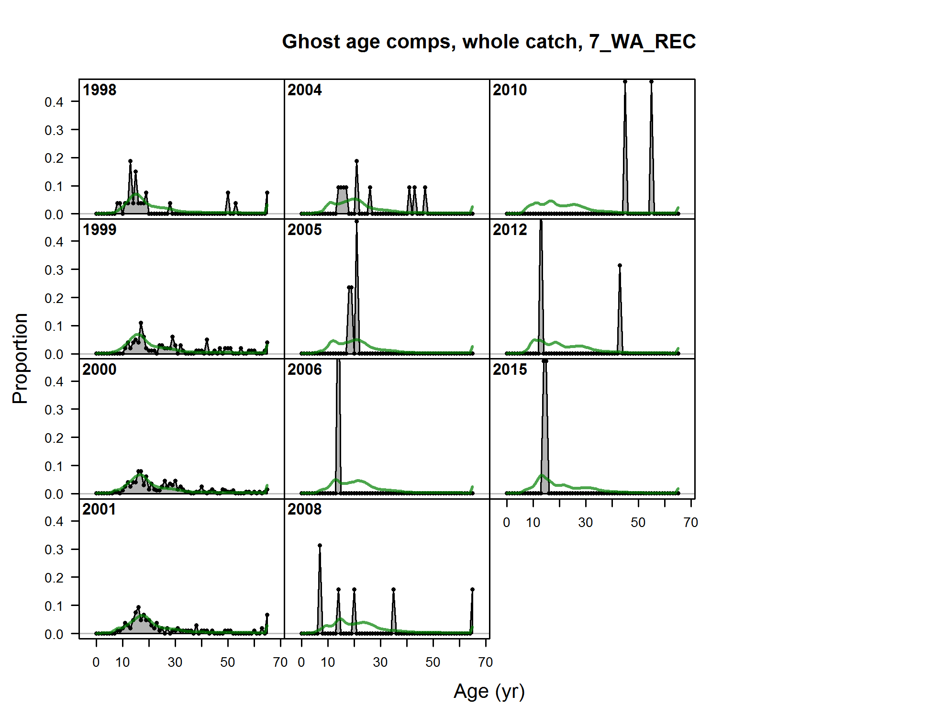

Figure . Implied fit to conditional ages-at-length compositions of yelloweye rockfish from Washington recreational marginal age frequencies. Fits are provided for evaluation only, but not included in the model likelihood.

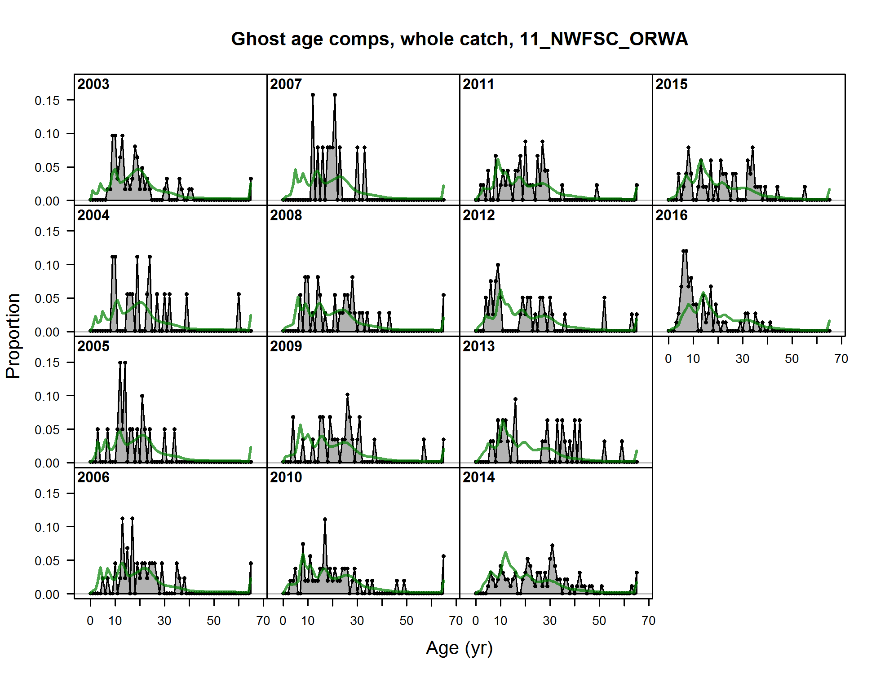

Figure . Implied fit to conditional ages-at-length compositions of yelloweye rockfish from NWFSC NWFSC trawl survey marginal age frequencies. Fits are provided for evaluation only, but not included in the model likelihood.

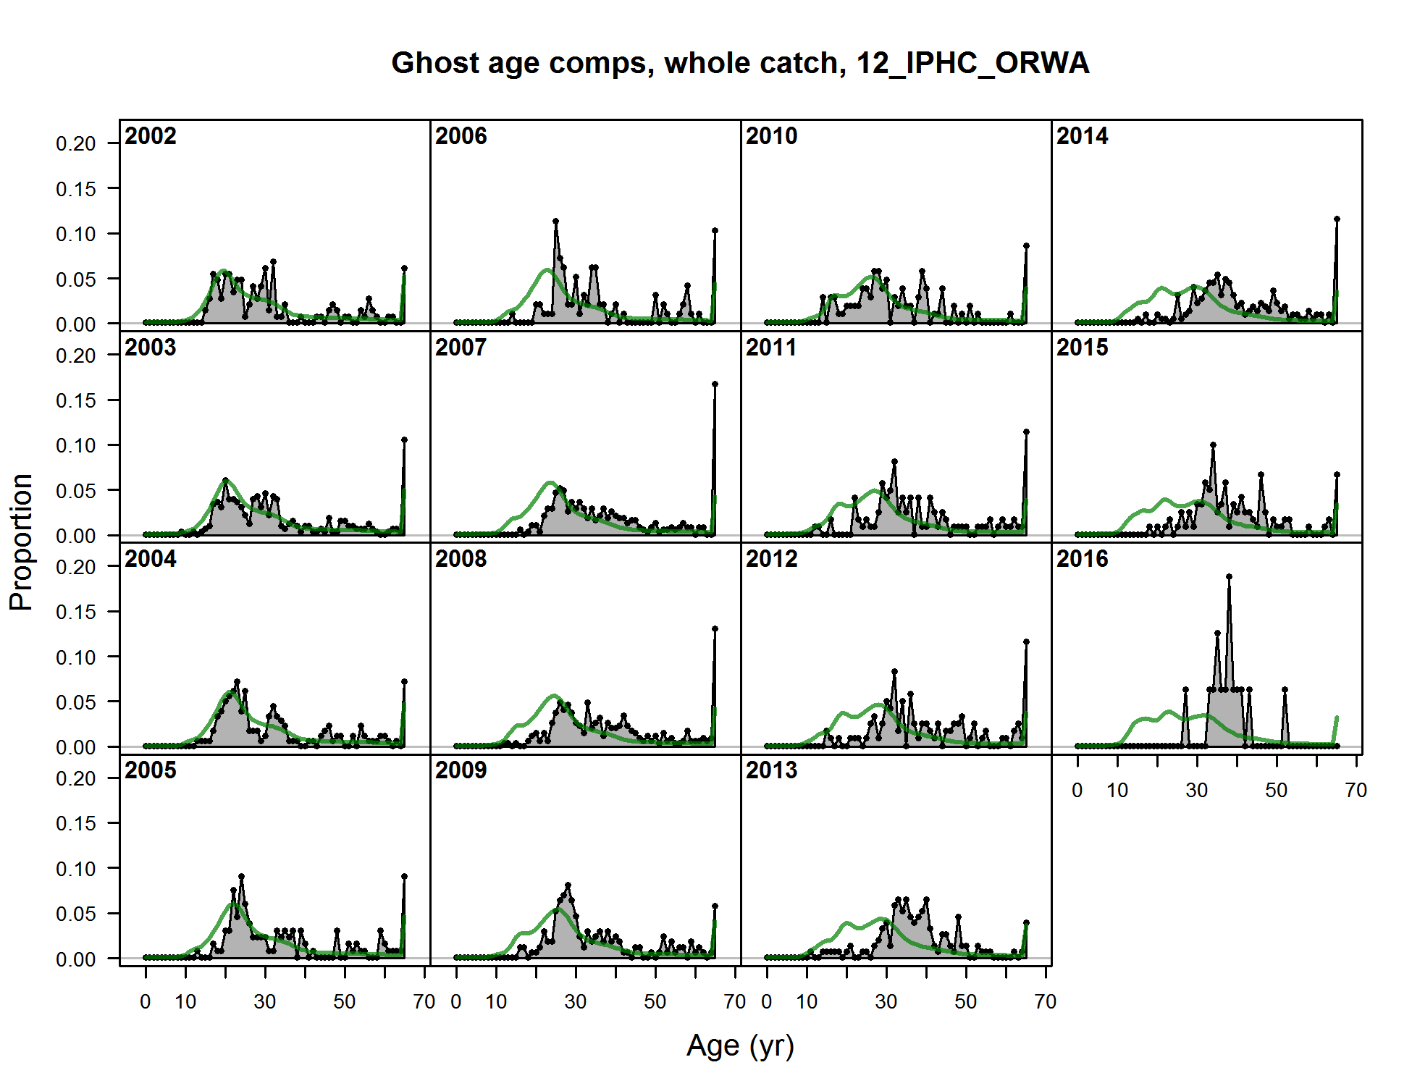

Figure . Implied fit to conditional ages-at-length compositions of yelloweye rockfish from IPHC survey marginal age frequencies. Fits are provided for evaluation only, but not included in the model likelihood.

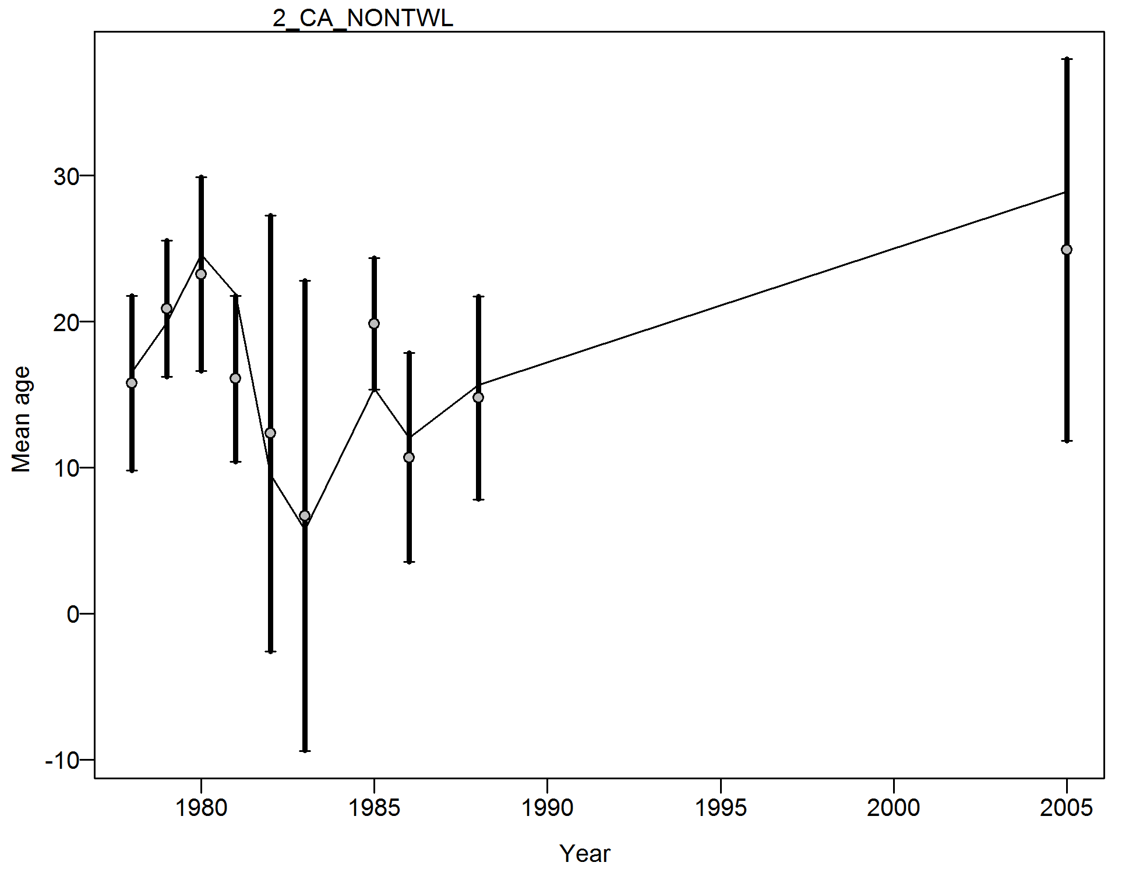

Figure . Francis weighting index fit of the conditional age-at-length data for the California non-trawl commercial fishery.

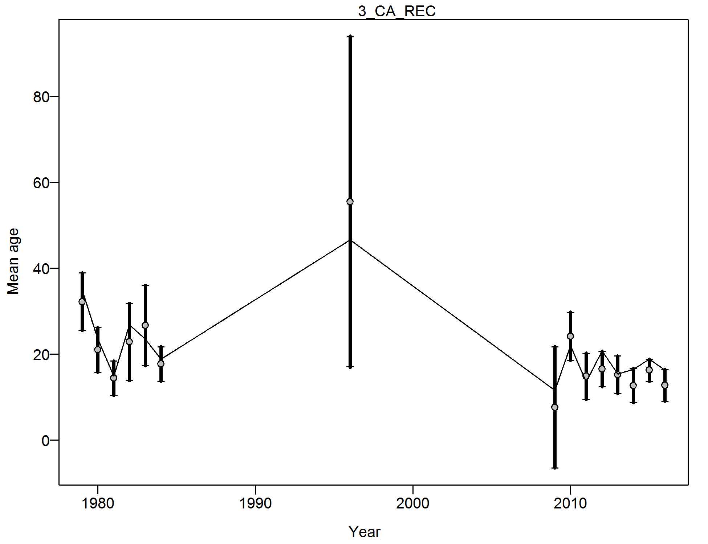

Figure . Francis weighting index fit of the conditional age-at-length data for the California recreational fishery.

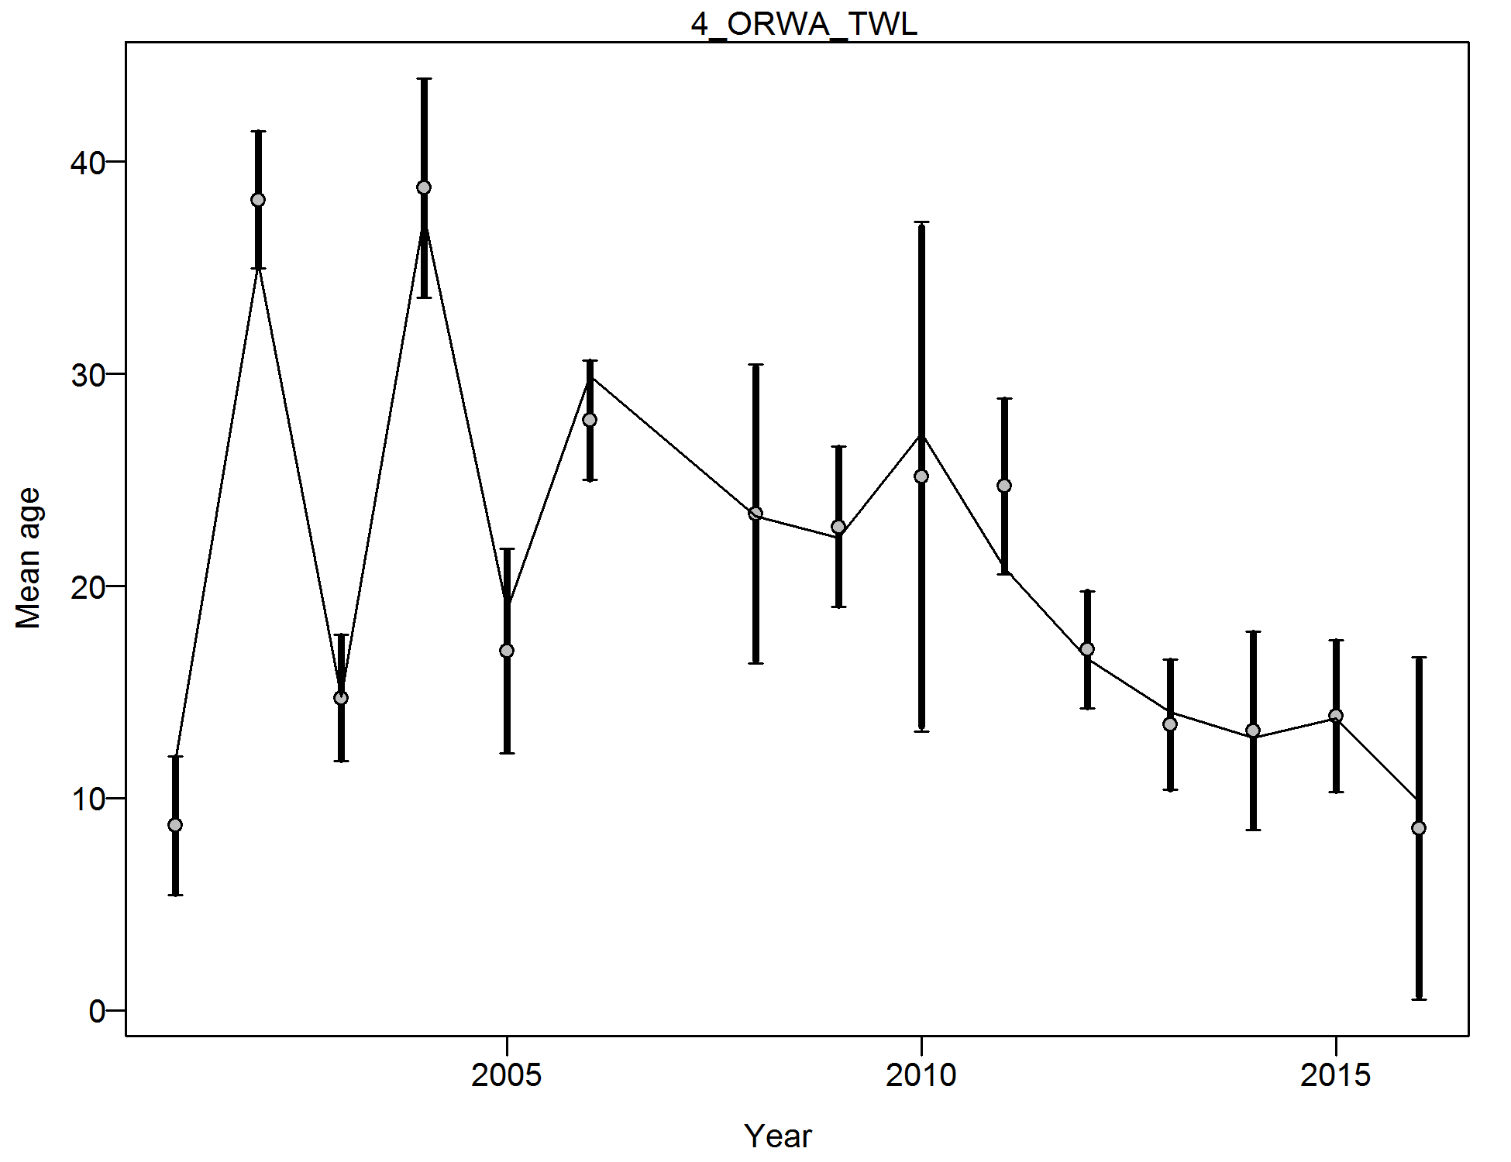

Figure . Francis weighting index fit of the conditional age-at-length data for the Oregon-Washington trawl commercial fishery.

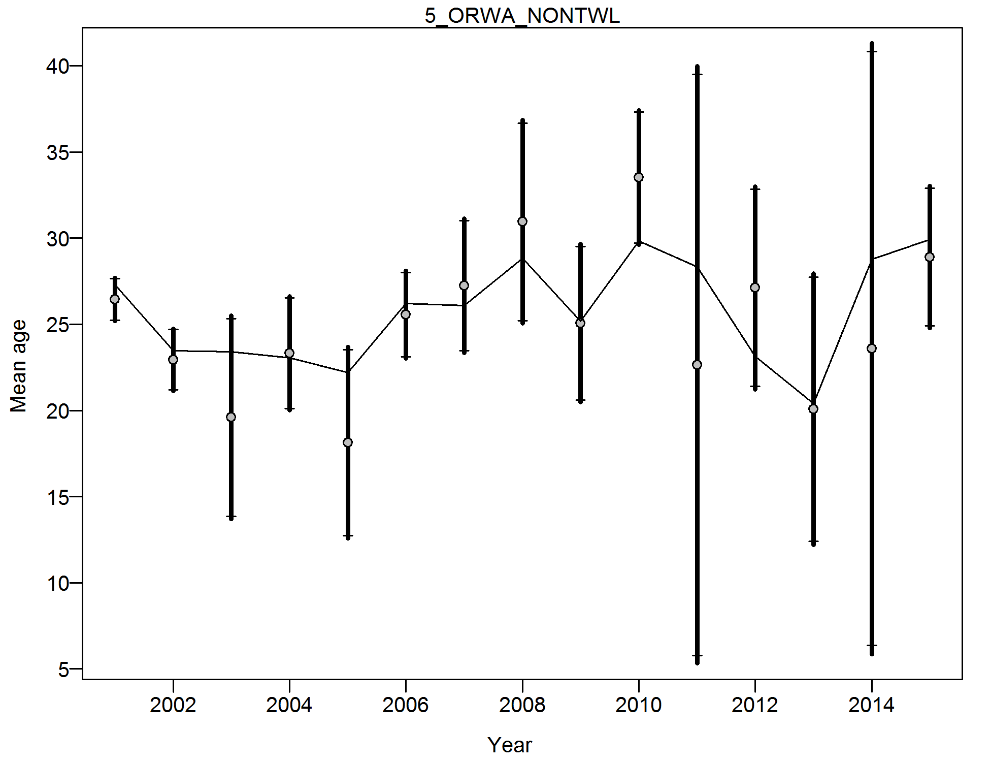

Figure . Francis weighting index fit of the conditional age-at-length data for the Oregon-Washington non-trawl commercial fishery.

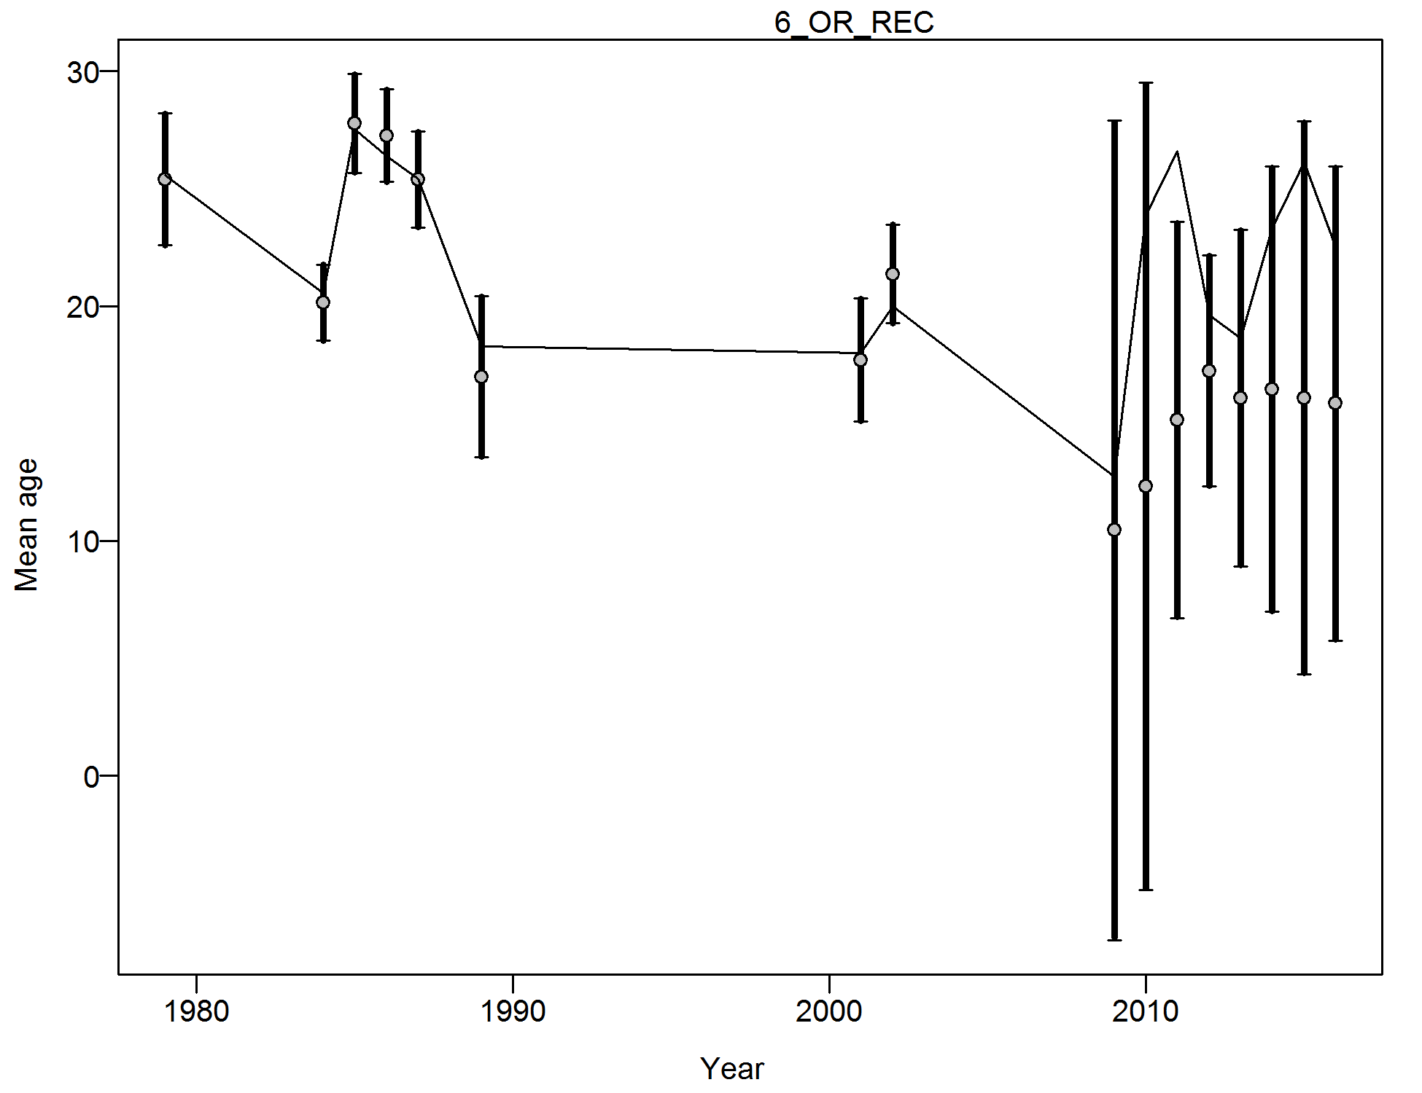

Figure . Francis weighting index fit of the conditional age-at-length data for the Oregon recreational fishery.

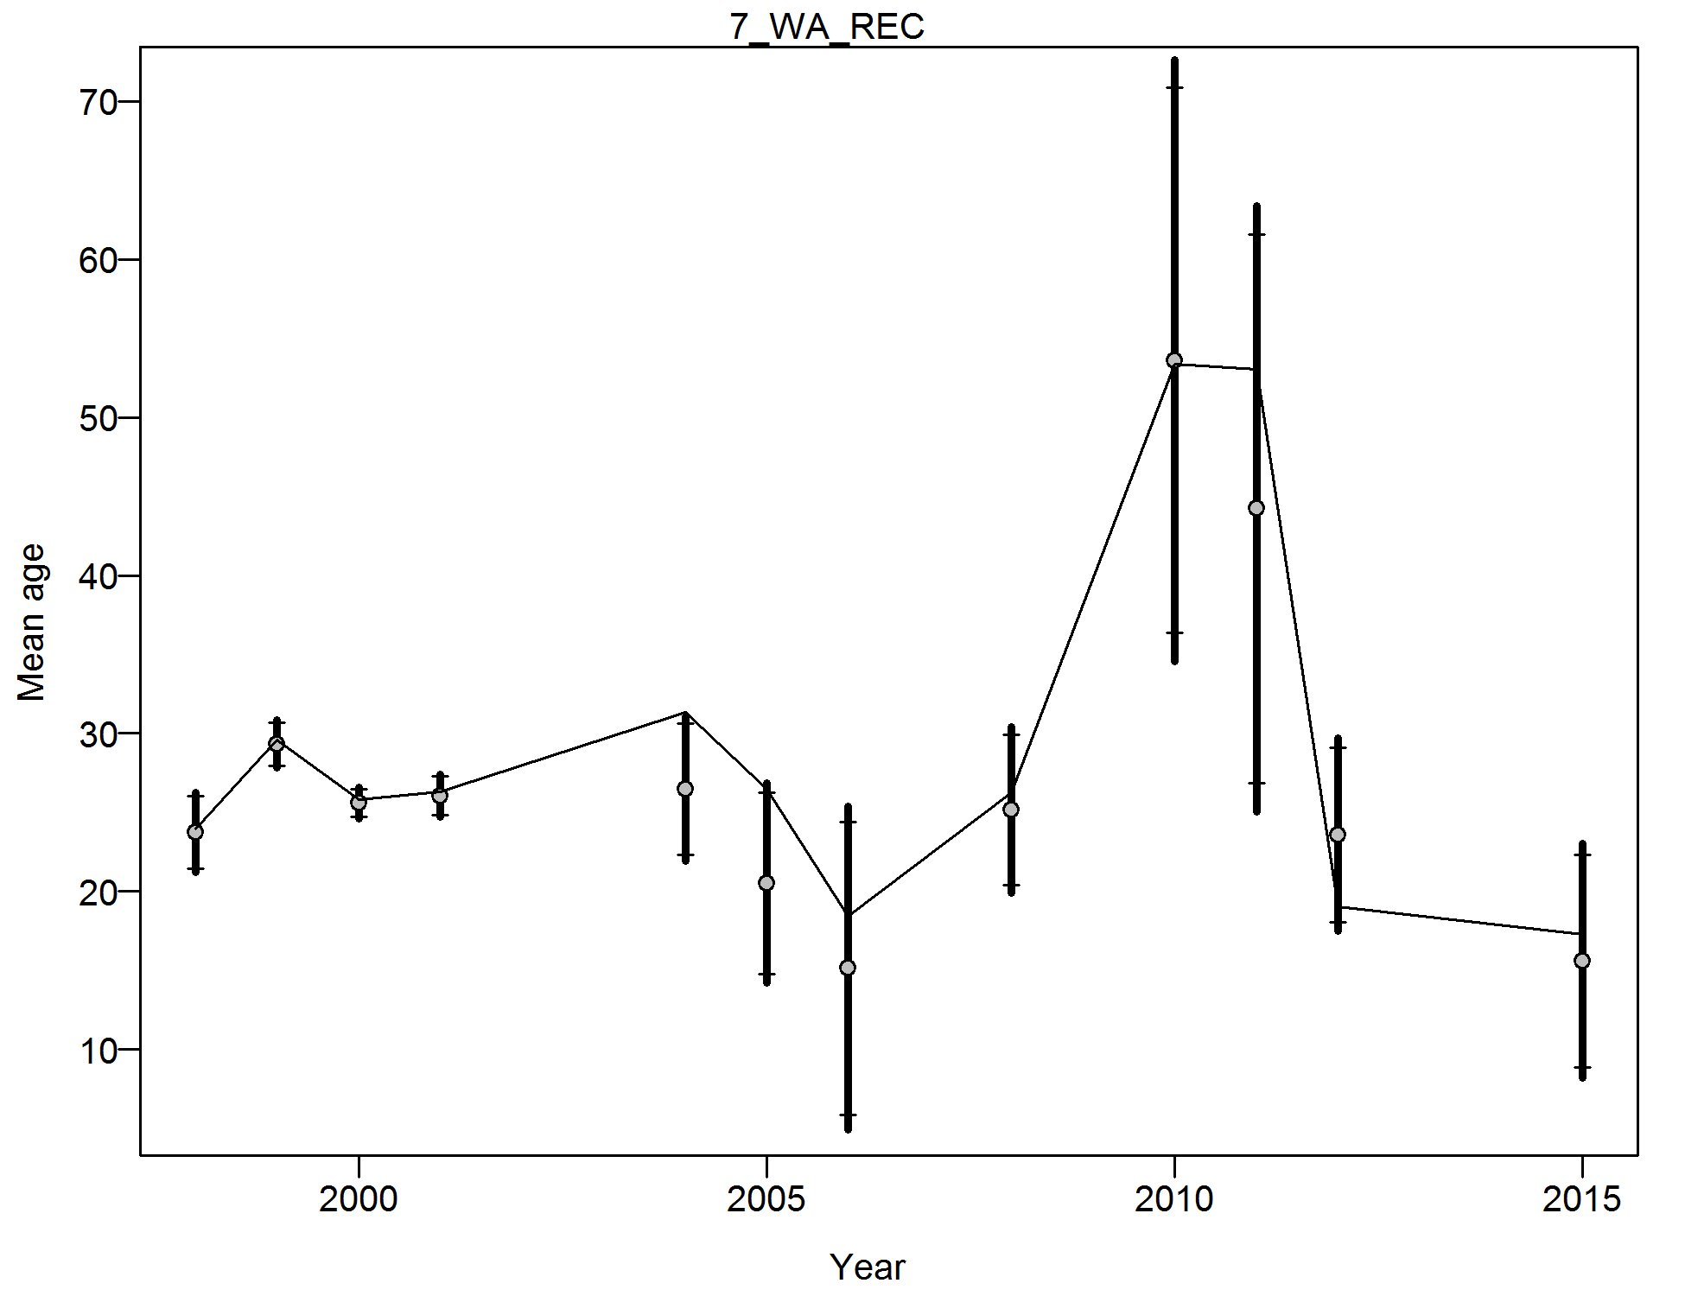

Figure . Francis weighting index fit of the conditional age-at-length data for the Washington recreational fishery.

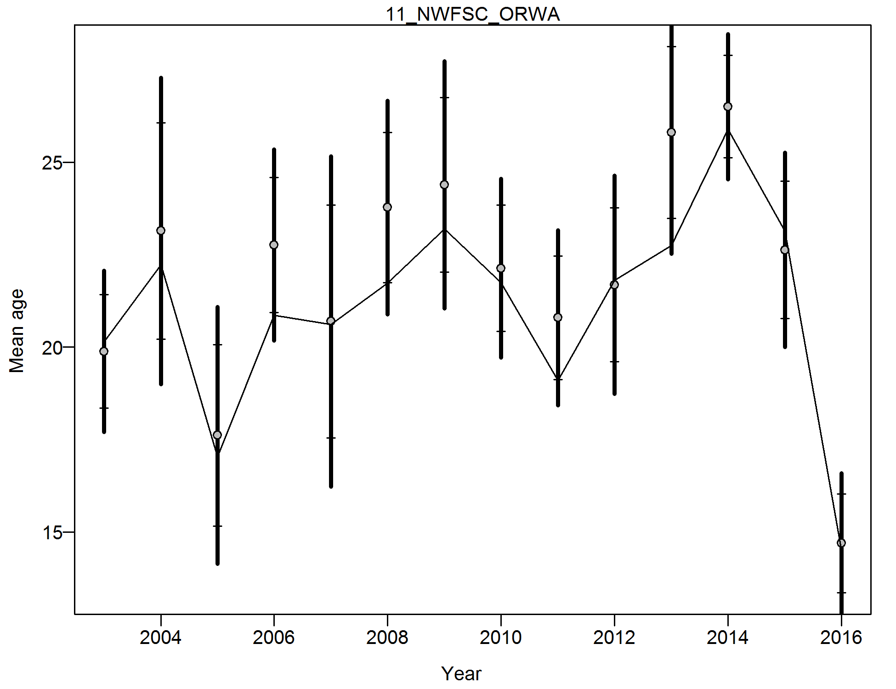

Figure . Francis weighting index fit of the conditional age-at-length data for the NWFSC trawl survey.

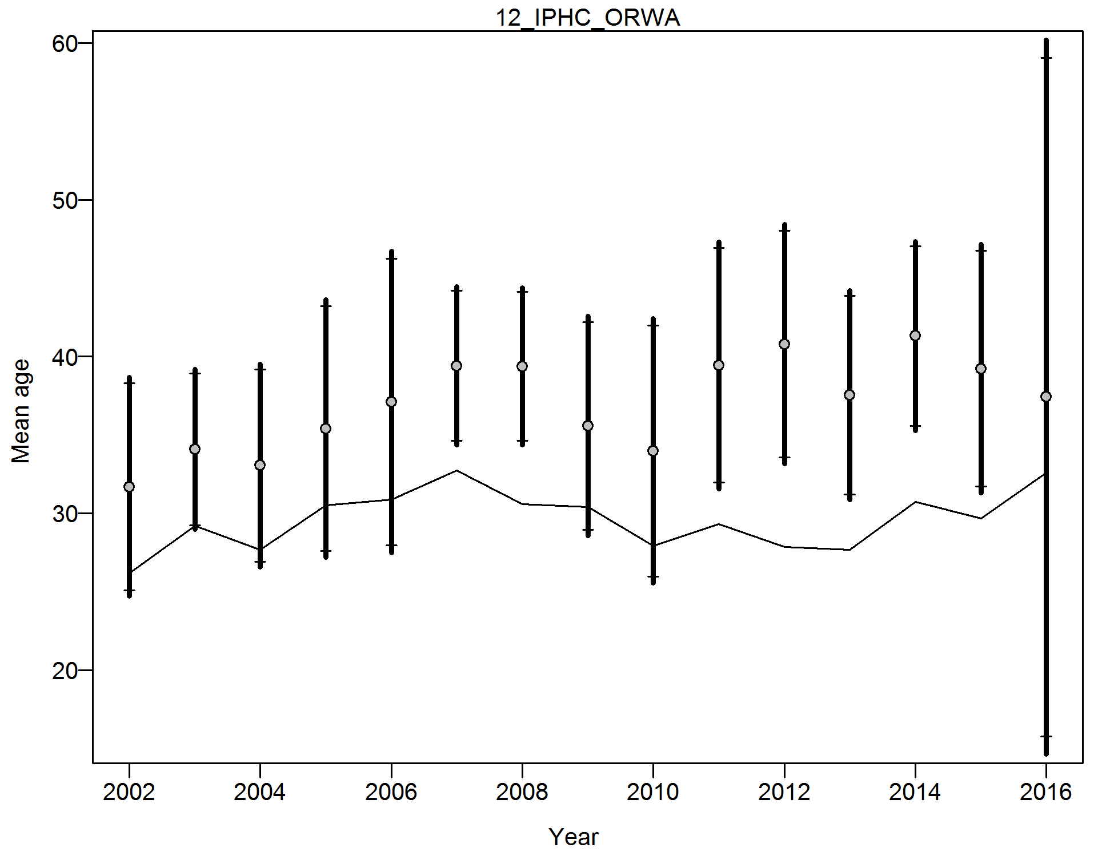

Figure . Francis weighting index fit of the conditional age-at-length data for the IPHC survey.

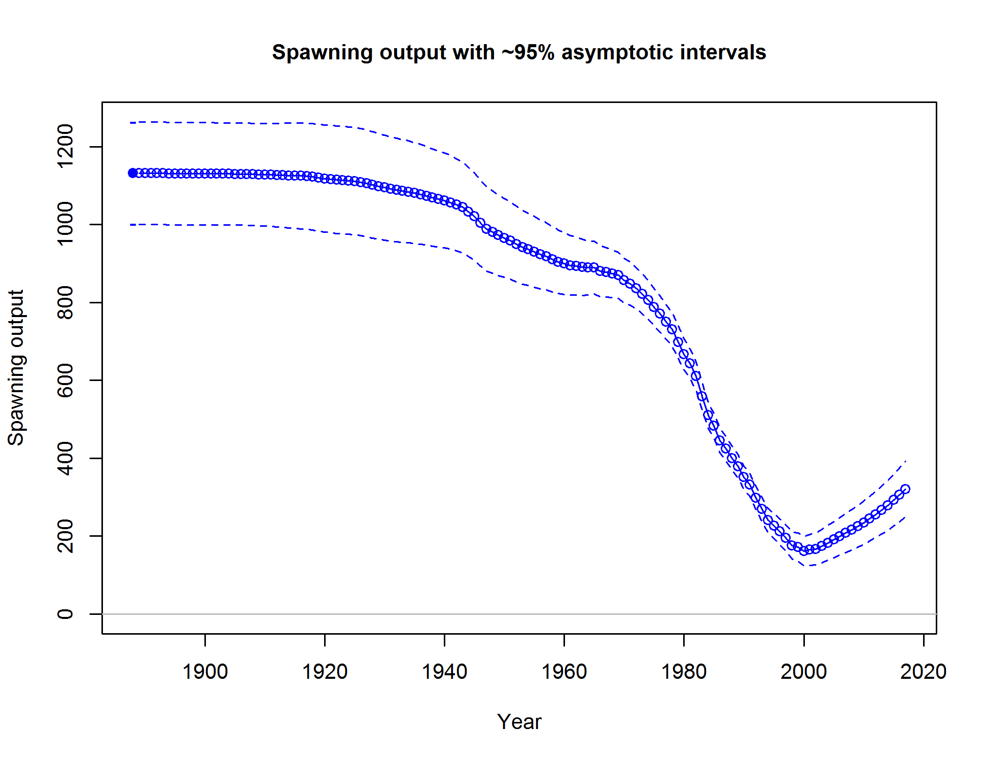

Figure . Time series of spawning output estimated in the assessment model (solid line) with ~ 95% interval (dashed lines). Spawning output is expressed in millions of eggs.

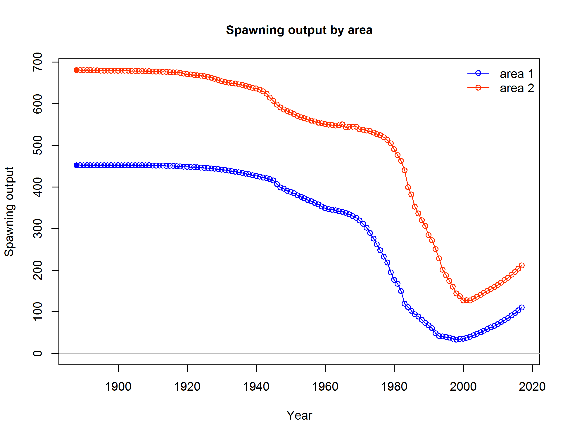

Figure . Time series of spawning output by area (area 1 = California, area 2 = Oregon and Washington) estimated in the assessment model. Spawning output is expressed in millions of eggs.

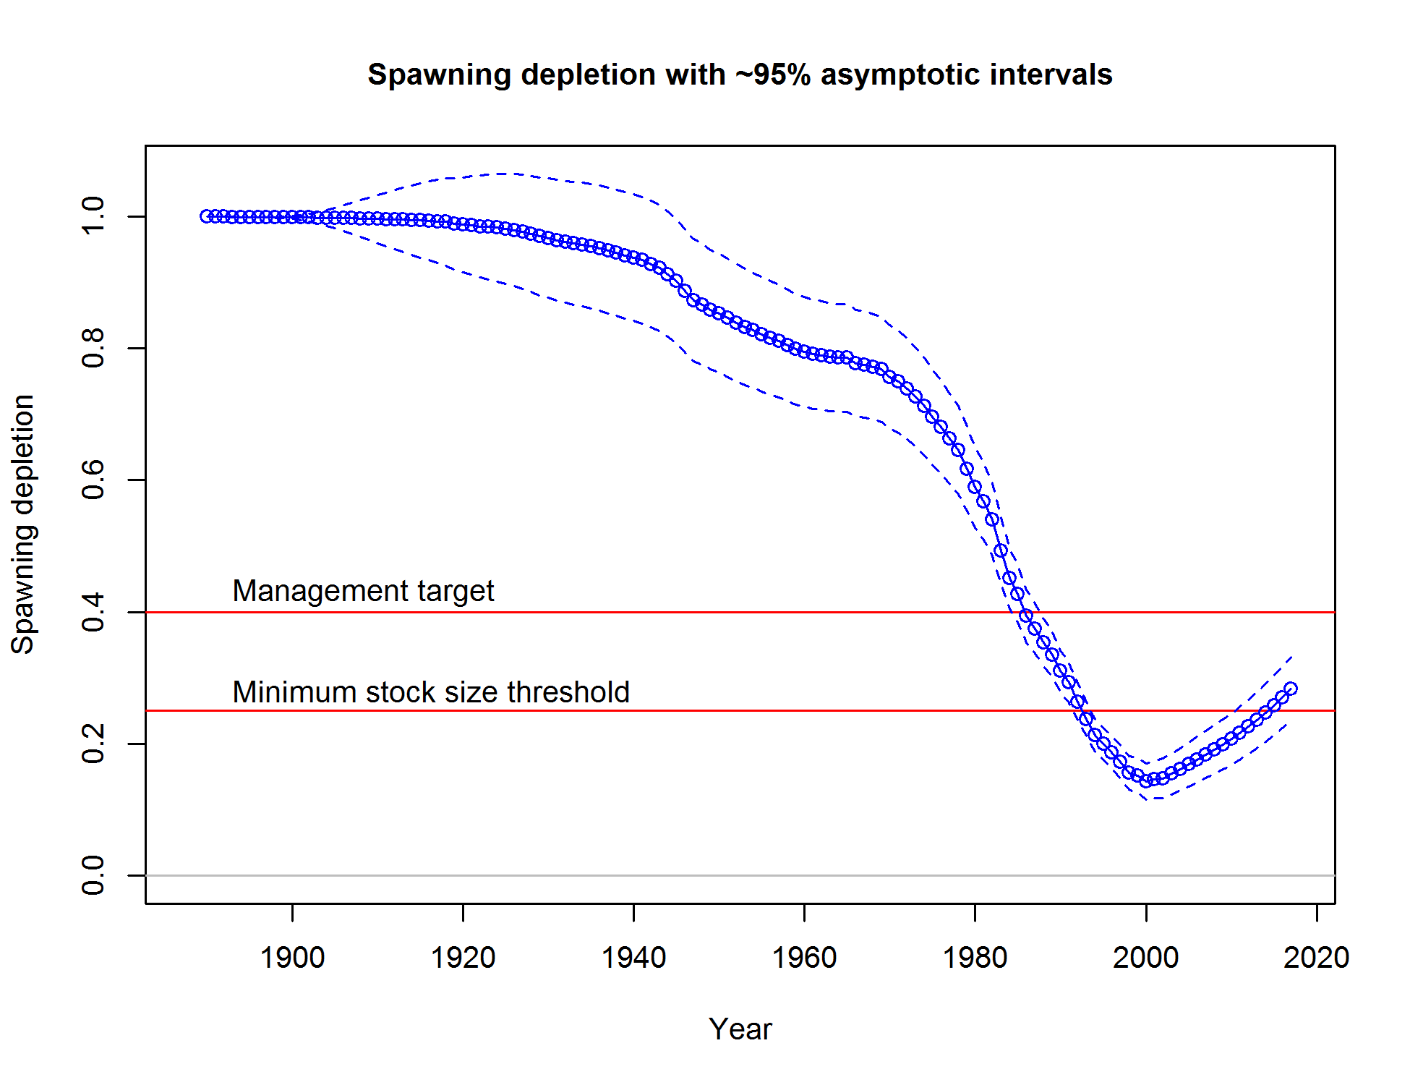

Figure . Time series of relative spawning output estimated in the assessment model (solid line) with ~ 95% interval (dashed lines).

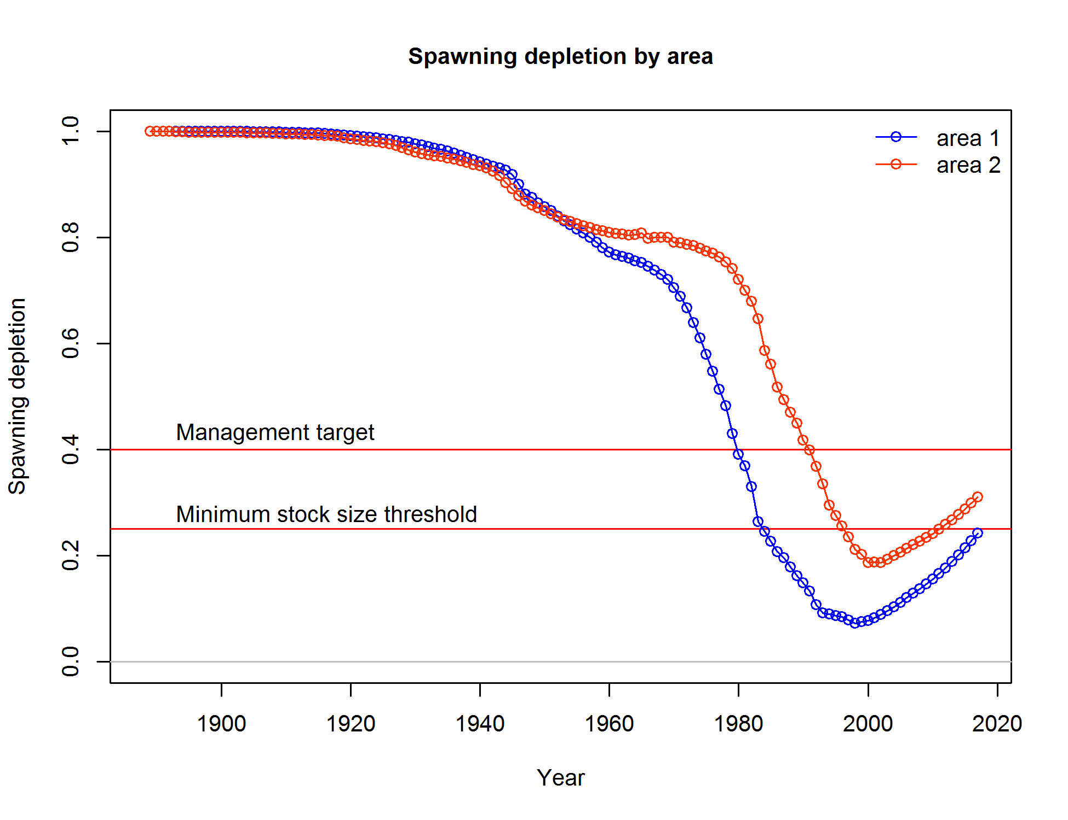

Figure . Time series of relative spawning output estimated by area (area 1= California, area 2 = Oregon and Washington).

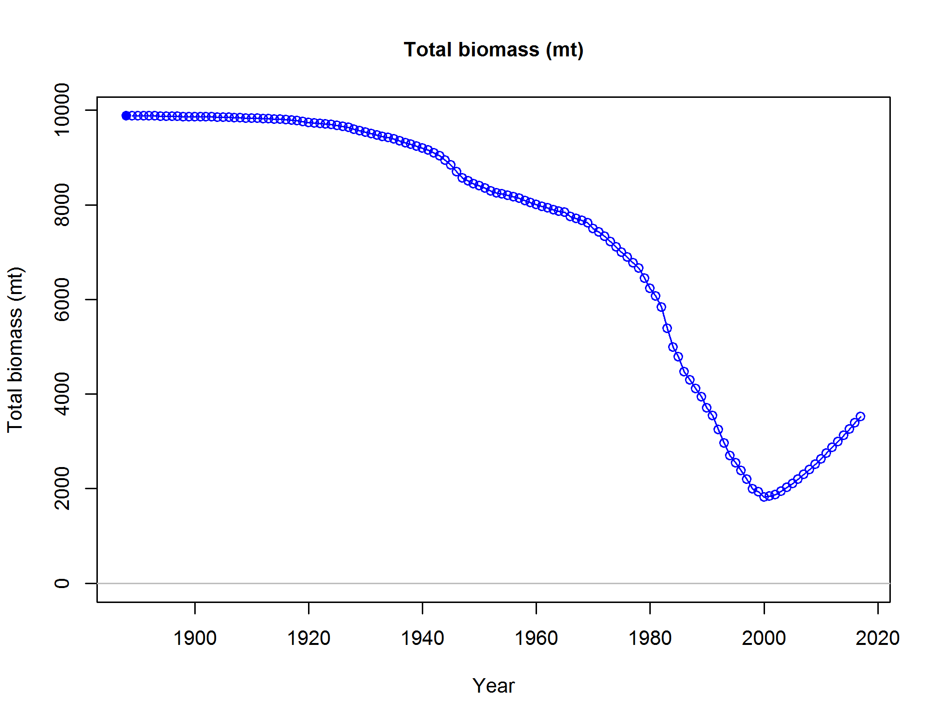

Figure . Time series of total biomass (mt) estimated in the assessment model.

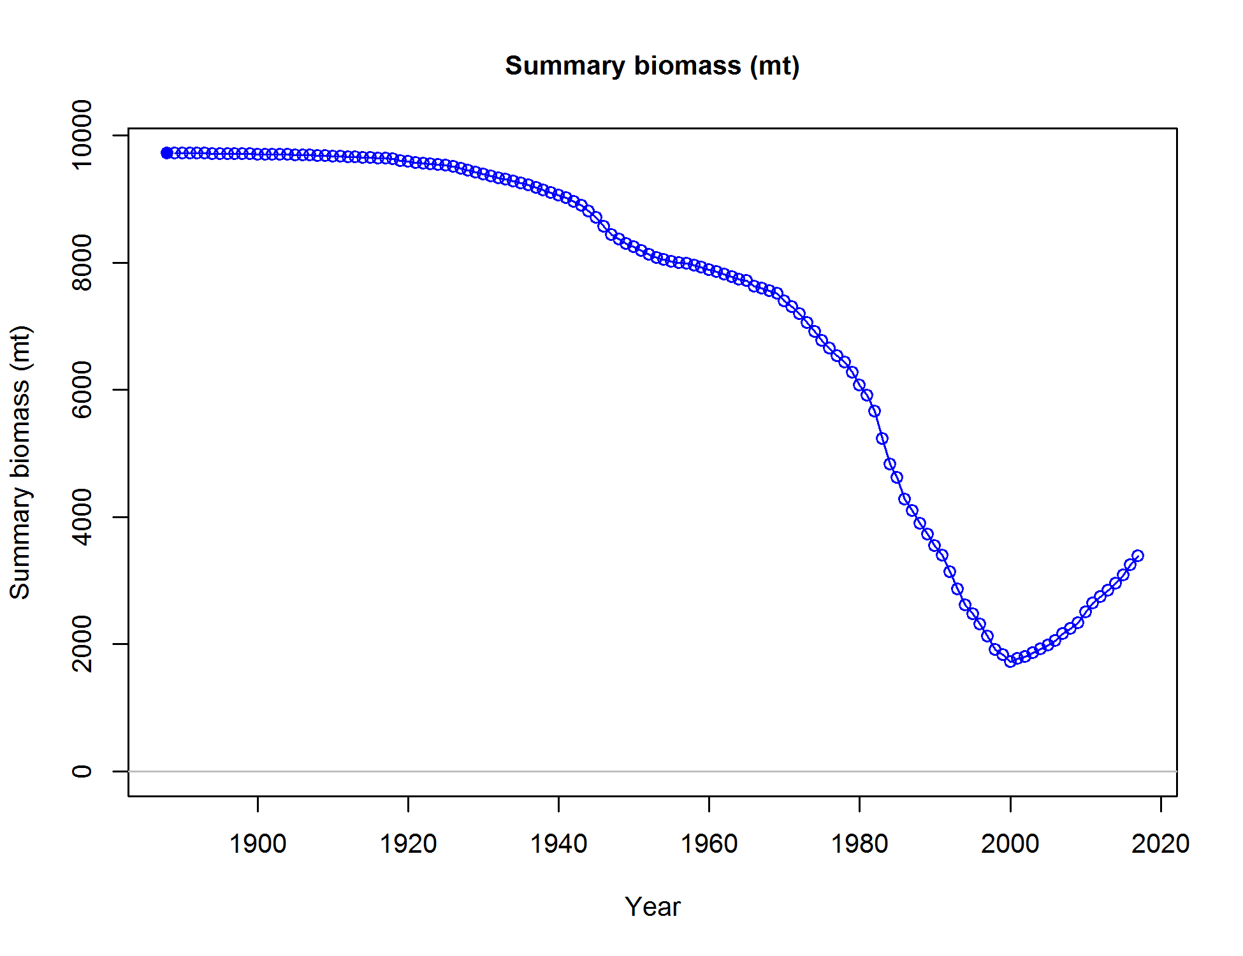

Figure . Time series of summary biomass (mt) estimated in the assessment model.

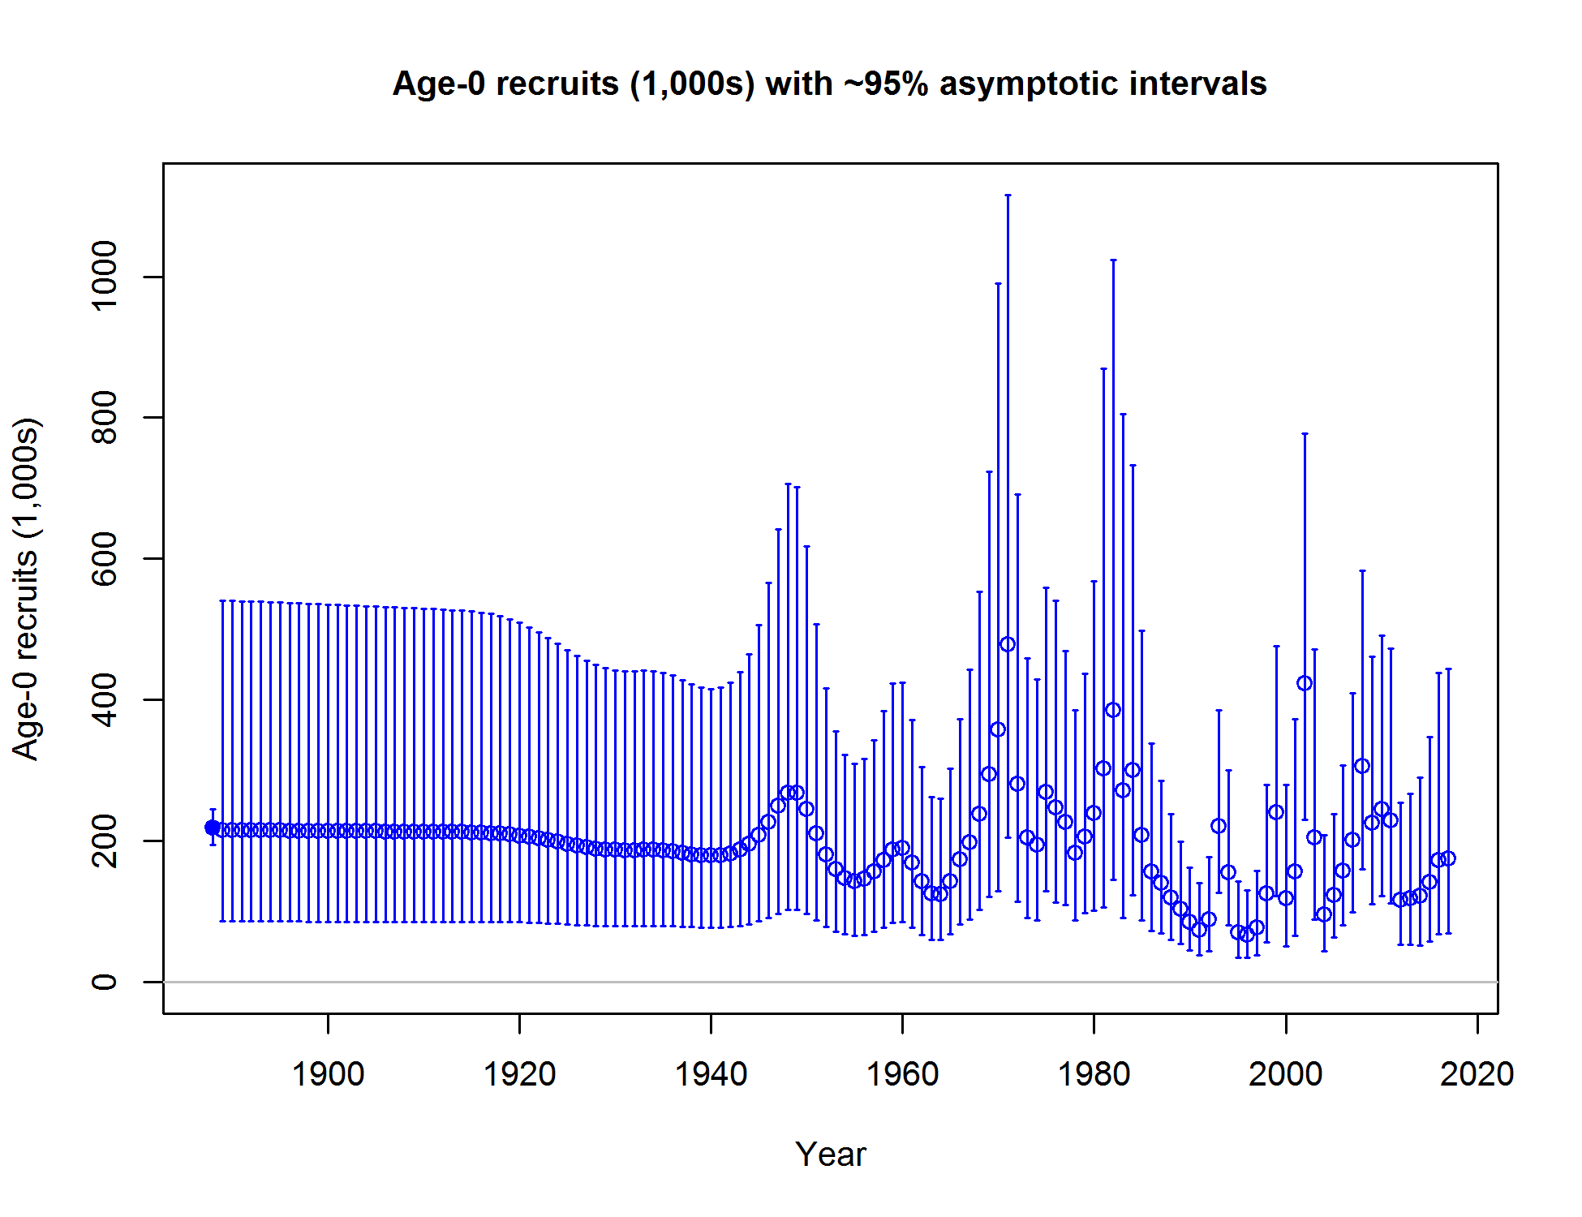

Figure . Time series of recruitment estimated in the assessment model with ~ 95% interval.

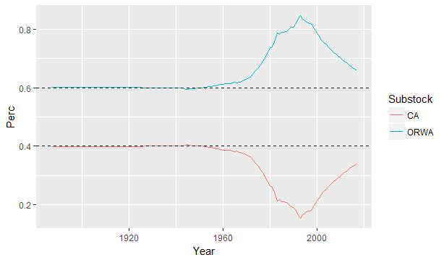

Figure . Spawning output ratio time series relative to the fixed ratio of recruitment distribution to each area. Solid lines indicate the spawning output (SO) ratio (SOarea/SOtotal), while broken lines are the fixed proportion of distributed recruits by area (40% CA, 60% ORWA).

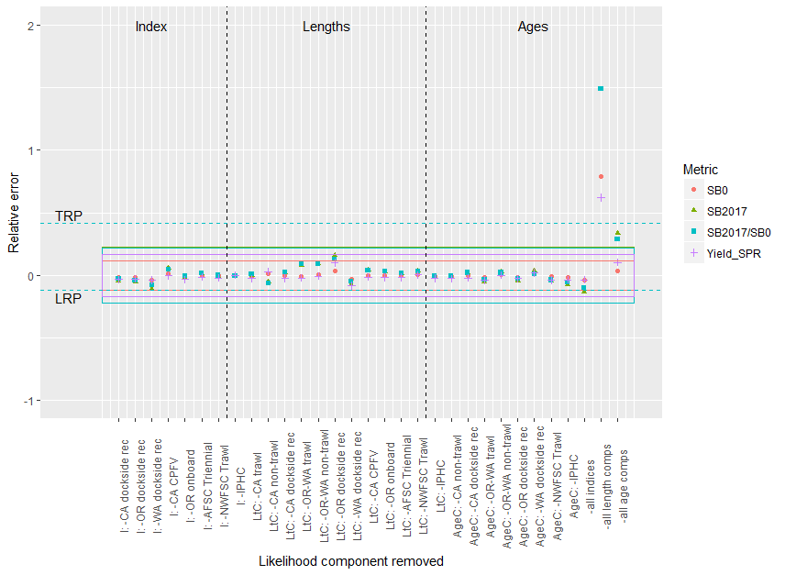

Figure . Sensitivity of base model to the removal of each data source. Relative error is defined as the difference in a given metric between the proposed model and the reference model, divided by the reference model value. I = Index; LtC = length composition; AgeC = Age composition. Boxes correspond to the 95% confidence interval of a derived quantity (indicated by color) in the reference model. Values outside the box would indicate significant uncertainty in the removal of data from the uncertainty provided in the reference model.

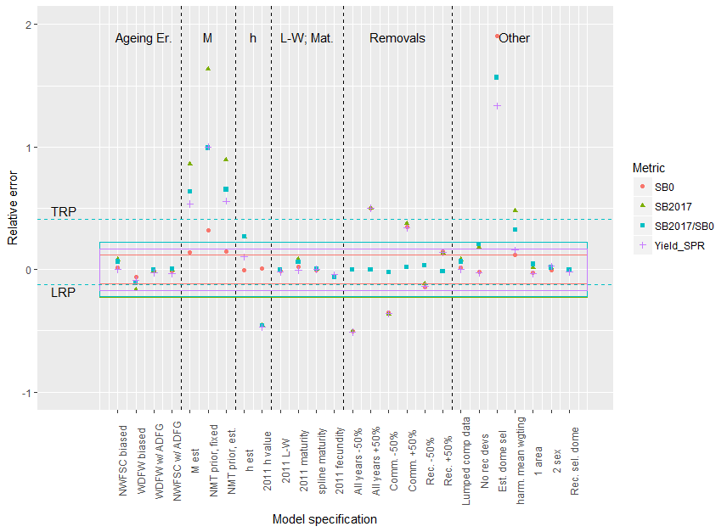

Figure . Sensitivity of the reference model to alternative model specifications. Relative error is defined as the difference in a given metric between the proposed model and the reference model, divided by the reference model value. Boxes correspond to the 95% confidence interval of a derived quantity (indicated by color) in the reference model. Values outside the box would indicate significant uncertainty in the removal of data from the uncertainty provided in the reference model.

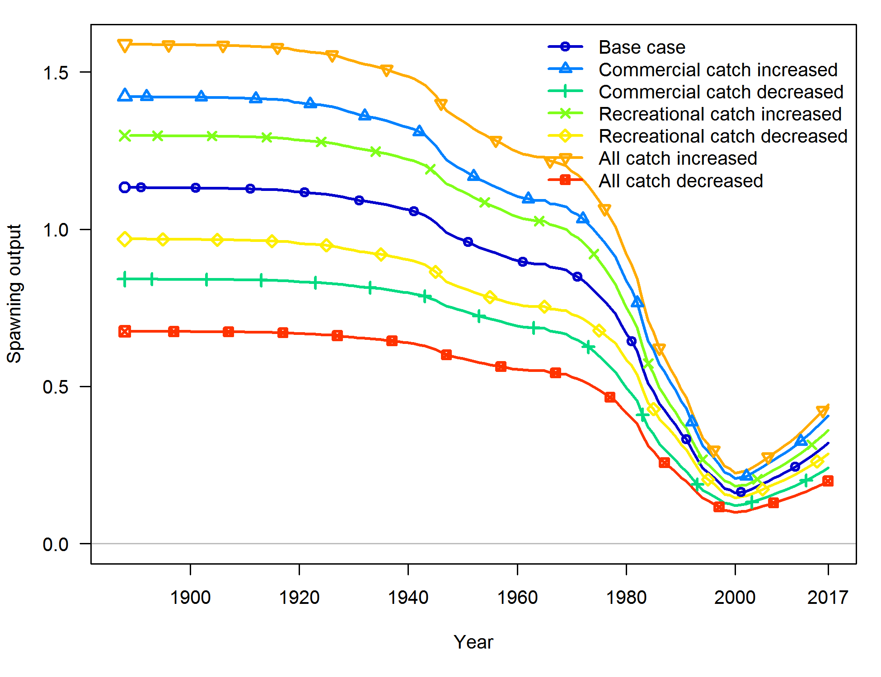

Figure . Sensitivity of yelloweye rockfish spawning output to alternative catch time series.

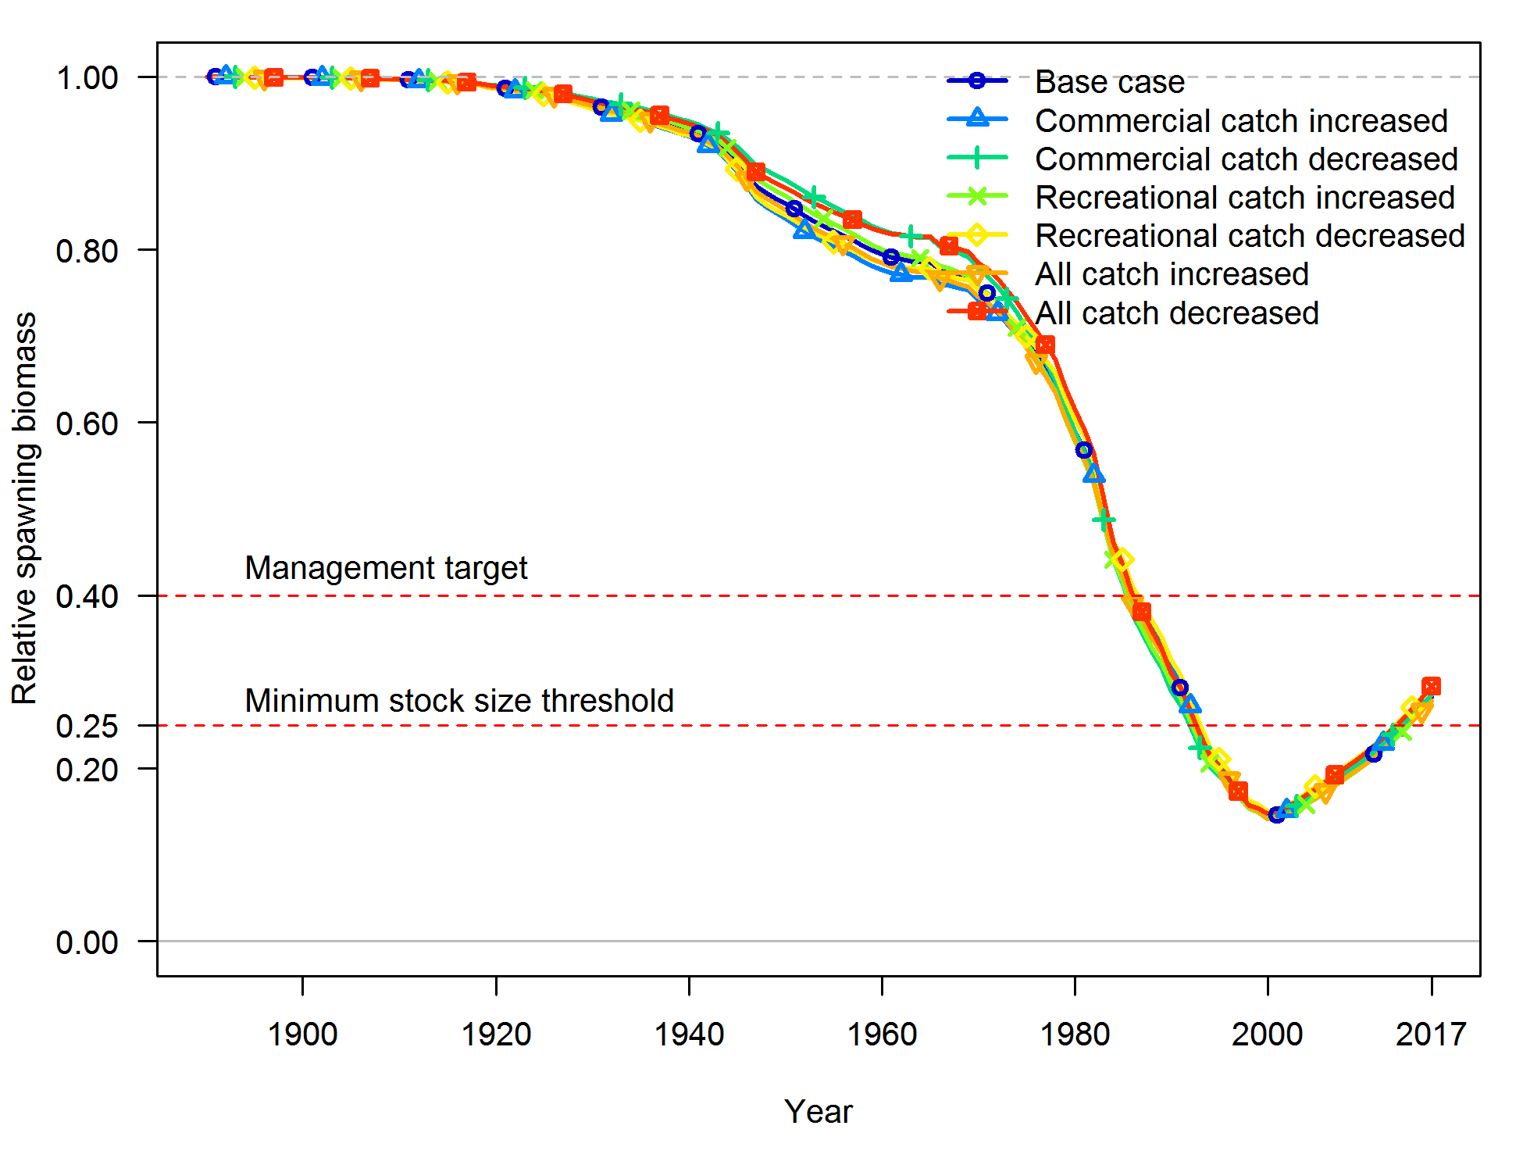

Figure . Sensitivity of yelloweye rockfish relative spawning output to alternative catch time series.

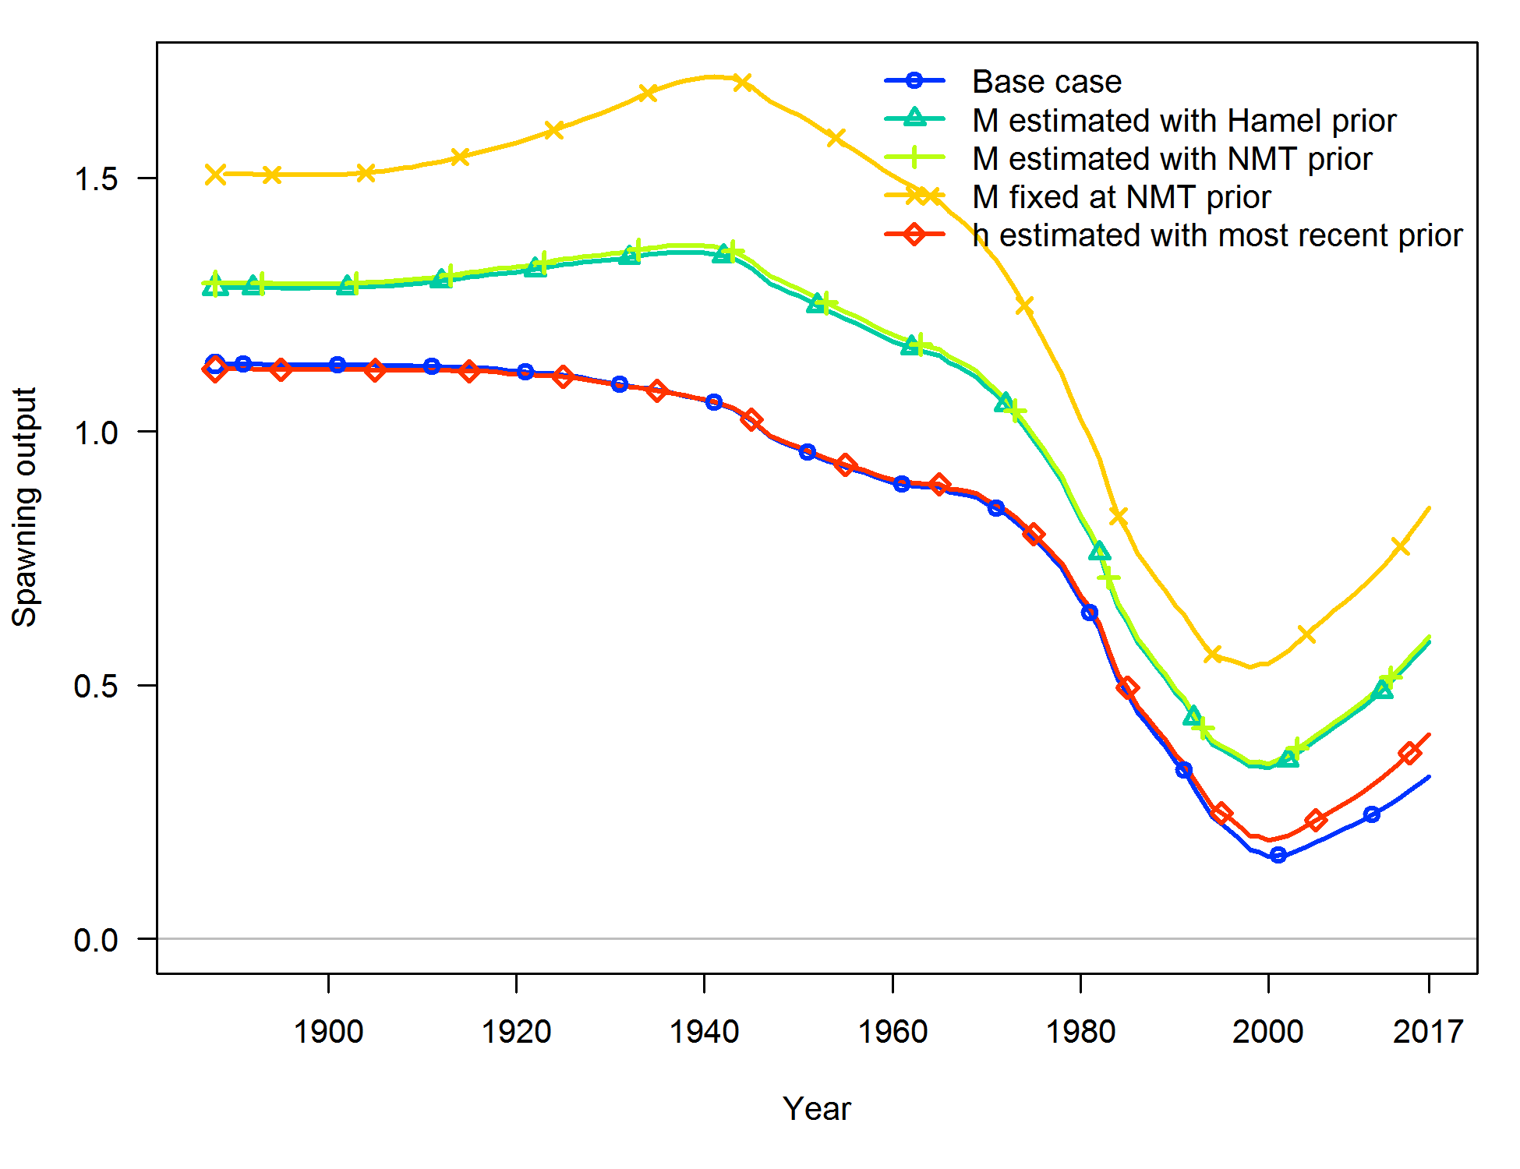

Figure . Sensitivity of yelloweye rockfish spawning output to alternative values of natural mortality and stock-recruit steepness.

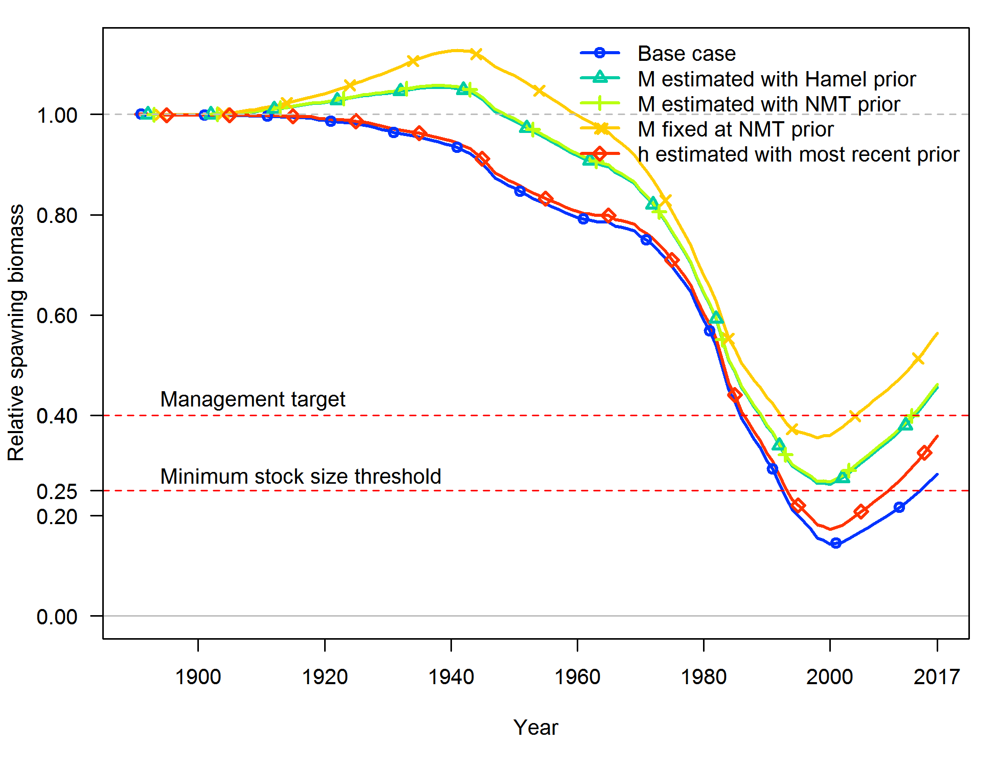

Figure Sensitivity of yelloweye rockfish relative spawning output to alternative values of natural mortality and stock-recruit steepness.

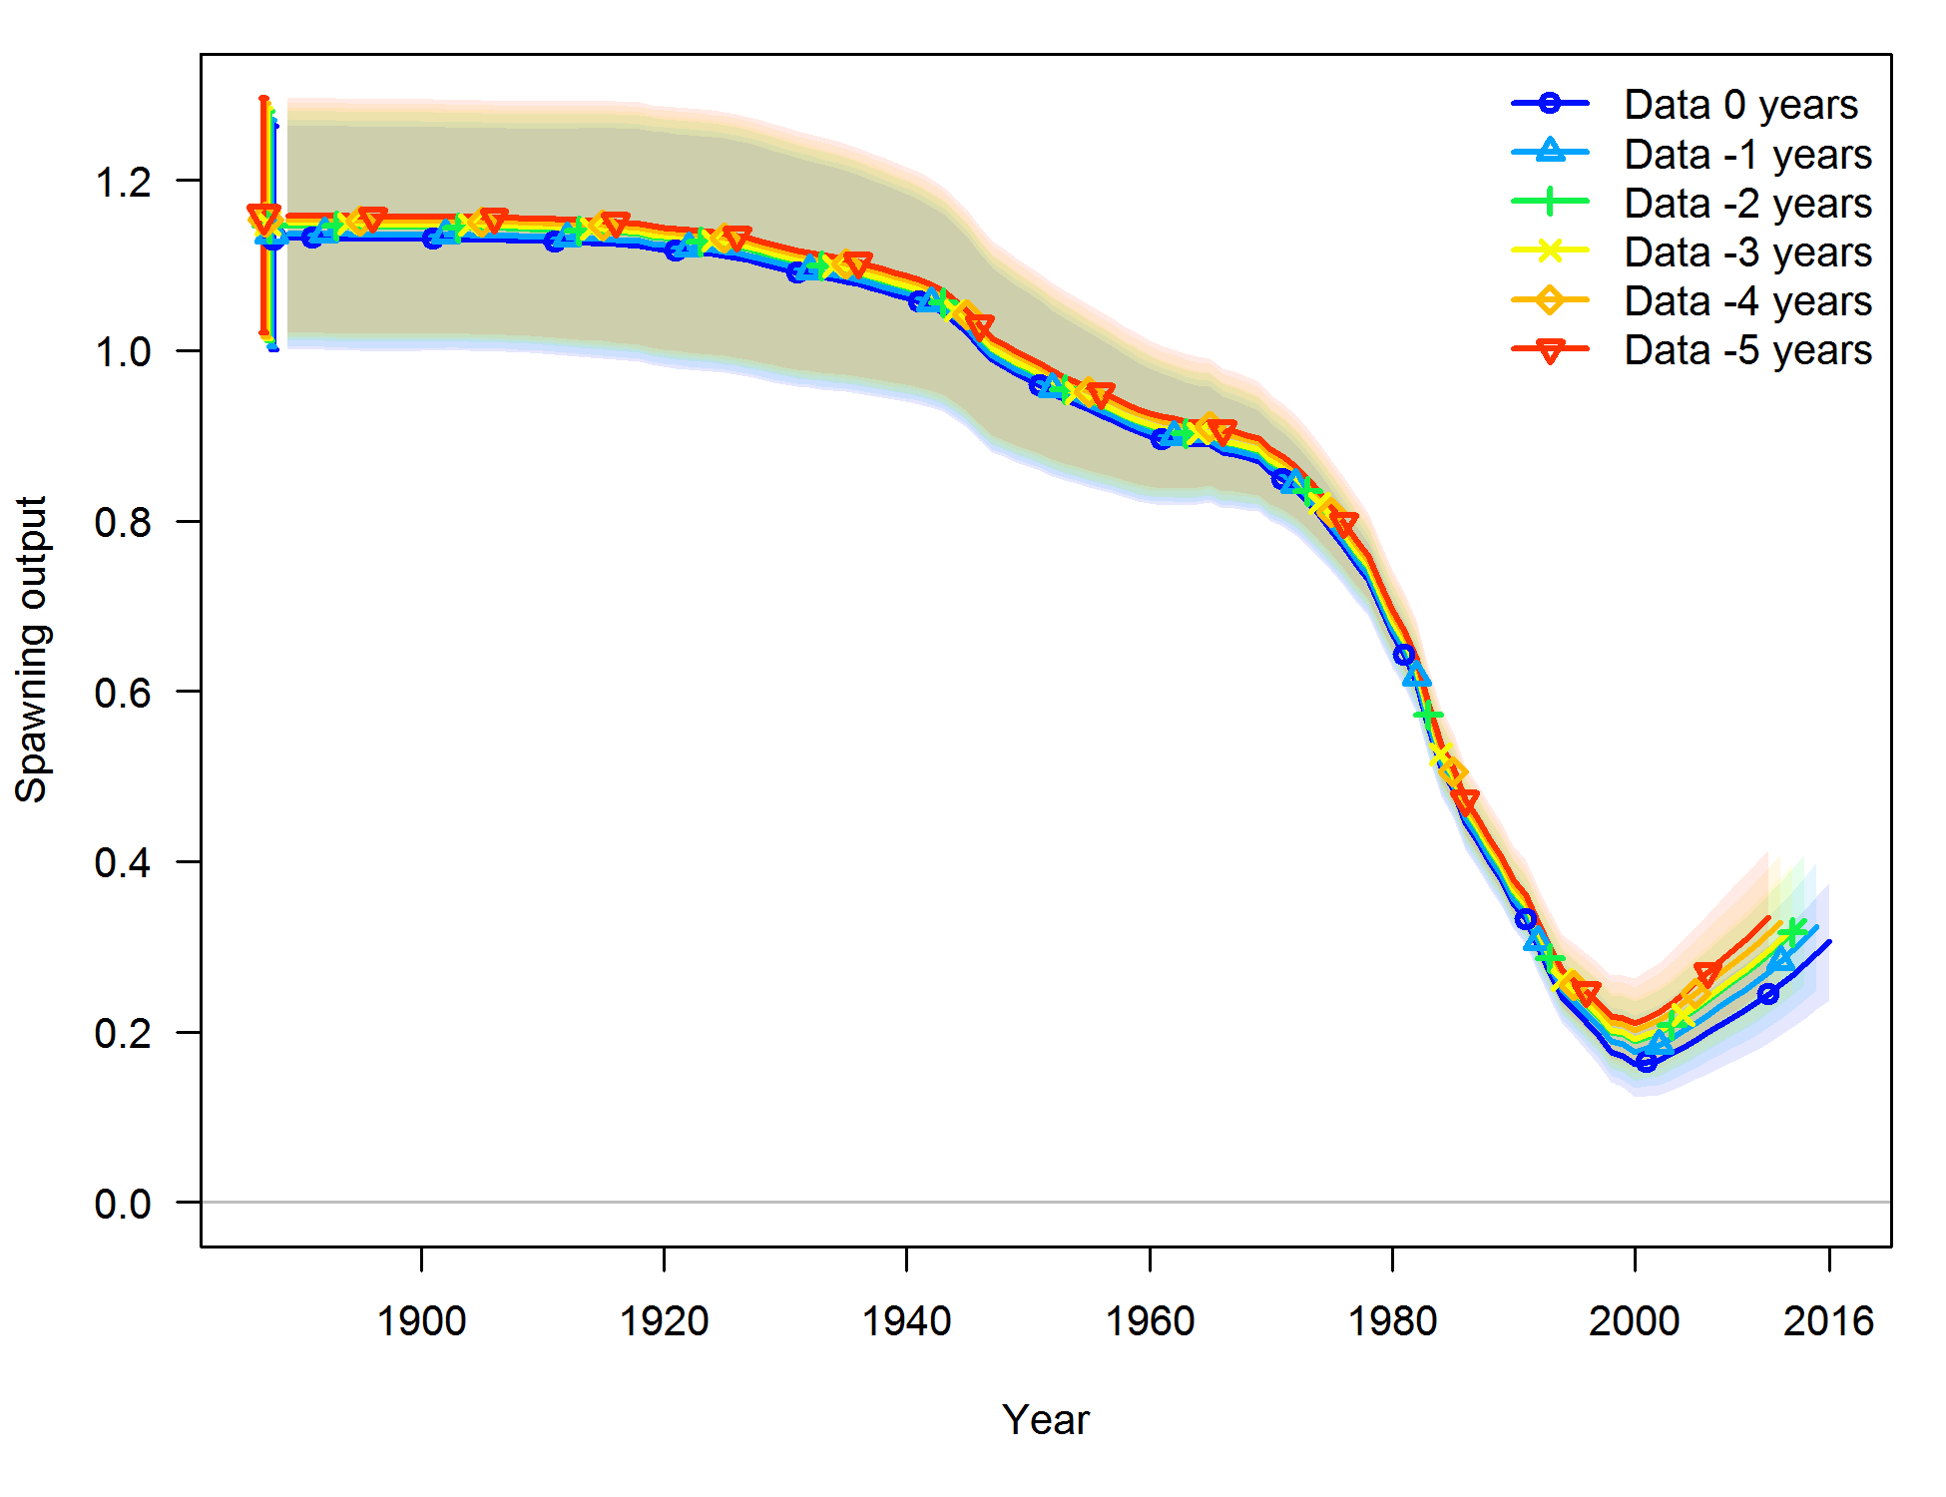

Figure . Results of retrospective analysis. Spawning output time series of this assessment base model are provided with ~ 95% interval.

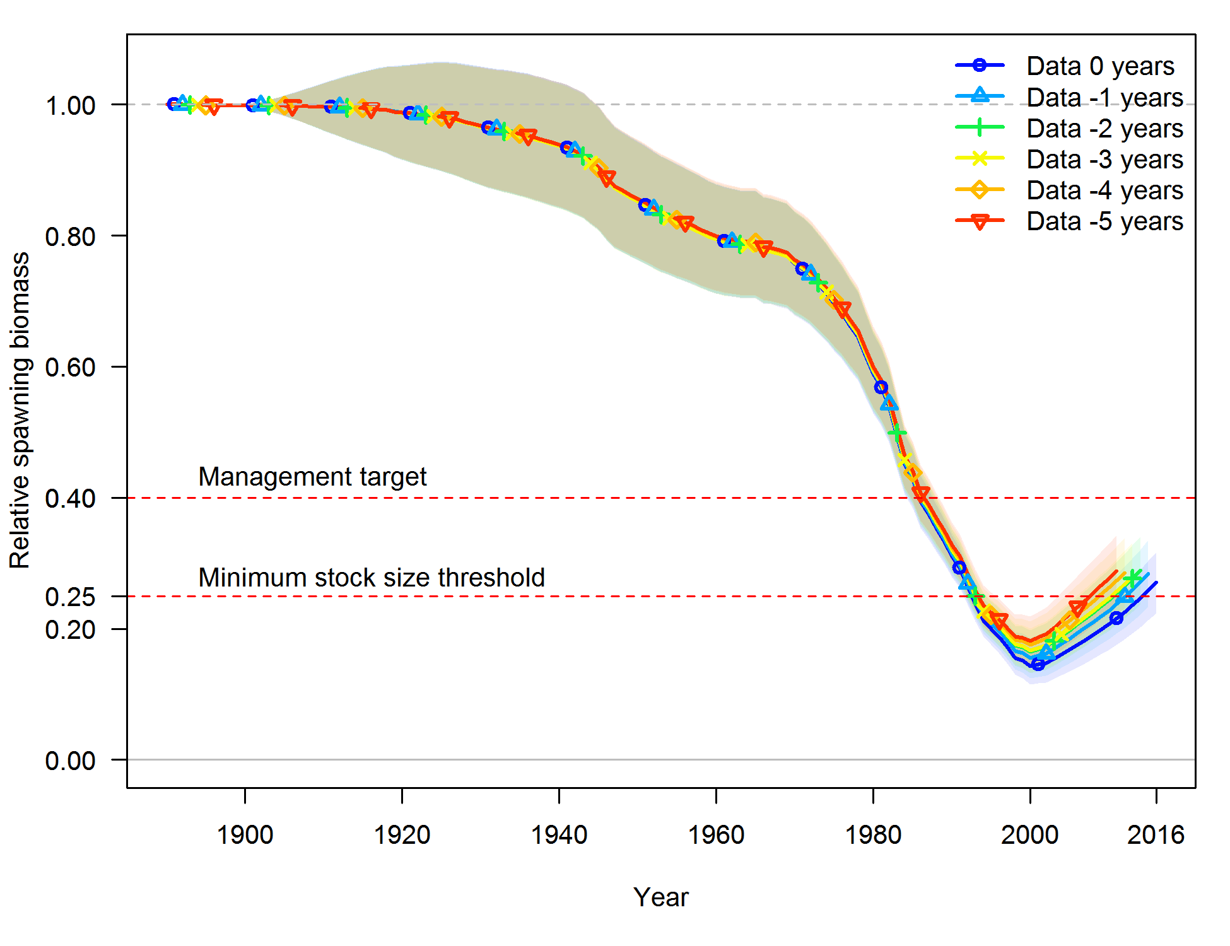

Figure . Results of retrospective analysis. Relative spawning output time series of this assessment base model are provided with ~ 95% interval.

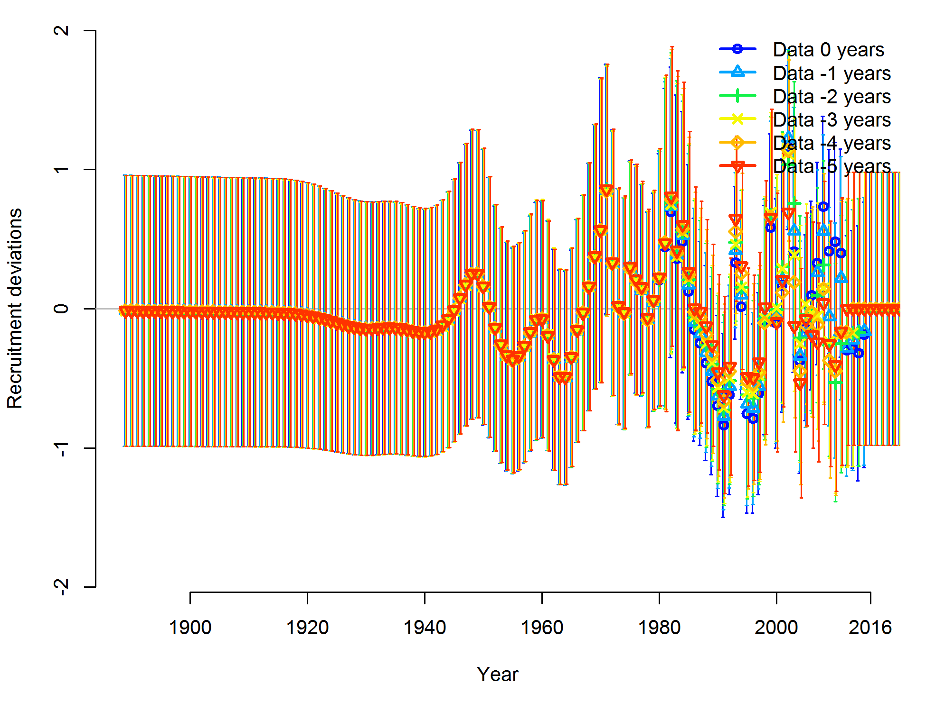

Figure . Recruitment deviation time series for each scenario of the retrospective analysis.

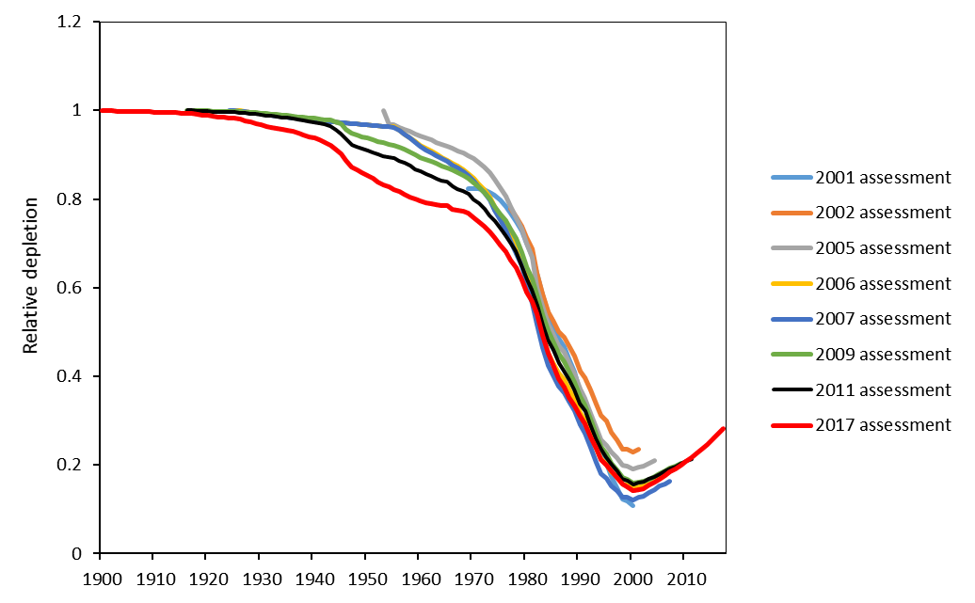

Figure . Comparison of relative spawning output time series among yelloweye rockfish assessments.

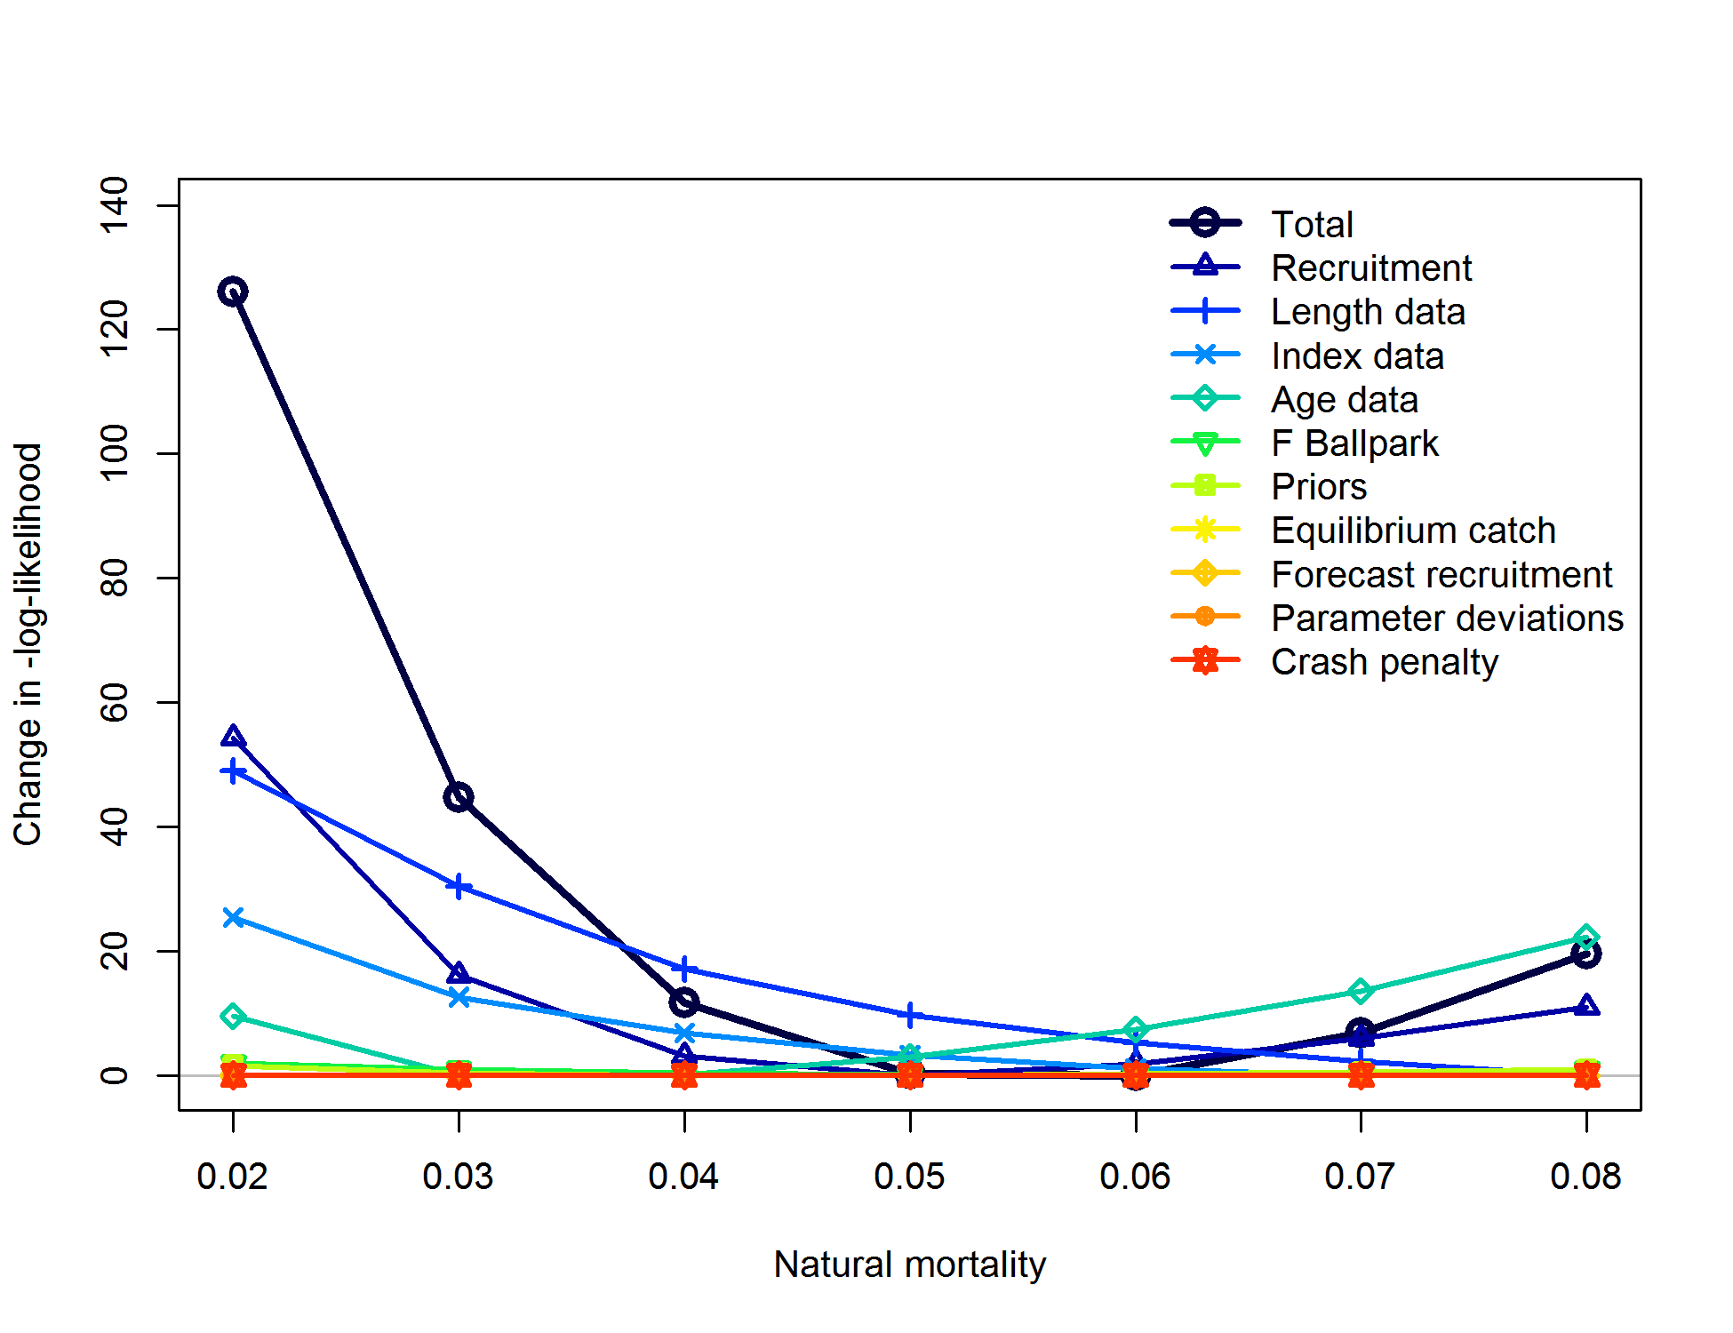

Figure . Negative log-likelihood profile for each data component and in total given different values of natural mortality ranging from 0.02 to 0.08 by increments of 0.01.

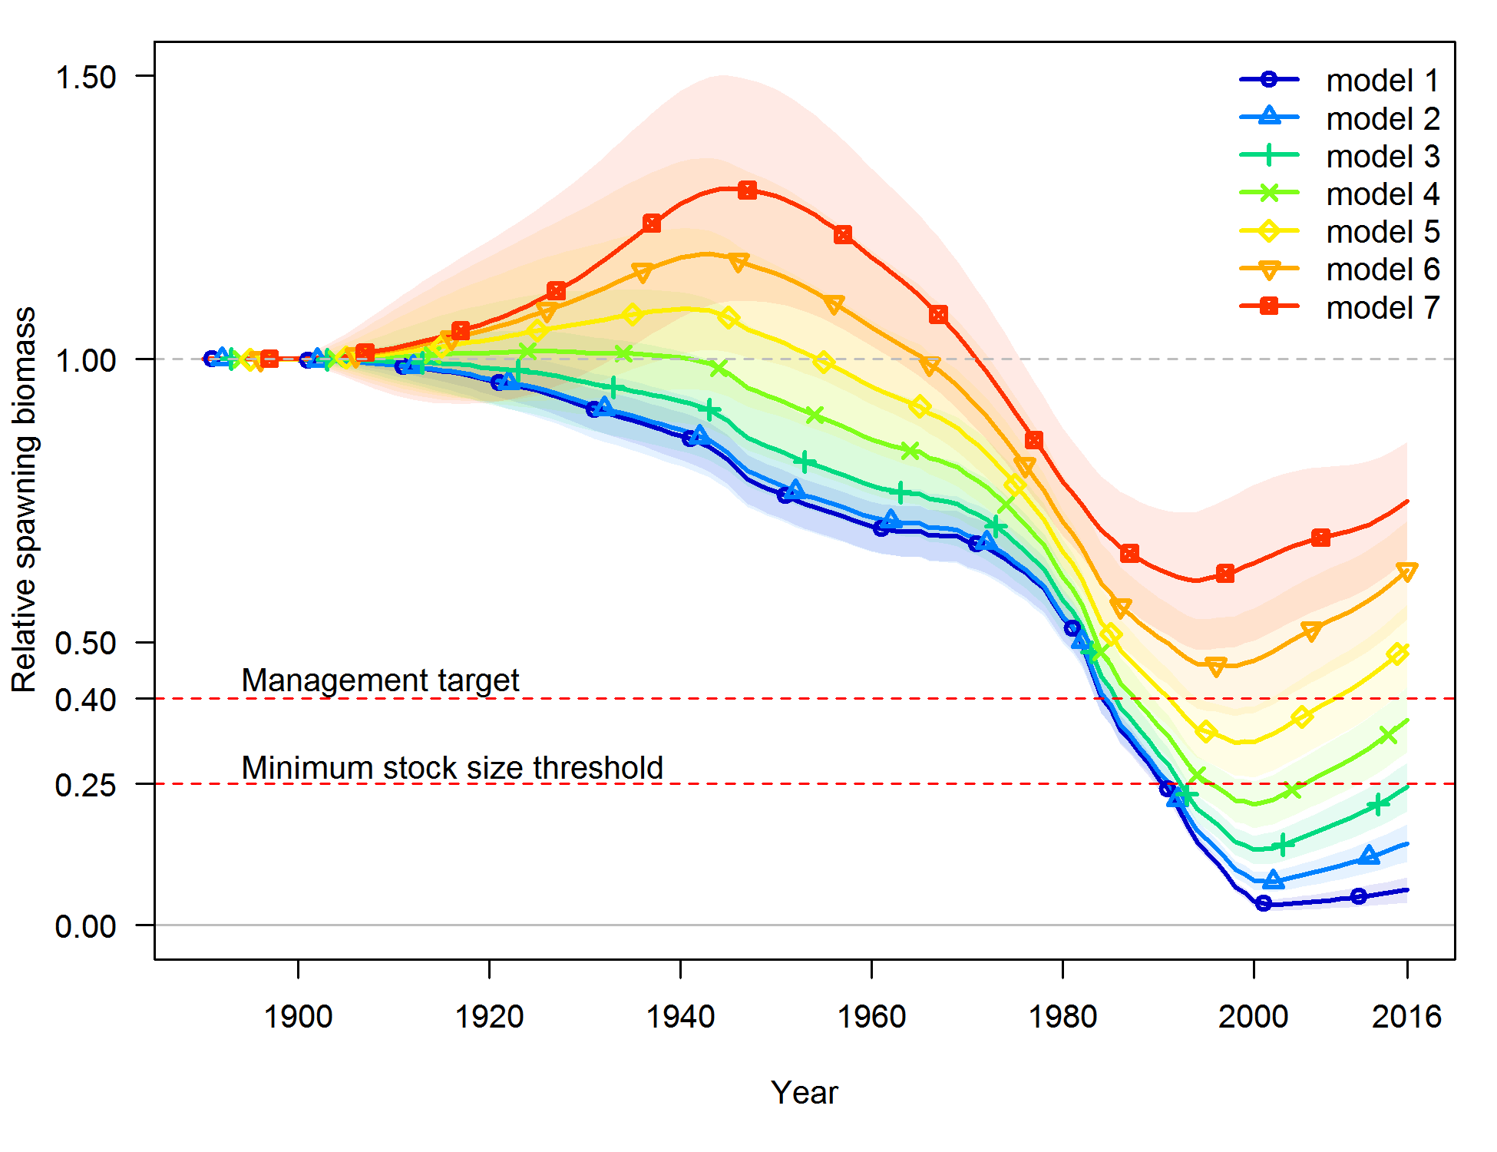

Figure . Time series of relative spawning output associated with different values of natural mortality ranging from 0.02 (Model 1) to 0.08 (Model 7) by increments of 0.01.

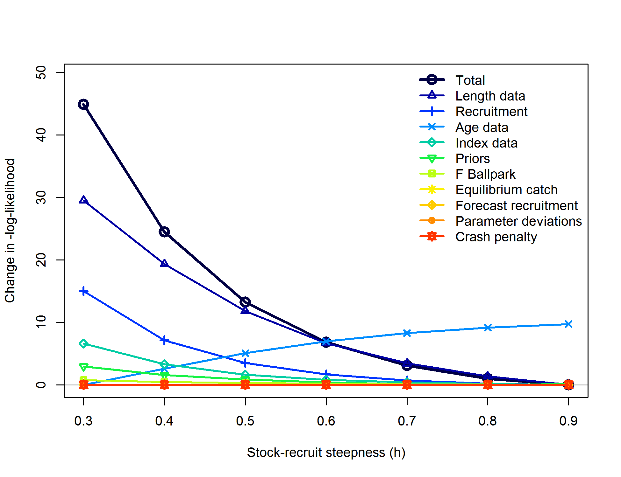

Figure . Negative log-likelihood profile for each data component and in total given different values of stock-recruit steepness ranging from 0.3 to 0.9 by increments of 0.1.

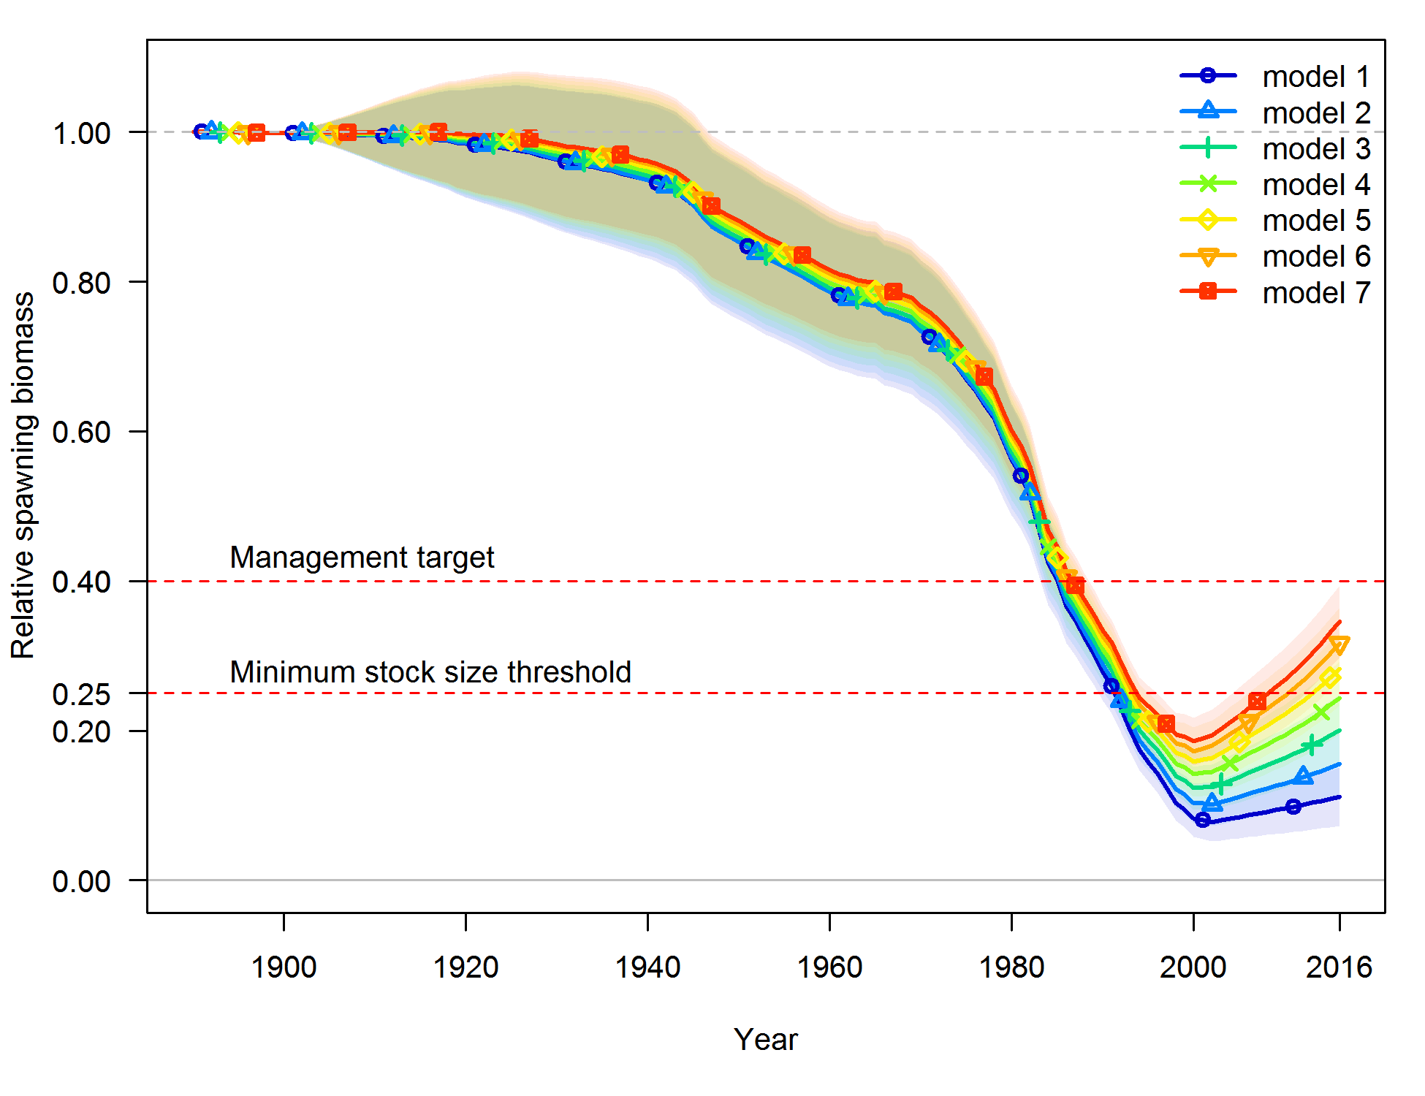

Figure . Time series of relative spawning output associated with different values of steepness ranging from 0.3 (Model 1) to 0.9 (Model 7) by increments of 0.1.

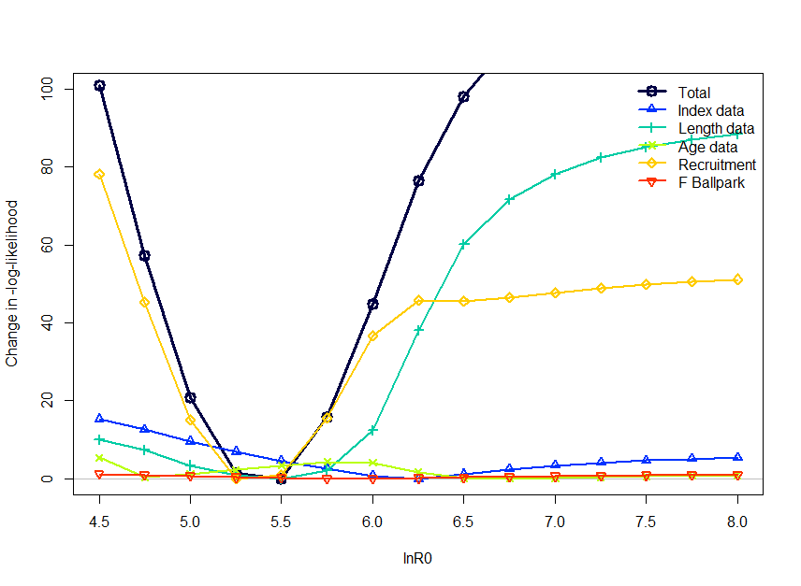

Figure . Likelihood profile for log initial recruitment (lnR0) by likelihood component.

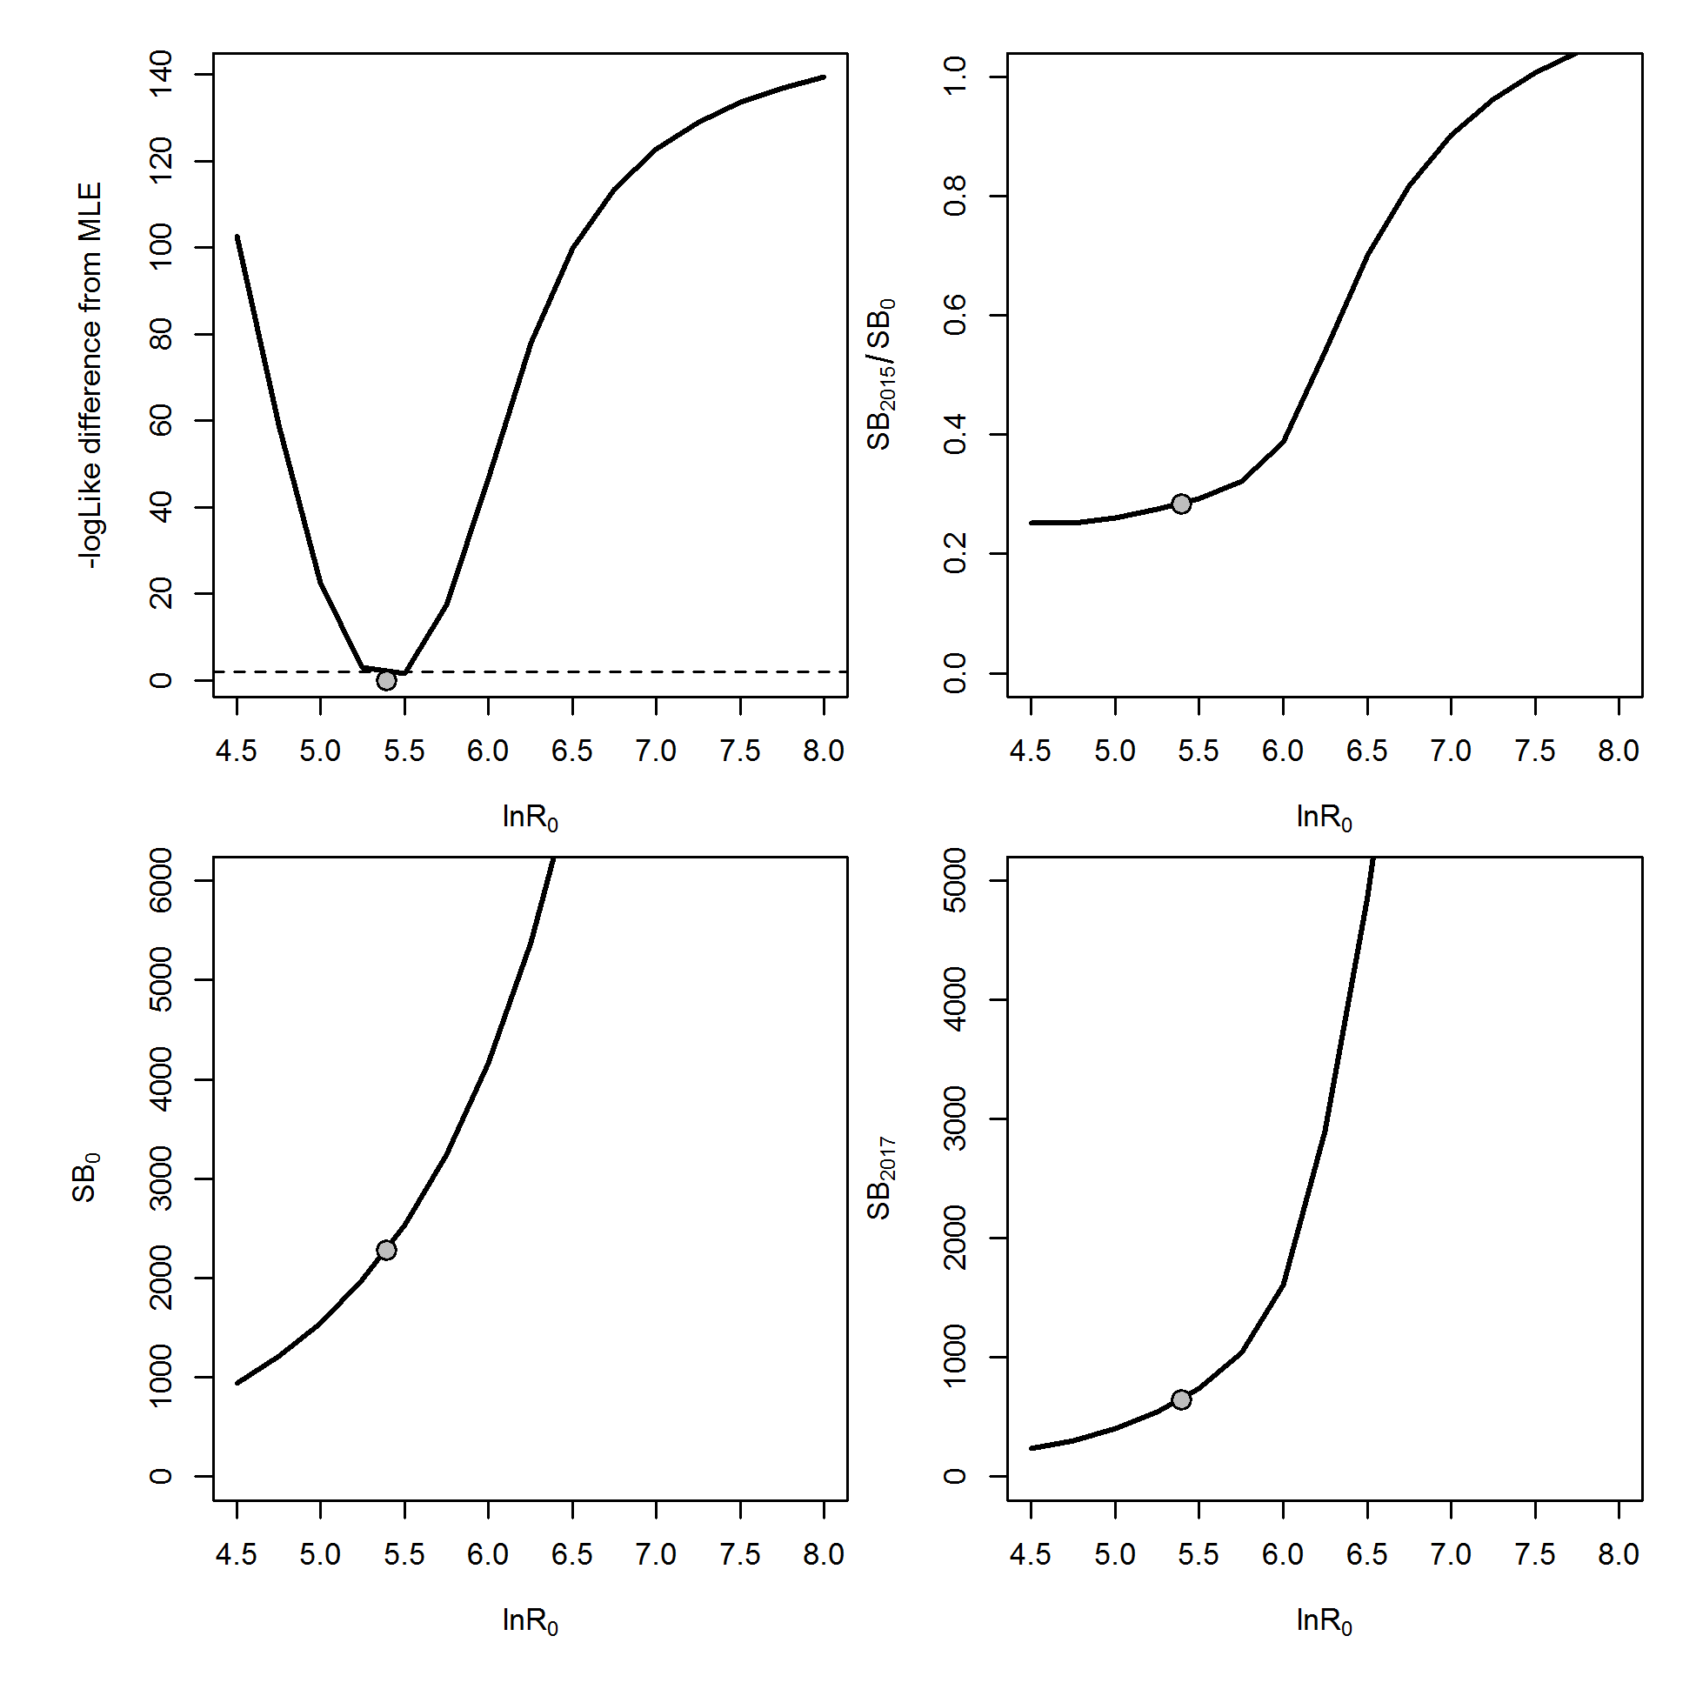

Figure . Likelihood profile (top left panel) for log initial recruitment (lnR0), with associated changes in stock status in the current year (SB2017/SB0; top right panel), initial spawning biomass (SB0; bottom left panel), and current year spawning biomass (SB2017; bottom right panel). Points indicate the base model MLE estimate.

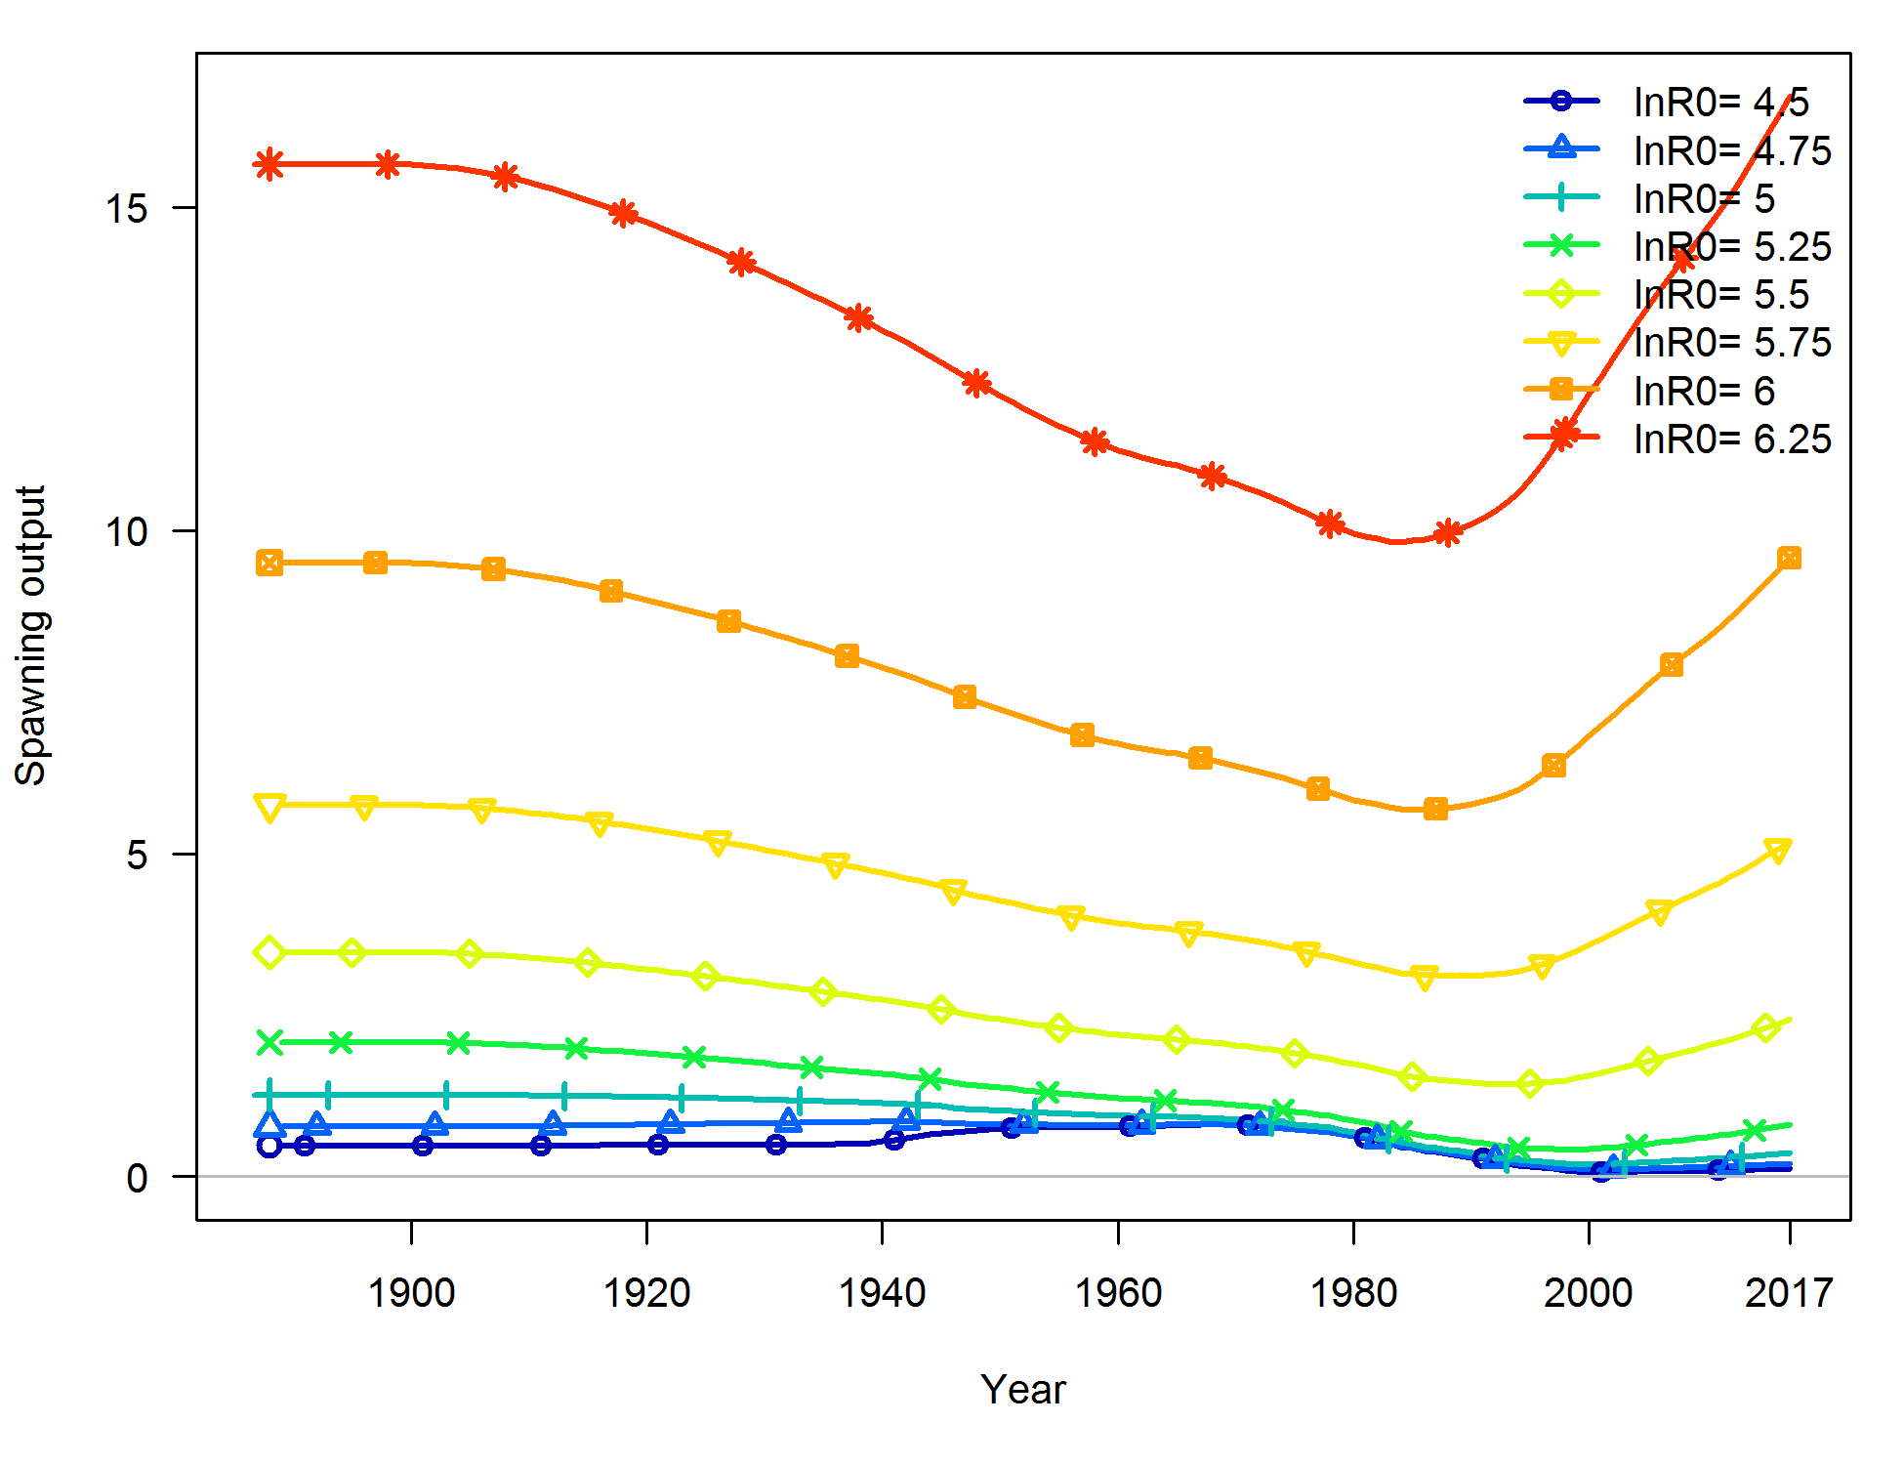

Figure . Spawning output as profiled over values of lnR0.

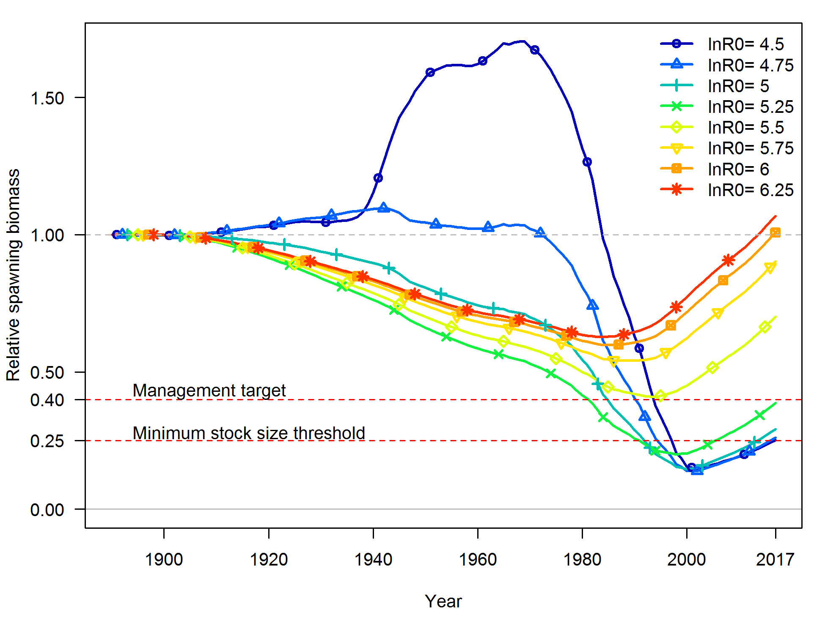

Figure . Relative stock status based on spawning biomass as profiled over values of lnR0.

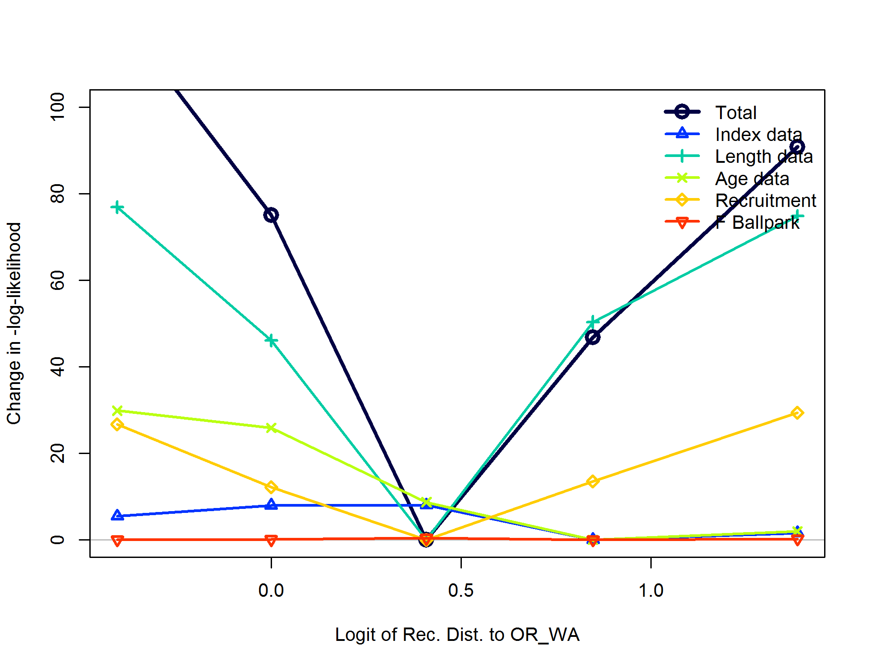

Figure . Negative log-likelihood profile for each data component and in total given different values of the area specific recruit distribution parameter. The values are given in the logit transformation, but can be translated as, from left to right, as 80% ORWA: 20% CA; 70% ORWA: 30% CA; 60% ORWA: 40% CA; 50% ORWA: 50% CA; 40% ORWA: 60% CA.

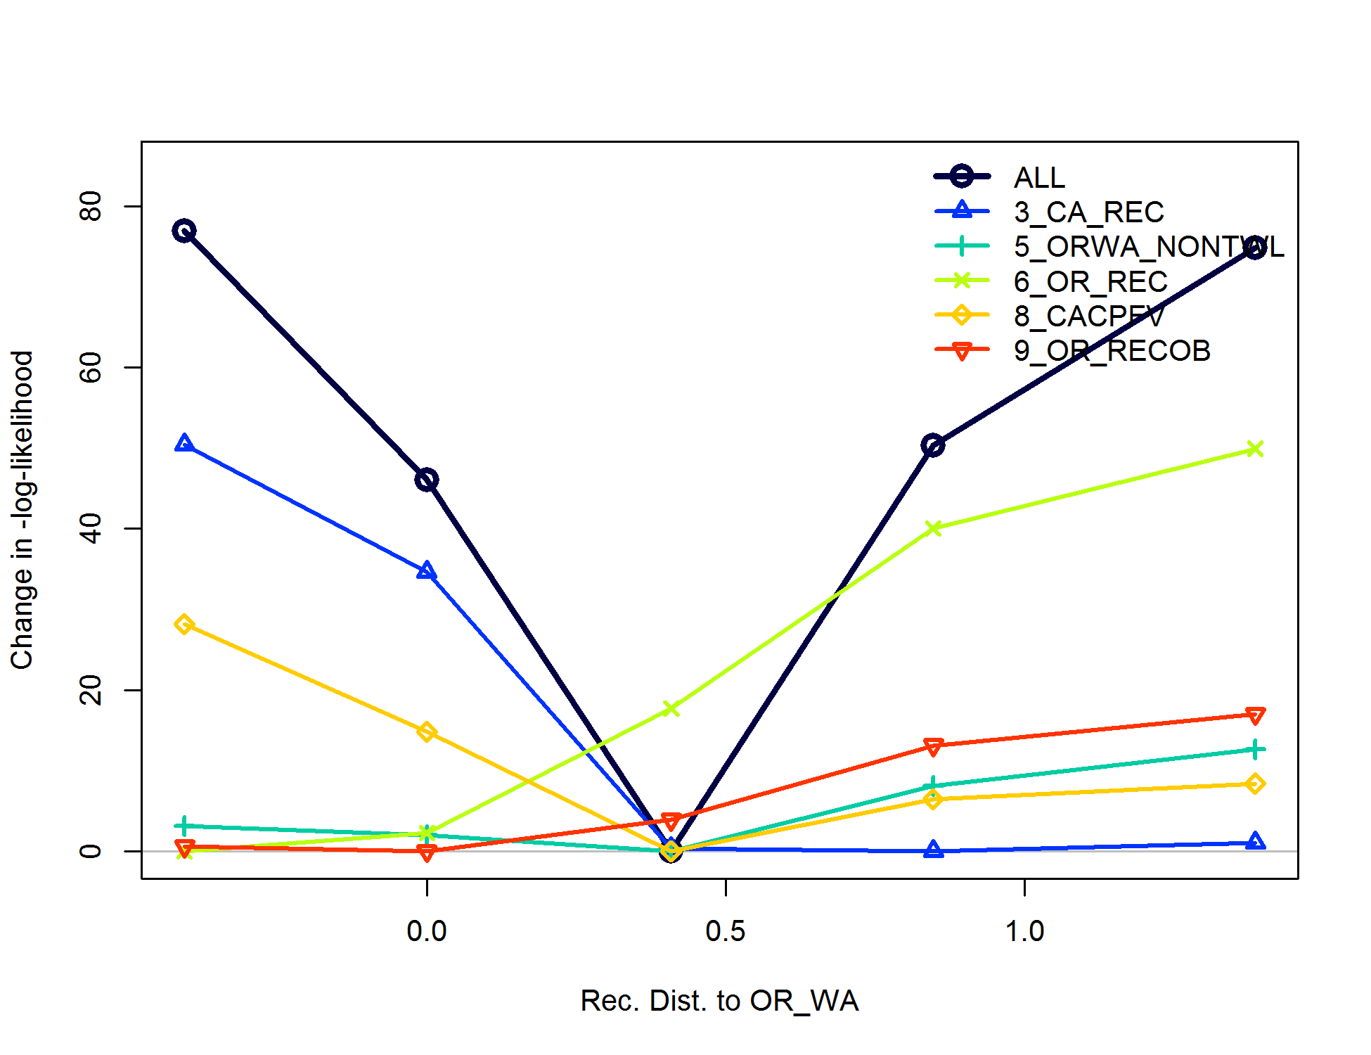

Figure . Negative log-likelihood profile for each data source of the length likelihood component given different values of the area specific recruit distribution parameter. The values are given in the logit transformation, but can be translated as, from left to right, as 80% ORWA: 20% CA; 70% ORWA: 30% CA; 60% ORWA: 40% CA; 50% ORWA: 50% CA; 40% ORWA: 60% CA.

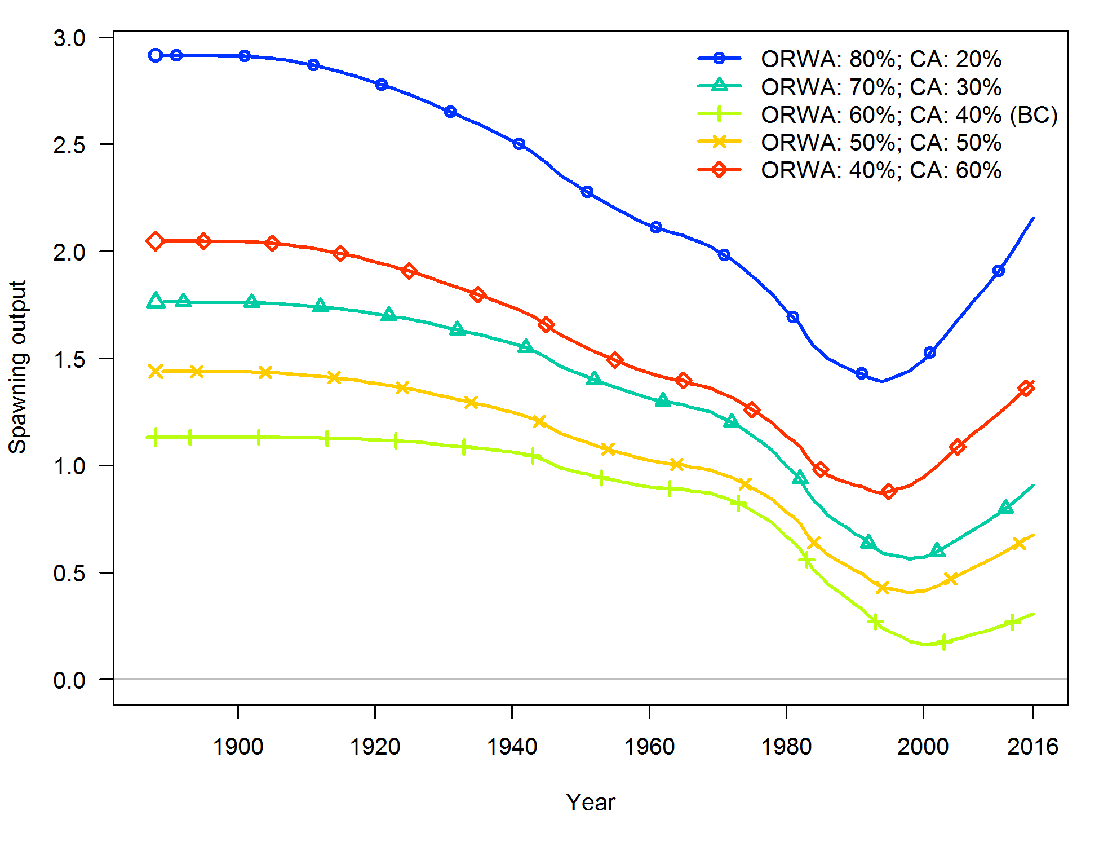

Figure . Spawning output as profiled over values of the area specific recruit distribution parameter.

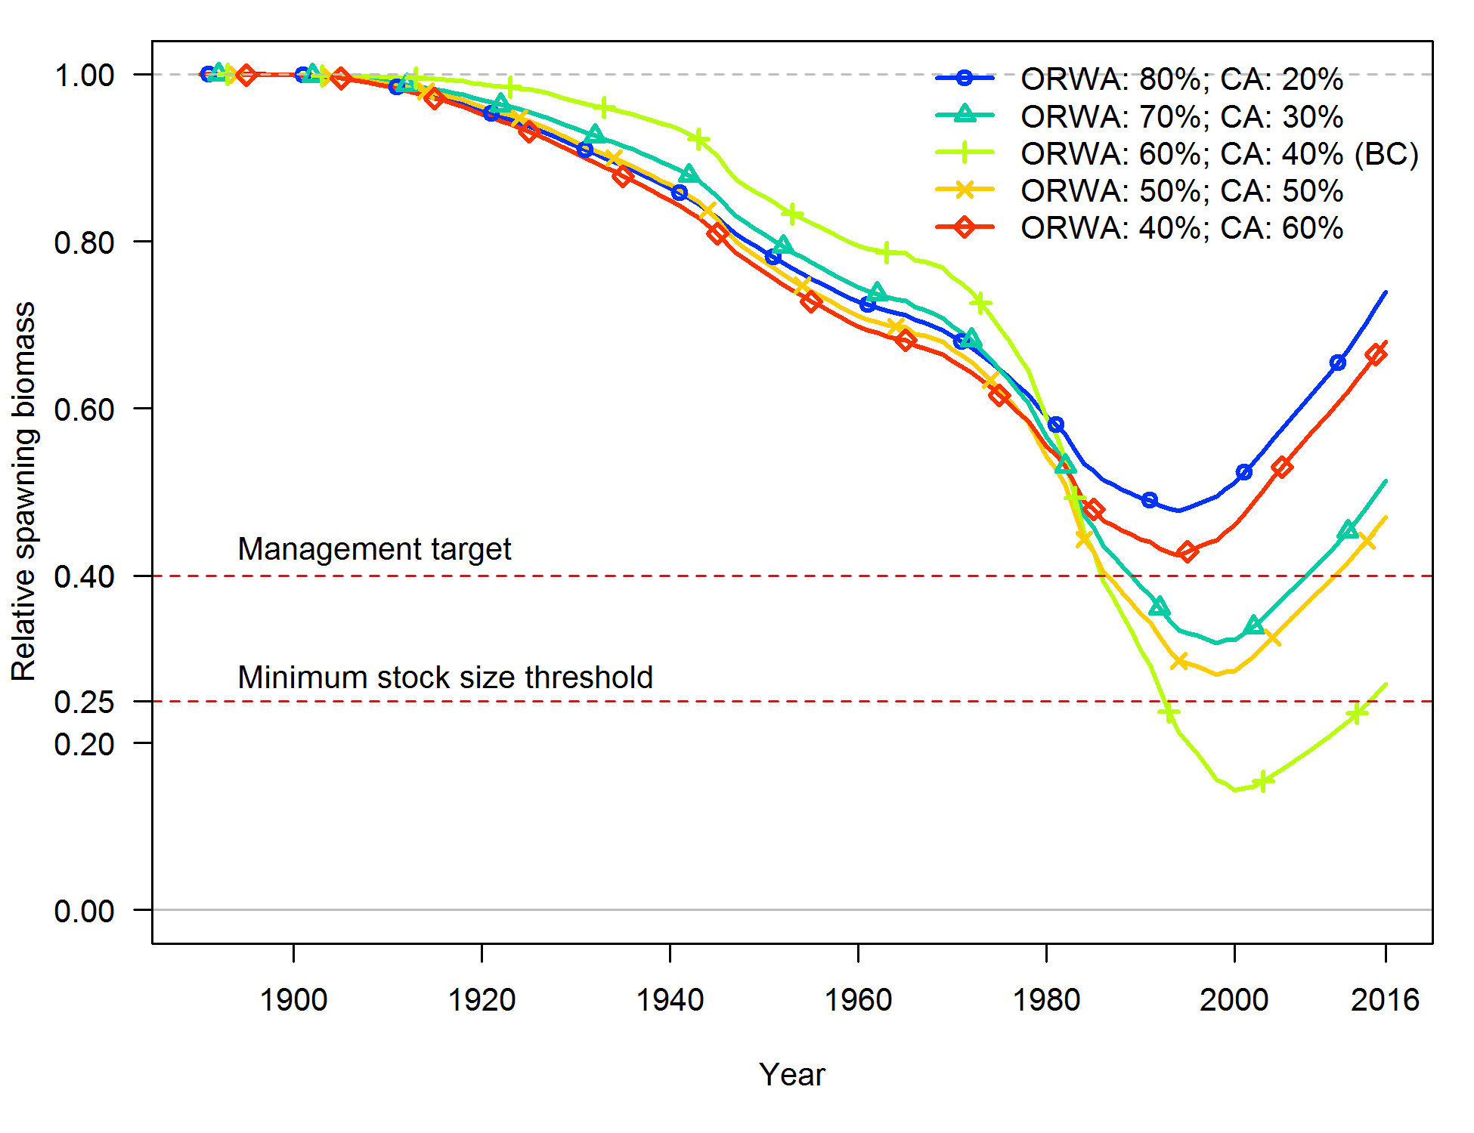

Figure . Relative stock status as profiled over values of the area specific recruit distribution parameter.

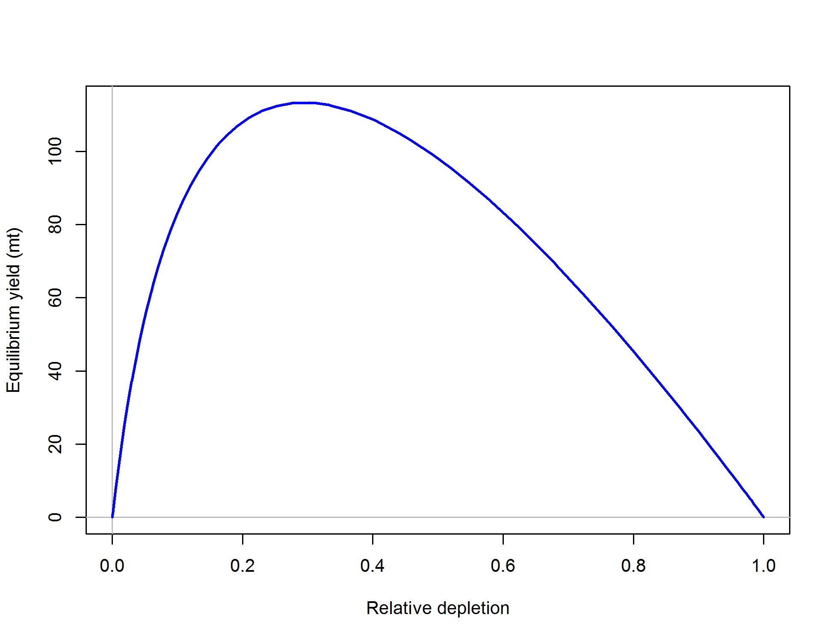

Figure . Equilibrium yield curve (derived from reference point values) for the base model. Values are based on 2016 fishery selectivity and distribution with steepness fixed at 0.718. The relative spawning output is relative to unfished spawning biomass.

1. SS data file

See model files folder provided

1. SS control file

See model files folder provided

1. SS starter file

See model files folder provided

1. SS forecast file

See model files folder provided